|  |  |
| --- | --- |
|  | **MINISTRY OF EDUCATION  AND TRAINING** |

**FPT UNIVERSITY**

|  |  |
| --- | --- |
| Capstone Project Document | |
| **Bike World** | |
| **Group 3** | |
| **Group Members** |  |
| **Supervisor** |  |
| **Ext. Supervisor** |  |
| **Project Code** |  |

– **Ho Chi Minh City, 11 January, 2019** –

*This page is intentionally left blank*

Table of Contents

A. Introduction 18

1. Project Information 18

2. Introduction 18

3. Current Situation 18

4. Problem Definition 18

5. Proposed Solution 19

5.1. Feature functions 19

5.2. Advantages and disadvantages 19

6. Functional Requirements 19

7. Role & Responsibility 21

B. Software Project Management Plan 23

1. Problem Definition 23

1.1. Name of this Capstone Project 23

1.2. Problem Abstract 23

1.3. Project Overview 23

2. Project Organization 26

2.1. Software Process Model 26

2.2. Roles and responsibilities 28

2.3. Tools and Techniques 28

3. Project Management Plan 29

3.1. Product Backlog 29

3.2. Sprint Backlog 31

3.3. Deliverables 31

3.4. All Meeting Minutes 31

4. Coding Convention 31

C. Software Requirement Specification 33

1. User Requirement Specification 33

1.1. Guest Requirement 33

1.2. Member Requirement 33

1.3. Admin Requirement 34

2. System Requirement Specification 34

2.1. External Interface Requirement 34

2.2. System Overview Use Case 35

2.3. List of use case 37

3. Software System Attribute 164

3.1. Usability 164

3.2. Reliability 164

3.3. Availability 164

3.4. Security 164

3.5. Maintainability 164

3.6. Portability 164

3.7. Performance 164

4. Conceptual Diagram 165

D. Software Design Description 166

1. Design Overview 166

2. System Architectural Design 167

3. Component Diagram 168

4. Detailed Description 170

4.1. Class Diagram 171

4.2. Class Diagram Explanation 171

4.3. Interaction Diagram 182

5. Interface 196

5.1. Guest 196

5.2. Member 204

5.3. Admin 223

6. Database Design 235

6.1. Entity Relationship Diagram 235

6.2. Data Dictionary 236

7. Algorithms 236

E. System Implementation & Test 241

1. Introduction 241

1.1. Overview 241

1.2. Test Approach 241

2. Data Relationship Diagram 242

2.1. Physical Diagram 242

3. Test Plan 250

3.1. Feature to be tested 250

3.2. Feature not to be tested 250

4. System testing test case 251

4.1. <Member> Supply Product test 252

4.2 <Member> Event test 254

4.3 <Member> News test 256

F. Software User’s Manual 258

1. Installation Guide 258

1.1. Setting up environment at server side 258

1.2. Deployment at server side 259

1.3. Setting up environment at client side 265

2. User Guide 266

2.1 Admin 266

2.2 Member 270

2.3 Guest 275

G. Appendix 277

**List of table**

Table 1 - Roles and Responsibilities 22

Table 2 - Hardware Requirements for Server 26

Table 3 - Hardware requirement for PC 26

Table 4 - Software Requirement 27

Table 5 - Roles and responsibilities 29

Table 6 - Tools and techniques 29

Table 7 - Product Backlog 31

Table 8 - Deliverables 32

Table 9 - <Guest> Login use case specification 40

Table 10 - <Guest> Register use case specification 43

Table 11 - <Guest> Search event use case specification 45

Table 12 - <Guest> View event detail use case specification 47

Table 13 - <Guest> Search news use case specification 50

Table 14 - <Guest> View event detail use case specification 51

Table 15 - <Guest> Search supply product use case specification 54

Table 16 - <Guest> View supply product detail use case specification 55

Table 17 - <Guest> Forgot Password use case specification 58

Table 18 - <Guest> View list supply productss use case specification 60

Table 19 - <Guest> View list events use case specification 61

Table 20 - <Guest> View list events use case specification 63

Table 21 -<Authorized User> Logout use case specification 66

Table 22 - <Authorized User> View user’s profile use case specification 68

Table 23 - <Authorized User> Edit comment use case specification 70

Table 24 - <Authorized User> Send comment use case specification 72

Table 25 - <Authorized User> Update profile use case specification 74

Table 26 - <Authorized User> Change password use case specification 77

Table 27 - <Member> Send report use case specification 81

Table 28 - <Member> Create request use case specification 83

Table 29 - <Member> Update request use case specification 86

Table 30 - <Member> View list requests use case specification 88

Table 31 - <Member> View request detail use case specification 90

Table 32 - <Member> Close request use case specification 92

Table 33 - <Member> View list notifications use case specification 94

Table 34 - <Member> Create transaction use case specification 95

Table 35 - <Member> Create supply product use case specification 99

Table 36 -<Member> Update supply product use case specification 102

Table 37 - <Member> View list followers of supply products 104

Table 38 - <Member> Close supply product use case specification 107

Table 39 - <Member> Approve transaction use case specification 109

Table 40 - <Member> View list transactions use case specification 112

Table 41 - <Member> Buy ticket use case specification 114

Table 42 -<Member> View transaction detail use case specification 116

Table 43 - <Member> Edit feedback use case specification 118

Table 44 - <Member> Create event use case specification 121

Table 45 - <Member>View list purchased tickets use case specification 123

Table 46 - <Member> Update event use case specification 126

Table 47 - <Member> View list reports use case specification 128

Table 48 - <Member > View report detail use case specification 130

Table 49 - <Member> Send feedback use case specification 132

Table 50 - <Admin> Add admin use case specification 135

Table 51 - <Admin> Block / unblock account use case specification 137

Table 52 - <Admin> View list accounts use case specification 139

Table 53 - <Admin> Block/Unblock comment use case specification 141

Table 54 - <Admin> Create news use case specification 144

Table 55 - <Admin> Update news use case specification 146

Table 56 - <Admin>View all news use case specification 148

Table 57 - <Admin> Approve supply product use case specification 151

Table 58 - <Admin> View all reports use case specification 152

Table 59 - <Admin> View report detail use case specification 154

Table 60 - <Admin> Reply report use case specification 157

Table 61 - <Admin>View all events use case specification 158

Table 62 - <Admin> Approve event use case specification 161

Table 63 - <Automatic System> Update event state use case specification 163

Table 64 - <Automatic System> Crawl data use case specification 164

Table 65 – Front End Component Diagram 169

Table 66 - Back End Component Diagram 170

Table 67 - Class Diagram Dictionary 172

Table 68 - Comment Attribute 173

Table 69 - Comment Method 173

Table 70 - Role Attribute 173

Table 71 - Report Attribute 173

Table 72 - Report Method 174

Table 73 - Feedback Attribute 174

Table 74 - Feedback Method 174

Table 75 - SupplyProduct Attribute 175

Table 76 - SupplyProduct Method 175

Table 77 - News Attribute 176

Table 78 - News Method 176

Table 79 - Account Attribute 177

Table 80 - Account Method 177

Table 81 - Image Attribute 177

Table 82 - Image Method 177

Table 83 - Event Attribute 179

Table 84 - Event Method 179

Table 85 - Bike Attribute 179

Table 86 - Bike Method 180

Table 87 - Accessory Attribute 180

Table 88 - Accessory Method 180

Table 89 - RequestProduct Attribute 181

Table 90 - RequestProduct Method 181

Table 91 - Category Attribute 181

Table 92 - Category Method 181

Table 93 - ReferenceLinkes Attribute 182

Table 94 - ReferenceLinks Method 182

Table 95 - <Buttons/Hyperlinks> Menu bar 197

Table 96 - <Buttons/Hyperlinks> Menu bar 197

Table 97 - <Buttons/Hyperlinks> Menu bar 198

Table 98 - <Buttons/Hyperlinks> View list event 199

Table 99 - <Buttons/Hyperlinks> View list bike posts 199

Table 100 - <Buttons/Hyperlinks> View list accessory posts 199

Table 101 - <Buttons/Hyperlinks> Search 200

Table 102 - <Fields> Search 200

Table 103 - <Buttons/Hyperlinks> Search 200

Table 104 - <Fields> Search 200

Table 105 - <Buttons/Hyperlinks> View list news 201

Table 106 - <Fields> Log in 202

Table 107 - <Buttons/Hyperlinks> Log in 202

Table 108 - <Fields> Register 202

Table 109 - <Buttons/Hyperlinks> Register 203

Table 110 - <Fields> Phone number confirm 203

Table 111 - <Buttons/Hyperlinks> Phone number confirm 203

Table 112 - <Fields> Register information 204

Table 113 - <Buttons/Hyperlinks> Register information 205

Table 114 - <Fields> View event detail 206

Table 115 - <Buttons/Hyperlinks> Buy ticket 206

Table 116 - <Fields> Buy ticket 207

Table 117 - <Buttons/Hyperlinks> Buy ticket 207

Table 118 - <Buttons/Hyperlinks> User menu 208

Table 119 - <Fields> View profile 208

Table 120 - <Buttons/Hyperlinks> View profile 209

Table 121 - <Fields> Change password 209

Table 122 - <Buttons/Hyperlinks> View profile 209

Table 123 - <Buttons/Hyperlinks> User navigator 211

Table 124 - <Buttons/Hyperlinks> View list events 212

Table 125 - <Fields> Create event 213

Table 126 - <Buttons/Hyperlinks> Create event 213

Table 127 - <Fields> Create accessory post 215

Table 128 - <Buttons/Hyperlinks> Create accessory post 215

Table 129 - <Buttons/Hyperlinks> View list events had bought ticket 216

Table 130 - <Buttons/Hyperlinks> View list supply products 216

Table 131 - <Fields> Create bike post 218

Table 132 - <Buttons/Hyperlinks> Create bike post 218

Table 133 - <Buttons/Hyperlinks> View list supply products had added to wishlist 218

Table 134 - <Buttons/Hyperlinks> View list request 219

Table 135 - <Fields> Create bike request 221

Table 136 - <Buttons/Hyperlinks> Create bike request 221

Table 137 - <Fields> Create accessory request 222

Table 138 - <Buttons/Hyperlinks> Create accessory request 222

Table 139 - <Buttons/Hyperlinks> Create accessory request 223

Table 140 - <Buttons/Hyperlinks> Admin navigation 225

Table 141 - <Buttons/Hyperlinks> View list members 225

Table 142 - <Fields> Add admin 226

Table 143 - <Buttons/Hyperlinks> Add admin 226

Table 144 - <Buttons/Hyperlinks> View list report 227

Table 145 - <Fields> View list report 228

Table 146 - <Buttons/Hyperlinks> View list report 228

Table 147 - <Buttons/Hyperlinks> View list events 229

Table 148 - <Fields> View list events 229

Table 149 - <Buttons/Hyperlinks> View list events that had created interface 230

Table 150 - <Buttons/Hyperlinks> View list tickets that had bought interface 230

Table 151 - <Buttons/Hyperlinks> View list supply products 232

Table 152 - <Fields> View list supply products 232

Table 153 - <Buttons/Hyperlinks> View list news 233

Table 154 - <Fields> View list news 233

Table 155 - <Fields> View list news 234

Table 156 - <Buttons/Hyperlinks> View list news 235

Table 157 - Entity Relationship Diagram Dictionary 237

Table 172 - Physical Diagram Dictionary 244

Table 158 - Comment Attribute 245

Table 159 - Role Attribute 245

Table 160 - Report Attribute 245

Table 161 - Feedback Attribute 246

Table 162 - SupplyProduct Attribute 246

Table 163 - News Attribute 247

Table 164 - Account Attribute 247

Table 165 - Image Attribute 248

Table 166 - Event Attribute 249

Table 167 - Bike Attribute 250

Table 168 - Accessory Attribute 250

Table 169 - RequestProduct Attribute 250

Table 170 - Category Attribute 251

Table 171 - ReferenceLinks Attribute 251

Table 173 - <Member> Supply post test 254

Table 174 - <Member> Event test 256

Table 175 - <Member> News test 258

Table 176 - Hardware requirement for server 259

Table 177 - Software requirement for server 260

Table 178 - <Admin> Block/Unblock member guide 267

Table 179 - <Admin> Add admin guide 267

Table 180 - <Admin> View list report guide 268

Table 181 - <Admin> Confirm event guide 269

Table 182 - <Admin> Confirm supply products guide 269

Table 183 - <Admin> Confirm news guide 270

Table 184 - <Admin> Create news guide 270

Table 185 - <Member> View list member buy ticket of event guide 271

Table 186 - <Member> Update event guide 272

Table 187 - <Member> Create event guide 273

Table 188 - <Member> View list event had bought ticket guide 273

Table 189 - <Member> Create bike post guide 274

Table 190 - <Member> Create accessory post guide 274

Table 191 - <Member> View list supply products had added to wishlist guide 275

Table 192 - <Member> View request guide 275

Table 193 - <Member> View list report guide 276

Table 194 - <Guest> Search title of events, supply products, news guide 277

Table 195- <Guest> Search location of events, supply products, news guide 277

**List of figure**

Figure 1 - Scrum Process 27

Figure 2 - Scrum Framework 27

Figure 3 - System Overview Use Case 36

Figure 4 - Guest Overview Use Case 37

Figure 5 - <Guest> Login 38

Figure 6 - <Guest> Register 40

Figure 7 - <Guest> Search event 42

Figure 8 - <Guest> View event detail 45

Figure 9 - <Guest> Search news 47

Figure 10 - <Guest> View news detail 49

Figure 11 - <Guest> Search supply post 51

Figure 12 - <Guest> View supply post detail 53

Figure 13 - <Guest> Forgot Password 55

Figure 14 - <Guest> View list supply posts 57

Figure 15 - <Guest> View list events 59

Figure 16 - <Guest> View list news 61

Figure 17 - Authorized User Overview Use Case 63

Figure 18 - <Authorized User> Logout 64

Figure 19 - <Authorized User> View user’s profile 65

Figure 20 - <Authorized User> Edit comment 67

Figure 21 - <Authorized User> Send comment 69

Figure 22 - <Authorized User> Update profile 71

Figure 23 - <Authorized User> Change password 74

Figure 24 - Member Overview Use Case 77

Figure 25 - <Member> Send report 78

Figure 26 - <Member> Manage request 80

Figure 27 - <Member> Create request 80

Figure 28 - <Member> Update request 83

Figure 29 - <Member> View list requests 85

Figure 30 - <Member> View request detail 87

Figure 31 - <Member> Close request 89

Figure 32 - <Member> View list notifications 91

Figure 33 - <Member>Create transaction 93

Figure 34 - <Member> Manage supply product 95

Figure 35 - <Member>Create supply product 95

Figure 36 - <Member>Update supply product 98

Figure 38 - <Member> View list followers of supply products 102

Figure 39 -<Member> Close supply product 103

Figure 40 - <Member> Approve transaction 106

Figure 41 - <Member> View list transactions 109

Figure 42 - <Member> Buy ticket 111

Figure 43 - <Member> View transaction detail 113

Figure 44 - <Member> Edit feedback 115

Figure 45 - <Member> Manage event 118

Figure 46 - <Member>Create event 118

Figure 48 - <Member> Create request 121

Figure 49 - <Member>Update event 123

Figure 50 - <Member> View list reports 126

Figure 51 - <Member> View report detail 127

Figure 52 - <Member> Send feedback 129

Figure 53 - <Admin> Overview use case 132

Figure 54 - <Admin> Manage account 133

Figure 55 - <Admin> Add admin 133

Figure 56 - <Admin> Block / unblock account 135

Figure 57 - <Admin> View list accounts 137

Figure 58 - <Admin> Block/Unblock comment 139

Figure 59 - <Admin> Manage news 142

Figure 60 - <Admin> Create news 142

Figure 61 - <Admin> Update news 144

Figure 62 - <Admin> View all news 147

Figure 63 - <Admin> Approve supply product 149

Figure 64 - <Admin> View all reports 151

Figure 65 - <Admin> View report detail 153

Figure 66 - <Admin> Reply report 155

Figure 67 - <Admin> View all events 157

Figure 68 - <Admin> Approve event 159

Figure 69 - Automatic System Overview Use Case 161

Figure 70 - <Automatic System> Update event state 161

Figure 71 - <Automatic System> Crawl data 163

Figure 72 - Conceptual Diagram 166

Figure 73 - Software Architecture Design 170

Figure 74 - Front End Component Diagram 171

Figure 75 - Back End Component Diagram 172

Figure 76 - Class Diagram 173

Figure 77 - <Sequence Diagram> Login 185

Figure 78 - <Sequence Diagram> Register 186

Figure 79 - <Sequence Diagram> Search Distance of Event 187

Figure 80 - <Sequence Diagram> Create event 188

Figure 81 - <Sequence Diagram> Create Event Feedback 189

Figure 82 - <Sequence Diagram> Create Supply Product Bike 190

Figure 83 - <Sequence Diagram> Update Supply Product 191

Figure 85 - <Sequence Diagram> Buy Event’s Ticket 193

Figure 87 - <Sequence Diagram> Create Wishlist Products (Request Product) 195

Figure 88 - <Sequence Diagram> Send notification 196

Figure 89 - <Sequence Diagram> Scheduler Update Event State 197

Figure 91 - <Guest> Menu bar interface 198

Figure 92 - <Guest> Supply menu bar interface 198

Figure 93 - <Guest> Event menu bar interface 199

Figure 94 - <Guest> View list events interface 199

Figure 95 - <Guest> View list bike posts interface 200

Figure 96 - <Guest> View list accessory posts interface 200

Figure 97 - <Guest> Search interface 201

Figure 98 - <Guest> Search by location interface 201

Figure 99 - <Guest> View list news interface 202

Figure 100 - <Guest> Login interface 202

Figure 101 - <Guest> Register interface 203

Figure 102 - <Guest> Phone number confirm interface 204

Figure 103 - <Guest> Register information interface 205

Figure 104 - <Member> View event detail interface 207

Figure 105 - <Member> Buy ticket interface 207

Figure 106 - <Member> View supply products details interface 208

Figure 107 - <Member> User menu interface 208

Figure 108 - <Member> View profile interface 209

Figure 109 - <Member> Change password interface 210

Figure 110 - <Member> User navigation interface 211

Figure 111 - <Member> View list events interface 212

Figure 112 - <Member> Create events interface 213

Figure 113 - <Member> Create accessory post interface 215

Figure 114 - <Member> View list events had bought ticket 216

Figure 115 - <Member> View list supply products interface 217

Figure 116 - <Member> Create bike post interface 218

Figure 117 - <Member> View list supply products had added to wishlist 219

Figure 118 - <Member> View timeline of the exchange interface 220

Figure 119 - <Member> View list request timeline interface 220

Figure 120 - <Member> View request detail interface 221

Figure 121 - <Member> Create bike request interface 221

Figure 122 - <Member> Create accessory request interface 222

Figure 123 - <Member> View notification interface 223

Figure 124 - <Member> View transaction of supply post interface 224

Figure 125 - <Admin> Admin navigation interface 225

Figure 126 - <Admin> View list members interface 226

Figure 127 - <Admin> Add admin interface 227

Figure 128 - <Admin> View list report interface 228

Figure 129 - <Admin> View report detail interface 228

Figure 130 - <Admin> View report detail to confirm interface 229

Figure 131 - <Admin> View list events interface 230

Figure 132 - <Admin> View list of events that had created interface 231

Figure 133 - <Admin> View list tickets that had bought interface 231

Figure 134 - <Admin> Preview event detail interface 232

Figure 135 - <Admin> View list supply products interface 232

Figure 136 - <Admin> Preview supply products post 233

Figure 137 - <Admin> View list news interface 234

Figure 138 - <Admin> Create news interface 235

Figure 139 - Entity Relationship Diagram 236

Figure 140 - Flowchart of Searching Distance Place 239

Figure 141- Physical Diagram 245

Figure 142 - <Admin> Block/Unblock member guide 268

Figure 143 - <Admin> Add admin guide 268

Figure 144 - <Admin> View list report guide 269

Figure 145 - <Admin> Confirm event guide 270

Figure 146 - <Admin> Confirm supply products guide 270

Figure 147 - <Admin> Confirm news guide 271

Figure 148 - <Admin> Create news guide 271

Figure 149 - <Member> View list member buy ticket of event guide 272

Figure 150 - <Member> Update event guide 273

Figure 151 - <Member> Create event guide 273

Figure 152 - <Member> View list event had bought ticket guide 274

Figure 153 - <Member> Create bike post guide 274

Figure 154 - <Member> Create accessory post guide 275

Figure 155 - <Member> View list supply products had added to wishlist guide 275

Figure 156 - <Member> View request guide 276

Figure 157 - <Member> View list report guide 276

Figure 158 - <Guest> Search title of event, supply products, news guide 277

Figure 159 - <Guest> Search location of events, supply products, news guide 278

*This page is intentionally left blank*

# A. Introduction

## 1. Project Information

* Project Name: **Bike World**
* Project Code: **BWA**
* Product Type: **Website Application, Mobile Application**
* Start Date: **January 7th, 2019**
* End Date: **--**

## 2. Introduction

Nowadays, the number of people who wish to own distinctive motorbike is rising rapidly. There is emerging need of a main channel of providing, exchanging information, components of motorbike for potential customers and suppliers. Therefore, intermediary partners appear to act as the main channel in order to support customers to supply product motorbike, accessories. The channel also provided updated information about motorbike, events for all users with limit experience about motorbike.

In this document, we introduce a solution for motorbike lovers a web and mobile application called Bike World. The Bike World System is built to assist stores, customers in order to catch up with new trends and obtain necessary information about motorbike world. Besides, customers’ detailed requirement and contacts would be filled in the form and sorted in category for advanced search. This document also describes our working process in 4 months including our perspective on the system, accessory designs and detailed core workflows.

## 3. Current Situation

The most popular currently available channel for motorbike enthusiasts is facebook small groups. On these facebook groups, members can keep updated with the latest motorbike trends, share experience, supply product accessories in all conditions with each other. This channel allows many different forms of exchanging not having sorting by required.

## 4. Problem Definition

Below are the disadvantages of the current situation:

* Inappropriate price: some people set their item’s price much higher than its real cost.
* Incompatible accessories: sometimes they buy an accessory that does not work well with their motorbike.
* Uncertain reliability of buyers, sellers.
* Waste time to search components, bikes.

Above problems may reduce users’ interest, level of trust in the facebook group.

## 5. Proposed Solution

Our solution is web and mobile application named Bike World. It assists motorbike enthusiasts a convenient and reliable place to supply product accessories, motorbike and provided information of motorbikes, events. The following workflow and features would be implemented:

### 5.1. Feature functions

* Supply product motorbikes, accessories
* Search/suggest compatible accessories
* Notification of available expected accessories, motorbikes
* Rate/Report/Feedback of buyers, sellers
* Confirm information of Bike World users
* Create/Propose/Join events

### 5.2. Advantages and disadvantages

The advantages and disadvantages of the proposed solution:

* **Advantages**:
  + Easier to compare prices
  + Easier to find information about requested accessories, motorbikes
  + Increase interaction of users
  + Rate certain reliability of the buyers, sellers
* **Disadvantages**:
  + No information authentication mechanisms available: no assurance on the transaction process.
  + No confirmation on quality of the products of sellers.

## 6. Functional Requirements

Function requirements of the system are listed as below:

* **Manager:**
  + Manage users
  + Manage supply product transactions
  + Manage events
  + Manage news
  + Manage feedbacks, reports
  + Approve events proposals
  + View list of registered users to approved events
* **User:**
  + View list of events
  + View account information
  + View event details
  + View list of news
  + View news detail
  + View list of supply product
  + View supply product information
  + View event feedback
  + View report/rating of other users
  + Search information about motorbike, accessories by price range, rating, name, category
  + Search supply product information of motorbike, accessories
  + Search events by time, name, location
  + Search news by rating, name, category
  + Send request or wishlist onto the system to get suggested matched request
  + Close supply product topic
  + Propose to open events
  + Register events
  + Send event feedback
  + Send transaction report/rating

## 7. Role & Responsibility

|  |  |  |  |  |
| --- | --- | --- | --- | --- |
| **No** | **Full Name** | **Role** | **Position** | **Contact** |
| 1 |  |  |  |  |
| 2 |  |  |  |  |
| ~~3~~ |  |  |  |  |
| ~~4~~ |  |  |  |  |
| ~~5~~ |  |  |  |  |

Table 1 - Roles and Responsibilities

*This page is intentionally left blank*

# B. Software Project Management Plan

## 1. Problem Definition

### 1.1. Name of this Capstone Project

* Official name: Bike World
* Vietnamese name: Thế giới xe
* Abbreviation: BWA

### 1.2. Problem Abstract

We provide Bike World Application (BWA). BWA is a website providing information about motorbike. The BWA will provide information about models of motorbike from companies, especially the latest news of motorbike’s model. BWA provides news which contains useful information to user like guidance for buying motorbike, experience for upgrading your motorbike, useful tips and motorbike events.

User can check information of motorbike events through our website and can register to join event. We also provide services for user to propose event in our website.

BWA helps matching between buyers and sellers. Seller can post the sale news which has attachment their sale product’s images. Buyer can receive product’s suggestions based on their profiles and activities on our website. BWA system will automatically match the product from a seller with the product in buyer’s request, and then send notification to both seller and buyer for them to make transaction.

### 1.3. Project Overview

#### 1.3.1. Current Situation

Below are the problems encountered in this project:

* **Absence of team member:** team member absence in meeting schedule because of class or work schedule, etc.
* **Hard to catch trends:** Most of team members lack of knowledge about motorbike, accessory.
* **New technique:** Some team members are new to the techniques used in project. We need a lot of time to training.
* **Reliability:** It is hard to confirm information of user or product. We should build something to reduce risk can happen.
* **Data format:** System get data from other website, so raw data depends on the structure of the site. If the site change structure, raw data could not correctly.

#### 1.3.2. The Proposed System

* Task will be assigned vertically to team members, so that if any member cannot continue there will be the least harmful to the project processes.
* Collect and update data from many sources.
* Build rating and report system to enhance the reputation for users.
* Build utilities to configure the data parsing module depended on structure of data sources.

#### 1.3.3. Boundaries of the System

The system can:

* Collect data from data sources.
* Search for information about motorbike, accessories by price range, rating, name, category.
* Direction from user to event place or buyer
* Matching a wish list with a list of required supply products to send a notification when a suitable product is available.

The system cannot:

* The system does not support direct sales.

#### 1.3.4. Future Plans

* Current system only runs on website. We will support mobile application in the future.
* Current system can only help seller and buyer get information and contact together by themselves. We will design a system to help user can pay online:
  + Pay by user ‘s wallet: each user has personal wallet to store money in system.
  + Pay by third partner: user can pay online by third partner (Nganluong.vn, baokim.vn, payoo.vn).
* Current system can only allow user to supply product motorbike and motorbike accessories. We design a system that can supply product car and car’s accessories.

#### 1.3.5. Development environment

**1.3.5.1. Hardware requirements**

**For server**

|  |  |  |
| --- | --- | --- |
| **Hardware** | **Minimum Requirement** | **Recommended** |
| Internet Connection | Cable, Wi-Fi (8 Mbps) | Cable, Wi-Fi (50 Mbps or more) |
| Operation System | XP, Vista, 7, 10, Window Server 2008 | 10, Window server 2008 |
| Computer Processor | Intel® Xeon ® 1.4GHz | Intel® Xeon ® Quad Core (12M Cache, 2.50 GHz) |
| Computer memory | 4GB RAM | 32 GB RAM or more |
| Storage space | 1GB | 5GB or more |

Table 2 - Hardware Requirements for Server

**For PC**

|  |  |  |
| --- | --- | --- |
| **PC** | **Minimum Requirements** | **Recommended** |
| Internet Connection | Cable, Wi-Fi (4 Mbps) | Cable, Wi-Fi (8 Mbps) |
| Operating System | Window 10, Android 6.0, IOS 9 | Windows 10, Android 8.0, IOS 10. |
| Computer Processor | Intel® Core i3 1.4GHz | Intel® Core i5 2.50GHz |
| Computer Memory | 1GB RAM | 2GB RAM or more |
| Web Browser | Chromes (v42 or higher) | Chrome latest stable version |

Table 3 - Hardware requirement for PC

**1.3.5.2. Software requirement**

|  |  |  |
| --- | --- | --- |
| **Software** | **Name / Version** | **Description** |
| Operation System | Windows 10 | Operating system and platform for development |
| Environment | Java EE 8.0, Node v10, npm v6 | Specification for developing web application and mobile application |
| Modeling tool | StarUML, draw.io | Used to design diagram |
| IDE | IntelliJ IDEA 2019.1.4, Visual Studio Code, Microsoft SQL Server 2014 (SQL) | Programming tools |
| DBMS | SQL Server 2014 | Used to create & manage the database for system |
| Source control | Github/Git cmd | Used for source control |
| Web browser | Chrome 69 or above | Testing browser |

Table 4 - Software Requirement

## 2. Project Organization

### 2.1. Software Process Model

This project is developed using Scrum model – part of an agile framework for Software development project. Our team chooses the Scrum model because of the following reasons:

* Before our team only has 4 members, and tasks are assigned vertically, do all steps from design, coding, testing and implementation. Scrum is the most suitable model for small and medium project.
* After research about Proximity Ranking, Local Rank, Elastic search, we have defined problems. The risk of changing algorithm is high because proving accuracy of those algorithms is complicated. We need to use “try and test” method.
* In the project there are many new technologies that need to be learned. With the Scrum model, the team can learn and develop in parallel to meet deadline.
* There is no leader, no hierarchy in team, so team members work cheerfully, stimulating the initiative and creativity of each member.
* Product owner can change requirement or extend scope. The team will adapt to change better.

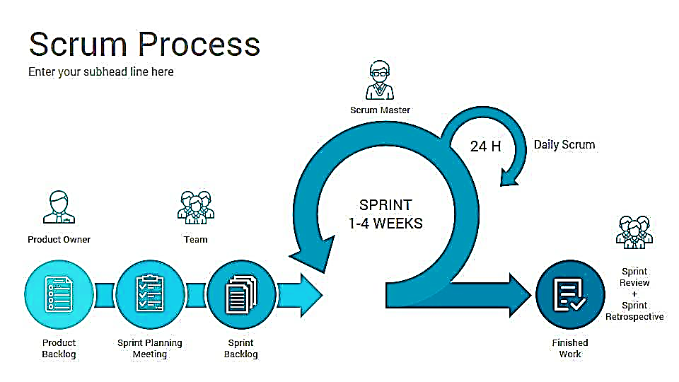

Figure 1 - Scrum Process

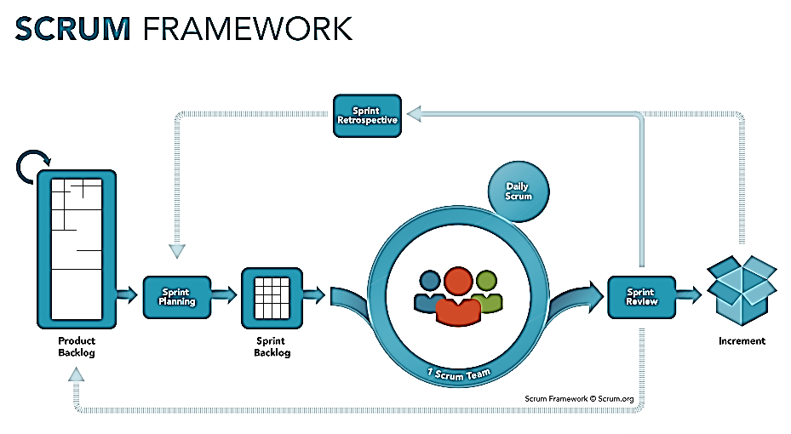

Figure 2 - Scrum Framework

*Reference*: [*https://www.scrum.org/resources/what-is-scrum*](https://www.scrum.org/resources/what-is-scrum)

### 2.2. Roles and responsibilities

|  |  |  |  |
| --- | --- | --- | --- |
| **No** | **Full name** | **Role in Group** | **Responsibilities** |
| 1 | Phạm Công Thành | Product Owner | Specify user requirement  Control the development process  Give out technique and business analysis support |
| 2 | Hoàng Yến Minh | Scrum Master | Managing process  Designing database  Clarifying requirements  Create Product Backlog  Create Sprint Backlog  Prepare documents  GUI Design  Create test plan  Coding  Testing  Arrange Meeting  Risk Management |

Table 5 - Roles and responsibilities

### 2.3. Tools and Techniques

|  |  |
| --- | --- |
| **Tool/Technique** | **Name** |
| Front-end Web | ReactJS |
| Back-end | JavaEE, Spring Boot framework, JPA, Hibernate |
| IDE | IntelliJ IDEA 2019.1.4, Visual Studio Code |
| DBMS | MS SQL Server 2014 |
| Source Control | Github/Git |
| Modelling tool | StarUML, draw.io |

Table 6 - Tools and techniques

## 3. Project Management Plan

### 3.1. Product Backlog

|  |  |  |  |  |
| --- | --- | --- | --- | --- |
| **Sprint** | **Story ID** | **Story** | **Task ID** | **Task** |
| 1 | 1 | Introduction document | 1.1 | Project Information |
| 1.2 | Introduction |
| 1.3 | Current Situation |
| 1.4 | Problem Definition |
| 1.5 | Proposed Solution |
| 1.6 | Role and Responsibility |
| 1.7 | Functional Requirements |
| 2 | Product Backlog | 2.1 | Create Product Backlog |
| 3 | Project management plan | 3.1 | Problem Definition |
| 3.2 | Project Organization |
| 3.3 | Project management plan |
| 3.4 | Coding Convention |
| 2 | 4 | Software Requirement Specification | 4.1 | User Requirement Specification |
| 4.2 | Software System attribute |
| 4.3 | Conceptual diagram |
| 3 | 5 | Software Design Diagram | 5.1 | Design Overview |
| 5.2 | System Architectural Design |
| 5.3 | Accessory Diagram |
| 4 | 5.4 | Interface |
| 5.5 | Interface Design |
| 5.6 | Algorithms |
| 5 | 6 | Crawl data | 6.1 | Manager Raw Data |
| 6.2 | Implement Algorithms |
| 7 | Event | 7.1 | Main Guest Functions |
| 7.2 | Main User Functions |
| 7.3 | Role and Responsibility |
| 6 | 8 | Search | 8.1 | Search Location |
| 8.2 | Search Request |
| 8.3 | Search Field |
| 9 | Manage User | 9.1 | Open Event |
| 9.2 | Manage Event |
| 9.3 | Feedback Event |
| 7 | 10 | Supply product | 10.1 | Manage Supply product |
| 10.2 | Supply Product |
| 11 | Transaction | 11.1 | Manage Transaction |
| 11.2 | Rating Supply product |
| 11.3 | Report Supply product |
| 8 | 12 | News | 12.1 | Manage news |
| 12.2 | Manage Comment |
| 13 | Feedback | 13 | Manage Feedback |
| 14 | Report | 14 | Manage Report |
| 9 | 15 | Test System | 15.1 | Run test |
| 15.2 | Report bug |
| 15.3 | Fix bug |
| 16 | Software User’s Manual | 16.1 | Test document |
| 16.2 | Installing guide |
| 16.3 | User manual |
| 10 | 17 | Document paper | 17 | Paper document |

Table 7 - Product Backlog

### 3.2. Sprint Backlog

Sprint Backlog can be found here.

### 3.3. Deliverables

|  |  |  |
| --- | --- | --- |
| **No** | **Deliverable** | **Note** |
| 1 | Introduction, Use Case Overview, Ask requirement, problem definition | Sprint 1 |
| 2 | Study Spring Boot Framework, React Native, Draw Use Case Diagram, Design User Interface for Web Application | Sprint 2 |
| … |  |  |
|  |  |  |

Table 8 - Deliverables

### 3.4. All Meeting Minutes

All sprint meeting minutes could be found here.

## 4. Coding Convention

**Summary:**

* Naming Convention:
  + Variable names should be short yet meaningful. The choice of a variable name should be designed to indicate to the casual observer the intent of its use.
  + Methods should be verbs, in mixed case with the first letter lowercase, with the first letter of each internal word capitalized.
* Indentation:
  + One declaration per line is recommended since it encourages commenting.
  + In absolutely no case should variables and functions be declared on the same line.
  + Do not put different types on the same line.
* Declarations Convention:
  + One declaration per line is recommended since it encourages commenting.
  + Using Java Code Convention from:

[*http://www.oracle.com/technetwork/java/codeconvtoc-136057.html*](http://www.oracle.com/technetwork/java/codeconvtoc-136057.html)

*This page is intentionally left blank*

# C. Software Requirement Specification

## 1. User Requirement Specification

### 1.1. Guest Requirement

*Guest is a person who does not have access into the system. Guest can use most basic of web applications or mobile consume the web services. Guest should have these following abilities:*

* Search news about guides, tips, another user’s experience, etc.
* Search supply post of bike or accessory
* Search event
* View news detail
* View supply post detail
* View event detail
* Log in
* Sign up
* Reset password

### 1.2. Member Requirement

*Member is a guest who logged in to the system with the role “member”. Member have ability to buy or sell product. Member have all abilities like guest and allow performing more functions like these followings:*

* Log out
* View user profile
* Update account
* Register/ Buy tickets events
* Send event feedback
* Propose to open events
* Send wish product (Get suggested products)
* View wish list products.
* View feedbacks of other user
* Report other member
* Create supply post
* Close supply post
* View list of transactions.
* View transaction detail
* Send feedback

### 1.3. Admin Requirement

*Manager is a guest who logged in to the system with role “manager”. Manager have permission to monitor and control the system’s content and user like:*

* Manage member’s account
* Manage news
* Manage events
* View list of feedbacks (event, supply post)
* Manage member’s reports
* Manage member’s supply posts
* Manage data source.
* View statistical (event statistics and supply statistics).

## 2. System Requirement Specification

### 2.1. External Interface Requirement

#### 2.1.1. User Interface

*The web application user interface will be in Vietnamese and provide the following components:*

* GUI should be simple, clear and have recognizable elements.
* The search results should be populated in 3 – 6 pages.
* The information content page should be simple and help user to focus.
* Remove redundant of self-explanatory instructions.
* Use undo rather than confirmations.
* Disable button when user click them to prevent duplicate submission.

*The mobile application user interface will have the following requirements:*

* Content should fit the screen of most android phone device. User should see primary content without zooming or scrolling horizontally.
* UI elements that are designed for touch gestures to make interaction with your app feel easy and natural.
* Create controls that measure at least 44 points x 44 points so they can be accurately tapped with a finger.
* Text should be at least 11 points so it’s legible at a typical viewing distance without zooming.
* There is ample contrast between the font color and the background so text is legible.
* Text should not let overlap. Improve legibility by increasing line height or letter spacing.
* Provide high-resolution versions of all image assets.
* An easy-to-read layout that puts controls close to the content they modify.
* Text, images, and buttons should be aligned to show users how information is related.

#### 2.1.2. Hardware Interface

N/A

#### 2.1.3. Software Interface

* Web application: browser Google Chrome (version 69 or higher) and Firefox (version 52 or higher), Internet Explorer (version 10 or higher) or with any web browser that support HTML5 & CSS3.
* Mobile application: phone operating system requires Android version 5.0 or higher.

#### 2.1.4. Communication Protocol

* HTTP protocol version 1.1 for communication between: web service and web application or mobile application that consumes the services.

### 2.2. System Overview Use Case

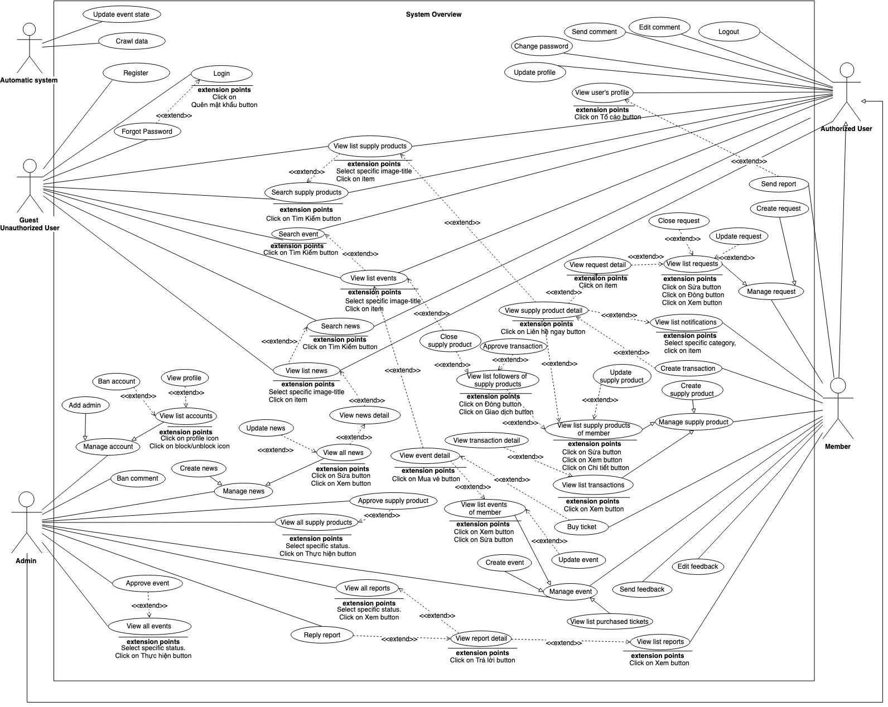

Figure 3 - System Overview Use Case

### 2.3. List of use case

#### 2.3.1. <Guest> Overview Use Case

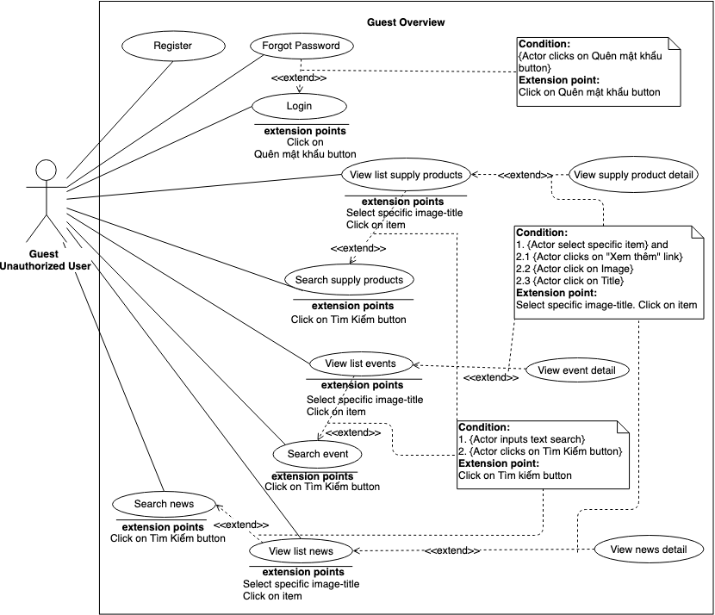

Figure 4 - Guest Overview Use Case

##### 2.3.1.1 Login

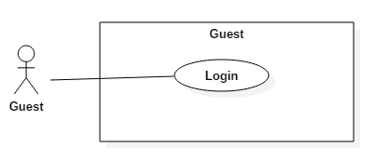

Figure 5 - <Guest> Login

|  |  |  |  |
| --- | --- | --- | --- |
| **USE CASE – BWA_G01** | | | |
| **Use Case No.** | BWA_G01 | **Use Case Version** | 2.0 |
| **Use Case Name** | Login | | |
| **Author** | MinhHY | | |
| **Date** | 17/03/2019 | **Priority** | Normal |
| **Actor:**   * Guest   **Summary:**   * This use case allows guest to login the system.   **Goal:**   * Guest can login the system.   **Triggers:**   * Guest clicks on “Đăng nhập” button in home page.   **Preconditions:** N/A  **Post conditions:**  **Success:** Guest is exactly authorized with specific role in the system.  **Fail:** System shows error messages.  **Main Success Scenario:**   |  |  |  | | --- | --- | --- | | **Step** | **Actor Action** | **System Response** | | 1 | Guest click “Đăng nhập” on menu in home page. |  | | 2 | Guest goes to login view. | System requires identity information from Guest:  - Số điện thoại: blank text input  - Mật khẩu: blank text input | | 2 | Guest inputs information |  | | 3 | Guest click “Đăng nhập” button to login to system. | Guest logins into system with his/her specific role. [Alternative 1] [Exception 1] |   **Alternative Scenario:**   |  |  |  | | --- | --- | --- | | **No** | **Actor Action** | **System Response** | | 1 | Guest enter wrong identity information. | System shows error message “Tài khoản không chính xác. Xin vui lòng thử lại”. |   **Exceptions:**   |  |  |  | | --- | --- | --- | | **No** | **Actor Action** | **System Response** | | 1 |  | System shows error message “Vui lòng kiểm tra lại đường truyền của bạn!” when the internet is lost. |   **Relationships:** BWA_G09.  **Business Rules:**  After login to system, guest will be redirected to specific view based on their role on the system: member or manager.  If role is “Member”, the system will display Member view.  If role is “Admin”, the system will display Admin Dashboard view. | | | |

Table 9 - <Guest> Login use case specification

##### 2.3.1.2. Register

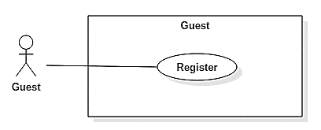

Figure 6 - <Guest> Register

|  |  |  |  |
| --- | --- | --- | --- |
| **USE CASE – BWA_G02** | | | |
| **Use Case No.** | BWA_G02 | **Use Case Version** | 2.0 |
| **Use Case Name** | Register | | |
| **Author** | MinhHY | | |
| **Date** | 17/03/2019 | **Priority** | Normal |
| **Actor:**   * Guest   **Summary:**   * This use case allows guest to register account in the system.   **Goal:**   * Guest can have account to log in in the system.   **Triggers:**   * Guest sends “Đăng ký” request.   **Preconditions:** N/A  **Post conditions:**  **Success:** Guest had an account with member role in the system.  **Fail:** System shows error messages.  **Main Success Scenario:**   |  |  |  | | --- | --- | --- | | **Step** | **Actor Action** | **System Response** | | 1 | Guest clicks “Đăng ký” button on menu in home page. |  | | 2 | Guest goes to register view. | System requires identity information from Guest:  - Số điện thoại: blank text input | | 2 | Guest inputs information |  | | 3 | Guest clicks “Đăng ký” button to login to system. | System checks phone number and sends sms to guest’s phone to confirm registered. | | 4 | Guest receives SMS in phone then input | System requires identity information from Guest:  - Mã xác thực: blank number input | | 5 | Guest inputs verify code which was sent in sms. Then click “Xác nhận”. | System check verify code [Alternative 1] [Alternative 2]. System requires identity information from Guest:  - Số điện thoại: disable phone number  - Mật khẩu: text input  - Xác nhận mật khẩu: text input  - Tên: text input  [Exception 1] | | 5 | Guest inputs information and clicks “Đăng ký” button | System creates an account with this information. Guest registered system with Member role. [Exception 2] |   **Alternative Scenario:**   |  |  |  | | --- | --- | --- | | **No** | **Actor Action** | **System Response** | | 1 | Guest inputs wrong digits. | System shows error message “Mã xác nhận không đúng!” | | 2 | Guest clicks “Gửi lại” button to send confirm SMS again. | System sends confirm SMS again. |   **Exceptions:**   |  |  |  | | --- | --- | --- | | **No** | **Actor Action** | **System Response** | | 1 | Guest inputs wrong information. | System shows error message “Xin vui lòng kiểm tra lại thông tin đã nhập.” | | 2 |  | System shows error message “Vui lòng kiểm tra lại đường truyền của bạn!” when the internet is lost. |   **Relationships:** N/A.  **Business Rules:**   * One phone number can only register one account. * After registered to system, guest will be redirected to login view. * After click “Gửi lại” button, system will countdown 60s to be available send again. | | | |

Table 10 - <Guest> Register use case specification

##### 2.3.1.3. Search event

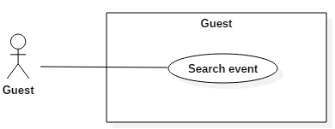

Figure 7 - <Guest> Search event

|  |  |  |  |
| --- | --- | --- | --- |
| **USE CASE – BWA_G03** | | | |
| **Use Case No.** | BWA_G03 | **Use Case Version** | 2.0 |
| **Use Case Name** | Search event | | |
| **Author** | MinhHY | | |
| **Date** | 17/03/2019 | **Priority** | Normal |
| **Actor:**   * Guest   **Summary:**   * This use case allows guest to search events in the system.   **Goal:**   * Guest can see a list of events after search in the system.   **Triggers:**   * Guest inputs key word in text input. * Guest sends “Tìm Kiếm” request.   **Preconditions:** N/A  **Post conditions:**   * Success: Guest can see results; this result is related to search keyword in the system. * Fail: System shows error messages.   **Main Success Scenario:**   |  |  |  | | --- | --- | --- | | **Step** | **Actor Action** | **System Response** | | 1 | Guest inputs search keyword in text input. | - Search box: blank text input  [Alternative 1] | | 2 | Guest choose dropdown category “Sự Kiện” | [Alternative 2] | | 2 | Guest clicks “Tìm Kiếm” on menu in home page. | System finds event by keyword at search text input in database. System responses result. [Alternative 3] [Exception 1] |   **Alternative Scenario:**   |  |  |  | | --- | --- | --- | | **No** | **Actor Action** | **System Response** | | 1 | Guest inputs empty text input and chooses dropdown category “Sự Kiện”. Then guest clicks “Tìm Kiếm” on menu in home page. | System responses a list of events latest. | | 2 | Guest inputs search text input and does not choose dropdown category “Sự Kiện”. Then guest clicks “Tìm Kiếm” on menu in home page. | System finds by keyword at search text input in database. System responses result. | | 3 |  | Not found any result. System will send message “Không tìm thấy”. |   **Exceptions:**   |  |  |  | | --- | --- | --- | | **No** | **Actor Action** | **System Response** | | 1 |  | System shows error message “Vui lòng kiểm tra lại đường truyền của bạn!” when the internet is lost. |   **Relationships:** BWA_G04.  **Business Rules:**  Result returns always sort with latest.  After searching, guest will see a list of events. | | | |

Table 11 - <Guest> Search event use case specification

##### 2.3.1.4. View event detail

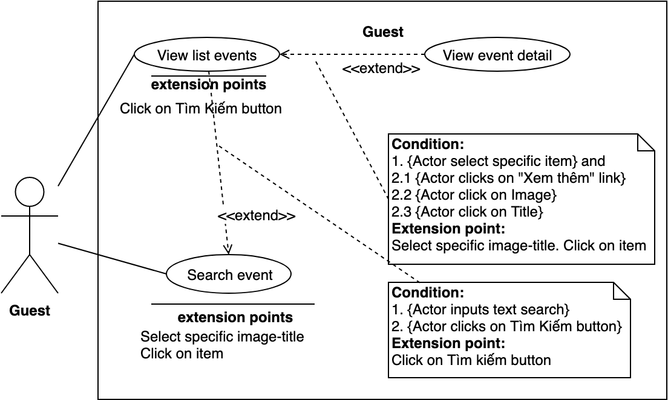

Figure 8 - <Guest> View event detail

|  |  |  |  |
| --- | --- | --- | --- |
| **USE CASE – BWA_G04** | | | |
| **Use Case No.** | BWA_G04 | **Use Case Version** | 2.0 |
| **Use Case Name** | View event detail | | |
| **Author** | MinhHY | | |
| **Date** | 14/03/2019 | **Priority** | High |
| **Actor:**   * Guest   **Summary:**   * This use case allows guest to view event detail in the system.   **Goal:**   * Guest can see an event detail in the system.   **Triggers:**   * After search event (BWA_G03) click on list results.   **Preconditions:** N/A  **Post conditions:**   * Success: Guest can see event detail in the system. * Fail: System shows error messages.   **Main Success Scenario:**   |  |  |  | | --- | --- | --- | | **Step** | **Actor Action** | **System Response** | | 1 | Guest inputs search text and clicks “Tìm kiếm” button. | System returns list events match with search text | | 2 | Guest clicks on image thumbnail of an event in list results. [Alternative 1] [Alternative 2] | System finds event by id to return event detail. [Exception 1] |   **Alternative Scenario:**   |  |  |  | | --- | --- | --- | | **No** | **Actor Action** | **System Response** | | 1 | Guest clicks on title of event at list results | System finds event by id to return event detail. | | 2 | Guest clicks on “Xem thêm” link at list results | System finds event by id to return event detail. |   **Exceptions:**   |  |  |  | | --- | --- | --- | | **No** | **Actor Action** | **System Response** | | 1 |  | System shows error message “Vui lòng kiểm tra lại đường truyền của bạn!” when the internet is lost. |   **Relationships:** BWA_G03, BWA_G11  **Business Rules:** N/A | | | |

Table 12 - <Guest> View event detail use case specification

##### 2.3.1.5. Search news

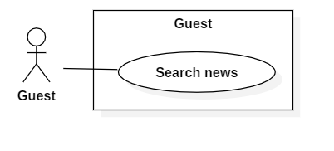

Figure 9 - <Guest> Search news

|  |  |  |  |
| --- | --- | --- | --- |
| **USE CASE – BWA_G05** | | | |
| **Use Case No.** | BWA_G05 | **Use Case Version** | 2.0 |
| **Use Case Name** | Search news | | |
| **Author** | MinhHY | | |
| **Date** | 17/03/2019 | **Priority** | Normal |
| **Actor:**   * Guest   **Summary:**   * This use case allows guest to search news in the system.   **Goal:**   * Guest can see a list of news after search in the system.   **Triggers:**   * Guest inputs key word in text input. * Guest sends “Tìm Kiếm” request.   **Preconditions:** N/A  **Post conditions:**   * Success: Guest can see results; this result is related to search keyword in the system. * Fail: System shows error messages.   **Main Success Scenario:**   |  |  |  | | --- | --- | --- | | **Step** | **Actor Action** | **System Response** | | 1 | Guest inputs search keyword in text input. | - Search: blank text input  [Alternative 1] | | 2 | Guest chooses dropdown category “Tin Tức” | [Alternative 2] | | 2 | Guest clicks “Tìm Kiếm” on menu in home page. | System finds news by keyword at search text input in database. System responses result. [Alternative 3] [Exception 1] |   **Alternative Scenario:**   |  |  |  | | --- | --- | --- | | **No** | **Actor Action** | **System Response** | | 1 | Guest inputs empty text input and chooses dropdown category “Tin tức”. Then guest clicks “Tìm Kiếm” on menu in home page. | System responses a list of news latest. | | 2 | Guest inputs search text input and does not choose dropdown category “Tin Tức”. Then guest clicks “Tìm Kiếm” on menu in home page. | System finds by keyword at search text input in database. System responses result. | | 3 |  | Not found any result. System will send message “Không tìm thấy”. |   **Exceptions:**   |  |  |  | | --- | --- | --- | | **No** | **Actor Action** | **System Response** | | 1 |  | System shows error message “Vui lòng kiểm tra lại đường truyền của bạn!” when the internet is lost. |   **Relationships:** BWA_G06.  **Business Rules:**  Result returns always sort with latest.  After searching, guest will see a list of news. | | | |

Table 13 - <Guest> Search news use case specification

##### 2.3.1.6. View news detail

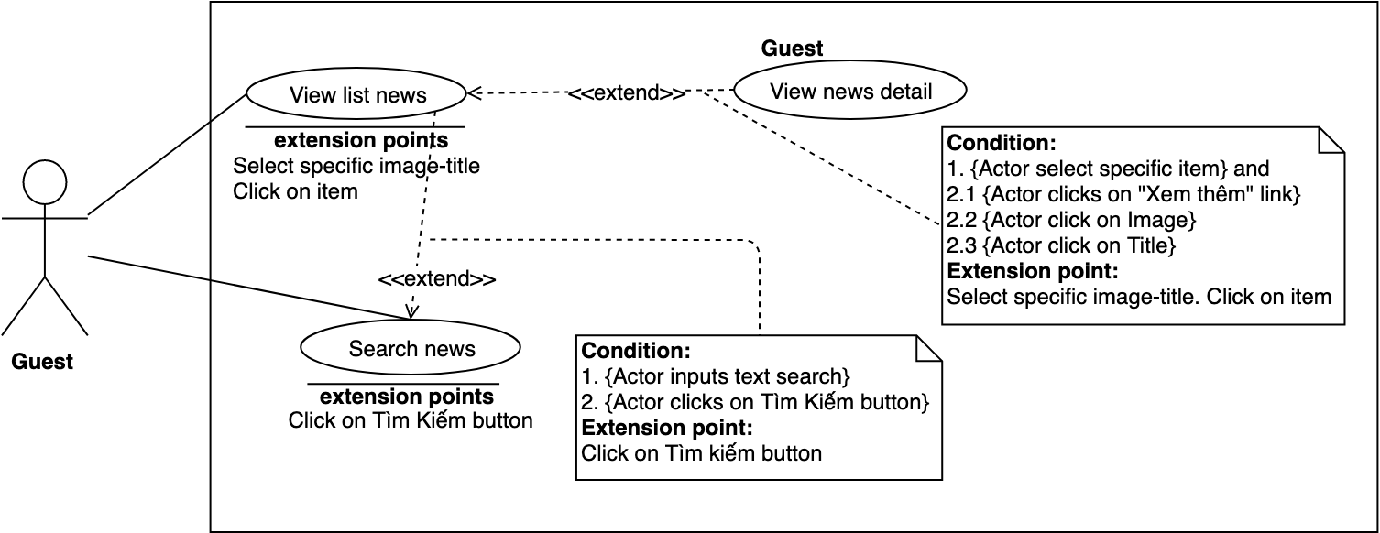

Figure 10 - <Guest> View news detail

|  |  |  |  |
| --- | --- | --- | --- |
| **USE CASE – BWA_G06** | | | |
| **Use Case No.** | BWA_G06 | **Use Case Version** | 2.0 |
| **Use Case Name** | View news detail | | |
| **Author** | MinhHY | | |
| **Date** | 17/03/2019 | **Priority** | High |
| **Actor:**   * Guest   **Summary:**   * This use case allows guest to view news detail in the system.   **Goal:**   * Guest can see news detail in the system.   **Triggers:**   * After search news click on list results.   **Preconditions:** N/A  **Post conditions:**   * Success: Guest can see news detail in the system. * Fail: System shows error messages.   **Main Success Scenario:**   |  |  |  | | --- | --- | --- | | **Step** | **Actor Action** | **System Response** | | 1 | Guest inputs search text and clicks “Tìm kiếm” button. | System returns list news match with search text | | 2 | Guest clicks on image thumbnail of an event in list results. [Alternative 1] [Alternative 2] | System finds news by id to return news detail. [Exception 1] |   **Alternative Scenario:**   |  |  |  | | --- | --- | --- | | **No** | **Actor Action** | **System Response** | | 1 | Guest clicks on title of news at list results | System finds news by id to return news detail. | | 2 | Guest clicks on “Xem thêm” link at list results | System finds news by id to return news detail. |   **Exceptions:**   |  |  |  | | --- | --- | --- | | **No** | **Actor Action** | **System Response** | | 1 |  | System shows error message “Vui lòng kiểm tra lại đường truyền của bạn!” when the internet is lost. |   **Relationships:** BWA_G03, BWA_G11  **Business Rules:** N/A | | | |

Table 14 - <Guest> View event detail use case specification

##### 2.3.1.7. Search supply product

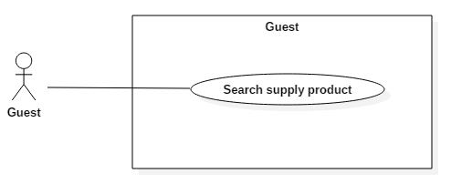

Figure 11 - <Guest> Search supply post

|  |  |  |  |
| --- | --- | --- | --- |
| **USE CASE – BWA_G07** | | | |
| **Use Case No.** | BWA_G07 | **Use Case Version** | 2.0 |
| **Use Case Name** | Search supply product | | |
| **Author** | MinhHY | | |
| **Date** | 17/03/2019 | **Priority** | High |
| **Actor:**   * Guest   **Summary:**   * This use case allows guest to search a supply post in the system.   **Goal:**   * Guest can see a list of products after search in the system.   **Triggers:**   * Guest inputs key word in text input. * Guest sends “Tìm Kiếm” request.   **Preconditions:** N/A  **Post conditions:**   * Success: Guest can see result; this result is related to search keyword in the system. * Fail: System shows error messages.   **Main Success Scenario:**   |  |  |  | | --- | --- | --- | | **Step** | **Actor Action** | **System Response** | | 1 | Guest inputs search keyword in text input. | - Search box: blank text input  [Alternative 1] | | 2 | Guest chooses dropdown category “Bài rao bán” | [Alternative 2] | | 2 | Guest clicks “Tìm Kiếm” on menu in home page. | System finds a supply post by keyword at search text input in database. System responses result. [Alternative 3] [Exception 1] |   **Alternative Scenario:**   |  |  |  | | --- | --- | --- | | **No** | **Actor Action** | **System Response** | | 1 | Guest inputs empty text input and chooses dropdown category “Rao Bán”. Then guest clicks “Tìm Kiếm” on menu in home page. | System responses a list of news latest. | | 2 | Guest inputs search text input and does not choose dropdown category “Rao Bán”. Then guest clicks “Tìm Kiếm” on menu in home page. | System finds by keyword at search text input in database. System responses result. | | 3 |  | Not found any result. System will send message “Không tìm thấy”. |   **Exceptions:**   |  |  |  | | --- | --- | --- | | **No** | **Actor Action** | **System Response** | | 1 |  | System shows error message “Vui lòng kiểm tra lại đường truyền của bạn!” when the internet is lost. |   **Relationships:** BWA_G08  **Business Rules:**  Result returns always sort with latest.  After searching, guest will see a list supply posts. | | | |

Table 15 - <Guest> Search supply product use case specification

##### 2.3.1.8. View supply product detail

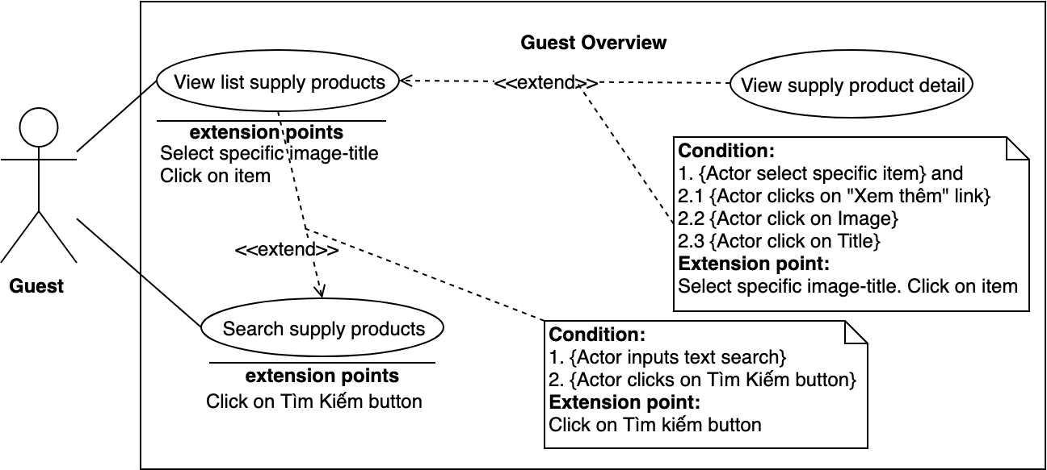

Figure 12 - <Guest> View supply post detail

|  |  |  |  |
| --- | --- | --- | --- |
| **USE CASE – BWA_G08** | | | |
| **Use Case No.** | BWA_G08 | **Use Case Version** | 2.0 |
| **Use Case Name** | View supply product detail | | |
| **Author** | MinhHY | | |
| **Date** | 17/03/2019 | **Priority** | High |
| **Actor:**   * Guest   **Summary:**   * This use case allows guest to view supply product detail in the system.   **Goal:**   * Guest can see a supply product detail in the system.   **Triggers:**   * After search news (BWA_G05)   **Preconditions:** N/A  **Post conditions:**   * Success: Guest can see supply product detail in the system. * Fail: System shows error messages.   **Main Success Scenario:**   |  |  |  | | --- | --- | --- | | **Step** | **Actor Action** | **System Response** | | 1 | Guest clicks on image thumbnail of supply post in home page. [Alternative 1] | System finds supply post by id to return detail. [Exception 1] |   **Alternative Scenario:**   |  |  |  | | --- | --- | --- | | **No** | **Actor Action** | **System Response** | | 1 | Guest clicks on title of supply post in home page | System finds supply post by id to return news detail. |   **Exceptions:**   |  |  |  | | --- | --- | --- | | **No** | **Actor Action** | **System Response** | | 1 |  | System shows error message “Vui lòng kiểm tra lại đường truyền của bạn!” when the internet is lost. |   **Relationships:** BWA_G07, BWA_G10  **Business Rules:**  A supply post detail do not show information of seller. | | | |

Table 16 - <Guest> View supply product detail use case specification

##### 2.3.1.9. Forgot Password

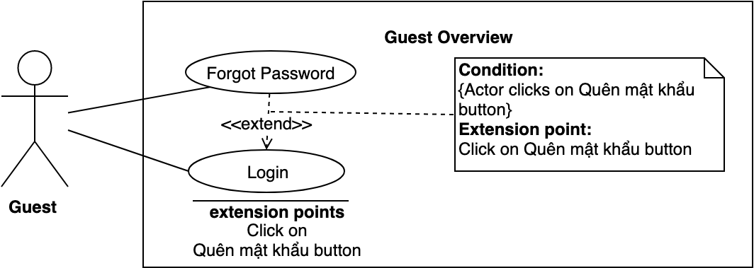

Figure 13 - <Guest> Forgot Password

|  |  |  |  |
| --- | --- | --- | --- |
| **USE CASE – BWA_G09** | | | |
| **Use Case No.** | BWA_G09 | **Use Case Version** | 2.0 |
| **Use Case Name** | Forgot Password | | |
| **Author** | MinhHY | | |
| **Date** | 17/03/2019 | **Priority** | Normal |
| **Actor:**   * Guest   **Summary:**   * This use case allows guest to reset password if they forgot it.   **Goal:**   * Guest can send request to change new password in the system.   **Triggers:**   * Guest sends “Quên mật khẩu” request in login page.   **Preconditions:**   * Having account in system.   **Post conditions:**   * Success: Guest changes new password after reset password. * Fail: System shows error messages.   **Main Success Scenario:**   |  |  |  | | --- | --- | --- | | **Step** | **Actor Action** | **System Response** | | 1 | Guest clicks “Đăng nhập” button on menu in home page. | System goes to login page. | | 2 | Guest clicks “Quên mật khẩu” button in login page. | System goes to forgot password page. System requires identity information from Guest:  - Số điện thoại: blank text input | | 2 | Guest inputs phone number. Guest clicks “Xác nhận” button. | System checks phone number and sends sms code 4 digits to reset password. [Exception 1]  System goes to verify code page, requires identity information from Guest:   * Mã xác nhận: blank number input   [Exception 2] | | 3 | Guest inputs code. Then click “Gửi” button [Alternative 1] | System validates code and redirects to change new password page.  System goes to change password page, requires identity information from Guest:  - Mật khẩu: blank text input  - Xác nhận mật khẩu: blank text input  [Exception 3] | | 6 | Guest clicks “Đổi mật khẩu” button | System validates password and change password of account [Exception 4] |   **Alternative Scenario:**   |  |  |  | | --- | --- | --- | | **No** | **Actor Action** | **System Response** | | 1 | Guest clicks “Gửi lại” button | System sends new sms code 6 digits by phone number to reset password. |   **Exceptions:**   |  |  |  | | --- | --- | --- | | **No** | **Actor Action** | **System Response** | | 1 | Guest inputs not exist phone number. | System shows error message “Số điện thoại không không hợp lệ” | | 2 | Guest inputs wrong confirm code. | System shows error message “Mã xác nhận không hợp lệ” | | 3 | Guest inputs wrong information to change password. | System shows error message “Mật khẩu không khớp. Vui lòng kiểm tra lại” | | 4 |  | System shows error message “Vui lòng kiểm tra lại đường truyền của bạn!” when the internet is lost. |   **Relationships:** BWA_G01.  **Business Rules:**  After change password to system, guest will be redirected to login view.  After click “Gửi lại” button, system will countdown 60s to be available send again. | | | |

Table 17 - <Guest> Forgot Password use case specification

##### 2.3.1.10. View list supply products

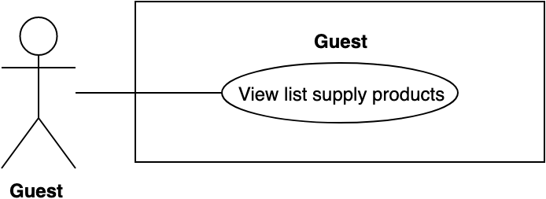

Figure 14 - <Guest> View list supply posts

|  |  |  |  |
| --- | --- | --- | --- |
| **USE CASE – BWA_G10** | | | |
| **Use Case No.** | BWA_G10 | **Use Case Version** | 2.0 |
| **Use Case Name** | View list supply products | | |
| **Author** | MinhHY | | |
| **Date** | 17/03/2019 | **Priority** | Normal |
| **Actor:**   * Guest   **Summary:**   * This use case allows guest to get all list supply posts public in the system.   **Goal:**   * Guest can see a list of products in the system.   **Triggers:**   * Click supply post on menu * Search supply post (BWA_G05)   **Preconditions:** N/A  **Post conditions:**   * Success: Guest can see list supply post in the system. * Fail: System shows error messages.   **Main Success Scenario:**   |  |  |  | | --- | --- | --- | | **Step** | **Actor Action** | **System Response** | | 1 | Guest clicks “Rao bán” on menu [Alternative 1] | System finds list supply posts latest. System responses result. [Exception 1] |   **Alternative Scenario:**   |  |  |  | | --- | --- | --- | | **No** | **Actor Action** | **System Response** | | 1 | Guest inputs search text input and chooses dropdown category “Bài rao bán”. Then guest clicks “Tìm Kiếm” on menu in home page. | System finds by keyword at search text input in database. System responses result. |   **Exceptions:**   |  |  |  | | --- | --- | --- | | **No** | **Actor Action** | **System Response** | | 1 |  | System shows error message “Vui lòng kiểm tra lại đường truyền của bạn!” when the internet is lost. |   **Relationships:** BWA_G08  **Business Rules:**  Result returns always sort with latest.  List supply posts were showed when status is public or finished. | | | |

Table 18 - <Guest> View list supply productss use case specification

##### 2.3.1.11. View list events

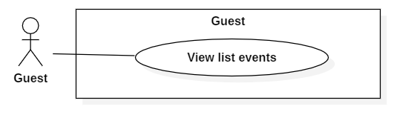

Figure 15 - <Guest> View list events

|  |  |  |  |
| --- | --- | --- | --- |
| **USE CASE – BWA_G11** | | | |
| **Use Case No.** | BWA_G11 | **Use Case Version** | 2.0 |
| **Use Case Name** | View list events | | |
| **Author** | MinhHY | | |
| **Date** | 17/03/2019 | **Priority** | Normal |
| **Actor:**   * Guest   **Summary:**   * This use case allows guest to get all list events public in the system.   **Goal:**   * Guest can see a list of events in the system.   **Triggers:**   * Click event on menu * Search event (BWA_G03)   **Preconditions:** N/A  **Post conditions:**   * Success: Guest can see list events in the system. * Fail: System shows error messages.   **Main Success Scenario:**   |  |  |  | | --- | --- | --- | | **Step** | **Actor Action** | **System Response** | | 1 | Guest clicks “Sự kiện” on menu [Alternative 1] | System finds list events latest. System responses result. [Exception 1] |   **Alternative Scenario:**   |  |  |  | | --- | --- | --- | | **No** | **Actor Action** | **System Response** | | 1 | Guest inputs search text input and chooses dropdown category “Sự kiện”. Then guest clicks “Tìm Kiếm” on menu in home page. | System finds by keyword at search text input in database. System responses result. |   **Exceptions:**   |  |  |  | | --- | --- | --- | | **No** | **Actor Action** | **System Response** | | 1 |  | System shows error message “Vui lòng kiểm tra lại đường truyền của bạn!” when the internet is lost. |   **Relationships:** BWA_G06  **Business Rules:**  Result returns always sort with latest. | | | |

Table 19 - <Guest> View list events use case specification

##### 2.3.1.12. View list news

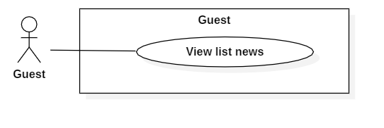

Figure 16 - <Guest> View list news

|  |  |  |  |
| --- | --- | --- | --- |
| **USE CASE – BWA_G12** | | | |
| **Use Case No.** | BWA_G12 | **Use Case Version** | 2.0 |
| **Use Case Name** | View list news | | |
| **Author** | MinhHY | | |
| **Date** | 17/03/2019 | **Priority** | Normal |
| **Actor:**   * Guest   **Summary:**   * This use case allows guest to get all list news public in the system.   **Goal:**   * Guest can see a list of news in the system.   **Triggers:**   * Click news on menu * Search news   **Preconditions:** N/A  **Post conditions:**   * Success: Guest can see list events in the system. * Fail: System shows error messages.   **Main Success Scenario:**   |  |  |  | | --- | --- | --- | | **Step** | **Actor Action** | **System Response** | | 1 | Guest clicks “Tin Tức” on menu [Alternative 1] | System finds list news latest. System responses result. [Exception 1] |   **Alternative Scenario:**   |  |  |  | | --- | --- | --- | | **No** | **Actor Action** | **System Response** | | 1 | Guest inputs search text input and chooses dropdown category “Tin Tức”. Then guest clicks “Tìm Kiếm” on menu in home page. | System finds by keyword at search text input in database. System responses result. |   **Exceptions:**   |  |  |  | | --- | --- | --- | | **No** | **Actor Action** | **System Response** | | 1 |  | System shows error message “Vui lòng kiểm tra lại đường truyền của bạn!” when the internet is lost. |   **Relationships:** BWA_G06  **Business Rules:**  Result returns always sort with latest. | | | |

Table 20 - <Guest> View list events use case specification

#### 2.3.2. <Authorized User> Overview Use Case

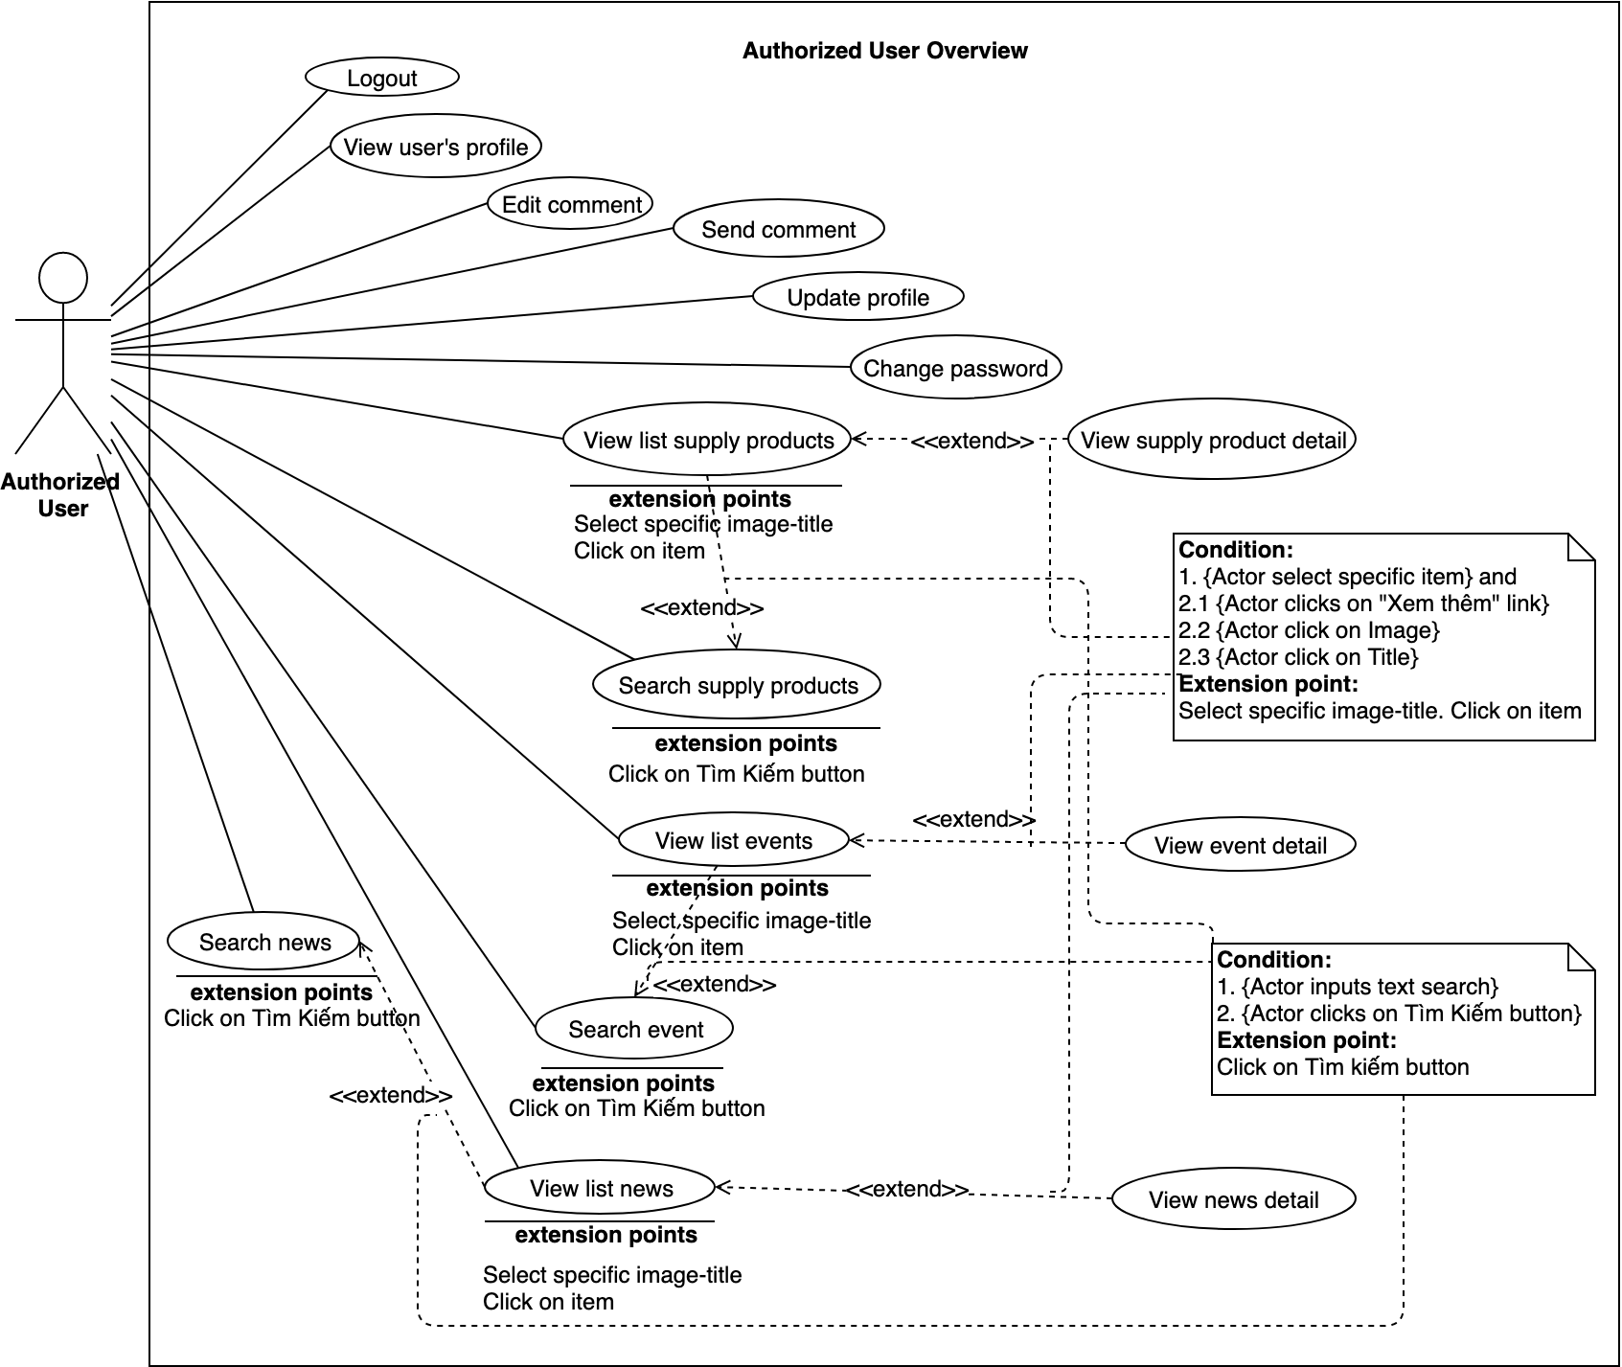

Figure 17 - Authorized User Overview Use Case

##### 2.3.2.1. Logout

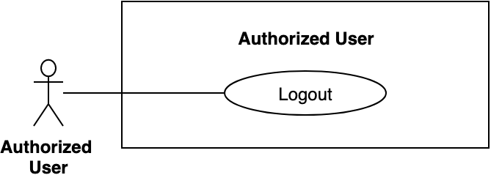

Figure 18 - <Authorized User> Logout

|  |  |  |  |
| --- | --- | --- | --- |
| **USE CASE – BWA_AUTH_01** | | | |
| **Use Case No.** | BWA_AUTH_01 | **Use Case Version** | 2.0 |
| **Use Case Name** | Logout | | |
| **Author** | MinhHy | | |
| **Date** | 17/03/2019 | **Priority** | Normal |
| **Actor:**   * Authorized User (Member or Admin)   **Summary:**   * Allow user logout from system.   **Goal:**   * User can logout from system.   **Triggers:**   * User sends request logout.   **Preconditions:**   * Guest logged into the system.   **Post conditions:**   * Success: System displays main page. * Fail: System shows error messages.   **Main Success Scenario:**   |  |  |  | | --- | --- | --- | | **Step** | **Actor Action** | **System Response** | | 1 | User clicks button “Đăng xuất” button in menu bar. | System takes user out of system and display main page.  [Exception 1] |   **Alternative Scenario:** N/A  **Exceptions:**   |  |  |  | | --- | --- | --- | | **No** | **Actor Action** | **System Response** | | 1 |  | System shows error message “Vui lòng kiểm tra lại đường truyền của bạn!” when the internet is lost. |   **Relationships:** BWA_G01.  **Business Rules:**  After member sends logout request, system redirects into main page and clear member token. | | | |

Table 21 -<Authorized User> Logout use case specification

##### 2.3.2.2. View user’s profile

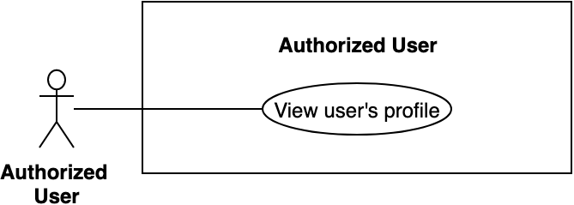

Figure 19 - <Authorized User> View user’s profile

|  |  |  |  |
| --- | --- | --- | --- |
| **USE CASE – BWA_AUTH_02** | | | |
| **Use Case No.** | BWA_AUTH _02 | **Use Case Version** | 2.0 |
| **Use Case Name** | View profile | | |
| **Author** | MinhHy | | |
| **Date** | 13/03/2019 | **Priority** | Normal |
| **Actor:**   * Authorized User (Member, Admin).   **Summary:**   * Allow user to view profile other user.   **Goal:**   * User can view profile.   **Triggers:**   * User sends request get profile of other user.   **Preconditions:**   * Guest logged successful into the system.   **Post conditions:**   * Success: System shows user information. * Fail: System shows error messages.   **Main Success Scenario:**   |  |  |  | | --- | --- | --- | | **Step** | **Actor Action** | **System Response** | | 1 | User clicks on Avatar of user  [Alternative 1] | System finds user by id to return user profile [Exception 1] |   **Alternative Scenario:**   |  |  |  | | --- | --- | --- | | **No** | **Actor Action** | **System Response** | | 1 | User clicks on username of user | System finds user by username to return user profile |   **Exceptions:**   |  |  |  | | --- | --- | --- | | **No** | **Actor Action** | **System Response** | | 1 |  | System shows error message “Vui lòng kiểm tra lại đường truyền của bạn!” when the internet is lost. |   **Relationships:** N/A.  **Business Rules:**  User can view profile of other user profile.  Only member can report other user at profile view | | | |

Table 22 - <Authorized User> View user’s profile use case specification

##### 2.3.2.3. Edit comment

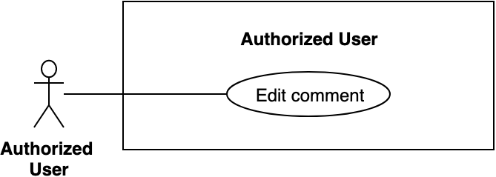

Figure 20 - <Authorized User> Edit comment

|  |  |  |  |
| --- | --- | --- | --- |
| **USE CASE – BWA_AUTH_03** | | | |
| **Use Case No.** | BWA_AUTH_03 | **Use Case Version** | 2.0 |
| **Use Case Name** | Edit comment | | |
| **Author** | MinhHy | | |
| **Date** | 18/03/2019 | **Priority** | Normal |
| **Actor:**   * Authorized User (Member, Admin)   **Summary:**   * Allow user to edit their comment in a news in 15 mins after created.   **Goal:**   * User can edit comment.   **Triggers:**   * User goes to news detail. * User send request to edit comment.   **Preconditions:**   * Guest logged into the system. * User had comment in 15 mins before.   **Post conditions:**   * Success: System shows success messages. * Fail: System shows error messages.   **Main Success Scenario:**   |  |  |  | | --- | --- | --- | | **Step** | **Actor Action** | **System Response** | | 1 | User goes to news detail. | System shows list comments of news. If comment of user can edit, systems will shows “Sửa” link. | | 2 | User clicks on “Sửa” link | System requires identity information of comment from User to edit:  - Comment content: input text area  - Đăng: button | | 2 | User inputs content of comment. | [Exception 1] [Exception 2] | | 4 | User clicks on “Đăng” button. | System create new comment of this news. System shows success message: “Cập nhật bình luận thành công”.  [Exception 3] |   **Exceptions:**   |  |  |  | | --- | --- | --- | | **No** | **Actor Action** | **System Response** | | 1 | User inputs empty content of comment. | System shows error message: “Vui lòng nhập thông tin” | | 2 | User inputs max or min length content of comment. | System shows error message: “Nội dung bình luận trên 20 kí tự dưới 100 kí tự.” | | 3 |  | System shows error message “Vui lòng kiểm tra lại đường truyền của bạn!” when the internet is lost. |   **Relationships:** N/A.  **Business Rules:**  Member and Admin can edit comment of themself in a news.  User can only edit their comment in 15 mins after comment was created. After 15 mins, “Sửa” link of comment will be hidden  User can edit comment many time in a news. | | | |

Table 23 - <Authorized User> Edit comment use case specification

##### 2.3.2.4. Send comment

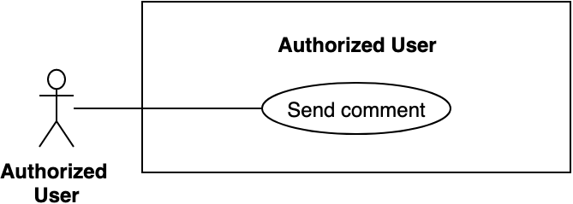

Figure 21 - <Authorized User> Send comment

|  |  |  |  |
| --- | --- | --- | --- |
| **USE CASE – BWA_AUTH_04** | | | |
| **Use Case No.** | BWA_ AUTH _04 | **Use Case Version** | 2.0 |
| **Use Case Name** | Send comment | | |
| **Author** | MinhHy | | |
| **Date** | 18/03/2019 | **Priority** | Normal |
| **Actor:**   * Authorized User (Member, Admin)   **Summary:**   * Allow user to send comment int any news that they want.   **Goal:**   * User can send comment.   **Triggers:**   * User goes to news detail. * User sends request to comment.   **Preconditions:**   * Guest logged into the system. * User comment in news detail page.   **Post conditions:**   * Success: System shows success messages. * Fail: System shows error messages.   **Main Success Scenario:**   |  |  |  | | --- | --- | --- | | **Step** | **Actor Action** | **System Response** | | 1 | User goes to news detail. | System requires identity information from User:  - Comment content: blank input text area  - Đăng: button | | 2 | User inputs content of comment. | [Exception 1] [Exception 2] | | 4 | User clicks on “Đăng” button. | System create new comment of this news. System shows success message: “Đăng bình luận thành công”.  [Exception 3] |   **Exceptions:**   |  |  |  | | --- | --- | --- | | **No** | **Actor Action** | **System Response** | | 1 | User inputs empty content of comment. | System shows error message: “Vui lòng nhập thông tin” | | 2 | User inputs max or min length content of comment. | System shows error message: “Nội dung bình luận trên 20 kí tự dưới 100 kí tự.” | | 3 |  | System shows error message “Vui lòng kiểm tra lại đường truyền của bạn!” when the internet is lost. |   **Relationships:** N/A.  **Business Rules:**  Member and Admin can comment in a news.  After user sent comment, system will update in list comments of that news.  User can comment many time in a news. | | | |

Table 24 - <Authorized User> Send comment use case specification

##### 2.3.2.5. Update profile

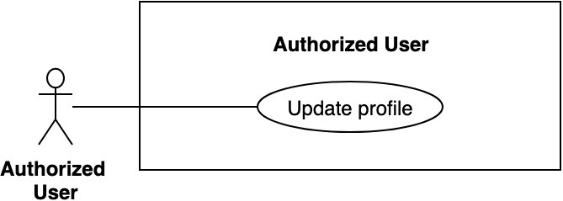

Figure 22 - <Authorized User> Update profile

|  |  |  |  |
| --- | --- | --- | --- |
| **USE CASE – BWA_AUTH_05** | | | |
| **Use Case No.** | BWA_ AUTH _05 | **Use Case Version** | 2.0 |
| **Use Case Name** | Update profile | | |
| **Author** | MinhHy | | |
| **Date** | 18/03/2019 | **Priority** | Normal |
| **Actor:**   * Authorized User (Member, Admin)   **Summary:**   * Allow user to update information of their profile.   **Goal:**   * User can update profile.   **Triggers:**   * User goes to user information page * User sends request to update account.   **Preconditions:**   * Guest logged into the system.   **Post conditions:**   * Success: System shows success messages. * Fail: System shows error messages.   **Main Success Scenario:**   |  |  |  | | --- | --- | --- | | **Step** | **Actor Action** | **System Response** | | 1 | User clicks on their icon in menu. Chooses “Trang cá nhân” sub menu. | System finds user by id to reponse profile information. | | 2 | User clicks “Thông tin cá nhân” on menu in user page. [Alternative 1] | System goes to user page and show information of user: - Số điện thoại: disable input phone number  - Tên: text input  - Giới tính: radio button (Nữ/Nam)  - Địa chỉ: text input  - Thay đổi ảnh đại diện: upload file  - Số điểm đánh giá: text  - Cập nhật: button.  [Exception 1] | | 3 | User inputs fields. |  | | 4 | User clicks on “Cập nhật” button. | System validates information and updates profile to database. System shows success message: “Cập nhật thành công”.  [Exception 2] |   **Alternative Scenario:**   |  |  |  | | --- | --- | --- | | **No** | **Actor Action** | **System Response** | | 1 | User clicks on their avatar in user page sidebar and clicks “Thông tin cá nhân” on sub menu. | System finds user by username to return user profile. |   **Exceptions:**   |  |  |  | | --- | --- | --- | | **No** | **Actor Action** | **System Response** | | 1 | User inputs empty fields or invalid information. | System shows error message match with fields invalid | | 2 |  | System shows error message “Vui lòng kiểm tra lại đường truyền của bạn!” when the internet is lost. |   **Relationships:** N/A.  **Business Rules:**  User can only update their profile.  Admin can not update member profile. | | | |

Table 25 - <Authorized User> Update profile use case specification

##### 2.3.2.6. Change password

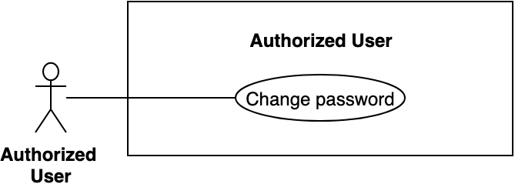

Figure 23 - <Authorized User> Change password

|  |  |  |  |
| --- | --- | --- | --- |
| **USE CASE – BWA_AUTH_06** | | | |
| **Use Case No.** | BWA_ AUTH _06 | **Use Case Version** | 2.0 |
| **Use Case Name** | Change password | | |
| **Author** | MinhHy | | |
| **Date** | 18/03/2019 | **Priority** | Normal |
| **Actor:**   * Authorized User (Member, Admin)   **Summary:**   * Allow user to change new password of their profile.   **Goal:**   * User can change password.   **Triggers:**   * User goes to user page. * User clicks on avatar on sidebar. * User clicks “Đổi mật khẩu” sub menu * User sends request to change password.   **Preconditions:**   * Guest logged into the system. * Remember old password of account.   **Post conditions:**   * Success: System shows success messages. * Fail: System shows error messages.   **Main Success Scenario:**   |  |  |  | | --- | --- | --- | | **Step** | **Actor Action** | **System Response** | | 1 | User clicks on their icon in menu. Chooses “Trang cá nhân” sub menu. | System finds user by id to response profile information. | | 2 | User clicks on their avatar in user page sidebar and clicks “Đổi mật khẩu” on sub menu. | System goes to change password page of user: - Mật khẩu hiện tại: blank password input  - Mật khẩu mới: blank password input  - Xác nhận mật khẩu mới: blank password input  - Cập nhật: button.  [Exception 1, 2, 3] | | 3 | User inputs fields. |  | | 4 | User clicks on “Cập nhật” button. | System changes new password to database. System shows success message: “Cập nhật thành công”.  [Exception 4] |   **Exceptions:**   |  |  |  | | --- | --- | --- | | **No** | **Actor Action** | **System Response** | | 1 | User inputs empty fields. | System shows error message: “Vui lòng nhập thông tin” | | 2 | User inputs incorrect old password. | System shows error message: “Mật khẩu hiện tại không chính xác.” | | 3 | User inputs new password not match with confirm new password | System shows error message: “Mật khẩu mới không khớp.” | | 4 |  | System shows error message “Vui lòng kiểm tra lại đường truyền của bạn!” when the internet is lost. |   **Relationships:** N/A.  **Business Rules:**  User can only update their password.  Admin can not update member password. | | | |

Table 26 - <Authorized User> Change password use case specification

#### 2.3.3. <Member> Overview Use Case

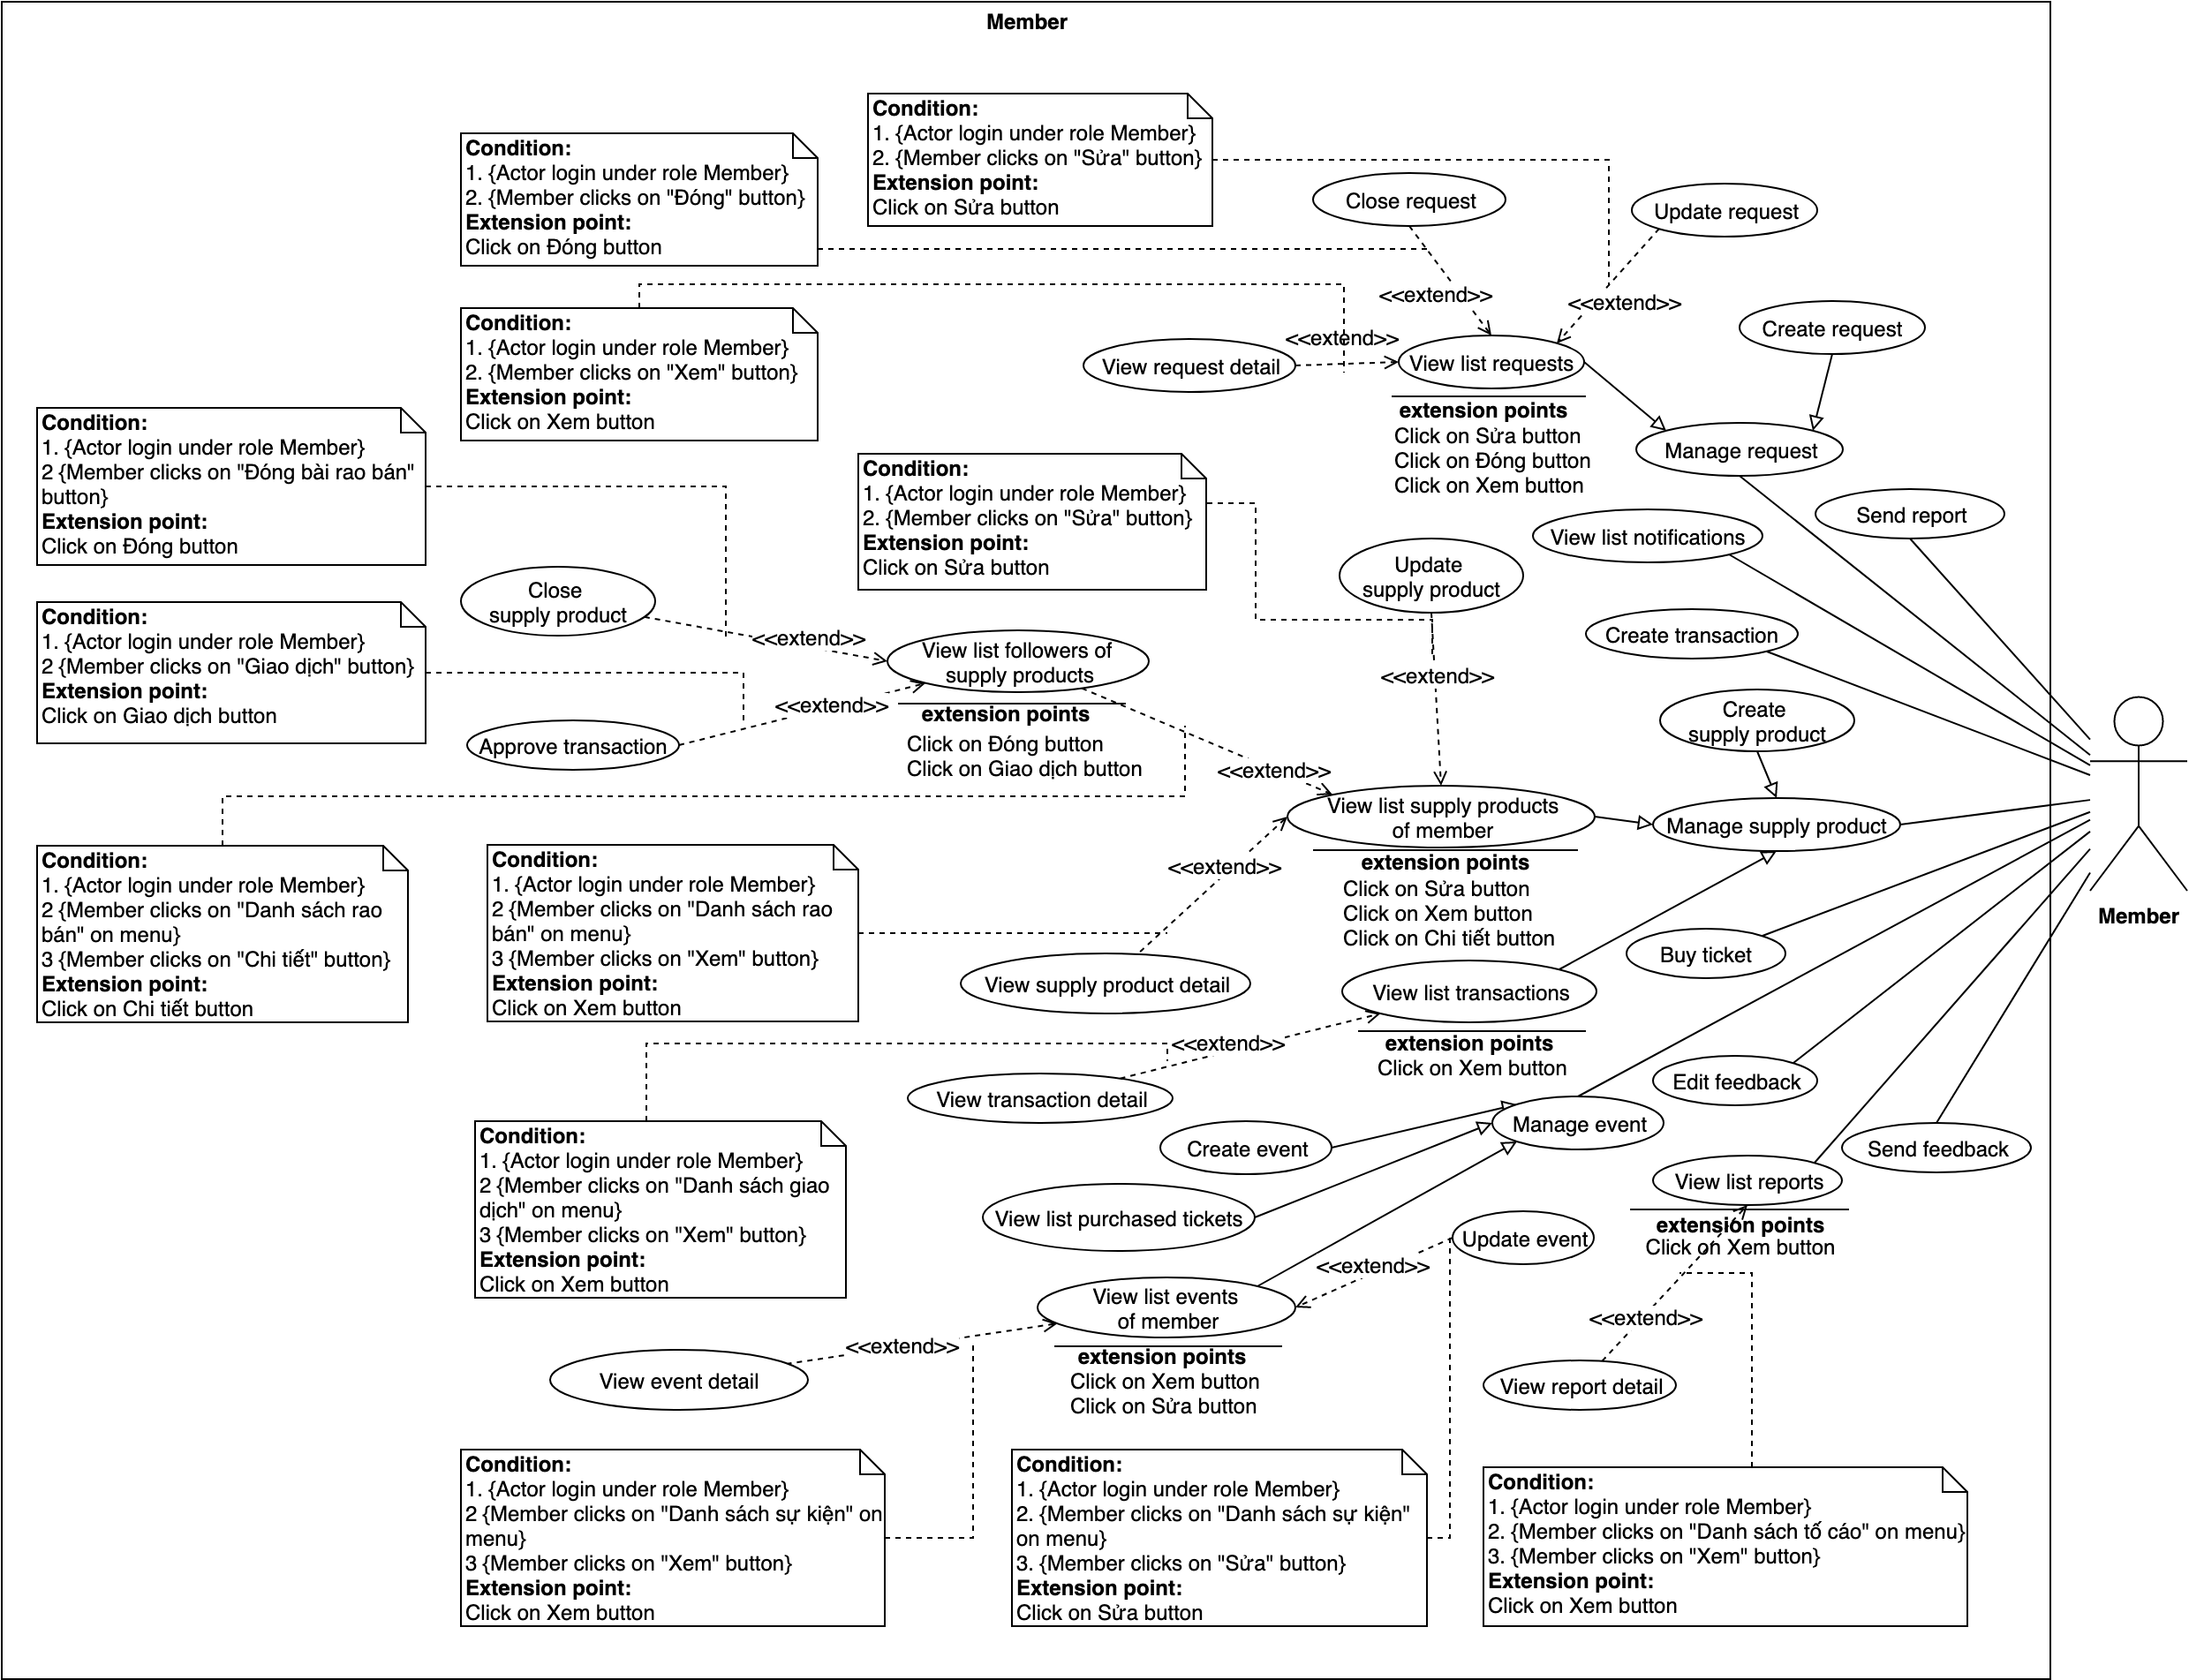

Figure 24 - Member Overview Use Case

##### 2.3.3.1. Send report

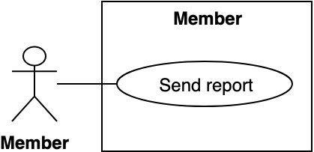

Figure 25 - <Member> Send report

|  |  |  |  |
| --- | --- | --- | --- |
| **USE CASE – BWA_MEM_01** | | | |
| **Use Case No.** | BWA_MEM_01 | **Use Case Version** | 2.0 |
| **Use Case Name** | Create report | | |
| **Author** | MinhHy | | |
| **Date** | 17/03/2019 | **Priority** | Normal |
| **Actor:**   * Member   **Summary:**   * Allow member to report other member.   **Goal:**   * Member can report other member.   **Triggers:**   * Member clicks on profile other member. * Member clicks “Tố cáo” button in profile.   **Preconditions:**   * Guest logged into the system with role as “Member”.   **Post conditions:**   * Success: System shows success messages. * Fail: System shows error messages.   **Main Success Scenario:**   |  |  |  | | --- | --- | --- | | **Step** | **Actor Action** | **System Response** | | 1 | Member goes to user page. Then clicks “Tố cáo” button | System opens popup and show form:  - Người tố cáo: disable  - Người bị tố cáo: disable  - Lý do: dropdown selector  - Tố cáo: button.  - Trở về: button | | 2 | Member inputs fields. [Alternative 1] | [Exception 1] | | 3 | Member clicks on “Tố cáo” button.  [Alternative 2] | System creates new report to database.  System shows success message: “Gửi phản ánh thành công”.[Exception 2] |   **Alternative Scenario:**   |  |  |  | | --- | --- | --- | | **Step** | **Actor Action** | **System Response** | | 1 | Member clicks on “Lý do khác” in option of selector. | System shows input reason of report user:  - Lý do: blank text input | |  | Member clicks on “Trở về” button | System closes popup and return to preview page |   **Exceptions:**   |  |  |  | | --- | --- | --- | | **No** | **Actor Action** | **System Response** | | 1 | Member inputs invalid fields. | System shows error message: "Vui lòng nhập đầy đủ thông tin." | | 2 |  | System shows error message “Vui lòng kiểm tra lại đường truyền của bạn!” when the internet is lost. |   **Relationships:** N/A  **Business Rules:**  Member can send multiple report to other member.  After member created report, report will be in status waiting for admin to response.  Only member can report to other member. | | | |

Table 27 - <Member> Send report use case specification

##### 2.3.3.2. Manage request

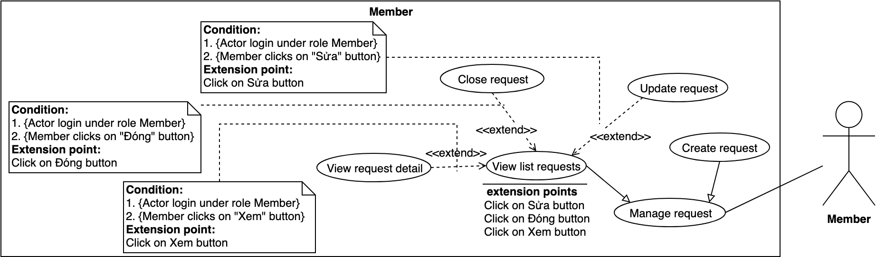

Figure 26 - <Member> Manage request

##### 2.3.3.3. Create request

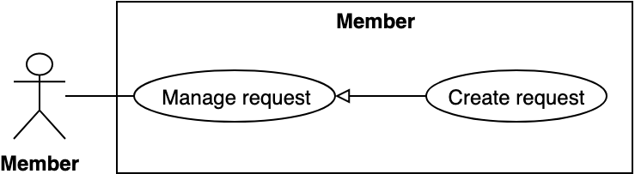

Figure 27 - <Member> Create request

|  |  |  |  |
| --- | --- | --- | --- |
| **USE CASE – BWA_MEM_03** | | | |
| **Use Case No.** | BWA_MEM_03 | **Use Case Version** | 2.0 |
| **Use Case Name** | Create request | | |
| **Author** | MinhHy | | |
| **Date** | 18/03/2019 | **Priority** | Normal |
| **Actor:**   * Member   **Summary:**   * Allow member to create request of bikes or accessories. After member created request, system will match products suitable with request information.   **Goal:**   * Member can create request in wishlist of products.   **Triggers:**   * Member creates request of bikes or accessories. * Member sends create request command.   **Preconditions:**   * Guest logged into the system as role “Member”   **Post conditions:**   * Success: System create request of bikes or accessories. * Fail: System shows error messages.   **Main Success Scenario:**   |  |  |  | | --- | --- | --- | | **Step** | **Actor Action** | **System Response** | | 1 | Member clicks “Gửi yêu cầu” button on menu | System shows pops up request:  - Tên sản phẩm: text input  - Giá: input range min max number or check box “Liên hệ”  - Tình trạng: radio button  - Hãng: dropdown selector  - Dòng xe: text input  - Loại: radio button  - Danh mục: dropdown selector  - Mô tả: text area  - Gửi yêu cầu: button  - Xóa: button | | 2 | Member inputs information fields. | [Exception 1] | | 3 | Member clicks on “Gửi yêu cầu” button [Alternative 1] | System creates request and sends success messages “Tạo yêu cầu thành công”. [Exception 2] |   **Alternative Scenario:**   |  |  |  | | --- | --- | --- | | **Step** | **Actor Action** | **System Response** | | 2 | Member choices “Trở về” | System return preview page. |   **Exceptions:**   |  |  |  | | --- | --- | --- | | **No** | **Actor Action** | **System Response** | | 1 |  | System shows error message “Vui lòng kiểm tra lại đường truyền của bạn!” when the internet is lost. |   **Relationships:** N/A.  **Business Rules:**  Member can create request every time.  After member created request, system will return list supply posts suitable with request information. | | | |

Table 28 - <Member> Create request use case specification

##### 2.3.3.4. Update request

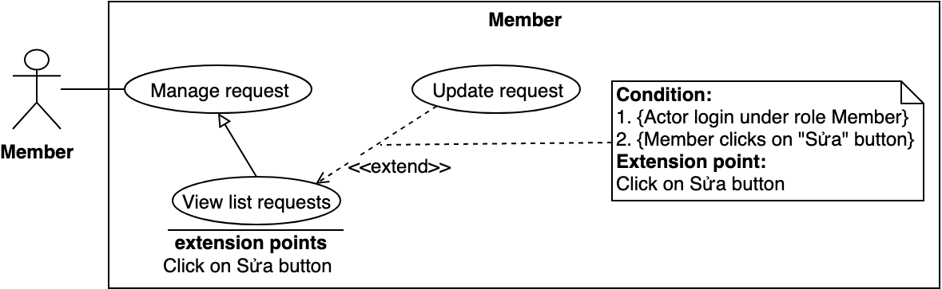

Figure 28 - <Member> Update request

|  |  |  |  |
| --- | --- | --- | --- |
| **USE CASE – BWA_MEM_04** | | | |
| **Use Case No.** | BWA_MEM_04 | **Use Case Version** | 2.0 |
| **Use Case Name** | Update request | | |
| **Author** | MinhHy | | |
| **Date** | 18/03/2019 | **Priority** | Normal |
| **Actor:**   * Member   **Summary:**   * Allow member to update request in member’s list requests of bikes or accessories. After member updated request, system will match products suitable with new request information.   **Goal:**   * Member can update request in wishlist of products.   **Triggers:**   * Member goes to user page. * Member sends request to view member’s list requests. * Member sends update request command.   **Preconditions:**   * Guest logged into the system as role “Member”. * Member views profile of himself/herself. * Member can only update request that create by himself/herself.   **Post conditions:**   * Success: System update request. * Fail: System shows error messages.   **Main Success Scenario:**   |  |  |  | | --- | --- | --- | | **Step** | **Actor Action** | **System Response** | | 1 | Member goes to user page and clicks to “Yêu cầu” on menu | System goes to list requests page. | | 2 | Member clicks on “Sửa” button of request member want to update. | System goes to update request page and shows:  - Tên sản phẩm: text input  - Giá: input range min max number or check box “Liên hệ”  - Tình trạng: radio button  - Hãng: dropdown selector  - Dòng xe: text input  - Danh mục: dropdown selector  - Mô tả: text area  - Cập nhật: button  - Đóng yêu cầu: button  - Trở về: button | | 3 | Member clicks on “Cập nhật” button [Alternative 1] | System updates request and sends success messages “Cập nhật thành công”. [Exception 1] |   **Alternative Scenario:**   |  |  |  | | --- | --- | --- | | **Step** | **Actor Action** | **System Response** | | 1 | Member choices “Trở về” | System returns list requests page. |   **Exceptions:**   |  |  |  | | --- | --- | --- | | **No** | **Actor Action** | **System Response** | | 1 |  | System shows error message “Vui lòng kiểm tra lại đường truyền của bạn!” when the internet is lost. |   **Relationships:** N/A.  **Business Rules:**  Member can update request in list requests every time.  After member updated request, system will return list supply posts suitable with request information. | | | |

Table 29 - <Member> Update request use case specification

##### 2.3.3.5. View list requests

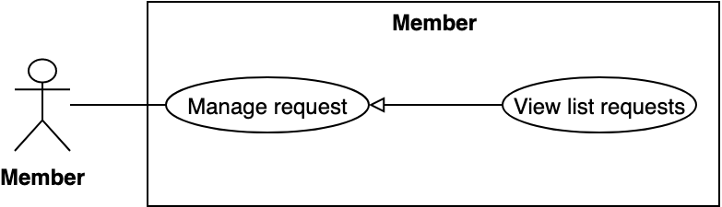

Figure 29 - <Member> View list requests

|  |  |  |  |
| --- | --- | --- | --- |
| **USE CASE – BWA_MEM_05** | | | |
| **Use Case No.** | BWA_MEM_05 | **Use Case Version** | 2.0 |
| **Use Case Name** | View list requests | | |
| **Author** | MinhHy | | |
| **Date** | 17/03/2019 | **Priority** | Normal |
| **Actor:**   * Member   **Summary:**   * Allow member to views wishlist products of themself.   **Goal:**   * Member can view their list request of products.   **Triggers:**   * Member goes to user page. * Member clicks on “Yêu cầu” menu. * Member clicks on “Danh sách yêu cầu” sub menu. * Member sends request to view list request of products.   **Preconditions:**   * Guest logged into the system as role “Member” * Member goes to user page.   **Post conditions:**   * Success: System shows list request of member. * Fail: System shows error messages.   **Main Success Scenario:**   |  |  |  | | --- | --- | --- | | **Step** | **Actor Action** | **System Response** | | 1 | Member goes to user page and clicks “Danh sách yêu cầu” | System finds list request by id of user to return list requests of user [Exception 1] |   **Exceptions:**   |  |  |  | | --- | --- | --- | | **No** | **Actor Action** | **System Response** | | 1 |  | System shows error message “Vui lòng kiểm tra lại đường truyền của bạn!” when the internet is lost. |   **Relationships:** N/A.  **Business Rules:**  Member can only view wish list of that member.  System fills wish list table with 10 newest wish products each page. | | | |

Table 30 - <Member> View list requests use case specification

##### 2.3.3.6. View request detail

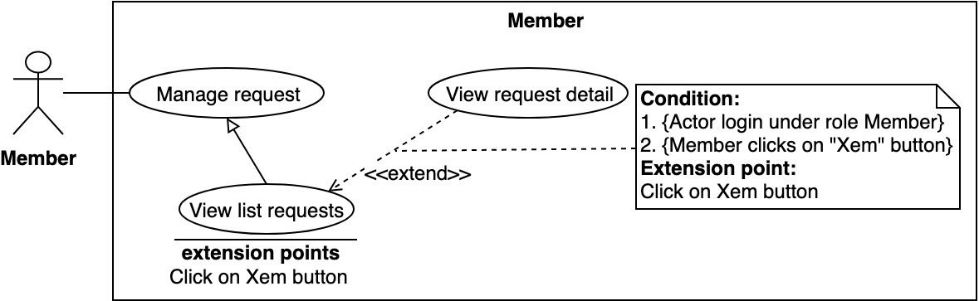

Figure 30 - <Member> View request detail

|  |  |  |  |
| --- | --- | --- | --- |
| **USE CASE – BWA_MEM_06** | | | |
| **Use Case No.** | BWA_MEM_06 | **Use Case Version** | 2.0 |
| **Use Case Name** | View request detail | | |
| **Author** | MinhHy | | |
| **Date** | 18/03/2019 | **Priority** | Normal |
| **Actor:**   * Member   **Summary:**   * Allow member to view request detail of bikes or accessories.   **Goal:**   * Member can view request detail in wishlist of products.   **Triggers:**   * Member goes to user page. * Member view request of bikes or accessories. * Member sends view request command.   **Preconditions:**   * Guest logged into the system as role “Member” * Member goes to user page   **Post conditions:**   * Success: System view request detail of bikes or accessories. * Fail: System shows error messages.   **Main Success Scenario:**   |  |  |  | | --- | --- | --- | | **Step** | **Actor Action** | **System Response** | | 1 | Member clicks on “Tạo yêu cầu” on menu | System shows pops up request:  - Tên sản phẩm: text input  - Giá: input range min max number or check box “Liên hệ”  - Tình trạng: radio button  - Hãng: dropdown selector  - Dòng xe: text input  - Loại: radio button  - Danh mục: dropdown selector  - Mô tả: text area  - Gửi yêu cầu: button  - Xóa: button | | 2 | Member inputs information fields. | [Exception 1] | | 3 | Member clicks on “Gửi yêu cầu” button [Alternative 1] | System creates request and sends success messages “Cập nhật thành công”. [Exception 2] |   **Alternative Scenario:**   |  |  |  | | --- | --- | --- | | **Step** | **Actor Action** | **System Response** | | 2 | Member choices “Trở về” | System return preview page. |   **Exceptions:**   |  |  |  | | --- | --- | --- | | **No** | **Actor Action** | **System Response** | | 1 |  | System shows error message “Vui lòng kiểm tra lại đường truyền của bạn!” when the internet is lost. |   **Relationships:** N/A.  **Business Rules:**  Member can create request every time.  After member created request, system will return list supply posts suitable with request information. | | | |

Table 31 - <Member> View request detail use case specification

##### 2.3.3.7. Close request

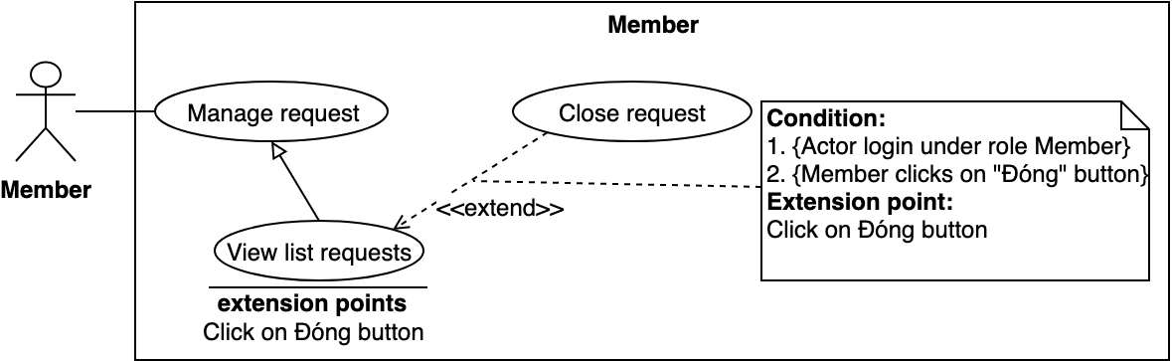

Figure 31 - <Member> Close request

|  |  |  |  |
| --- | --- | --- | --- |
| **USE CASE – BWA_MEM_07** | | | |
| **Use Case No.** | BWA_MEM_07 | **Use Case Version** | 2.0 |
| **Use Case Name** | Close request | | |
| **Author** | MinhHy | | |
| **Date** | 18/03/2019 | **Priority** | Normal |
| **Actor:**   * Member   **Summary:**   * Allow member to close request in member’s list requests of bikes or accessories. After member closed request, system will stop matching suitable products.   **Goal:**   * Member can close request in wishlist of products.   **Triggers:**   * Member goes to user page. * Member sends request to view member’s list requests. * Member sends closing request command.   **Preconditions:**   * Guest logged into the system as role “Member”. * Member views profile of himself/herself. * Member can only close request that create by himself/herself.   **Post conditions:**   * Success: System closes request and shows success message. * Fail: System shows error messages.   **Main Success Scenario:**   |  |  |  | | --- | --- | --- | | **Step** | **Actor Action** | **System Response** | | 1 | Member goes to user page and clicks to “Danh sách yêu cầu” on menu | System goes to list requests page. | | 2 | Member clicks on “Đóng” button of a request. | System shows confirm box with message “Bạn có chắc chắn đóng yêu cầu này?”   * Hủy: button * Đồng ý: button | | 3 | Member clicks on “Đồng ý” button [Alternative 1] | System updates request and sends success messages “Đóng yêu cầu thành công”. [Exception 1] |   **Alternative Scenario:**   |  |  |  | | --- | --- | --- | | **Step** | **Actor Action** | **System Response** | | 1 | Member choices “Hủy” | System closes confirm box and goes to list requests page. |   **Exceptions:**   |  |  |  | | --- | --- | --- | | **No** | **Actor Action** | **System Response** | | 1 |  | System shows error message “Vui lòng kiểm tra lại đường truyền của bạn!” when the internet is lost. |   **Relationships:** N/A.  **Business Rules:**  Member can update request in list requests every time.  Member closes request, they can not receive noti about suitable supply posts and open it again. | | | |

Table 32 - <Member> Close request use case specification

##### 2.3.3.8. View list notifications

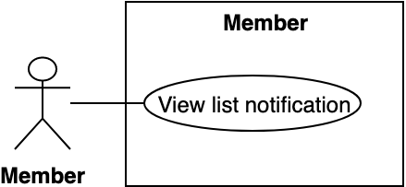

Figure 32 - <Member> View list notifications

|  |  |  |  |
| --- | --- | --- | --- |
| **USE CASE – BWA_MEM_08** | | | |
| **Use Case No.** | BWA_MEM_08 | **Use Case Version** | 2.0 |
| **Use Case Name** | View list notifications | | |
| **Author** | MinhHy | | |
| **Date** | 18/03/2019 | **Priority** | High |
| **Actor:**   * Member   **Summary:**   * Allow member to view list notifications. This list notification will notify when system finds suitable supply posts of request products.   **Goal:**   * Member can view list notifications.   **Triggers:**   * Member sends view list notifications request command.   **Preconditions:**   * Guest logged into the system as role “Member” * Member goes to home page   **Post conditions:**   * Success: System returns list notifications for member. * Fail: System shows error messages.   **Main Success Scenario:**   |  |  |  | | --- | --- | --- | | **Step** | **Actor Action** | **System Response** | | 1 | Member goes to home page. Member clicks on bell icon. | System shows to list notifications of member. |   **Exceptions:**   |  |  |  | | --- | --- | --- | | **No** | **Actor Action** | **System Response** | | 1 |  | System shows error message “Vui lòng kiểm tra lại đường truyền của bạn!” when the internet is lost. [Exception 1] |   **Relationships:** N/A.  **Business Rules:**  After member viewed list notifications, member clicks on content notification to go to that supply post.  List notifications only shows unread noti. | | | |

Table 33 - <Member> View list notifications use case specification

##### 2.3.3.9. Create transaction

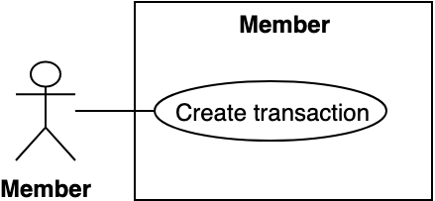

Figure 33 - <Member>Create transaction

|  |  |  |  |
| --- | --- | --- | --- |
| **USE CASE – BWA_MEM_09** | | | |
| **Use Case No.** | BWA_MEM_09 | **Use Case Version** | 2.0 |
| **Use Case Name** | Create transaction | | |
| **Author** | MinhHy | | |
| **Date** | 18/03/2019 | **Priority** | Normal |
| **Actor:**   * Member   **Summary:**   * Allow member to create transaction that member wants to follow.   Goal:   * Member can create transaction in supply post.   **Triggers:**   * Member views supply post detail. * Member sends create transaction request.   **Preconditions:**   * Guest logged into the system as role “Member”.   **Post conditions:**   * Success: System shows success messages and create transaction. * Fail: System shows error messages.   **Main Success Scenario:**   |  |  |  | | --- | --- | --- | | **Step** | **Actor Action** | **System Response** | | 1 | Member goes to supply post detail | System shows supply post detail information and “Liên hệ ngay” button | | 2 | Member clicks on “Liên hệ ngay” button. | System displays popup that show information of supply post owner and creates transaction in server:  - Số điện thoại: text  [Exception 1] |   **Alternative Scenario:** N/A  **Exceptions:**   |  |  |  | | --- | --- | --- | | **Step** | **Actor Action** | **System Response** | | 1 |  | System shows error message “Vui lòng kiểm tra lại đường truyền của bạn!” when the internet is lost. |   **Relationships:** N/A  **Business Rules:**  Member can only create one transaction in one supply post detail. | | | |

Table 34 - <Member> Create transaction use case specification

##### 2.3.3.10. Manage supply product

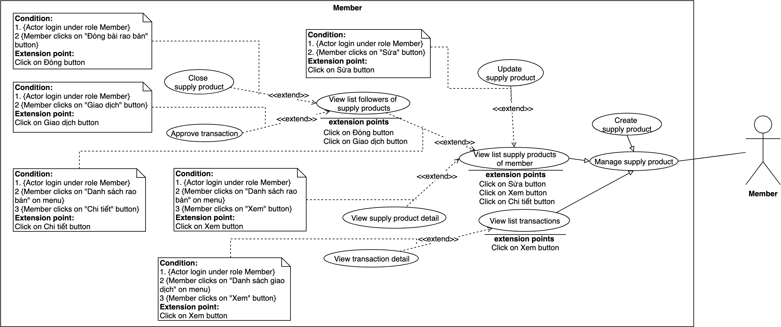

Figure 34 - <Member> Manage supply product

##### 2.3.3.11. Create supply product

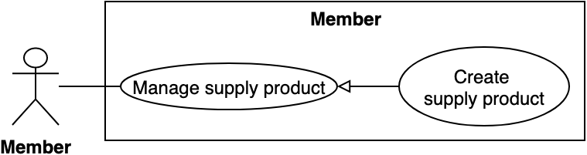

Figure 35 - <Member>Create supply product

|  |  |  |  |
| --- | --- | --- | --- |
| **USE CASE – BWA_MEM_11** | | | |
| **Use Case No.** | BWA_MEM_11 | **Use Case Version** | 2.0 |
| **Use Case Name** | Create supply post | | |
| **Author** | MinhHy | | |
| **Date** | 18/03/2019 | **Priority** | Normal |
| **Actor:**   * Member   **Summary:**   * Allow member to create new supply post of bikes or accessories.   **Goal:**   * Member can create new supply post.   **Triggers:**   * Member goes to user page. * Member sends request to create supply post.   **Preconditions:**   * Guest logged into the system as role “Member”.   **Post conditions:**   * Success: System shows success messages and add supply post to database. * Fail: System shows error messages.   **Main Success Scenario:**   |  |  |  | | --- | --- | --- | | Step | Actor Action | System Response | | 1 | Member goes to user page and clicks on “Rao Bán” menu. Then clicks “Rao bán xe” on sub menu. [Alternative 1] [Alternative 2] | System goes to create supply post bike page and show form:  - Tiêu đề: blank text input  - Nơi bán: blank text input / Địa điểm hiện tại: button  - Giá bán: blank number input / Liên hệ: checkbox  - Danh mục tin đăng: dropdown selector  - Đã đi (km): blank number input  - Trạng thái độ: checkbox (Xe độ)  - Tình trạng xe: radio button (Mới/Đã sử dụng)  - Hãng xe: dropdown selector  - Dòng xe: blank text input  - Đời xe: blank text input  - Màu xe: blank text input  - Image upload: upload file  - Mô tả: text editor  - Đăng bài: button | | 2 | Member inputs fields. | [Exception 1] | | 3 | Member clicks on “Đăng bài” button. | System show success message: “Đăng tin thành công”. [Exception 2] |   **Alternative Scenario:**   |  |  |  | | --- | --- | --- | | **Step** | **Actor Action** | **System Response** | | 1 | Member clicks “Rao bán phụ kiện” on sub menu. | System goes to create supply post accessory page and show form:  - Tiêu đề: blank text input  - Nơi bán: blank text input / Địa điểm hiện tại: button  - Giá bán: blank number input / Liên hệ: checkbox  - Danh mục tin đăng: dropdown selector  - Tên phụ kiện: blank text input  - Tình trạng xe: radio button (Mới/Đã sử dụng)  - Hãng phụ kiện: dropdown selector  - Công dụng: blank text input  - Dành cho loại xe: blank text input  - Image upload: upload file  - Mô tả: text editor  - Đăng bài: button | | 2 | Member clicks on “Địa điểm hiện tại” button. | System get current location and add in “Địa chỉ giao dịch” textbox. |   **Exceptions:**   |  |  |  | | --- | --- | --- | | **Step** | **Actor Action** | **System Response** | | 1 | Member inputs invalid information. | System shows error message match with fields. | | 2 |  | System shows error message “Vui lòng kiểm tra lại đường truyền của bạn!” when the internet is lost. |   **Relationships:** N/A.  **Business Rules:**  Member can create many supply posts.  After member created supply post, supply post need admin approve to be public. | | | |

Table 35 - <Member> Create supply product use case specification

##### 2.3.3.12. Update supply product

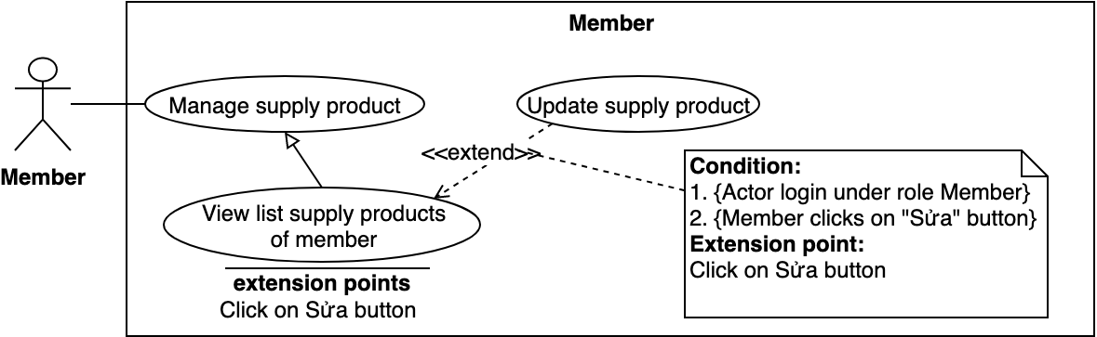

Figure 36 - <Member>Update supply product

|  |  |  |  |
| --- | --- | --- | --- |
| **USE CASE – BWA_MEM_12** | | | |
| **Use Case No.** | BWA_MEM_12 | **Use Case Version** | 2.0 |
| **Use Case Name** | Update supply post | | |
| **Author** | MinhHy | | |
| **Date** | 18/03/2019 | **Priority** | Normal |
| **Actor:**   * Member   **Summary:**   * Allow member to update exist supply post of bikes or accessories.   **Goal:**   * Member can update supply post of themselves.   **Triggers:**   * Member goes to user page. * Member sends request to update supply post.   **Preconditions:**   * Guest logged into the system as role “Member”. * Member goes to list supply posts   **Post conditions:**   * Success: System shows success messages and updates supply post to database. * Fail: System shows error messages.   **Main Success Scenario:**   |  |  |  | | --- | --- | --- | | **Step** | **Actor Action** | **System Response** | | 1 | Member clicks on “Rao Bán” menu in user page and clicks “Danh sách bài rao bán” on sub menu. [Alternative 1] | System shows list supply posts of member:  - Tiêu đề: text  - Thời gian diễn ra: text  - Tình trạng: text  - Chỉnh sửa: button  - Xem: button  - Chi tiết: button (Người quan tâm)  - Đóng: button | | 2 | Member clicks “Chỉnh Sửa” button. | If supply post is type of bike, system goes to update supply post bike page and show form:  - Tiêu đề: text input  - Nơi bán: text input / Địa điểm hiện tại: button  - Giá bán: number input / Liên hệ: checkbox  - Danh mục tin đăng: dropdown selector  - Đã đi (km): number input  - Trạng thái độ: checkbox (Xe độ)  - Tình trạng xe: radio button (Mới/Đã sử dụng)  - Hãng xe: dropdown selector  - Dòng xe: text input  - Đời xe: text input  - Màu xe: text input  - Image upload: upload file  - Mô tả: text editor  - Cập nhật: button  [Alternative 1] [Exception 1] | | 3 | Member clicks on “Cập nhật” button. | System show success message: “Cập nhật thành công”. [Exception 2] |   **Alternative Scenario:**   |  |  |  | | --- | --- | --- | | **Step** | **Actor Action** | **System Response** | | 1 |  | If supply post is type of accessory, system goes to update supply post accessory page and show form:  - Tiêu đề: text input  - Nơi bán: text input / Địa điểm hiện tại: button  - Giá bán: number input / Liên hệ: checkbox  - Danh mục tin đăng: dropdown selector  - Tên phụ kiện: text input  - Tình trạng xe: radio button (Mới/Đã sử dụng)  - Hãng phụ kiện: dropdown selector  - Công dụng: text input  - Dành cho loại xe: text input  - Image upload: upload file  - Mô tả: text editor  - Cập nhật: button  [Exception 1] |   **Exceptions:**   |  |  |  | | --- | --- | --- | | **Step** | **Actor Action** | **System Response** | | 1 | Member inputs invalid information. | System shows error message match with fields. | | 2 |  | System shows error message “Vui lòng kiểm tra lại đường truyền của bạn!” when the internet is lost. |   **Relationships:** N/A.  **Business Rules:**  Member can update supply post many time but all transaction of supply post will delete.  After member updated supply post, supply post need admin approve to be public again. | | | |

Table 36 -<Member> Update supply product use case specification

##### 2.3.3.13. View list followers of supply products

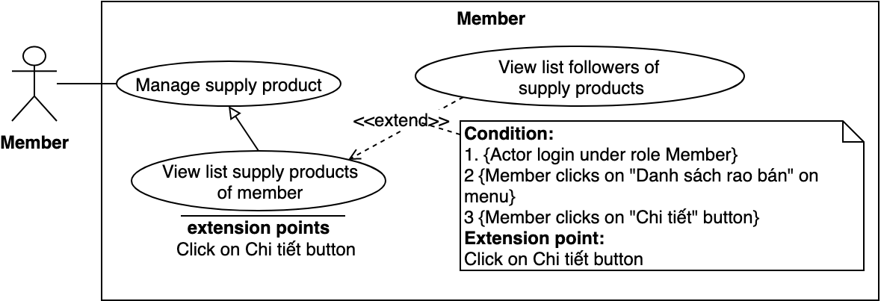

Figure 38 - <Member> View list followers of supply products

|  |  |  |  |
| --- | --- | --- | --- |
| **USE CASE – BWA_MEM_13** | | | |
| **Use Case No.** | BWA_MEM_13 | **Use Case Version** | 2.0 |
| **Use Case Name** | View listfollowers of supply products | | |
| **Author** | MinhHy | | |
| **Date** | 18/03/2019 | **Priority** | High |
| **Actor:**   * Member   **Summary:**   * Allow member to view list user following of supply products. This list will show user’s information and state of transaction for own supply products to contact with them.   **Goal:**   * Member can view list followers of supply products.   **Triggers:**   * Member clicks “Danh sách bài rao bán” on sub menu * Member sends view list followers of supply products command.   **Preconditions:**   * Guest logged into the system as role “Member” * Supply product of member had follower   **Post conditions:**   * Success: System returns list followers of supply product. * Fail: System shows error messages.   **Main Success Scenario:**   |  |  |  | | --- | --- | --- | | **Step** | **Actor Action** | **System Response** | | 1 | Member clicks on “Chi tiết” button | System shows to list followers with user’s information.   * Giao dịch: button * Đóng bài bán: button   [Exception 1] |   **Exceptions:**   |  |  |  | | --- | --- | --- | | **No** | **Actor Action** | **System Response** | | 1 |  | System shows error message “Vui lòng kiểm tra lại đường truyền của bạn!” when the internet is lost. |   **Relationships:** N/A  **Business Rules:** N/A | | | |

Table 37 - <Member> View list followers of supply products

##### 2.3.3.14. Close supply product

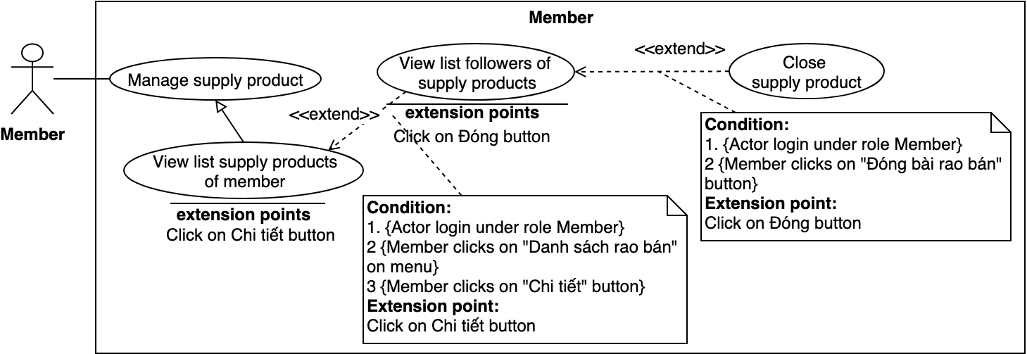

Figure 39 -<Member> Close supply product

|  |  |  |  |
| --- | --- | --- | --- |
| **USE CASE – BWA_MEM_14** | | | |
| **Use Case No.** | BWA_MEM_14 | **Use Case Version** | 2.0 |
| **Use Case Name** | Close supply post | | |
| **Author** | MinhHy | | |
| **Date** | 13/03/2019 | **Priority** | Normal |
| **Actor:**   * Member   **Summary:**   * Allow member to close supply post of themselves.   **Goal:**   * Member can close supply post.   **Triggers:**   * Member goes to user page. * Member goes to list supply posts page. * Member sends request to close supply post.   **Preconditions:**   * Guest logged into the system as role “Member”. * Member goes to user page.   **Post conditions:**   * Success: System shows success messages and closes supply post. * Fail: System shows error messages.   **Main Success Scenario:**   |  |  |  | | --- | --- | --- | | **Step** | **Actor Action** | **System Response** | | 1 | Member clicks “Rao Bán” on menu at user page and clicks “Danh sách bài rao bán” on sub menu. | System shows list supply posts of member:  - Tiêu đề: text  - Thời gian diễn ra: text  - Tình trạng: text  - Chỉnh sửa: button  - Xem: button  - Chi tiết: button (Người quan tâm)  - Đóng: button | | 2 | Member clicks on “Chi tiết” button.  [Alternative 1] | System shows list transactions who want to exchange this supply post.  - Giao dịch: button  - Đóng bài rao: button | | 3 | Member clicks on “Đóng bài rao” button. | System opens confirm message: “Bạn có chắc muốn đóng bài rao bán <Tiêu đề> không?”  - Đóng: button  - Trở về: button | | 4 | Member click on “Đóng” button.  [Alternative 2] | System closes supply post. System shows success messages “Đóng tin bán thành công”  [Exception 1] |   **Alternative Scenario:**   |  |  |  | | --- | --- | --- | | **Step** | **Actor Action** | **System Response** | | 1 | Member clicks on “Đóng” button | System opens confirm message: “Bạn có chắc muốn đóng bài rao bán <Tiêu đề> không?”  - Đóng: button  - Trở về: button | | 2 | Member clicks on “Trở về” button | System closes confirm message. |   **Exceptions:**   |  |  |  | | --- | --- | --- | | **No** | **Actor Action** | **System Response** | | 1 |  | System shows error message “Vui lòng kiểm tra lại đường truyền của bạn!” when the internet is lost. |   **Relationships:** N/A.  **Business Rules:**  Member can close supply post everytime.  After member closed supply post, all pending transactions of supply post will change to fail.  Member can not open again after closed. | | | |

Table 38 - <Member> Close supply product use case specification

##### 2.3.3.15. Approve transaction

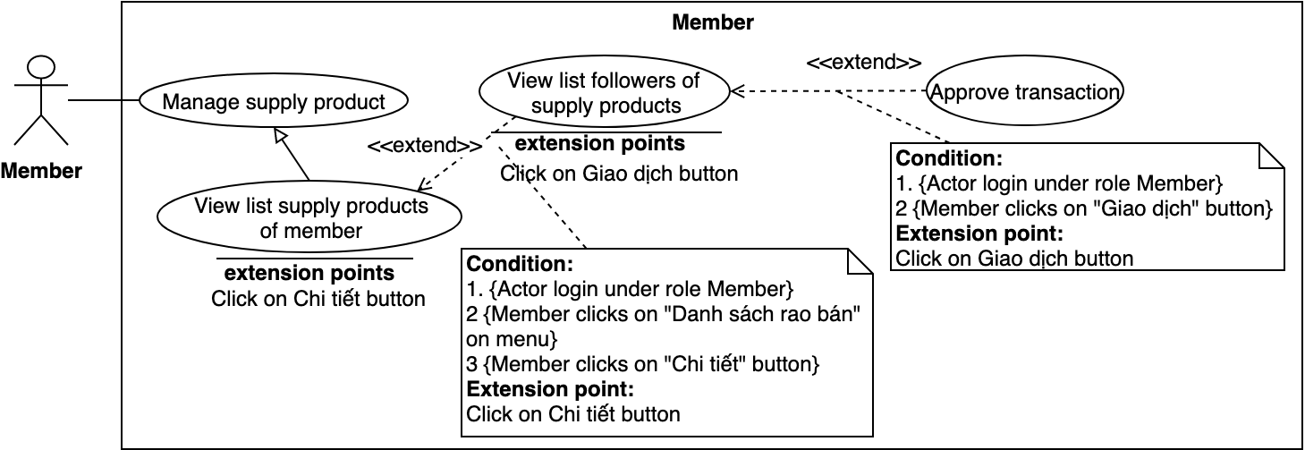

Figure 40 - <Member> Approve transaction

|  |  |  |  |
| --- | --- | --- | --- |
| **USE CASE – BWA_MEM_15** | | | |
| **Use Case No.** | BWA_MEM_15 | **Use Case Version** | 2.0 |
| **Use Case Name** | Approve transaction | | |
| **Author** | MinhHy | | |
| **Date** | 18/03/2019 | **Priority** | Normal |
| **Actor:**   * Member   **Summary:**   * Allow member to approve transaction. Member – own of supply post chooses user following to approve their transaction.   **Goal:**   * Member can approve transaction.   **Triggers:**   * Member clicks on “Chi tiết” button in list supply products. * Member sends request to approve transaction.   **Preconditions:**   * Guest logged into the system as role “Member”. * Supply product of member is public * Member can only approve transaction that is existed and create by himself/herself   **Post conditions:**   * Success: System shows success messages and reload list transactions. * Fail: System shows error messages.   **Main Success Scenario:**   |  |  |  | | --- | --- | --- | | **Step** | **Actor Action** | **System Response** | | 1 | Member clicks “Rao Bán” on menu and clicks on “Danh sách bài rao bán”. | System shows list supply posts of member:  - Tiêu đề: text  - Thời gian diễn ra: text  - Tình trạng: text  - Chỉnh sửa: button  - Xem: button  - Chi tiết: button (Người quan tâm)  - Đóng: button | | 2 | Member clicks on “Chi tiết” button. | System shows list transactions of supply post:  - Member name follow supply post: text  - Status of transaction: text  - Giao dịch/Hủy giao dịch: button | | 3 | Member clicks on “Giao dịch” button.  [Alternative 1] | System shows dialog message: “Xác nhận giao dịch này?”  - Xác nhận: button  - Trở về: button | | 4 | Member clicks on “Xác nhận” button.  [Alternative 2] | System shows success message: “Giao dịch đã được cập nhật”  [Exception 1] |   **Alternative Scenario:**   |  |  |  | | --- | --- | --- | | **Step** | **Actor Action** | **System Response** | | 1 | Member clicks on “Hủy giao dịch” button | System shows dialog message: “Bạn có chắc muốn hủy giao dịch này không?”  - Hủy: button  - Trở về: button | | 2 | Member clicks “Trở về” button | System closes dialog message |   **Exceptions:**   |  |  |  | | --- | --- | --- | | **No** | **Actor Action** | **System Response** | | 1 |  | System shows error message “Vui lòng kiểm tra lại đường truyền của bạn!” when the internet is lost. |   **Relationships:** N/A.  **Business Rules:**  Member can update, cancel transaction when supply post is public.  Member can only update one success transaction in one supply post. | | | |

Table 39 - <Member> Approve transaction use case specification

##### 2.3.3.16. View list transactions

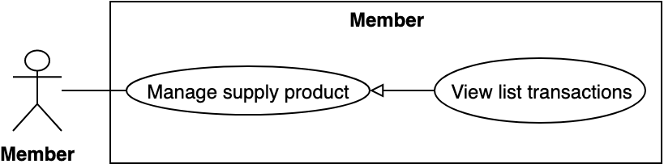

Figure 41 - <Member> View list transactions

|  |  |  |  |
| --- | --- | --- | --- |
| **USE CASE – BWA_MEM_16** | | | |
| **Use Case No.** | BWA_MEM_16 | **Use Case Version** | 2.0 |
| **Use Case Name** | View list transactions | | |
| **Author** | MinhHy | | |
| **Date** | 18/03/2019 | **Priority** | Normal |
| **Actor:**   * Member   **Summary:**   * Allow member to views list transactions have two situations: * Member – own of supply post can view list user transactions of his/her supply post. * Member – follow supply post can view list transactions of his her following.   **Goal:**   * Member can view list transactions.   **Triggers:**   * Member goes to user page. * Member sends request to view list transactions.   **Preconditions:**   * Guest logged into the system as role “Member”. * Member goes to user page.   **Post conditions:**   * Success: System displays list transactions. * Fail: System shows error messages.   **Main Success Scenario:**   |  |  |  | | --- | --- | --- | | **Step** | **Actor Action** | **System Response** | | 1 | Member clicks “Rao Bán” on menu and clicks on “Danh sách bài rao bán”  [Alternative 1] | System shows list supply posts of member:  - Tiêu đề: text  - Thời gian diễn ra: text  - Tình trạng: text  - Chỉnh sửa: button  - Xem: button  - Chi tiết: button (Người quan tâm)  - Đóng: button  [Exception 1] | | 2 | Member clicks “Chi tiết” button | System shows list transactions of supply post. |   **Alternative Scenario:**   |  |  |  | | --- | --- | --- | | **Step** | **Actor Action** | **System Response** | | 1 | Member clicks “Rao Bán” on menu and clicks on “Các bài rao bán quan tâm”. | System shows list transactions of member following:  - Bài rao bán: text  - Ngày theo dõi: text  - Tình trạng: text  - Chi tiết: button  [Exception 1] |   **Exceptions:**   |  |  |  | | --- | --- | --- | | **No** | **Actor Action** | **System Response** | | 1 |  | System shows error message “Vui lòng kiểm tra lại đường truyền của bạn!” when the internet is lost. |   Relationships: N/A.  Business Rules:  Member can view list transactions of following supply post and list transactions his/herself supply post. | | | |

Table 40 - <Member> View list transactions use case specification

##### 2.3.3.17. Buy ticket

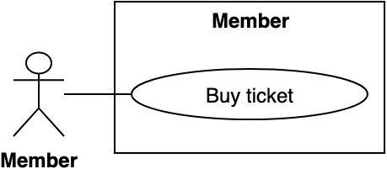

Figure 42 - <Member> Buy ticket

|  |  |  |  |
| --- | --- | --- | --- |
| **USE CASE – BWA_MEM_17** | | | |
| **Use Case No.** | BWA_MEM_17 | **Use Case Version** | 2.0 |
| **Use Case Name** | Buy tickets of event | | |
| **Author** | MinhHy | | |
| **Date** | 17/03/2019 | **Priority** | Normal |
| **Actor:**   * Member   **Summary:**   * Allow member to buy tickets if number of tickets is still remained.   **Goal:**   * Member can buy tickets.   **Triggers:**   * Member views event detail. * Member sends request to buy tickets.   **Preconditions:**   * Guest logged into the system as role “Member”. * Member goes to event detail page.   **Post conditions:**   * Success: System shows success messages and update number of event ticket in event detail. * Fail: System shows error messages.   **Main Success Scenario:**   |  |  |  | | --- | --- | --- | | **Step** | **Actor Action** | **System Response** | | 1 | Member goes to event detail page and clicks “Mua vé” button.  [Exception 1] | System shows popup buy tickets:  - Số lượng vé: number input  - Tổng tiền: text  - Trở về: button  - PayPal Payer: button | | 2 | Member inputs fields. | [Exception 2] | | 3 | Member clicks on “PayPal Payer” button. [Alternative 1] | System goes to PayPal popups to buy tickets. | | 4 | Member inputs payment information and confirms it. | If Paypal return tranction with success status, system will show success message: “Mua vé thành công.”  [Exception 3, 4] |   **Alternative Scenario:**   |  |  |  | | --- | --- | --- | | **No** | **Actor Action** | **System Response** | | 1 | Member clicks on “Trở về” button. | System closes buy tickets popup. |   **Exceptions:**   |  |  |  | | --- | --- | --- | | **No** | **Actor Action** | **System Response** | | 1 | Member clicks on disable “Đăng ký” button when event ticket is out. |  | | 2 |  | Paypal sent tranction with fail status. System shows error message: "Thanh toán không thành công." | | 3 |  | System shows error message “Vui lòng kiểm tra lại đường truyền của bạn!” when the internet is lost. |   **Relationships:** N/A.  **Business Rules:**  Member can buy tickets multiple time.  Member can only buy tickets in register time of event. | | | |

Table 41 - <Member> Buy ticket use case specification

##### 2.3.3.18. View transaction detail

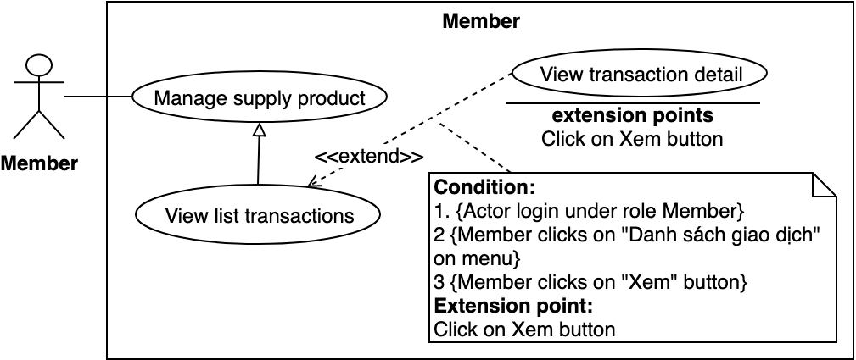

Figure 43 - <Member> View transaction detail

|  |  |  |  |
| --- | --- | --- | --- |
| **USE CASE – BWA_MEM_18** | | | |
| **Use Case No.** | BWA_MEM_18 | **Use Case Version** | 2.0 |
| **Use Case Name** | View transaction detail | | |
| **Author** | MinhHy | | |
| **Date** | 18/03/2019 | **Priority** | Normal |
| **Actor:**   * Member   **Summary:**   * Allow member to view transaction detail of themselves.   **Goal:**   * Member can view transaction detail.   **Triggers:**   * Member goes to user page. * Member goes to list transactions page. * Member sends request to view transaction detail.   **Preconditions:**   * Guest logged into the system as role “Member”. * Member goes to user page.   **Post conditions:**   * Success: System displays transaction detail. * Fail: System shows error messages.   **Main Success Scenario:**   |  |  |  | | --- | --- | --- | | **Step** | **Actor Action** | **System Response** | | 1 | Member clicks “Rao Bán” on menu and clicks on “Các bài rao bán quan tâm”. | System shows list transactions of member following:  - Bài rao bán: text  - Ngày theo dõi: text  - Tình trạng: text  - Chi tiết: button | | 2 | Member clicks on “Chi tiết” button | System shows popup transaction detail page with timeline. [Exception 1] |   **Alternative Scenario:** N/A  **Exceptions:**   |  |  |  | | --- | --- | --- | | **No** | **Actor Action** | **System Response** | | 1 |  | System shows error message “Vui lòng kiểm tra lại đường truyền của bạn!” when the internet is lost. |   **Relationships:** BWA_MEM_16, BWA_MEM_10.  **Business Rules:**  Member can only view transaction detail of supply post following. | | | |

Table 42 -<Member> View transaction detail use case specification

##### 2.3.3.19. Edit feedback

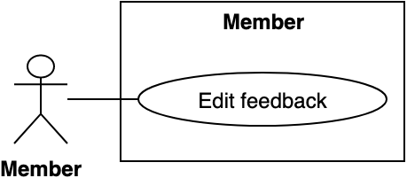

Figure 44 - <Member> Edit feedback

|  |  |  |  |
| --- | --- | --- | --- |
| **USE CASE – BWA_MEM_19** | | | |
| **Use Case No.** | BWA_MEM_19 | **Use Case Version** | 2.0 |
| **Use Case Name** | Edit feedback | | |
| **Author** | MinhHy | | |
| **Date** | 18/03/2019 | **Priority** | Normal |
| **Actor:**   * Member   **Summary:**   * Allow member to edit feedback in supply posts or events after 15 mins create time.   **Goal:**   * Member can edit feedback.   **Triggers:**   * Member goes to supply post/ event detail * Member sends request to update feedback.   **Preconditions:**   * Guest logged into the system as role “Member”. * Member goes to supply post/event detail. * Member can only edit feedback that is existed and create by himself/herself.   **Post conditions:**   * Success: System shows success messages and edits feedback. * Fail: System shows error messages.   **Main Success Scenario:**   |  |  |  | | --- | --- | --- | | **Step** | **Actor Action** | **System Response** | | 1 | Member goes to event detail page. Member clicks on “Sửa” link.  [Alternative 1] | System checks member is satisfying conditions or not if satisfy system shows event detail:  - Feedback content: text area  - Đăng: button | | 2 | Member inputs fields. | [Exception 1] | | 3 | Member clicks on “Đăng” button | System updates feedback and shows success message: “Đăng thành công”.  [Exception 2] |   **Alternative Scenario:**   |  |  |  | | --- | --- | --- | | **Step** | **Actor Action** | **System Response** | | 1 | Member goes to supply post detail page. Member clicks on “Sửa” link. | System checks member is satisfying conditions or not if satisfy system shows supply post detail:  - Feedback content: text area  - Đăng: button |   **Exceptions:**   |  |  |  | | --- | --- | --- | | **No** | **Actor Action** | **System Response** | | 1 | Member inputs empty content of feedback. | System shows error message “Vui lòng nhập thông tin.” | | 2 |  | System shows error message “Vui lòng kiểm tra lại đường truyền của bạn!” when the internet is lost. |   **Relationships:** N/A.  **Business Rules:**  Feedback can only edit in 15 mins after create time.  In 15 mins, member can edit feedback many time. | | | |

Table 43 - <Member> Edit feedback use case specification

##### 2.3.3.20. Manage event

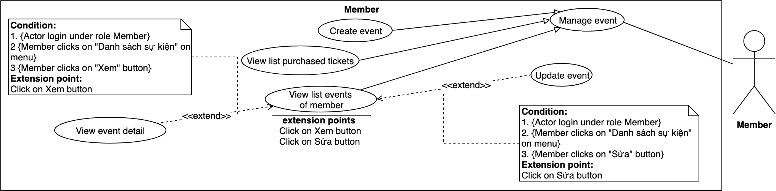

Figure 45 - <Member> Manage event

##### 2.3.3.21. Create event

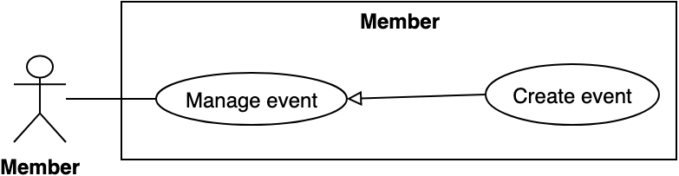

Figure 46 - <Member>Create event

|  |  |  |  |
| --- | --- | --- | --- |
| **USE CASE – BWA_MEM_21** | | | |
| **Use Case No.** | BWA_MEM_21 | **Use Case Version** | 2.0 |
| **Use Case Name** | Create event | | |
| **Author** | MinhHy | | |
| **Date** | 17/03/2019 | **Priority** | Normal |
| **Actor:**   * Member   **Summary:**   * Allow member to create event.   **Goal:**   * Member can create event.   **Triggers:**   * Member goes to user page.   **Preconditions:**   * Guest logged into the system as role “Member”   **Post conditions:**   * Success: System shows success messages. * Fail: System shows error messages.   **Main Success Scenario:**   |  |  |  | | --- | --- | --- | | **Step** | **Actor Action** | **System Response** | | 1 | Member clicks “Sự kiện” on menu then clicks “Tạo sự kiện” in sub menu | System goes to create event page and show form:  - Tiêu đề: text input  - Địa điểm tổ chức: text input  - Lấy địa điểm hiện tại: button  - Ngày công bố: date picker  - Thời gian cho phép mua vé sự kiện: range date picker  - Thời gian diễn ra sự kiện: date picker  - Thể loại: dropdown selector  - Số vé tối thiểu: number input  - Số tối đa: number input  - Giá vé: number input  - Image upload: upload file  - Mô tả: text editor  - Đăng tin: button  - Trở về: button | | 2 | Member inputs fields. [Alternative 1] | [Exception 1, 2, 3] | | 3 | Member clicks on “Gửi đề nghị” button.  [Alternative 2] | System shows success message: *“*Gửi đề nghị event thành công*”.*  [Exception 4] |   **Alternative Scenario:**   |  |  |  | | --- | --- | --- | | **No** | **Actor Action** | **System Response** | | 1 | Member clicks on “Lấy địa chỉ hiện tại” button | System will get current location and fill it in location input. | | 2 | Member clicks on “Trở về” button. | System goes to list events page. |   **Exceptions:**   |  |  |  | | --- | --- | --- | | **No** | **Actor Action** | **System Response** | | 1 | Member inputs invalid information | System shows error message match with invalid information. | | 2 | Member does not uploaded any image | System shows error message “Bài viết sự kiện phải có ít nhất 1 hình ảnh” | | 3 | Member does not input location or  invalid location. | System shows error message “Vui lòng nhập địa chỉ chính xác hoặc chọn nút “Lấy địa điểm hiện tại”” | | 4 |  | System shows error message “Vui lòng kiểm tra lại đường truyền của bạn!” when the internet is lost. |   **Relationships:** N/A.  **Business Rules:**  Member can create multiple events.  Member must to wait admin who will approve their event. | | | |

Table 44 - <Member> Create event use case specification

##### 2.3.3.22. View list purchased tickets

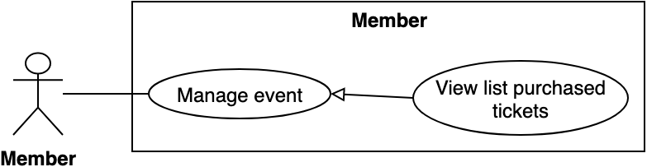

Figure 48 - <Member> Create request

|  |  |  |  |
| --- | --- | --- | --- |
| **USE CASE – BWA_MEM_22** | | | |
| **Use Case No.** | BWA_MEM_22 | **Use Case Version** | 2.0 |
| **Use Case Name** | View list purchased tickets | | |
| **Author** | MinhHy | | |
| **Date** | 17/03/2019 | **Priority** | Normal |
| **Actor:**   * Member   **Summary:**   * This use case allows member to view the number of tickets include two situations: * Member bought tickets of events. So that he/she can view list tickets of his/herself. * Member sold tickets of his/her event. So that he/she can view list tickets who buy it.   **Goal:**   * Member views list of tickets include list users registered of an event.   **Triggers:**   * Member goes to user page. * Member sends command to view list tickets.   **Preconditions:**   * Guest logged into the system as role “Member”.   **Post conditions:**   * Success: System displays list tickets. * Fail: System shows error messages.   **Main Success Scenario:**   |  |  |  | | --- | --- | --- | | **Step** | **Actor Action** | **System Response** | | 1 | Member goes to user page, clicks “Sự kiện” on menu and clicks “Sự kiện đã mua vé” on sub menu. [Alternative 1] | System goes to list tickets page and shows:  - Sự kiện  - Thời gian mua  - Số lượng vé  - Xem: button  [Exception 1] |   **Alternative Scenario:**   |  |  |  | | --- | --- | --- | | **Step** | **Actor Action** | **System Response** | | 1 | Member clicks “Xem” button | System goes to event detail page, if member is seller he/she will see list tickets of his/herself. |   **Exceptions:**   |  |  |  | | --- | --- | --- | | **No** | **Actor Action** | **System Response** | | 1 |  | System shows error message “Vui lòng kiểm tra lại đường truyền của bạn!” when the internet is lost. |   **Relationships:** N/A.  **Business rules:**  Member (Seller) can view list users bought tickets of his/her event.  Member (Buyer) can view list bought tickets of themselves.  List tickets only show success transaction of buying ticket. | | | |

Table 45 - <Member>View list purchased tickets use case specification

##### 2.3.3.23. Update event

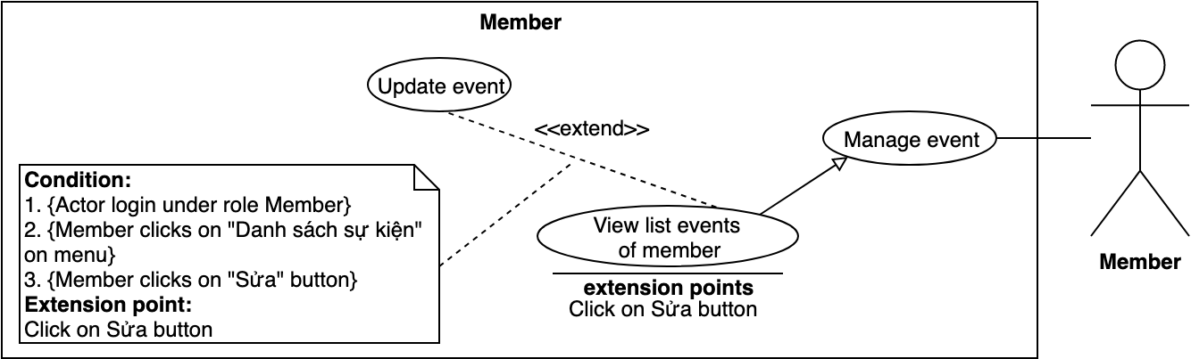

Figure 49 - <Member>Update event

|  |  |  |  |
| --- | --- | --- | --- |
| **USE CASE – BWA_MEM_23** | | | |
| **Use Case No.** | BWA_MEM_23 | **Use Case Version** | 2.0 |
| **Use Case Name** | Update event | | |
| **Author** | MinhHy | | |
| **Date** | 17/03/2019 | **Priority** | Normal |
| **Actor:**   * Member   **Summary:**   * Allow member to update event information of themselves before public time.   **Goal:**   * Member can update event information   **Triggers:**   * Member views list events. * Member sends request to update event.   **Preconditions:**   * Guest logged into the system as role “Member” * Member goes to list events in user page. * Member can only update event that create by himself/herself. * Member can only update event before public time.   **Post conditions:**   * Success: System shows success messages. * Fail: System shows error messages.   **Main Success Scenario:**   |  |  |  | | --- | --- | --- | | **Step** | **Actor Action** | **System Response** | | 1 | Member goes to user page clicks on “Sự kiện” menu and clicks on “Danh sách sự kiện” sub menu | System goes to list events page. | | 2 | Member clicks “Sửa” button in an item of list events. | System goes to update event page and shows:  System goes to create event page and show form:  - Tiêu đề: text input  - Địa điểm tổ chức: text input  - Lấy địa điểm hiện tại: button  - Ngày công bố: date picker  - Thời gian cho phép mua vé sự kiện: range date picker  - Thời gian diễn ra sự kiện: date picker  - Thể loại: dropdown selector  - Số vé tối thiểu: number input  - Số tối đa: number input  - Giá vé: number input  - Image upload: upload file  - Mô tả: text editor  - Cập nhật: button  - Trở về: button | | 3 | Member inputs fields. | [Exception 1, 2, 3, 4] | | 4 | Member clicks “Cập nhật” button. [Alternative 1] | System updates event detail into database. System shows success message: “Sự kiện cập nhật thành công”.  [Exception 5] |   **Alternative Scenario:**   |  |  |  | | --- | --- | --- | | **Step** | **Actor Action** | **System Response** | | 1 | Member clicks on “Trở về” button. | System goes back to list events page. |   **Exceptions:**   |  |  |  | | --- | --- | --- | | **No** | **Actor Action** | **System Response** | | 1 | Member inputs invalid information | System shows error message match with invalid information. | | 2 | Member does not uploaded any image | System shows error message “Bài viết sự kiện phải có ít nhất 1 hình ảnh” | | 3 | Member does not input location or  invalid location. | System shows error message “Vui lòng nhập địa chỉ chính xác hoặc chọn nút “Lấy địa điểm hiện tại.” | | 4 |  | System shows error message “Vui lòng kiểm tra lại đường truyền của bạn!” when the internet is lost. |   **Relationships:** N/A.  **Business Rules:**  Before public time, member can update their event.  After member updated event, event must to approve event by admin to public.  Member cannot update event after event is public. | | | |

Table 46 - <Member> Update event use case specification

##### 2.3.3.24. View list reports

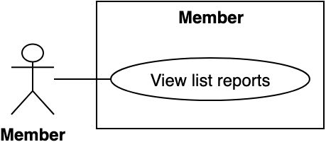

Figure 50 - <Member> View list reports

|  |  |  |  |
| --- | --- | --- | --- |
| **USE CASE – BWA_MEM_24** | | | |
| **Use Case No.** | BWA_MEM_24 | **Use Case Version** | 2.0 |
| **Use Case Name** | View list reports | | |
| **Author** | MinhHy | | |
| **Date** | 17/03/2019 | **Priority** | Normal |
| **Actor:**   * Member   **Summary:**   * Allow member to views list reports of member with all status in system.   **Goal:**   * Member can view their list reports with all status.   **Triggers:**   * Member clicks on “Danh sách tố cáo” button * Member sends request to view list reports.   **Preconditions:**   * Guest logged into the system with role “Member”.   **Post conditions:**   * Success: System shows list reports of member with all status. * Fail: System shows error messages.   **Main Success Scenario:**   |  |  |  | | --- | --- | --- | | **Step** | **Actor Action** | **System Response** | | 1 | Member clicks “Danh sách tố cáo” on menu. | System goes to list reports page:  - Người tố cáo: text  - Người bị tố cáo: text  - Thời gian gửi: text  - Tình trạng: text  - Chi tiết: button  [Exception 1] |   **Exceptions:**   |  |  |  | | --- | --- | --- | | **No** | **Actor Action** | **System Response** | | 1 |  | System shows error message “Vui lòng kiểm tra lại đường truyền của bạn!” when the internet is lost. |   **Relationships:** N/A.  **Business Rules:**  Member can view all of reports of themself in system. | | | |

Table 47 - <Member> View list reports use case specification

##### 2.3.3.25. View report detail

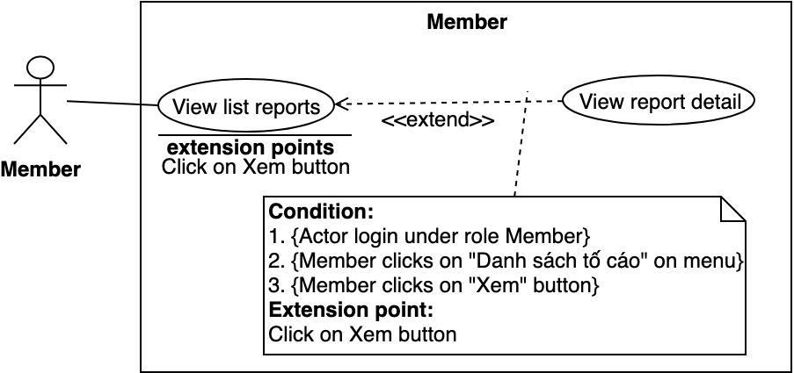

Figure 51 - <Member> View report detail

|  |  |  |  |
| --- | --- | --- | --- |
| **USE CASE – BWA_MEM_25** | | | |
| **Use Case No.** | BWA_MEM_25 | **Use Case Version** | 2.0 |
| **Use Case Name** | View report detail | | |
| **Author** | MinhHy | | |
| **Date** | 19/03/2019 | **Priority** | Normal |
| **Actor:**   * Member   **Summary:**   * Allow member to views specified a report of themself.   **Goal:**   * Member can view report detail.   **Triggers:**   * Member clicks “Danh sách tố cáo” menu. * Member sends request to view specified a report.   **Preconditions:**   * Guest logged into the system in role “Member”.   **Post conditions:**   * Success: System shows report detail information. * Fail: System shows error messages.   **Main Success Scenario:**   |  |  |  | | --- | --- | --- | | **Step** | **Actor Action** | **System Response** | | 1 | Admin clicks “Chi tiết” button on a specified report | System shows popup and displays report detail:  - Người tố cáo: text  - Người bị tố cáo: text  - Thời gian gửi: text  - Tình trạng: text  - Lý do: text  - Xác nhận: button  - Trở về: button |   **Alternative Scenario:** N/A  **Exceptions:**   |  |  |  | | --- | --- | --- | | **No** | **Actor Action** | **System Response** | | 1 |  | System shows error message “Vui lòng kiểm tra lại đường truyền của bạn!” when the internet is lost. |   **Relationships:** N/A.  **Business Rules:** N/A | | | |

Table 48 - <Member > View report detail use case specification

##### 2.3.3.26. Send feedback

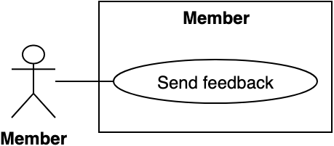

Figure 52 - <Member> Send feedback

|  |  |  |  |
| --- | --- | --- | --- |
| **USE CASE – BWA_MEM_26** | | | |
| **Use Case No.** | BWA_MEM_26 | **Use Case Version** | 2.0 |
| **Use Case Name** | Send feedback | | |
| **Author** | MinhHy | | |
| **Date** | 18/03/2019 | **Priority** | Normal |
| **Actor:**   * Member   **Summary:**   * Allow member to send feedback in supply posts or events if satisfy conditions.   **Goal:**   * Member can send feedback.   **Triggers:**   * Member goes to supply post/ event detail * Member sends request to send feedback.   **Preconditions:**   * Guest logged into the system as role “Member”. * Member goes to supply post/event detail.   **Post conditions:**   * Success: System shows success messages and create feedback. * Fail: System shows error messages.   **Main Success Scenario:**   |  |  |  | | --- | --- | --- | | **Step** | **Actor Action** | **System Response** | | 1 | Member goes to event detail page.  [Alternative 1] | System checks member is satisfying conditions or not if satisfy system shows event detail:  - Feedback content: text area  - Đăng: button | | 2 | Member inputs fields. | [Exception 1] | | 3 | Member clicks on “Đăng” button | System creates feedback and shows success message: “Đăng thành công”.  [Exception 2] |   **Alternative Scenario:**   |  |  |  | | --- | --- | --- | | **Step** | **Actor Action** | **System Response** | | 1 | Member goes to supply post detail page. | System checks member is satisfying conditions or not if satisfy system shows supply post detail:  - Feedback content: text area  - Đăng: button |   **Exceptions:**   |  |  |  | | --- | --- | --- | | **No** | **Actor Action** | **System Response** | | 1 | Member inputs empty content of feedback. | System shows error message “Vui lòng nhập thông tin.” | | 2 |  | System shows error message “Vui lòng kiểm tra lại đường truyền của bạn!” when the internet is lost. |   **Relationships:** N/A  **Business Rules:**  Supply post: Only member has success transaction of supply post can send feedback, one supply post just has one feedback. Member can send feedback when supply post closed.  Event: Member can send feedback when an event closed and member bought tickets of event. | | | |

Table 49 - <Member> Send feedback use case specification

#### 2.3.4. <Admin> Overview Use Case

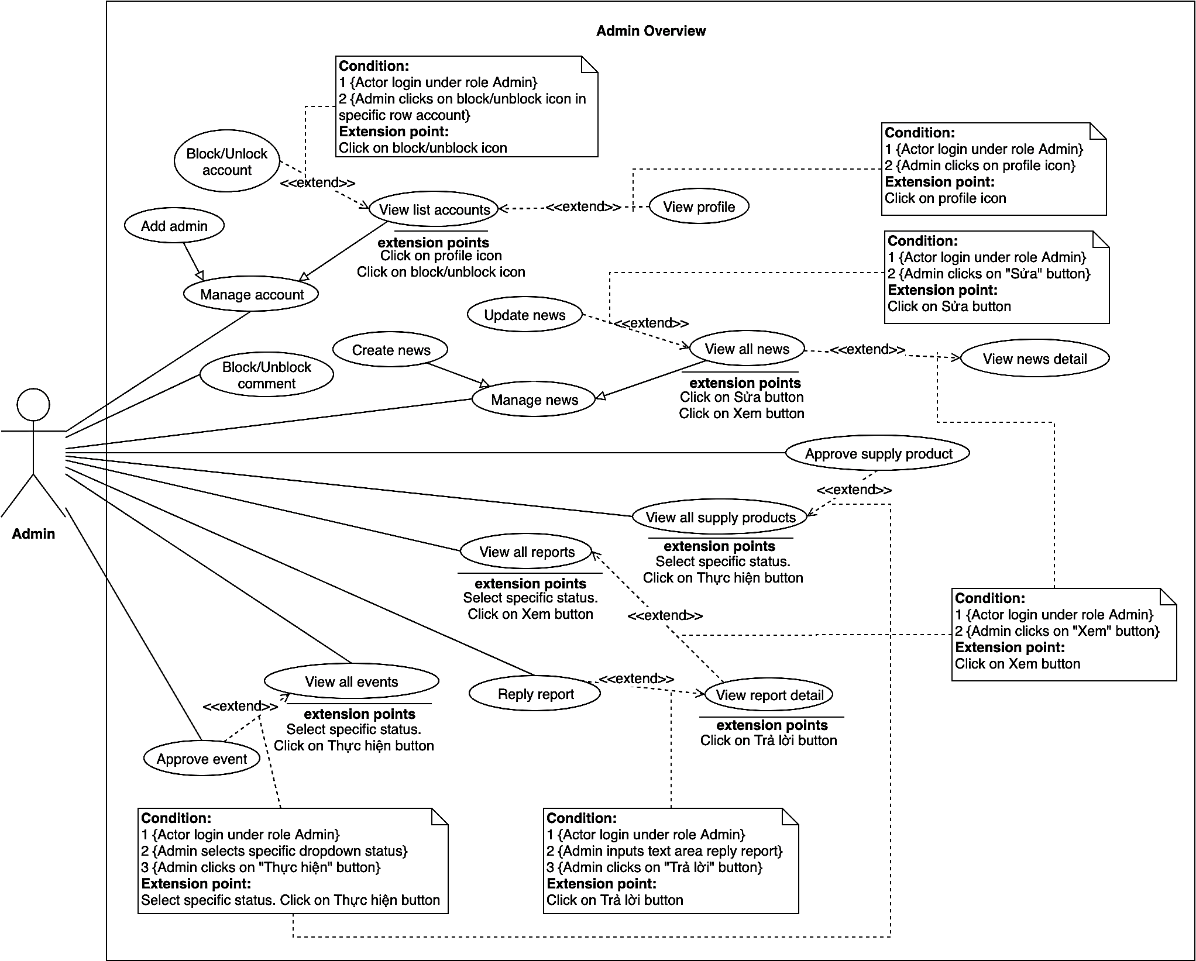

Figure 53 - <Admin> Overview use case

##### 2.3.4.1. Manage account

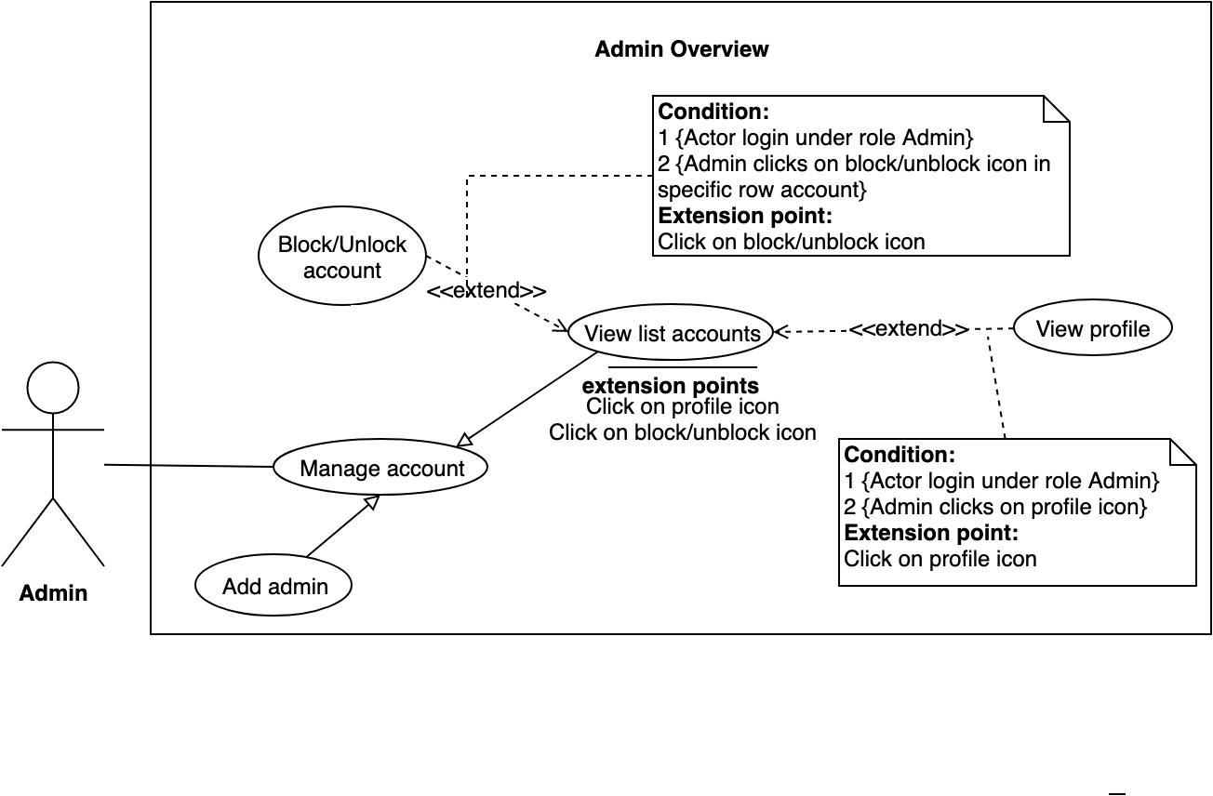

Figure 54 - <Admin> Manage account

##### 2.3.4.2. Add admin

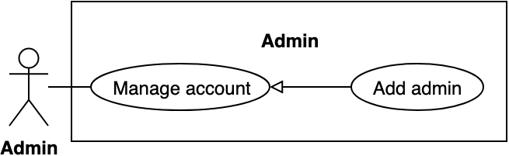

Figure 55 - <Admin> Add admin

|  |  |  |  |
| --- | --- | --- | --- |
| **USE CASE – BWA_ADMIN_02** | | | |
| **Use Case No.** | BWA_ADMIN_02 | **Use Case Version** | 2.0 |
| **Use Case Name** | Add admin | | |
| **Author** | MinhHy | | |
| **Date** | 19/03/2019 | **Priority** | Normal |
| **Actor:**   * Admin   **Summary:**   * This use case allows admin to add an account of admin without confirm verify code.   **Goal:**   * Admin adds new account with role admin to the system.   **Triggers:**   * Admin goes to admin page * Admin clicks on “Quản lý tài khoản” on menu * Admin sends command to add admin account.   **Preconditions:**   * User must login into the system with role Admin.   **Post conditions:**   * Success: System displays success messages. * Fail: System shows error messages.   **Main Success Scenario:**   |  |  |  | | --- | --- | --- | | **Step** | **Actor Action** | **System Response** | | 1 | Admin clicks “Thêm quản trị viên” on sub menu. | System goes to add admin page and shows create admin form:  - Số điện thoại di động: blank text input  - Tên: blank text input  - Mật khẩu: blank password input  - Xác nhận mật khẩu: blank password input  - Thêm quản trị viên: button | | 2 | Admin inputs fields. | [Exception 1] | | 3 | Manager clicks on “Thêm quản trị viên” button | System displays message “Tạo thành công” and adds new admin.  [Exception 2] |   **Alternative Scenario:** N/A  **Exceptions:**   |  |  |  | | --- | --- | --- | | **No** | **Actor Action** | **System Response** | | 1 | Admin inputs invalid information | System shows error message match with invalid information fields. | | 2 |  | System shows error message “Vui lòng kiểm tra lại đường truyền của bạn!” when the internet is lost. |   **Relationships:** N/A  **Business rules:** N/A | | | |

Table 50 - <Admin> Add admin use case specification

##### 2.3.4.3. Block/Unblock account

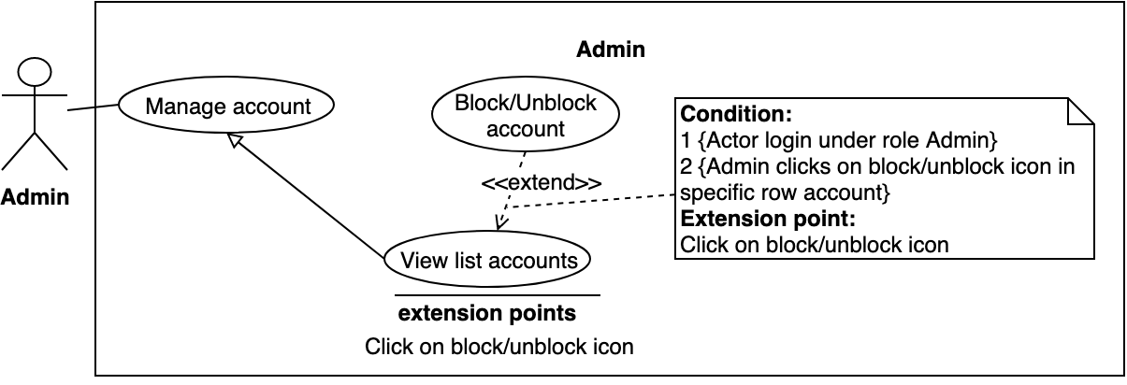

Figure 56 - <Admin> Block / unblock account

|  |  |  |  |
| --- | --- | --- | --- |
| **USE CASE – BWA_ADMIN_03** | | | |
| **Use Case No.** | BWA_ADMIN_03 | **Use Case Version** | 2.0 |
| **Use Case Name** | Block/unblock account | | |
| **Author** | MinhHy | | |
| **Date** | 18/03/2019 | **Priority** | Normal |
| **Actor:**   * Admin   **Summary:**   * This use case allows the admin to block or unblock an account of every member.   **Goal:**   * Admin can block/unblock account.   **Triggers:**   * Admin goes to admin page. * Admin clicks “Quản lý tài khoản” on menu in home page. * Admin sends request to block/unblock an account   **Preconditions:**   * User must login into the system with role Admin.   **Post conditions:**   * Success: System shows success messages and block/unblock an account. * Fail: System shows error messages.   **Main Success Scenario:**   |  |  |  | | --- | --- | --- | | **Step** | **Actor Action** | **System Response** | | 1 | Admin clicks “Khóa tài khoản” button on an account item. [Alternative 1] | System shows popup in list accounts view with message: “Bạn xác nhận khóa tài khoản của <Tên>?”  - Xác nhận: button  - Trở về: button | | 2 | Admin clicks on “Xác nhận” button. [Alternative 2] |  | | 3 |  | System displays success message “Đã khóa/Mở khóa tài khoản thành công” and reload list accounts.[Exception 1] |   **Alternative Scenario:**   |  |  |  | | --- | --- | --- | | **No** | **Actor Action** | **System Response** | | 1 | Admin clicks “Mở khóa tài khoản” button on an account item. | System shows popup in list accounts view with message: “Bạn xác nhận muốn mở khóa tài khoản của <Tên>?”  - Xác nhận: button  - Trở về: button | | 2 | Admin clicks on “Trở về” button. | System closes popup ban an account. |   **Exceptions:**   |  |  |  | | --- | --- | --- | | **No** | **Actor Action** | **System Response** | | 4 |  | System shows error message “Vui lòng kiểm tra lại đường truyền của bạn!” when the internet is lost. |   **Relationships:** BWA_ADMIN_04  **Business rules:**  Admin can block/unblock member.  Admin can not ban other admin. | | | |

Table 51 - <Admin> Block / unblock account use case specification

##### 2.3.4.4. View list accounts

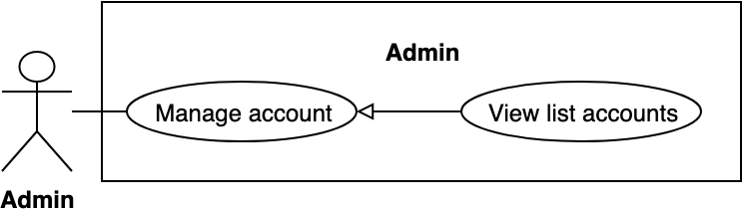

Figure 57 - <Admin> View list accounts

|  |  |  |  |
| --- | --- | --- | --- |
| **USE CASE – BWA_ADMIN_04** | | | |
| **Use Case No.** | BWA_ADMIN_04 | **Use Case Version** | 2.0 |
| **Use Case Name** | View list accounts | | |
| **Author** | MinhHy | | |
| **Date** | 18/03/2019 | **Priority** | Normal |
| **Actor:**   * Admin   **Summary:**   * This use case allows manager to view list accounts.   **Goal:**   * Admin can view list accounts.   **Triggers:**   * Admin goes to admin page * Admin clicks “Quản lý tài khoản”.   **Preconditions:**   * User must login into the system with role Admin.   **Post conditions:**   * Success: System displays list accounts. * Fail: System shows error messages.   **Main Success Scenario:**   |  |  |  | | --- | --- | --- | | **Step** | **Actor Action** | **System Response** | | 1 | Admin clicks “Quản lý tài khoản” on menu in admin page and clicks “Danh sách thành viên” on sub menu. | System shows list all accounts:  - Tên: text  - Ngày tham gia: text  - Đánh giá: text  - Tình trạng: text  - Số bình luận đã viết: number  - Số lượng bài đăng: number  - Khóa tài khoản: button  - Mở tài khoản: button  - Xem thông tin: button  [Exception 1] |   **Alternative Scenario:** N/A  **Exceptions:**   |  |  |  | | --- | --- | --- | | **No** | **Actor Action** | **System Response** | | 1 |  | System shows error message “Vui lòng kiểm tra lại đường truyền của bạn!” when the internet is lost. |   **Relationships:** BWA_ADMIN_03  **Business rules:**  If admin views list accounts with all status (BAN & ACTIVE) | | | |

Table 52 - <Admin> View list accounts use case specification

##### 2.3.4.5. Block/Unblock comment

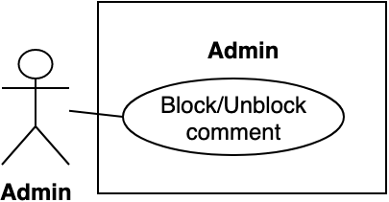

Figure 58 - <Admin> Block/Unblock comment

|  |  |  |  |
| --- | --- | --- | --- |
| **USE CASE – BWA_ADMIN_05** | | | |
| **Use Case No.** | BWA_ ADMIN _05 | **Use Case Version** | 2.0 |
| **Use Case Name** | Block/unblock comment | | |
| **Author** | MinhHy | | |
| **Date** | 18/03/2019 | **Priority** | Normal |
| **Actor:**   * Admin   **Summary:**   * Allow admin to block/unblock comments in a news.   **Goal:**   * Admin can block/unblock comment.   **Triggers:**   * Admin views list comments of news. * Admin sends request to block/ unblock a specific comment.   **Preconditions:**   * Guest logged into the system with role “Admin”. * Comment had existed.   **Post conditions:**   * Success: System updates status comment and shows success messages. * Fail: System shows error messages.   **Main Success Scenario:**   |  |  |  | | --- | --- | --- | | **Step** | **Actor Action** | **System Response** | | 1 | Admin goes to news detail. | System shows list comments of news. | | 2 | Admin clicks on “Ẩn” link in a page. [Alternative 1] | System shows popup to confirm block comment with message: “Bạn muốn ẩn bình luận này?”  - Có: button  - Hủy: button | | 2 | User clicks on “Có” button. [Alternative 2] |  | | 4 |  | System blocks comment of this news. System shows success message: “Cập nhật bình luận thành công”.  [Exception 2] |   **Alternative Scenario:**   |  |  |  | | --- | --- | --- | | **No** | **Actor Action** | **System Response** | | 1 | Admin clicks on “Bỏ ẩn” button. | System shows popup to confirm unblock comment with message: “Bạn muốn bỏ ẩn bình luận này?”  - Có: button  - Hủy: button | | 2 | Admin clicks on “Hủy” button | System closes popup. |   **Exceptions:**   |  |  |  | | --- | --- | --- | | **No** | **Actor Action** | **System Response** | | 1 |  | System shows error message “Vui lòng kiểm tra lại đường truyền của bạn!” when the internet is lost. |   **Relationships:** N/A  **Business Rules:**  Admin can block many comments in a news.  Blocked comment can be unblocked by admin. | | | |

Table 53 - <Admin> Block/Unblock comment use case specification

##### 2.3.4.6. Manage news

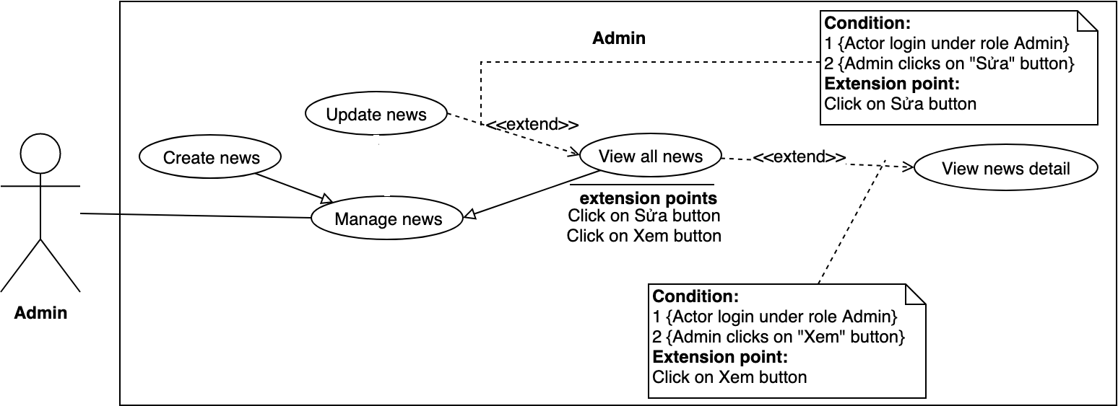

Figure 59 - <Admin> Manage news

##### 2.3.4.7. Create news

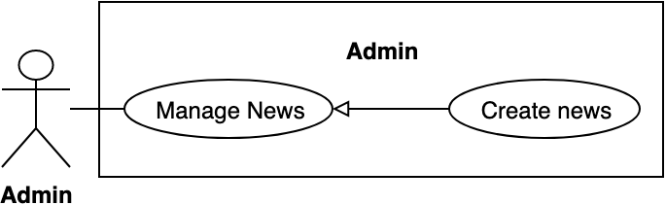

Figure 60 - <Admin> Create news

|  |  |  |  |
| --- | --- | --- | --- |
| **USE CASE – BWA_ADMIN_07** | | | |
| **Use Case No.** | BWA_ADMIN_07 | **Use Case Version** | 2.0 |
| **Use Case Name** | Create news | | |
| **Author** | MinhHy | | |
| **Date** | 19/03/2019 | **Priority** | Normal |
| **Actor:**   * Admin   **Summary:**   * This use case allows admin to create news and everybody can view this news.   **Goal:**   * Admin creates a news.   **Triggers:**   * Admin goes to admin page * Admin clicks “Tin tức” on menu * Adin sends command to create news.   **Preconditions:**   * User must login into the system with role Admin.   **Post conditions:**   * Success: System creates a news and displays success message. * Fail: System shows error messages.   **Main Success Scenario:**   |  |  |  | | --- | --- | --- | | **Step** | **Actor Action** | **System Response** | | 1 | Admin clicks “Tạo tin tức” on sub menu. | System shows create news page with form:  - Tiêu đề: blank text input  - Image upload: upload file  - Danh mục: dropdown selector  - Mô tả: text editor  - Đăng bài: button  - Trở về: button | | 2 | Admin inputs fields. | [Exception 1] | | 3 | Admin clicks “Đăng bài” button [Alternative 2] | System shows success message “Tạo tin tức thành công”. [Exception 2,3] |   **Alternative Scenario:**   |  |  |  | | --- | --- | --- | | **No** | **Actor Action** | **System Response** | | 1 | Admin clicks “Trở về” button. | System returns list news page. |   **Exceptions:**   |  |  |  | | --- | --- | --- | | **No** | **Actor Action** | **System Response** | | 1 | Admin inputs invalid information | System shows error message match with invalid information fields. | | 2 |  | System shows error message “Tạo tin tức thất bại” | | 3 |  | System shows error message “Vui lòng kiểm tra lại đường truyền của bạn!” when the internet is lost. |   **Relationships:** BWA_ADMIN_06  **Business rules:**  Only admin can create news.  Admin can create many news.  After admin created, news is public with everybody. | | | |

Table 54 - <Admin> Create news use case specification

##### 2.3.4.8. Update news

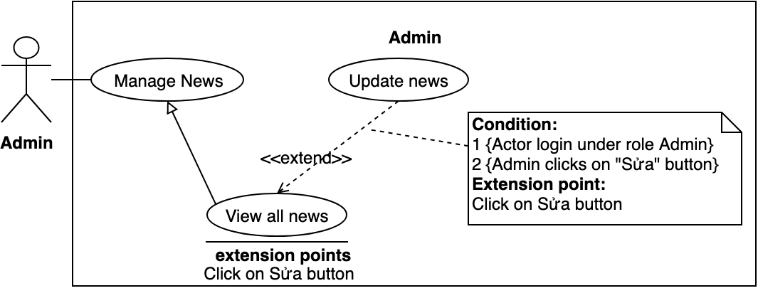

Figure 61 - <Admin> Update news

|  |  |  |  |
| --- | --- | --- | --- |
| **USE CASE – BWA_ADMIN_08** | | | |
| **Use Case No.** | BWA_ADMIN_08 | **Use Case Version** | 2.0 |
| Use Case Name | Update news | | |
| **Author** | MinhHy | | |
| **Date** | 19/03/2019 | **Priority** | Normal |
| **Actor:**   * Admin   **Summary:**   * This use case allows admin to update information of a news.   **Goal:**   * Admin can update news.   **Triggers:**   * Admin goes to admin page * Admin clicks “Tin tức” on menu * Admin clicks “Danh sách tin tức” on sub menu * Admin sends command to update news.   **Preconditions:**   * User must login into the system with role Admin.   **Post conditions:**   * Success: System displays success message and update news. * Fail: System shows error messages.   **Main Success Scenario:**   |  |  |  | | --- | --- | --- | | **Step** | **Actor Action** | **System Response** | | 1 | Admin clicks on “Sửa” button of item news in “Danh sách tin tức” page. | Systems goes to update news and shows form:  - Tiêu đề: text input  - Image upload: upload file  - Danh mục: dropdown selector  - Mô tả: text editor  - Cập nhật: button  - Trở về: button | | 2 | Admin inputs formation in fields. | [Exception 1] | | 3 | Admin clicks on “Cập nhật” button [Alternative 1] | System displays success message “Cập nhật thành công”. [Exception 2, 3] |   **Alternative Scenario:**   |  |  |  | | --- | --- | --- | | **No** | **Actor Action** | **System Response** | | 1 | Admin clicks on “Trở về” button. | System redirects to list news page. |   **Exceptions:**   |  |  |  | | --- | --- | --- | | **No** | **Actor Action** | **System Response** | | 1 | Admin inputs invalid information. | System shows error message match with invalid information fields. | | 2 |  | System shows error message “Cập nhật thất bại” | | 3 |  | System shows error message “Vui lòng kiểm tra lại đường truyền của bạn!” when the internet is lost. |   **Relationships:** BWA_ADMIN_06, BWA_ADMIN_9.  **Business rules:**  Admin can update news many time.  Admin can update news of other admin.  Crawled news can not update. | | | |

Table 55 - <Admin> Update news use case specification

##### 2.3.4.9. View all news

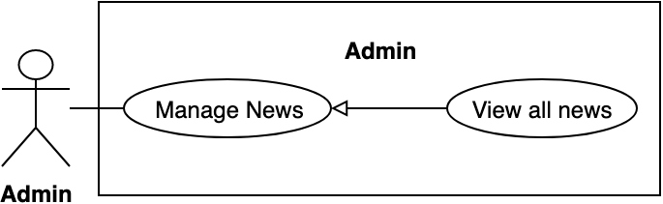

Figure 62 - <Admin> View all news

|  |  |  |  |
| --- | --- | --- | --- |
| **USE CASE – BWA_ADMIN_09** | | | |
| **Use Case No.** | BWA_ADMIN_09 | **Use Case Version** | 2.0 |
| **Use Case Name** | View list news | | |
| **Author** | MinhHy | | |
| **Date** | 18/03/2019 | **Priority** | Normal |
| **Actor:**   * Admin   **Summary:**   * Allow admin to views all news in system.   **Goal:**   * Admin can view their list news with all status.   **Triggers:**   * Admin goes to admin page. * Admin clicks “Tin tức” on menu. * Admin send request to view list news.   **Preconditions:**   * Guest logged into the system with role admin. * Admin goes to admin page.   **Post conditions:**   * Success: System shows list news. * Fail: System shows error messages.   **Main Success Scenario:**   |  |  |  | | --- | --- | --- | | **Step** | **Actor Action** | **System Response** | | 1 | Admin clicks “Danh sách tin tức” on sub menu. | System goes to list news page:  - Tiêu đề: text  - Thời gian tạo: text  - Tình trạng: text  - Tổng bình luận: text  - Sửa: button  - Xem: button  [Exception 1] |   **Exceptions:**   |  |  |  | | --- | --- | --- | | **No** | **Actor Action** | **System Response** | | 1 |  | System shows error message “Vui lòng kiểm tra lại đường truyền của bạn!” when the internet is lost. |   **Relationships:** BWA_ADMIN_06, BWA_ADMIN_08  **Business Rules:**  Admin can view all news in system. List news always sort latest | | | |

Table 56 - <Admin>View all news use case specification

##### 2.3.4.10. Approve supply product

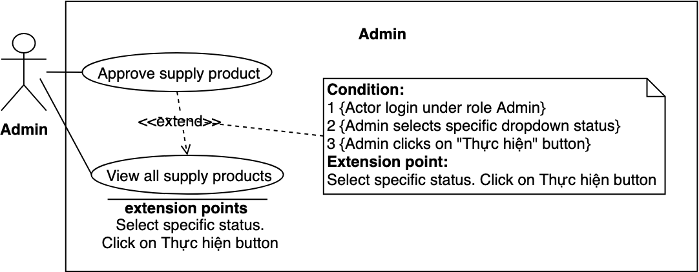

Figure 63 - <Admin> Approve supply product

|  |  |  |  |
| --- | --- | --- | --- |
| **USE CASE – BWA_ADMIN_10** | | | |
| **Use Case No.** | BWA_ADMIN_10 | **Use Case Version** | 2.0 |
| **Use Case Name** | Approve supply product | | |
| **Author** | MinhHy | | |
| **Date** | 19/03/2019 | **Priority** | Normal |
| **Actor:**   * Admin   **Summary:**   * This use case allows admin to approve pending supply post of members.   **Goal:**   * Admin can approve supply post of members.   **Triggers:**   * Admin goes to admin page. * Admin clicks “Quản lý bài rao bán” on menu. * Admin clicks “Danh sách rao bán” on sub menu. * Admin sends command to approve supply post.   **Preconditions:**   * User must login into the system with role Admin. * Supply post status is pending.   **Post conditions:**   * Success: System displays success message and approves supply post. * Fail: System shows error messages.   **Main Success Scenario:**   |  |  |  | | --- | --- | --- | | **Step** | **Actor Action** | **System Response** | | 1 | Admin clicks “Duyệt” button in an item of list events. | System shows popup confirm with message “Bạn muốn duyệt sự kiện này?”  - Duyệt: button  - Trở về: button | | 2 | Admin clicks “Duyệt” button. [Alternative 1] | System updates supply post and shows success message: “Cập nhật thành công”. [Exception 2, 3] |   **Alternative Scenario:**   |  |  |  | | --- | --- | --- | | **Step** | **Actor Action** | **System Response** | | 1 | Admin clicks on “Trở về” button. | System goes back to list supply posts page. |   **Exceptions:**   |  |  |  | | --- | --- | --- | | **No** | **Actor Action** | **System Response** | | 1 |  | System shows error message “Cập nhật thất bại” | | 2 |  | System shows error message “Vui lòng kiểm tra lại đường truyền của bạn!” when the internet is lost. |   **Relationships:** N/A  **Business Rules:**  After admin approved event, supply post is public. | | | |

Table 57 - <Admin> Approve supply product use case specification

##### 2.3.4.11. View all reports

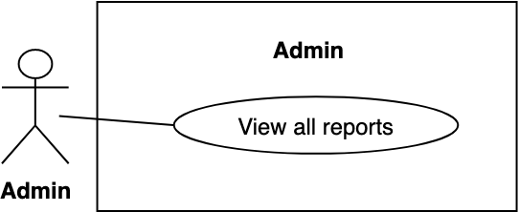

Figure 64 - <Admin> View all reports

|  |  |  |  |
| --- | --- | --- | --- |
| **USE CASE – BWA_ADMIN_11** | | | |
| **Use Case No.** | BWA_ADMIN_11 | **Use Case Version** | 2.0 |
| **Use Case Name** | View all reports | | |
| **Author** | MinhHy | | |
| **Date** | 17/03/2019 | **Priority** | Normal |
| **Actor:**   * Admin   **Summary:**   * Allow admins to views list reports of all members with all status in system.   **Goal:**   * Admin can view their list report with all status.   **Triggers:**   * Admin goes to admin page.   **Preconditions:**   * Guest logged into the system with role admin.   **Post conditions:**   * Success: System shows list reports with all status. * Fail: System shows error messages.   **Main Success Scenario:**   |  |  |  | | --- | --- | --- | | **Step** | **Actor Action** | **System Response** | | 1 | Admin clicks “Quản lý tố cáo” on menu. | System goes to list reports page:  - Người tố cáo: text  - Người bị tố cáo: text  - Thời gian gửi: text  - Tình trạng: text  - Chi tiết: button  [Exception 1] |   **Exceptions:**   |  |  |  | | --- | --- | --- | | **No** | **Actor Action** | **System Response** | | 1 |  | System shows error message “Vui lòng kiểm tra lại đường truyền của bạn!” when the internet is lost. |   **Relationships:** BWA_ADMIN_13, BWA_ADMIN_14  **Business Rules:**  Admin can view all of reports in system.  Admin can review all reports after replied. | | | |

Table 58 - <Admin> View all reports use case specification

##### 2.3.4.12. View report detail

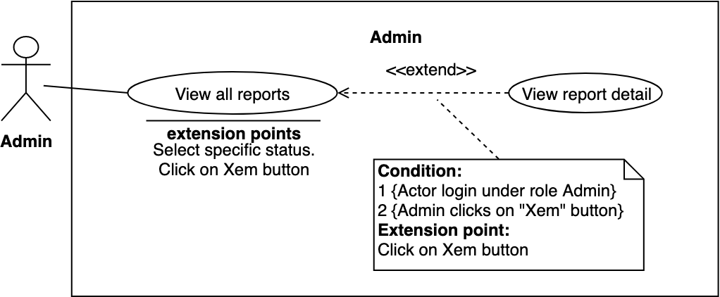

Figure 65 - <Admin> View report detail

|  |  |  |  |
| --- | --- | --- | --- |
| **USE CASE – BWA_ADMIN_12** | | | |
| **Use Case No.** | BWA_ADMIN_12 | **Use Case Version** | 2.0 |
| **Use Case Name** | View report detail | | |
| **Author** | MinhHy | | |
| **Date** | 19/03/2019 | **Priority** | Normal |
| **Actor:**   * Admin   **Summary:**   * Allow admin to views specified a report of members.   **Goal:**   * Admin can view report detail.   **Triggers:**   * Admin goes to admin page. * Admin clicks “Quản lý tố cáo” menu. * Admin sends request to view specified a report.   **Preconditions:**   * User logged into the system in role admin.   **Post conditions:**   * Success: System shows report detail information. * Fail: System shows error messages.   **Main Success Scenario:**   |  |  |  | | --- | --- | --- | | **Step** | **Actor Action** | **System Response** | | 1 | Admin clicks “Chi tiết” button on a specified report | System shows popup and displays report detail:  - Người tố cáo: text  - Người bị tố cáo: text  - Thời gian gửi: text  - Lý do: text  - Trả lời: text area  - Trả lời: button  - Trở về: button |   **Alternative Scenario:** N/A  **Exceptions:**   |  |  |  | | --- | --- | --- | | **No** | **Actor Action** | **System Response** | | 1 |  | System shows error message “Vui lòng kiểm tra lại đường truyền của bạn!” when the internet is lost. |   **Relationships:** BWA_ADMIN_12, BWA_ADMIN_14  **Business Rules**: N/A | | | |

Table 59 - <Admin> View report detail use case specification

##### 2.3.4.13. Reply report

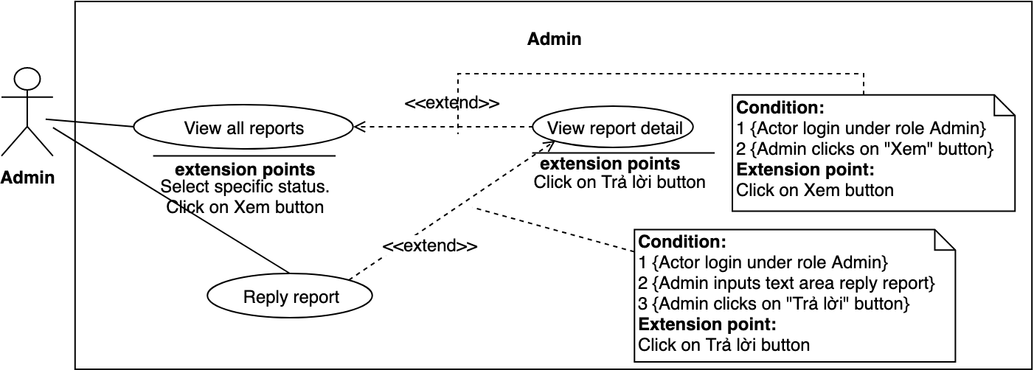

Figure 66 - <Admin> Reply report

|  |  |  |  |
| --- | --- | --- | --- |
| **USE CASE – BWA_ADMIN_13** | | | |
| **Use Case No.** | BWA_ADMIN_13 | **Use Case Version** | 1.0 |
| **Use Case Name** | Reply report | | |
| **Author** | MinhHy | | |
| **Date** | 19/03/2019 | **Priority** | Normal |
| **Actor:**   * Admin   **Summary:**   * Allow admin to reply a pending report of member.   **Goal:**   * Admin can reply a report   **Triggers:**   * Admin clicks “Quản lý tố cáo” on menu. * Admin clicks “Chi tiết” button on a specified report. * Admin sends request to reply specified report.   **Preconditions:**   * User logged into the system with role admin. * Report is pending.   **Post conditions:**   * Success: System shows messages and reply report. * Fail: System shows popup on screen to update fail.   **Main Success Scenario:**   |  |  |  | | --- | --- | --- | | **Step** | **Actor Action** | **System Response** | | 1 | Admin clicks “Chi tiết” button on a specified report. | System shows popup and displays report detail:  - Người tố cáo: text  - Người bị tố cáo: text  - Thời gian gửi: text  - Lý do: text  - Trả lời: text area  - Trả lời: button  - Trở về: button | | 2 | Admin replies a report. Admin clicks on “Thay đổi” button.  [Alternative 2] | System will update report to database and show message: “Thay đổi thành công”  [Exception 1] |   **Alternative Scenario:**   |  |  |  | | --- | --- | --- | | **No** | **Actor Action** | **System Response** | | 1 | Admin clicks on “Trở về” button. | System closes popup. |   **Exceptions:**   |  |  |  | | --- | --- | --- | | **No** | **Actor Action** | **System Response** | | 1 |  | System shows error message “Vui lòng kiểm tra lại đường truyền của bạn!” when the internet is lost. |   **Relationships:** BWA_ADMIN_12, BWA_ADMIN_13  **Business Rules:**  After admin replied report, member will see answer of report.  The replied report can not reply again. | | | |

Table 60 - <Admin> Reply report use case specification

##### 2.3.4.14. View all events

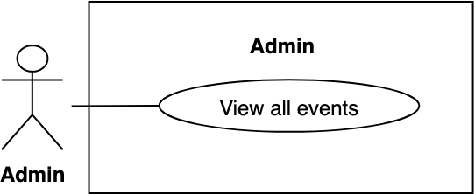

Figure 67 - <Admin> View all events

|  |  |  |  |
| --- | --- | --- | --- |
| **USE CASE – BWA_ADMIN_14** | | | |
| **Use Case No.** | BWA_ADMIN_14 | **Use Case Version** | 2.0 |
| **Use Case Name** | View all events | | |
| **Author** | MinhHy | | |
| **Date** | 17/03/2019 | **Priority** | Normal |
| **Actor:**   * Admin   **Summary:**   * Allow admins to views list events with all status in system.   **Goal:**   * Admin can view their list events with all status.   **Triggers:**   * Admin goes to admin page.   **Preconditions:**   * Guest logged into the system with role admin.   **Post conditions:**   * Success: System shows list events with all status. * Fail: System shows error messages.   **Main Success Scenario:**   |  |  |  | | --- | --- | --- | | **Step** | **Actor Action** | **System Response** | | 1 | Admin clicks “Quản lý sự kiện” on menu then clicks “Danh sách sự kiện” on sub menu. | System goes to list events and load list events of member:  - Tiêu đề: text  - Địa điểm: text  - Thời gian diễn ra: text  - Tình trạng: text  - Sửa: button  - Xem: button  [Exception 1] |   **Exceptions:**   |  |  |  | | --- | --- | --- | | **No** | **Actor Action** | **System Response** | | 1 |  | System shows error message “Vui lòng kiểm tra lại đường truyền của bạn!” when the internet is lost. |   **Relationships:** N/A.  **Business Rules:**  Admin can view all of events in system. | | | |

Table 61 - <Admin>View all events use case specification

##### 2.3.4.15. Approve event

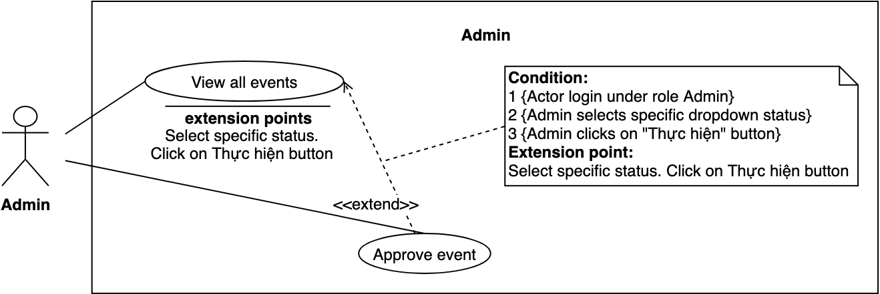

Figure 68 - <Admin> Approve event

|  |  |  |  |
| --- | --- | --- | --- |
| **USE CASE – BWA_ADMIN_15** | | | |
| **Use Case No.** | BWA_ADMIN_15 | **Use Case Version** | 2.0 |
| **Use Case Name** | Approve event | | |
| **Author** | MinhHy | | |
| **Date** | 19/03/2019 | **Priority** | Normal |
| **Actor:**   * Admin   **Summary:**   * This use case allows admin to approve pending event of members.   **Goal:**   * Admin can approve event of members.   **Triggers:**   * Admin goes to admin page. * Admin clicks “Quản lý sự kiện” on menu. * Admin clicks “Danh sách sự kiện on sub menu. * Admin sends command to approve event.   **Preconditions:**   * User must login into the system with role Admin. * Current time is before buy ticket start time of event. * Event status is pending.   **Post conditions:**   * Success: System displays success message and approves event. * Fail: System shows error messages.   **Main Success Scenario:**   |  |  |  | | --- | --- | --- | | **Step** | **Actor Action** | **System Response** | | 1 | Admin clicks “Duyệt” button in an item of list events. | System shows popup confirm with message “Bạn muốn duyệt sự kiện này?”  - Duyệt: button  - Trở về: button | | 2 | Admin clicks “Duyệt” button. [Alternative 1] | System updates event and shows success message: “Cập nhật thành công”. [Exception 2, 3] |   **Alternative Scenario:**   |  |  |  | | --- | --- | --- | | **Step** | **Actor Action** | **System Response** | | 1 | Admin clicks on “Trở về” button. | System goes back to list events page. |   **Exceptions:**   |  |  |  | | --- | --- | --- | | **No** | **Actor Action** | **System Response** | | 1 |  | System shows error message “Cập nhật thất bại” | | 2 |  | System shows error message “Vui lòng kiểm tra lại đường truyền của bạn!” when the internet is lost. |   **Relationships:** BWA_ADMIN_14  **Business Rules:**  Before buy tickets time, admin can approve their event.  After admin approved event, event waits to public time. | | | |

Table 62 - <Admin> Approve event use case specification

#### 2.3.5. Automatic System Overview Use Case

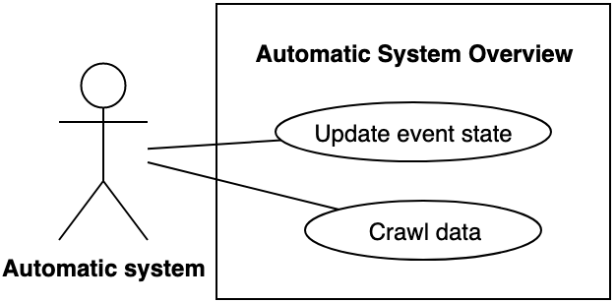

Figure 69 - Automatic System Overview Use Case

##### 2.3.5.1. Update event state

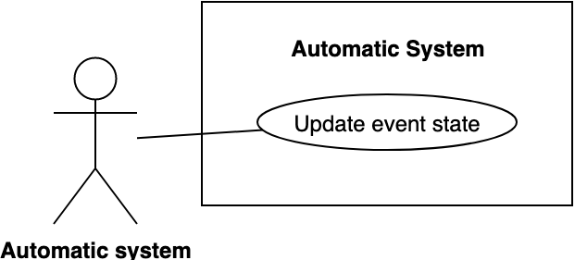

Figure 70 - <Automatic System> Update event state

|  |  |  |  |
| --- | --- | --- | --- |
| **USE CASE – BWA_AUTO_01** | | | |
| **Use Case No.** | BWA_ AUTO _01 | **Use Case Version** | 2.0 |
| **Use Case Name** | Update event state | | |
| **Author** | MinhHy | | |
| **Date** | 09/04/2019 | **Priority** | Normal |
| **Actor:**   * Automatic System   **Summary:**   * Allow automatic system to update state of list events in database when event’s public time comes.   **Goal:**   * Change status of list events.   **Triggers:**   * Scheduler is enable.   **Preconditions:**   * Scheduler runs at 00:00 AM every day. * Having at least one event   **Post conditions:**   * Success: System shows success logs. * Fail: System shows error logs.   **Main Success Scenario:**   |  |  |  | | --- | --- | --- | | **Step** | **Actor Action** | **System Response** | | 1 | Automatic system runs time task to check event state and update database | System responses:   * List events will update if conditions are satisfy. * Logs with information “Update event state”   [Exception 1] |   **Alternative Scenario:** N/A  **Exceptions:**   |  |  |  | | --- | --- | --- | | **No** | **Actor Action** | **System Response** | | 1 |  | System sends error logs. |   **Relationships:** N/A  **Business Rules:**  System checks list events which wait for public time and closing register time comes.  If closing register time comes but an event doesn’t have enough tickets, this events will be hidden. | | | |

Table 63 - <Automatic System> Update event state use case specification

##### 2.3.5.2. Crawl data

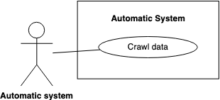

Figure 71 - <Automatic System> Crawl data

|  |  |  |  |
| --- | --- | --- | --- |
| **USE CASE – BWA_AUTO_02** | | | |
| **Use Case No.** | BWA_ AUTO _02 | **Use Case Version** | 2.0 |
| **Use Case Name** | Crawl data | | |
| **Author** | MinhHy | | |
| **Date** | 09/04/2019 | **Priority** | Normal |
| **Actor:**   * Automatic System   **Summary:**   * Allow automatic system to crawl data of bikes, accessories, news.   **Goal:**   * Crawl data and insert to database.   **Triggers:**   * Scheduler is enable.   **Preconditions:**   * Scheduler runs at 00:00 AM every Monday.   **Post conditions:**   * Success: System shows success logs. * Fail: System shows error logs.   **Main Success Scenario:**   |  |  |  | | --- | --- | --- | | **Step** | **Actor Action** | **System Response** | | 1 | Automatic system runs time task to crawl data and insert database | System responses logs with information “Crawl done”  [Exception 1] |   **Alternative Scenario:** N/A  **Exceptions:**   |  |  |  | | --- | --- | --- | | **No** | **Actor Action** | **System Response** | | 1 |  | System sends error logs. |   **Relationships:** N/A  **Business Rules:**  Crawl data have origin and url. | | | |

Table 64 - <Automatic System> Crawl data use case specification

## 3. Software System Attribute

### 3.1. Usability

Website’s UI is fit for each browser on each device

Font style: Arial, Sans-serif

Font size: 12px -26px

Color: green, black, red, white, blue, Light Slate Grey, Fuego, Honeysuckle…

Background: White, Catalina Blue, Whisper…

### 3.2. Reliability

The information storing on the database is permanent.

### 3.3. Availability

The system must be available at any time 24/7.

### 3.4. Security

Only Manager has fully access to the system

Input data is validated before saving to database.

### 3.5. Maintainability

The system is divided into separate modules for easy maintain.

### 3.6. Portability

Web application can be run on Chrome browser version 42 or later.

### 3.7. Performance

System has successfully test with basic standard

## 4. Conceptual Diagram

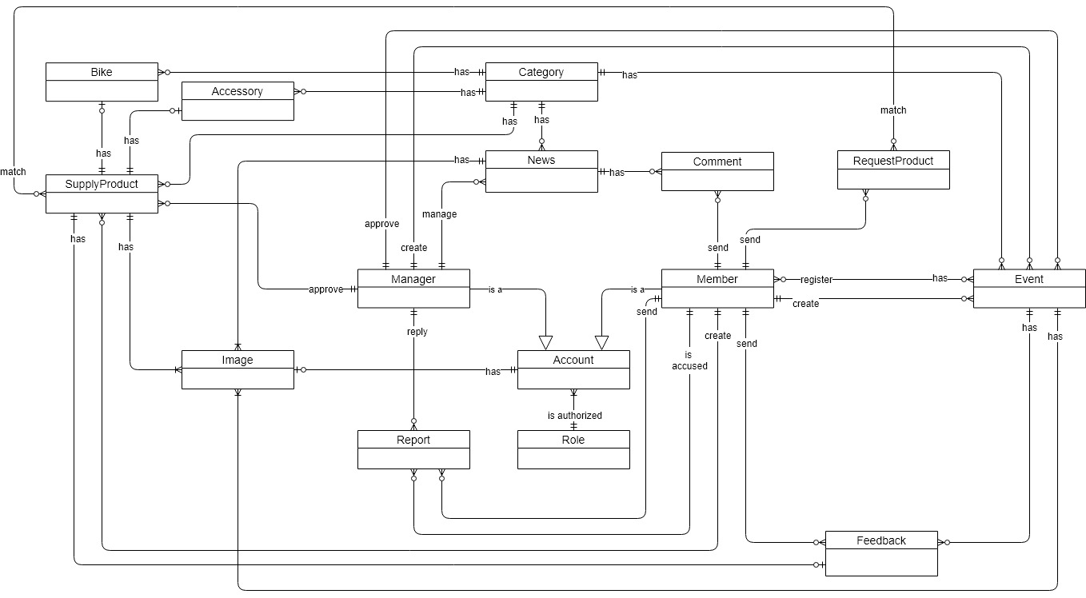

Figure 72 - Conceptual Diagram

|  |  |
| --- | --- |
| **Enitity Name** | **Description** |
| **Comment** | Contain the comment information. |
| **News** | Contain the news information. |
| **RequestProduct** | Contain the request product post information |
| **Role** | Contain the role information. |
| **Event** | Contain the event information. |
| **Report** | Contain the report information. |
| **Account** | Contain the account information. |
| **Feedback** | Contain the feedback information. |
| **Category** | Contain the category information. |
| **Bike** | Contain the bike information. |
| **Image** | Contain the image information. |
| **Accessory** | Contain the accessory information |
| **ReferenceLinks** | Contain the reference links crawl information |
| **SupplyProduct** | Contain the supply product information |

*This page is intentionally left blank*

# D. Software Design Description

## 1. Design Overview

This document describes the technical and user interface design of MSSC System. It includes the architectural design, the detailed design of common functions and business functions and the design of database model.

The architectural design describes the overall architecture of the system and the architecture of each main component and subsystem.

The detailed design describes static and dynamic structure for each component and functions. It includes class diagrams, class explanations and sequence diagrams for each use cases.

The database design describes the relationships between entities and details of each entity.

Document overview:

* Section 2: gives an overall description of the system architecture design.
* Section 3: gives component diagrams that describe the connection and integration of the system.
* Section 4: gives the detail design description which includes class diagram, class explanation, and sequence diagram to details the application functions.
* Section 5: describe screens design.
* Section 6: describe a fully attributed ERD.
* Section 7: describe algorithms

## 2. System Architectural Design

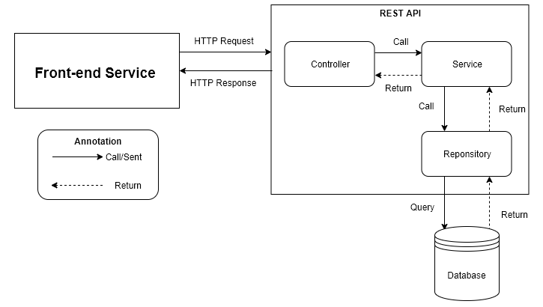

Figure 73 - Software Architecture Design

In Web Application, the system is developed under MVC architecture style. We choose this architecture for Web Application because of following advantages:

Ecosystem: Java has a big ecosystem. It has a lot of libraries and support for nearly every platform (OS, Database, etc.).

It offers wide support for enterprise capabilities like messaging (Using SMS), Web services, Rest.

ReactJS is quite easy to be learnt.

ReactJS is easy to maintain isolated components in React.

Constant re-rendering of components provides efficient arranging at increasing complexity.

Convenient React is highly competitive to MVC. One-way data flow provides maintainability and efficient arrangement of data and DOM elements.

It is the most light-weighted framework among the ones that are widely used today.

## 3. Component Diagram

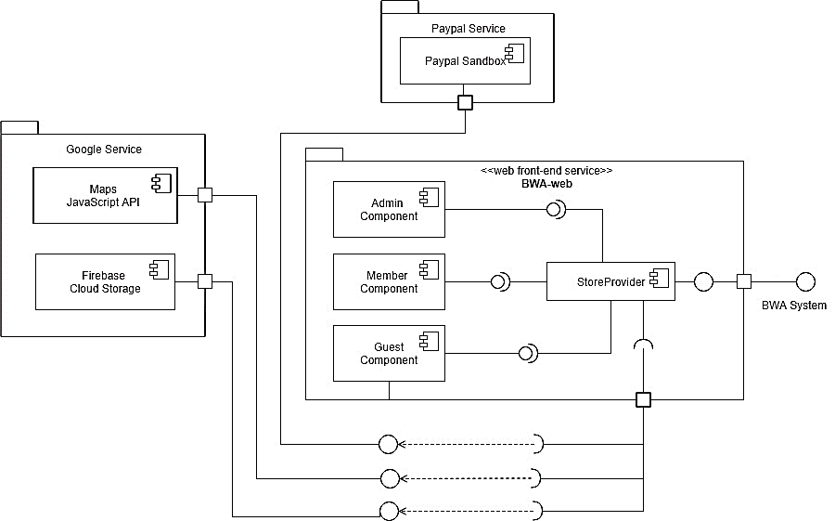

Figure 74 - Front End Component Diagram

|  |  |
| --- | --- |
| **COMPONENT DICTIONARY: DESCRIBES COMPONENTS** | |
| Paypal Sandbox | It is an open service developed by Paypal Service. System uses it to handle checkout tickets of event.  *Reference:* <https://developer.paypal.com/developer/accounts/> |
| Maps JavaScript API | It is an open service developed by Google Service. System uses it to handle google map api.  *Reference:* <https://developers.google.com/maps/documentation/javascript/tutorial> |
| Firebase Cloud Storage | It is an open service developed by Google Service. System uses it to handle images storage.  *Reference:* <https://firebase.google.com/docs/storage/> |
| Admin Component | Handle admin activities in the system |
| Member Component | Handle member activities in the system |
| Guest Component | Handle guest activities in the system |
| Router | Handle request and response, accept input and convert it to commands for back end |

Table 65 – Front End Component Diagram

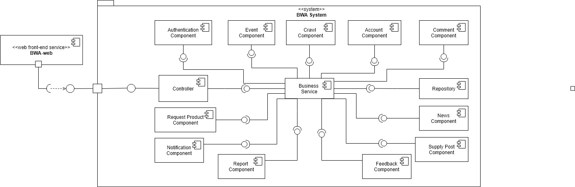

Figure 75 - Back End Component Diagram

|  |  |
| --- | --- |
| **COMPONENT DICTIONARY: DESCRIBES COMPONENTS** | |
| Controller | Handle requests and responses; ­­accept input and convert it to commands for model and view. |
| Business Service | Handle system’s business operations |
| Repository | Store Data |

Table 66 - Back End Component Diagram

## 4. Detailed Description

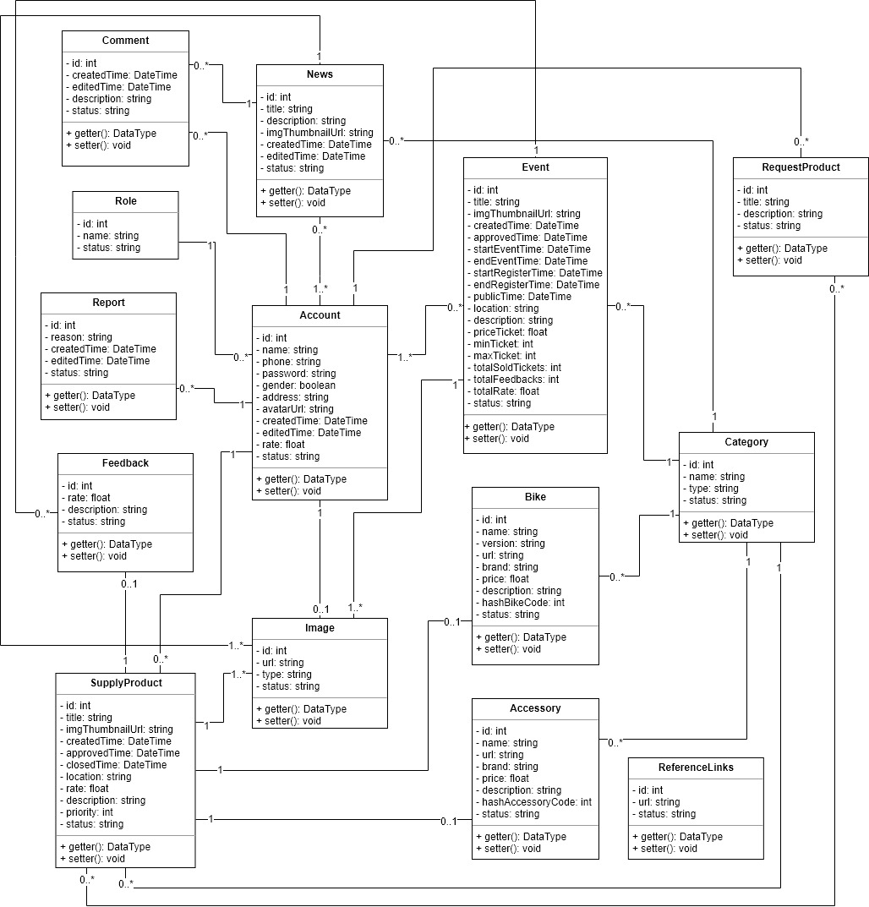

Figure 76 - Class Diagram

### 4.1. Class Diagram

|  |  |  |
| --- | --- | --- |
| **Class dictionary: describe Class** | | |
| **Class Name** | **Mapping column with Conceptual diagram** | **Description** |
| Comment | Comment | Contain the comment information. |
| News | News | Contain the news information. |
| RequestProduct | RequestProduct | Contain the request product post information |
| Role | Role | Contain the role information. |
| Event | Event | Contain the event information. |
| Report | Report | Contain the report information. |
| Account | Account | Contain the account information. |
| Feedback | Feedback | Contain the feedback information. |
| Category | Category | Contain the category information. |
| Bike | Bike | Contain the bike information. |
| Image | Image | Contain the image information. |
| Accessory | Accessory | Contain the accessory information |
| ReferenceLinks | ReferenceLinks | Contain the reference links crawl information |
| SupplyProduct | SupplyProduct | Contain the supply product information |

Table 67 - Class Diagram Dictionary

### 4.2. Class Diagram Explanation

#### 4.2.1. Comment

|  |  |  |  |
| --- | --- | --- | --- |
| **Attribute** | **Type** | **Visibility** | **Description** |
| id | int | Private | Unique identifier of a comment |
| createdTime | DateTime | Private | The time comment was created |
| editedTime | DateTime | Private | The time comment was edited |
| description | string | Private | The description of comment |
| status | string | Private | The status of comment |

Table 68 - Comment Attribute

|  |  |  |  |
| --- | --- | --- | --- |
| **Method** | **Return Type** | **Visibility** | **Description** |
| Getter | Attribute type | Public | Get attribute value. |
| Setter | Void | Public | Set value of attribute. |

Table 69 - Comment Method

#### 4.2.2. Role

|  |  |  |  |
| --- | --- | --- | --- |
| **Attribute** | **Type** | **Visibility** | **Description** |
| id | int | Private | Unique identifier of a role |
| name | string | Private | The name of the role |
| status | string | Private | The status of the role |

Table 70 - Role Attribute

#### 4.2.3. Report

|  |  |  |  |
| --- | --- | --- | --- |
| **Attribute** | **Type** | **Visibility** | **Description** |
| id | int | Private | Unique identifier of a report |
| reason | string | Private | The reason of the report |
| createdTime | DateTime | Private | The time when the report was created |
| editedTime | DateTime | Private | The time when the report was edited |
| status | string | Private | The status of the report |

Table 71 - Report Attribute

|  |  |  |  |
| --- | --- | --- | --- |
| **Method** | **Return Type** | **Visibility** | **Description** |
| Getter | Attribute type | Public | Get attribute value. |
| Setter | Void | Public | Set value of attribute. |

Table 72 - Report Method

#### 4.2.4. Feedback

|  |  |  |  |
| --- | --- | --- | --- |
| **Attribute** | **Type** | **Visibility** | **Description** |
| id | int | Private | Unique identifier of a feedback |
| rate | float | Private | The rate of the feedback |
| description | string | Private | The description of the feedback |
| status | string | Private | The status of the feedback |

Table 73 - Feedback Attribute

|  |  |  |  |
| --- | --- | --- | --- |
| **Method** | **Return Type** | **Visibility** | **Description** |
| Getter | Attribute type | Public | Get attribute value. |
| Setter | Void | Public | Set value of attribute. |

Table 74 - Feedback Method

#### 4.2.5. Supply Product

|  |  |  |  |
| --- | --- | --- | --- |
| **Attribute** | **Type** | **Visibility** | **Description** |
| id | int | Private | Unique identifier of a supply product |
| title | string | Private | The title of the supply product |
| imgThumbnailUrl | string | Private | The image thumbnail url of the supply product |
| createdTime | DateTime | Private | The time when the supply product was created |
| approvedTime | DateTime | Private | The time when the supply product was approved |
| closedTime | DateTime | Private | The time when the supply product was closed |
| location | string | Private | The location of the supply product |
| rate | float | Private | The rate of the supply product |
| description | string | Private | The description of the supply product |
| priority | int | Private | The priority of the supply product |
| status | string | Private | The status of the supply product |

Table 75 - SupplyProduct Attribute

|  |  |  |  |
| --- | --- | --- | --- |
| **Method** | **Return Type** | **Visibility** | **Description** |
| Getter | Attribute type | Public | Get attribute value. |
| Setter | Void | Public | Set value of attribute. |

Table 76 - SupplyProduct Method

#### 4.2.6. News

|  |  |  |  |
| --- | --- | --- | --- |
| **Attribute** | **Type** | **Visibility** | **Description** |
| id | int | Private | Unique identifier of a news |
| title | string | Private | The title of the news |
| Description | string | Private | The description of the news |
| imgThumbnailUrl | string | Private | The image thumbnail url of the news |
| createdTime | DateTime | Private | The time when the news was created |
| editedTime | DateTime | Private | The time when the news was edited |
| status | string | Private | The status of the news |

Table 77 - News Attribute

|  |  |  |  |
| --- | --- | --- | --- |
| **Method** | **Return Type** | **Visibility** | **Description** |
| Getter | Attribute type | Public | Get attribute value. |
| Setter | Void | Public | Set value of attribute. |

Table 78 - News Method

#### 4.2.7. Account

|  |  |  |  |
| --- | --- | --- | --- |
| **Attribute** | **Type** | **Visibility** | **Description** |
| id | int | Private | Unique identifier of an account |
| name | string | Private | The name of the account |
| phone | string | Private | The phone of the account |
| password | string | Private | The password of the account |
| gender | boolean | Private | The gender of the account |
| address | string | Private | The address of the account |
| avatarUrl | string | Private | The avatar url of the account |
| createdTime | DateTime | Private | The time when the account was created |
| editedTime | Datetime | Private | The time when the account was edited |
| rate | float | Private | The rate of the account |
| status | string | Private | the status of the account |

Table 79 - Account Attribute

|  |  |  |  |
| --- | --- | --- | --- |
| **Method** | **Return Type** | **Visibility** | **Description** |
| Getter | Attribute type | Public | Get attribute value. |
| Setter | Void | Public | Set value of attribute. |

Table 80 - Account Method

#### 4.2.8. Image

|  |  |  |  |
| --- | --- | --- | --- |
| **Attribute** | **Type** | **Visibility** | **Description** |
| id | int | Private | Unique identifier of an image |
| url | string | Private | The url of the raw data |
| type | string | Private | The type of the own entity relation |
| status | string | Private | The status of the image |

Table 81 - Image Attribute

|  |  |  |  |
| --- | --- | --- | --- |
| **Method** | **Return Type** | **Visibility** | **Description** |
| Getter | Attribute type | Public | Get attribute value. |
| Setter | Void | Public | Set value of attribute. |

Table 82 - Image Method

#### 4.2.9. Event

|  |  |  |  |
| --- | --- | --- | --- |
| **Attribute** | **Type** | **Visibility** | **Description** |
| id | int | Private | Unique identifier of an event |
| title | string | Private | The title of the event |
| imgThumbnailUrl | string | Private | The image thumbnail url of the event |
| createdTime | DateTime | Private | The time when the event was created |
| approvedTime | DateTime | Private | The time when the event was approved by admin |
| startEventTime | DateTime | Private | The time when the event was started |
| endEventTime | DateTime | Private | The time when the event was ended |
| startRegisterTime | DateTime | Private | The time start to register of the event |
| endRegisterTime | DateTime | Private | The time stop to register of the event |
| publicTime | DateTime | Private | The time when the event was public event in system |
| location | string | Private | The location of the event |
| description | string | Private | The description of the event |
| priceTicket | float | Private | The ticket price of the event |
| minTicket | int | Private | The minimum amount of tickets of the event |
| maxTicket | int | Private | The maximum amount of the tickets of the event |
| totalSoldTickets | int | Private | The total of tickets was sold of the event |
| totalFeedbacks | int | Private | The total of feedbacks was received of the event |
| totalRate | float | Private | The total rates of the event |
| **status** | string | Private | The status of the event |

Table 83 - Event Attribute

|  |  |  |  |
| --- | --- | --- | --- |
| **Method** | **Return Type** | **Visibility** | **Description** |
| Getter | Attribute type | Public | Get attribute value. |
| Setter | Void | Public | Set value of attribute. |

Table 84 - Event Method

#### 4.2.10. Bike

|  |  |  |  |
| --- | --- | --- | --- |
| **Attribute** | **Type** | **Visibility** | **Description** |
| id | int | Private | Unique identifier of a bike |
| name | string | Private | The name of the bike |
| version | string | Private | The version of the bike |
| url | string | Private | The url of the raw bike data |
| brand | string | Private | The brand of the bike |
| price | float | Private | The price of the bike |
| description | string | Private | The description of the bike |
| hashBikeCode | int | Private | The hash bike code of the bike |
| status | string | Private | The status of the bike |

Table 85 - Bike Attribute

|  |  |  |  |
| --- | --- | --- | --- |
| **Method** | **Return Type** | **Visibility** | **Description** |
| Getter | Attribute type | Public | Get attribute value. |
| Setter | Void | Public | Set value of attribute. |

Table 86 - Bike Method

#### 4.2.11. Accessory

|  |  |  |  |
| --- | --- | --- | --- |
| **Attribute** | **Type** | **Visibility** | **Description** |
| id | int | Private | Unique identifier of a accessory |
| name | string | Private | The name of the accessory |
| url | string | Private | The url of the raw accessory data |
| brand | string | Private | The brand of the accessory |
| price | float | Private | The price of the accessory |
| description | string | Private | The description of the accessory |
| hashAccessoryCode | int | Private | The hash accessory code of accessory |
| status | string | Private | The status of the accessory |

Table 87 - Accessory Attribute

|  |  |  |  |
| --- | --- | --- | --- |
| **Method** | **Return Type** | **Visibility** | **Description** |
| Getter | Attribute type | Public | Get attribute value. |
| Setter | Void | Public | Set value of attribute. |

Table 88 - Accessory Method

#### 4.2.12. RequestProduct

|  |  |  |  |
| --- | --- | --- | --- |
| **Attribute** | **Type** | **Visibility** | **Description** |
| id | int | Private | Unique identifier of a request product |
| title | string | Private | The title of the request product |
| description | string | Private | The description of the request product |
| status | string | Private | The status of the request product |

Table 89 - RequestProduct Attribute

|  |  |  |  |
| --- | --- | --- | --- |
| **Method** | **Return Type** | **Visibility** | **Description** |
| Getter | Attribute type | Public | Get attribute value. |
| Setter | Void | Public | Set value of attribute. |

Table 90 - RequestProduct Method

#### 4.2.13. Category

|  |  |  |  |
| --- | --- | --- | --- |
| **Attribute** | **Type** | **Visibility** | **Description** |
| id | int | Private | Unique identifier of a category |
| name | string | Private | The name of the category |
| type | string | Private | The type of the category |
| status | string | Private | The status of the category |

Table 91 - Category Attribute

|  |  |  |  |
| --- | --- | --- | --- |
| **Method** | **Return Type** | **Visibility** | **Description** |
| Getter | Attribute type | Public | Get attribute value. |
| Setter | Void | Public | Set value of attribute. |

Table 92 - Category Method

#### 4.2.14. ReferenceLinks

|  |  |  |  |
| --- | --- | --- | --- |
| **Attribute** | **Type** | **Visibility** | **Description** |
| id | int | Private | Unique identifier of a reference link |
| url | string | Private | The url of the reference links |
| status | string | Private | The status of the reference link |

Table 93 - ReferenceLinkes Attribute

|  |  |  |  |
| --- | --- | --- | --- |
| **Method** | **Return Type** | **Visibility** | **Description** |
| Getter | Attribute type | Public | Get attribute value. |
| Setter | Void | Public | Set value of attribute. |

Table 94 - ReferenceLinks Method

### 4.3. Interaction Diagram

#### 4.3.1. Login

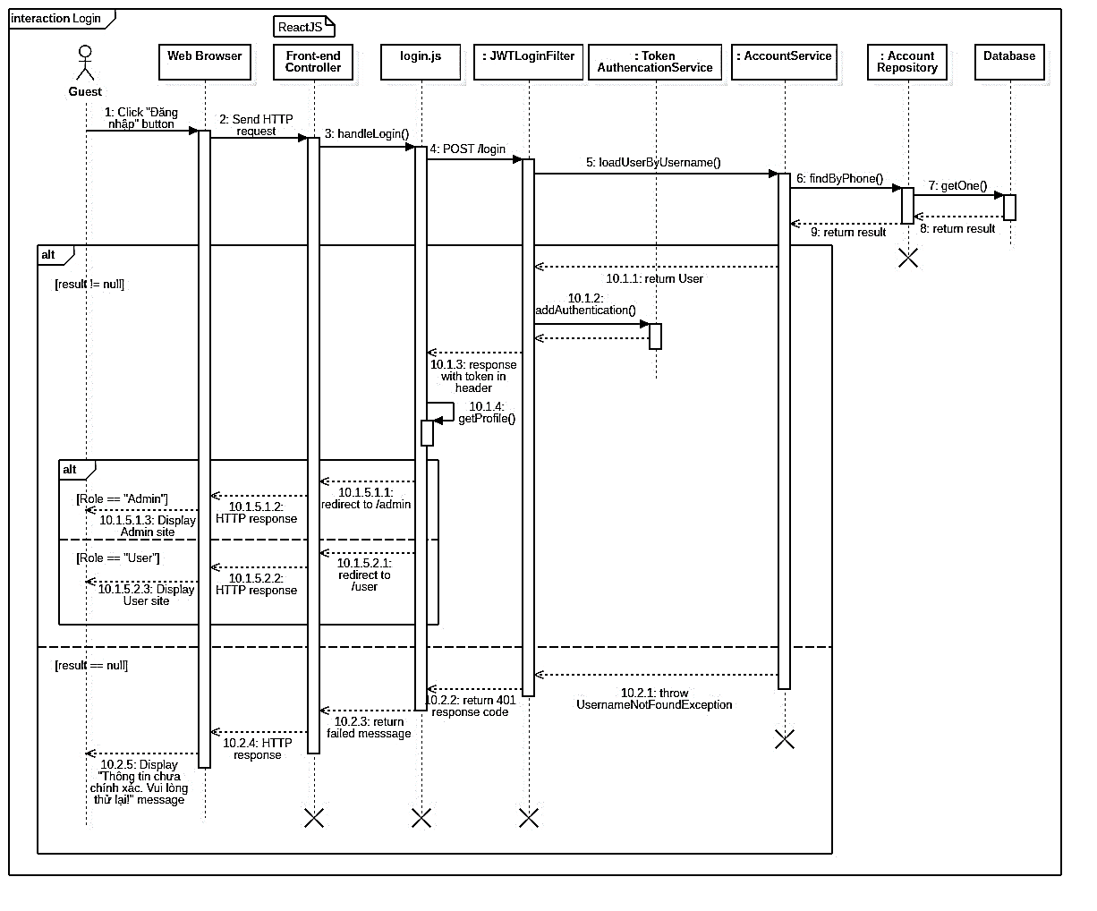

Figure 77 - <Sequence Diagram> Login

#### 4.3.2. Register

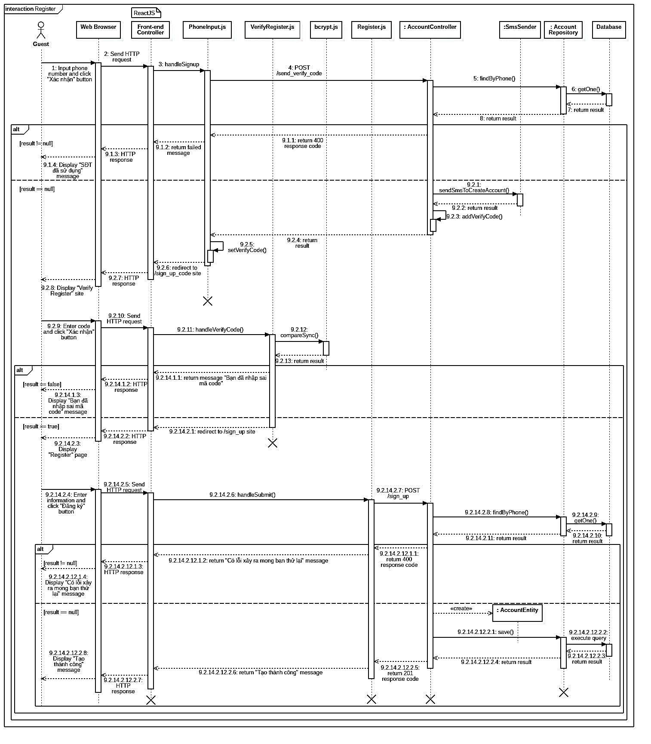

Figure 78 - <Sequence Diagram> Register

#### 4.3.3. Search Distance Of Event

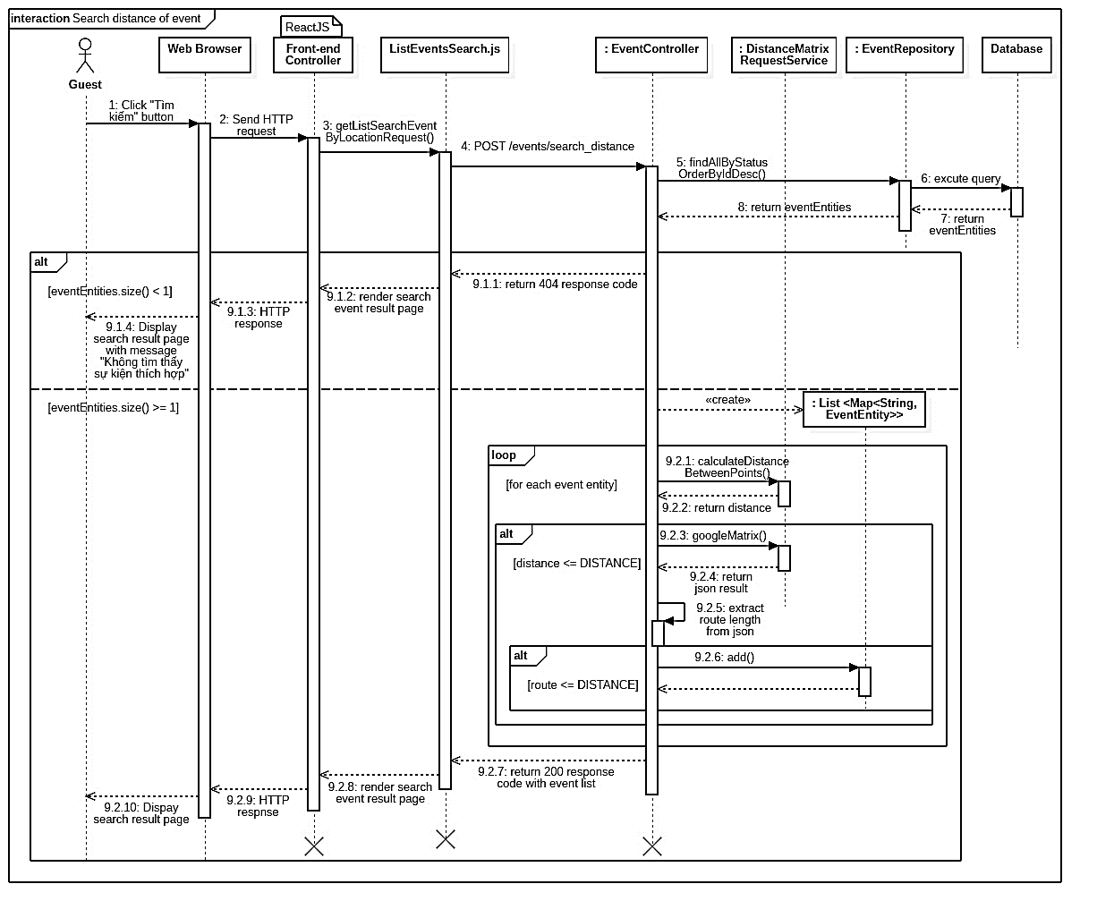

Figure 79 - <Sequence Diagram> Search Distance of Event

#### 4.3.4. Create Event

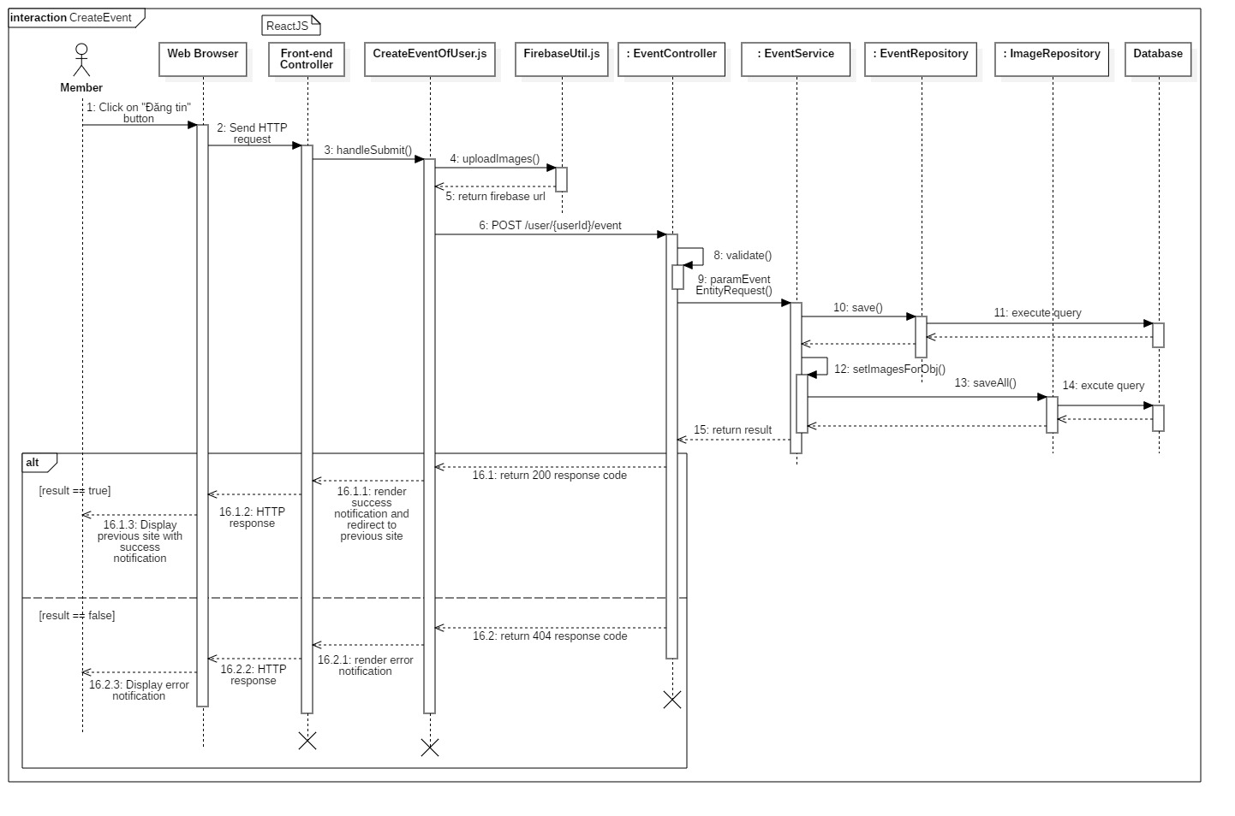

Figure 80 - <Sequence Diagram> Create event

#### 4.3.5. Create Event Feedback

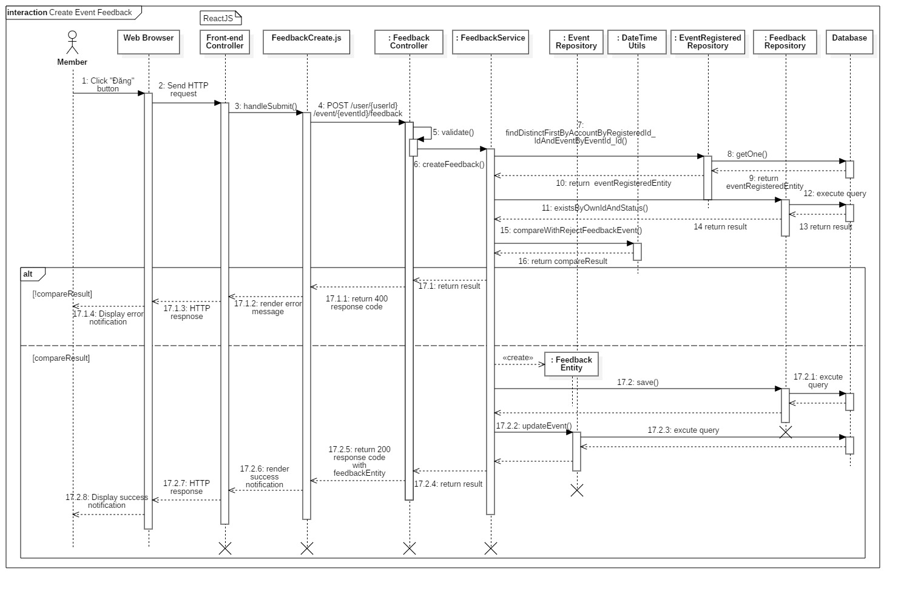

Figure 81 - <Sequence Diagram> Create Event Feedback

#### 4.3.6. Create Supply Product bike

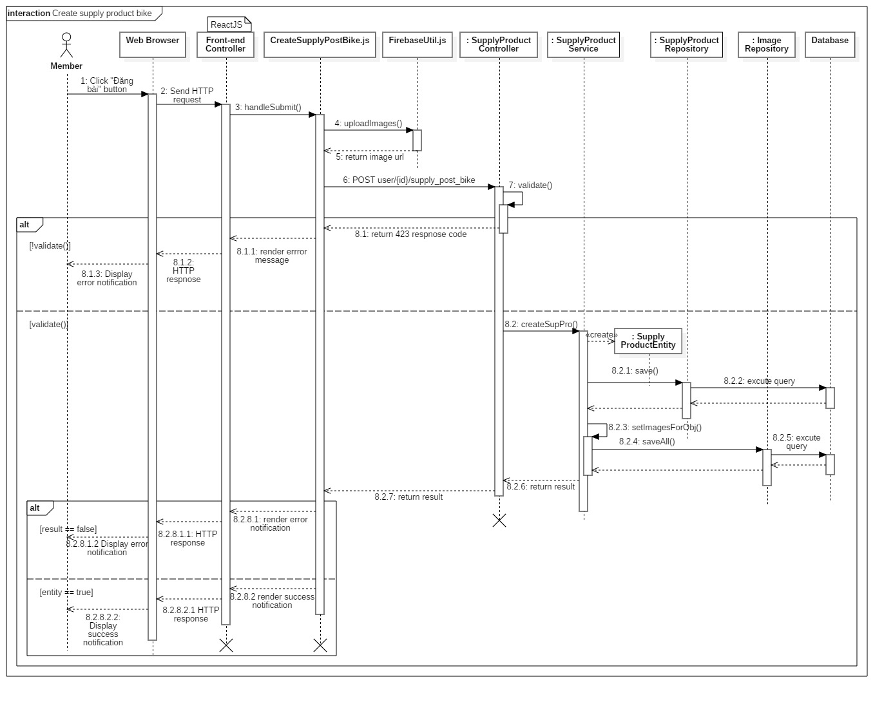

Figure 82 - <Sequence Diagram> Create Supply Product Bike

#### 4.3.7. Update Supply Product

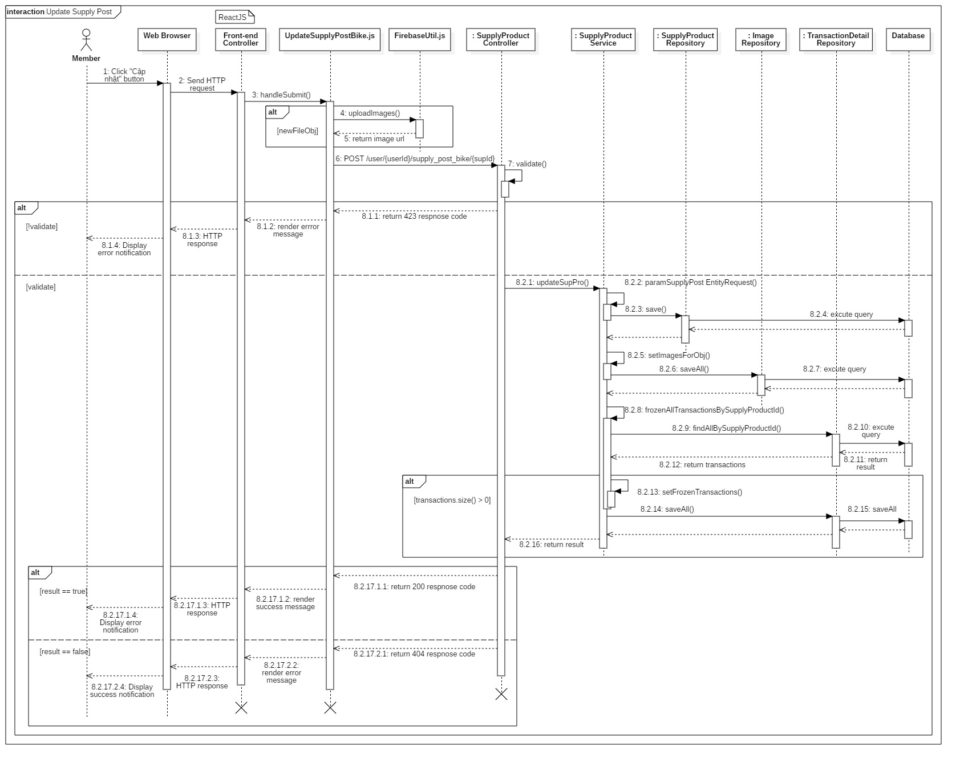

Figure 83 - <Sequence Diagram> Update Supply Product

#### 4.3.8. Create News

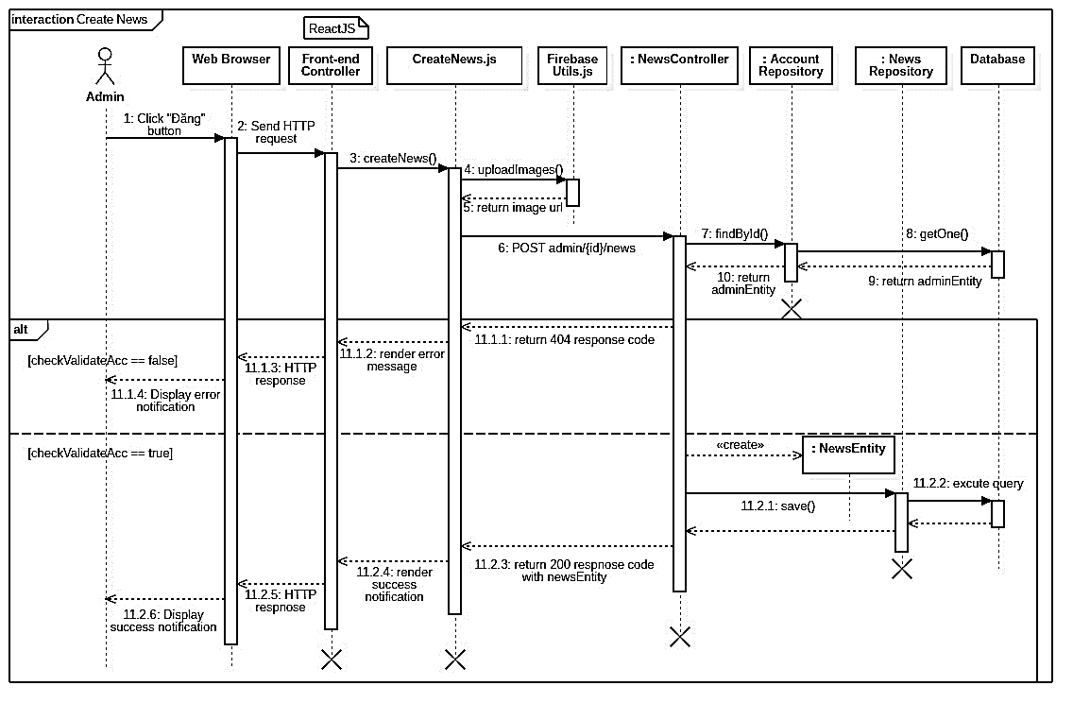

Figure 84 - <Sequence Diagram> Create News

#### 4.3.9. Buy Event’s Ticket

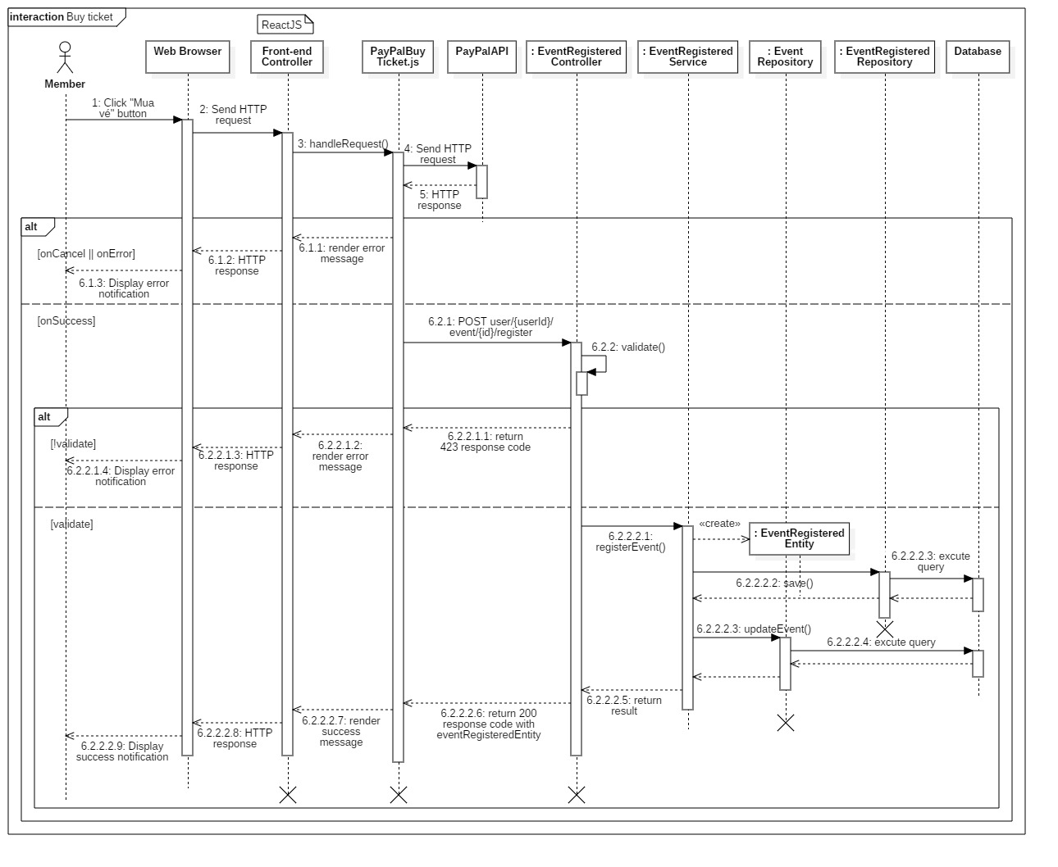

Figure 85 - <Sequence Diagram> Buy Event’s Ticket

#### 4.3.11. Follow Supply Product

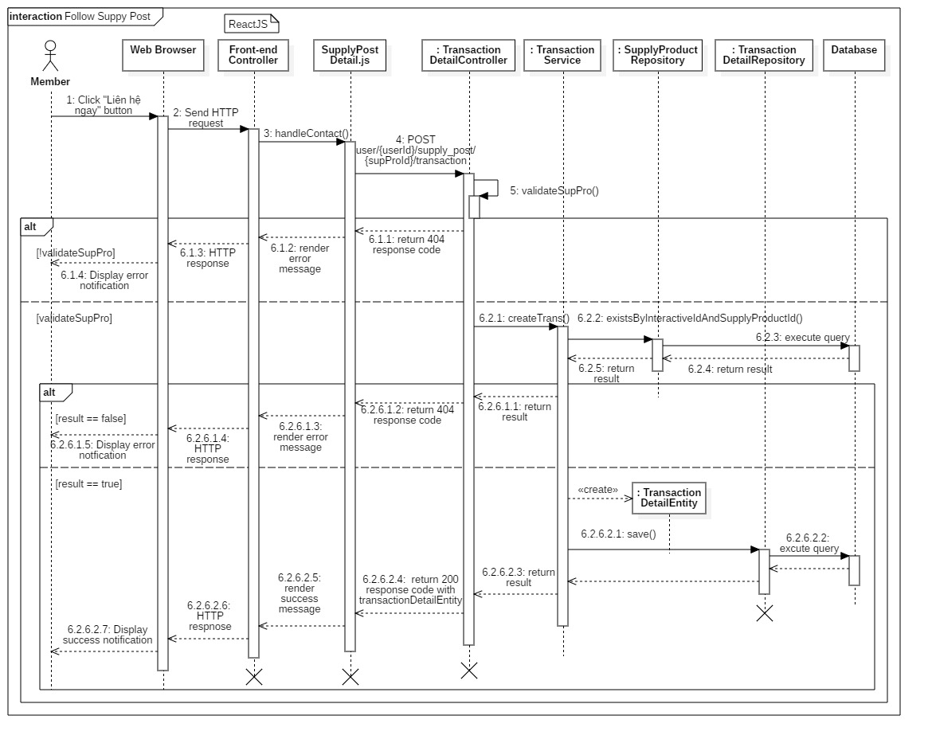

Figure 86 - <Sequence Diagram> Follow Supply Product

#### 4.3.12. Create Request Bike

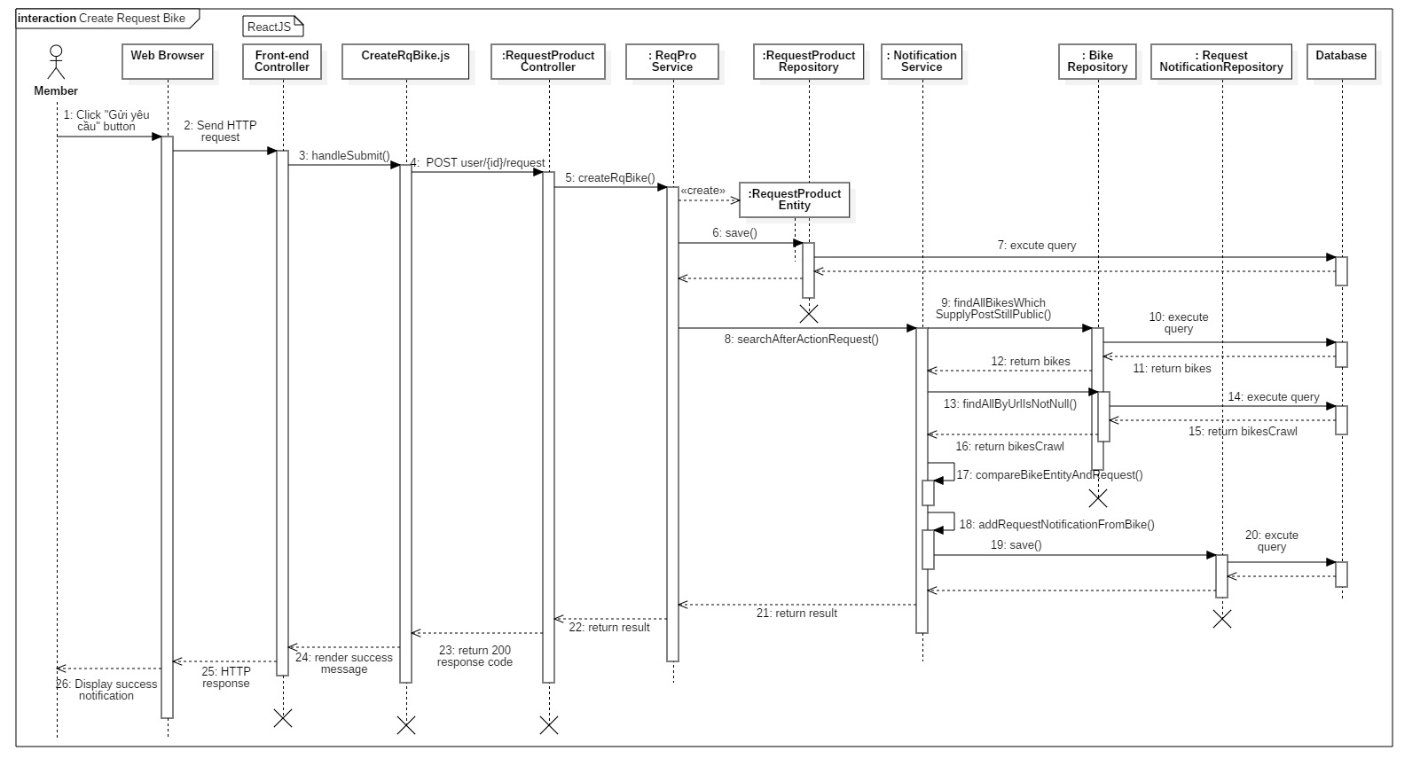

Figure 87 - <Sequence Diagram> Create Wishlist Products (Request Product)

#### 4.3.13. Send notification

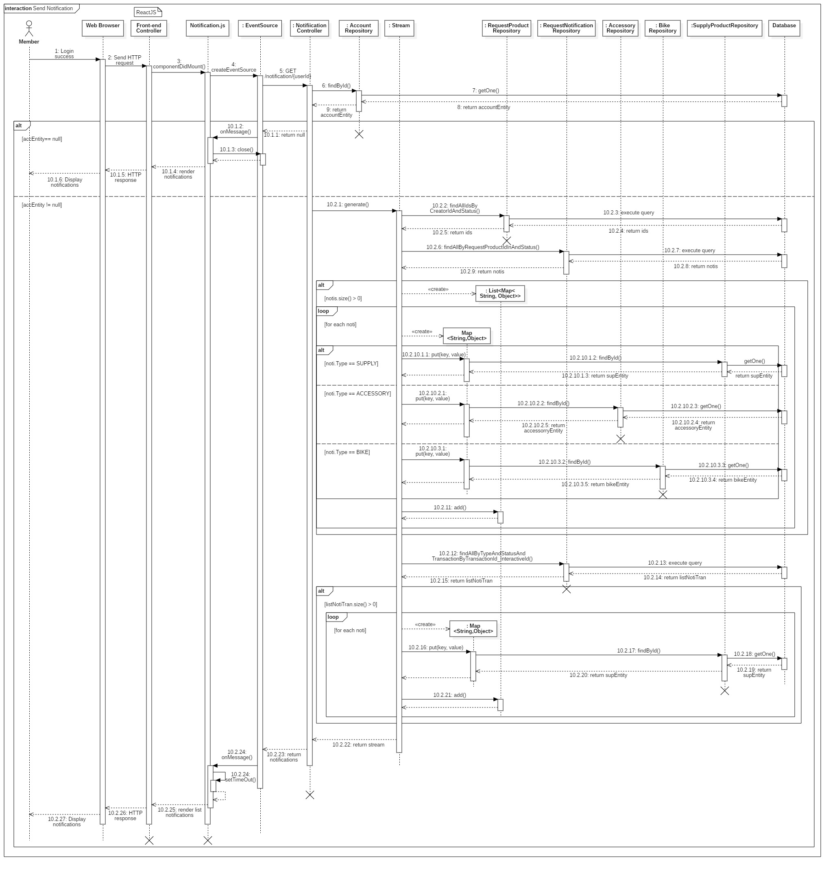

Figure 88 - <Sequence Diagram> Send notification

#### 4.3.14. Update Event Status

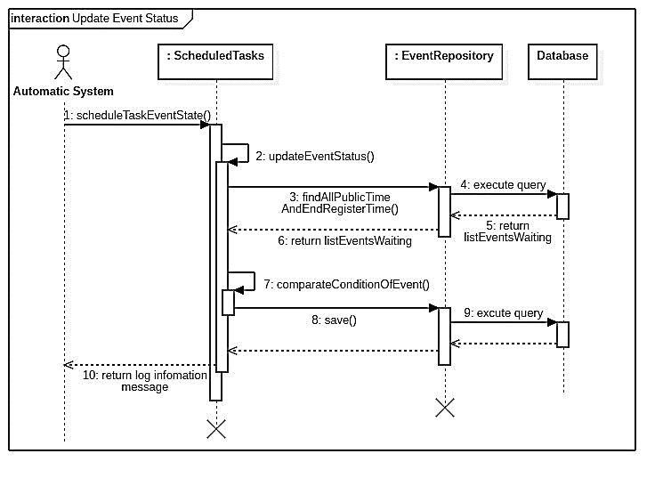

Figure 89 - <Sequence Diagram> Scheduler Update Event State

## 5. Interface

### 5.1. Guest

#### Menu bar



Figure 91 - <Guest> Menu bar interface

Buttons/Hyperlinks

|  |  |  |  |  |
| --- | --- | --- | --- | --- |
| **No** | **Function** | **Description** | **Validation** | **Outcome** |
| 1 | Đăng ký | Register to the system | N/A | Transfer to register page |
| 2 | Đăng nhập | Login into the system | N/A | Transfer to login page |
| 3 | Tin Tức | View list news | N/A | Transfer to view list news page |

Table 95 - <Buttons/Hyperlinks> Menu bar

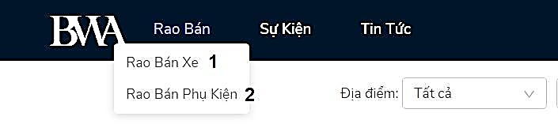

Figure 92 - <Guest> Supply menu bar interface

Buttons/Hyperlinks

|  |  |  |  |  |
| --- | --- | --- | --- | --- |
| **No** | **Function** | **Description** | **Validation** | **Outcome** |
| 1 | Rao bán xe | View list bike posts | N/A | Transfer to view list bike posts page |
| 2 | Rao bán phụ kiện | View list accessory posts | N/A | Transfer to view list accessory posts page |

Table 96 - <Buttons/Hyperlinks> Menu bar

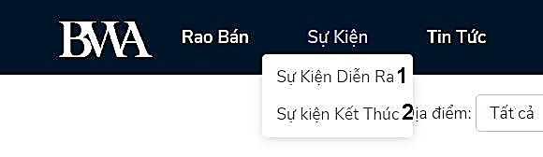

Figure 93 - <Guest> Event menu bar interface

Buttons/Hyperlinks

|  |  |  |  |  |
| --- | --- | --- | --- | --- |
| **No** | **Function** | **Description** | **Validation** | **Outcome** |
| 1 | Sự kiện diễn ra | View list events is ongoing | N/A | Transfer to view list events is ongoing page |
| 2 | Sự kiện kết thúc | View list events have ended | N/A | Transfer to view list events have ended page |

Table 97 - <Buttons/Hyperlinks> Menu bar

#### View list events

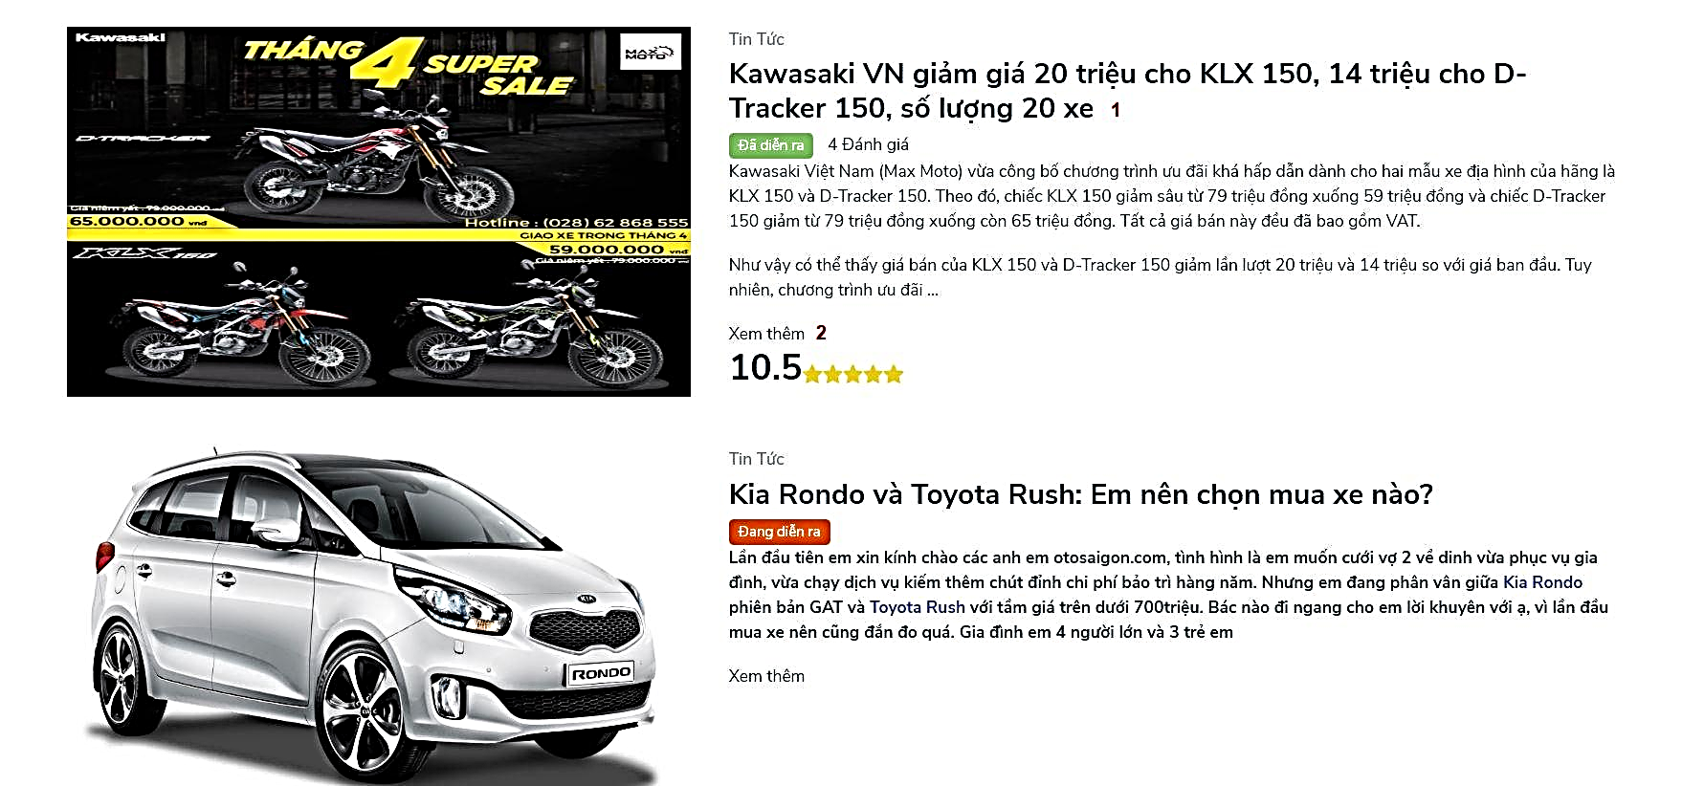

Figure 94 - <Guest> View list events interface

Buttons/Hyperlinks

|  |  |  |  |  |
| --- | --- | --- | --- | --- |
| **No** | **Function** | **Description** | **Validation** | **Outcome** |
| 1 | Title of event | View event detail | N/A | Transfer to view event detail page |
| 2 | “Xem thêm” links | View event detail | N/A | Transfer to view event detail page |

Table 98 - <Buttons/Hyperlinks> View list event

#### View list bike posts

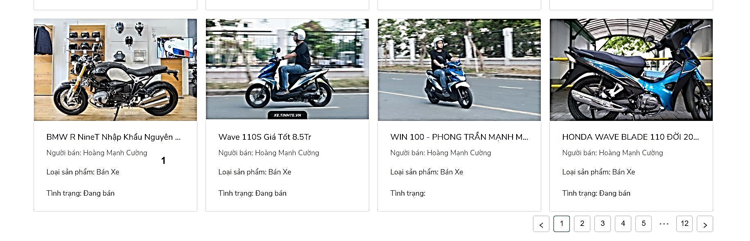

Figure 95 - <Guest> View list bike posts interface

Buttons/Hyperlinks

|  |  |  |  |  |
| --- | --- | --- | --- | --- |
| **No** | **Function** | **Description** | **Validation** | **Outcome** |
| 1 | Title of supply product | View supply product detail | N/A | Transfer to view supply product detail page |

Table 99 - <Buttons/Hyperlinks> View list bike posts

#### View list accessory posts



Figure 96 - <Guest> View list accessory posts interface

Buttons/Hyperlinks

|  |  |  |  |  |
| --- | --- | --- | --- | --- |
| **No** | **Function** | **Description** | **Validation** | **Outcome** |
| 1 | Title of supply product | View supply product detail | N/A | Transfer to view supply product detail page |

Table 100 - <Buttons/Hyperlinks> View list accessory posts

#### Search



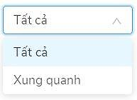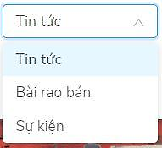

Figure 97 - <Guest> Search interface

Button/Hyperlinks

|  |  |  |  |  |
| --- | --- | --- | --- | --- |
| **No** | **Function** | **Description** | **Validation** | **Outcome** |
| 1 | Location option | Choose type of location to search | N/A |  |
| 2 | Category option | Choose category of post to search | N/A |  |
| 4 | Tìm kiếm | Search | Required | Transfer to result page |

Table 101 - <Buttons/Hyperlinks> Search

Fields

|  |  |  |  |  |  |  |
| --- | --- | --- | --- | --- | --- | --- |
| **No** | **Field Name** | **Description** | **Read only** | **Mandatory** | **Control Type** | **Data Type** |
| 3 | Search box | Search title of event, supply post, news | No | Yes | TextBox | String |

Table 102 - <Fields> Search 

Figure 98 - <Guest> Search by location interface

Button/Hyperlinks

|  |  |  |  |  |
| --- | --- | --- | --- | --- |
| **No** | **Function** | **Description** | **Validation** | **Outcome** |
| 2 | Địa điểm hiện tại | Choose current location | N/A |  |
| 3 | Tìm kiếm | Search | N/A |  |

Table 103 - <Buttons/Hyperlinks> Search

Fields

|  |  |  |  |  |  |  |
| --- | --- | --- | --- | --- | --- | --- |
| **No** | **Field Name** | **Description** | **Read only** | **Mandatory** | **Control Type** | **Data Type** |
| 1 | Địa chỉ | Search location of event, supply post, news | No | Yes | TextBox | String |

Table 104 - <Fields> Search

#### View list news

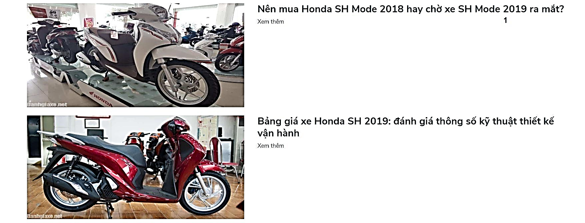

Figure 99 - <Guest> View list news interface

Buttons/Hyperlinks

|  |  |  |  |  |
| --- | --- | --- | --- | --- |
| **No** | **Function** | **Description** | **Validation** | **Outcome** |
| 1 | Title of news | View news detail | N/A | Transfer to view news detail page |

Table 105 - <Buttons/Hyperlinks> View list news

#### Login

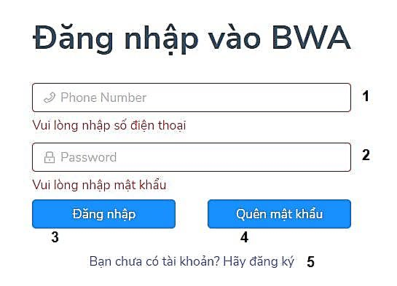

Figure 100 - <Guest> Login interface

Fields

|  |  |  |  |  |  |  |
| --- | --- | --- | --- | --- | --- | --- |
| **No** | **Field Name** | **Description** | **Read only** | **Mandatory** | **Control Type** | **Data Type** |
| 1 | Số điện thoại di động | Phone number to login | No | Yes | TextBox | String |
| 2 | Mật khẩu | Password to login | No | Yes | TextBox | String |

Table 106 - <Fields> Log in

Buttons/Hyperlinks

|  |  |  |  |  |
| --- | --- | --- | --- | --- |
| **No** | **Function** | **Description** | **Validation** | **Outcome** |
| 3 | Đăng nhập | Login into the system | Require |  |
| 4 | Quên mật khẩu | Recovery user password | N/A |  |
| 5 | Đăng ký | Register to the system | N/A |  |

Table 107 - <Buttons/Hyperlinks> Log in

#### Register

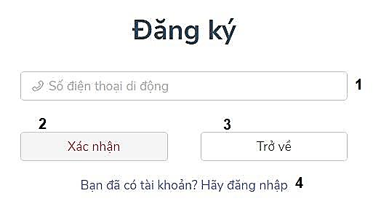

Figure 101 - <Guest> Register interface

Fields

|  |  |  |  |  |  |  |
| --- | --- | --- | --- | --- | --- | --- |
| **No** | **Field Name** | **Description** | **Read only** | **Mandatory** | **Control Type** | **Data Type** |
| 1 | Số điện thoại di động | Phone Number to register | No | Yes | TextBox | String |

Table 108 - <Fields> Register

Buttons/Hyperlinks

|  |  |  |  |  |
| --- | --- | --- | --- | --- |
| **No** | **Function** | **Description** | **Validation** | **Outcome** |
| 2 | Xác nhận | Register to the systems | Required |  |
| 3 | Trở về | Back to home page | No |  |
| 4 | Đăng nhập | Login into the system | No | Transfer to Log in |

Table 109 - <Buttons/Hyperlinks> Register

#### Phone number confirm

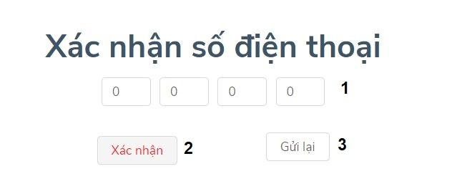

Figure 102 - <Guest> Phone number confirm interface

Fields

|  |  |  |  |  |  |  |
| --- | --- | --- | --- | --- | --- | --- |
| **No** | **Field Name** | **Description** | **Read only** | **Mandatory** | **Control Type** | **Data Type** |
| 1 | Mã xác nhận | Verify code to confirm phone number | No | Yes | TextBox | String |

Table 110 - <Fields> Phone number confirm

Buttons/Hyperlinks

|  |  |  |  |  |
| --- | --- | --- | --- | --- |
| **No** | **Function** | **Description** | **Validation** | **Outcome** |
| 2 | Xác nhận | Confirm phone number | Required |  |
| 3 | Gửi lại | Re-send verify code | No |  |

Table 111 - <Buttons/Hyperlinks> Phone number confirm

#### Register information

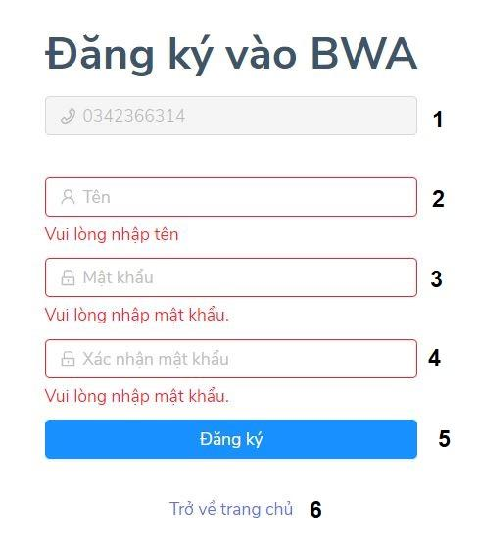

Figure 103 - <Guest> Register information interface

Fields

|  |  |  |  |  |  |  |
| --- | --- | --- | --- | --- | --- | --- |
| **No** | **Field Name** | **Description** | **Read only** | **Mandatory** | **Control Type** | **Data Type** |
| 1 | Số điện thoại | Phone number of user | Yes | Yes | TextBox | String |
| 2 | Tên | Name of user | No | Yes | TextBox | String |
| 3 | Mật khẩu | Password of user | No | Yes | TextBox | String |
| 4 | Xác nhận mật khẩu | Confirm password | No | Yes | TextBox | String |

Table 112 - <Fields> Register information

Buttons/Hyperlinks

|  |  |  |  |  |
| --- | --- | --- | --- | --- |
| **No** | **Function** | **Description** | **Validation** | **Outcome** |
| 5 | Đăng kí | Register to the system | Required | Transfer to member page |
| 6 | Trở về trang chủ | Back to home page | No | Transfer to home page |

Table 113 - <Buttons/Hyperlinks> Register information

### 5.2. Member

#### View event detail

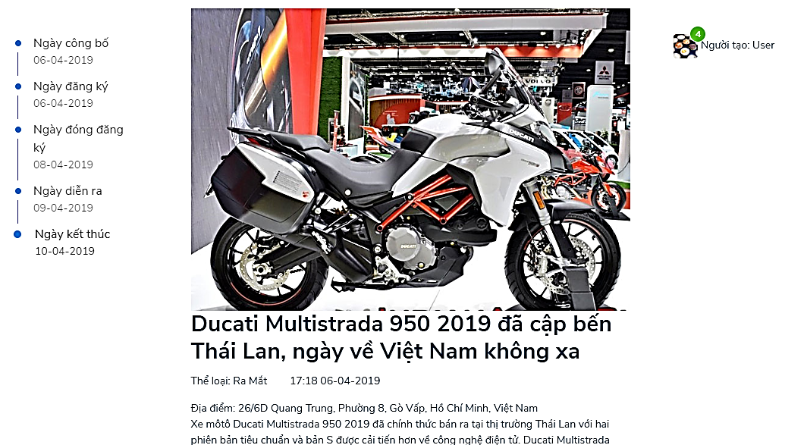

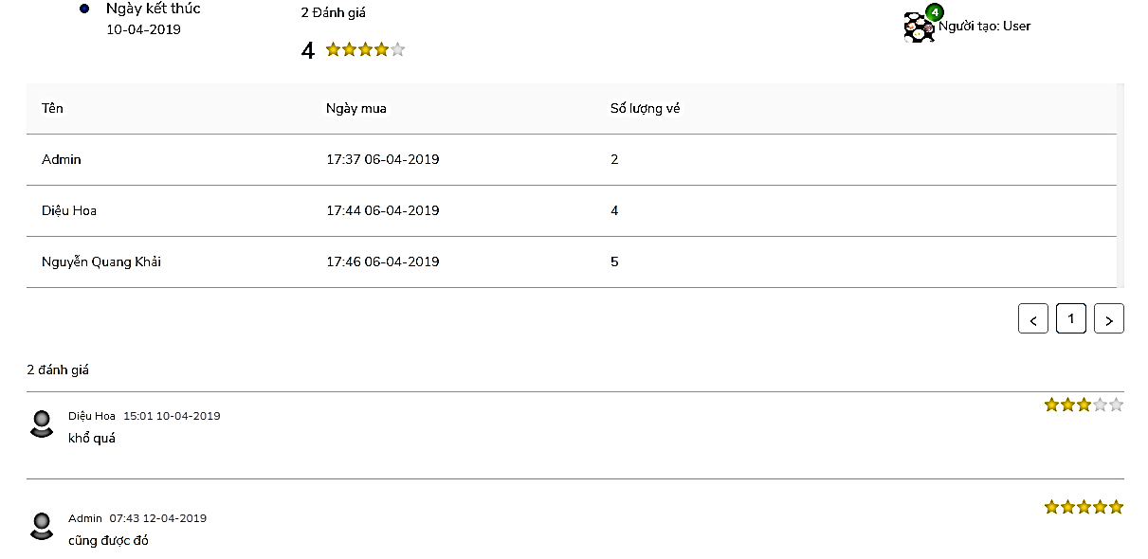

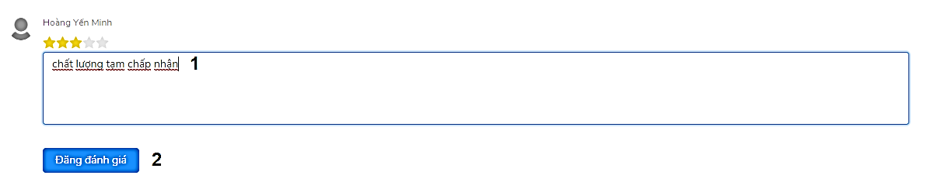

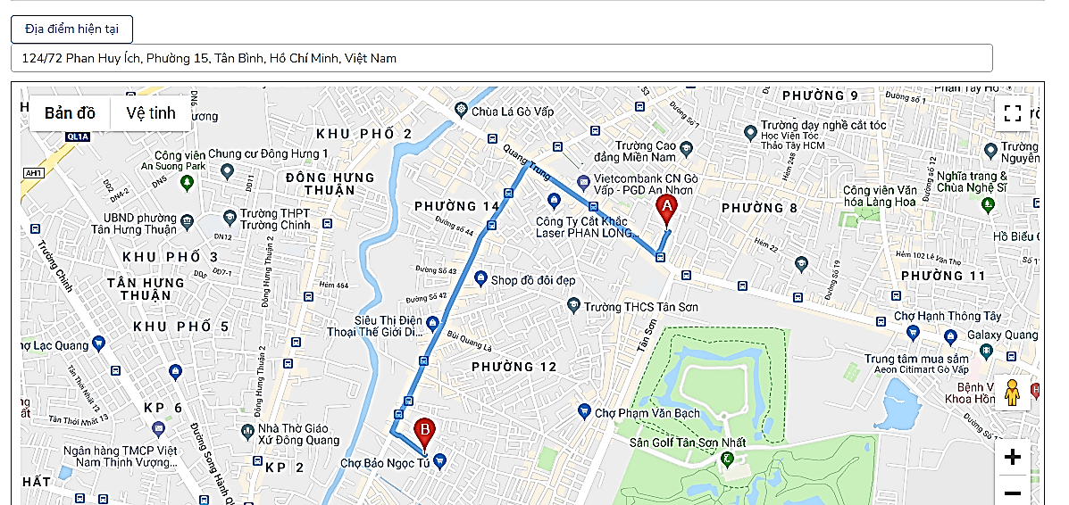

Figure 104 - <Member> View event detail interface

Fields

|  |  |  |  |  |  |  |
| --- | --- | --- | --- | --- | --- | --- |
| **No** | **Field Name** | **Description** | **Read only** | **Mandatory** | **Control Type** | **Data Type** |
| 1 | Đánh giá | Comment | No | Yes | TextBox | String |

Table 114 - <Fields> View event detail

Buttons/Hyperlinks

|  |  |  |  |  |
| --- | --- | --- | --- | --- |
| **No** | **Function** | **Description** | **Validation** | **Outcome** |
| 2 | Đăng đánh giá | Send comment | Required | Send comment to the event |

Table 115 - <Buttons/Hyperlinks> Buy ticket

#### Buy ticket

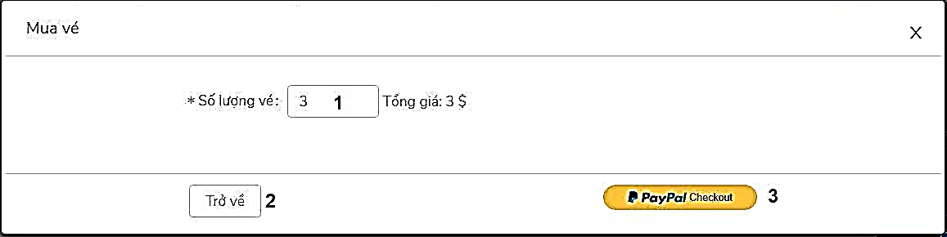

Figure 105 - <Member> Buy ticket interface

Fields

|  |  |  |  |  |  |  |
| --- | --- | --- | --- | --- | --- | --- |
| **No** | **Field Name** | **Description** | **Read only** | **Mandatory** | **Control Type** | **Data Type** |
| 1 | Số lượng vé | Number of tickets | No | Yes | TextBox | Number |

Table 116 - <Fields> Buy ticket

Buttons/Hyperlinks

|  |  |  |  |  |
| --- | --- | --- | --- | --- |
| **No** | **Function** | **Description** | **Validation** | **Outcome** |
| 2 | Trở về | Back | No | Transfer to view event detail page |
| 3 | Paypal checkout | pay by Paypal | No | Transfer to Paypal page |

Table 117 - <Buttons/Hyperlinks> Buy ticket

#### View supply products detail

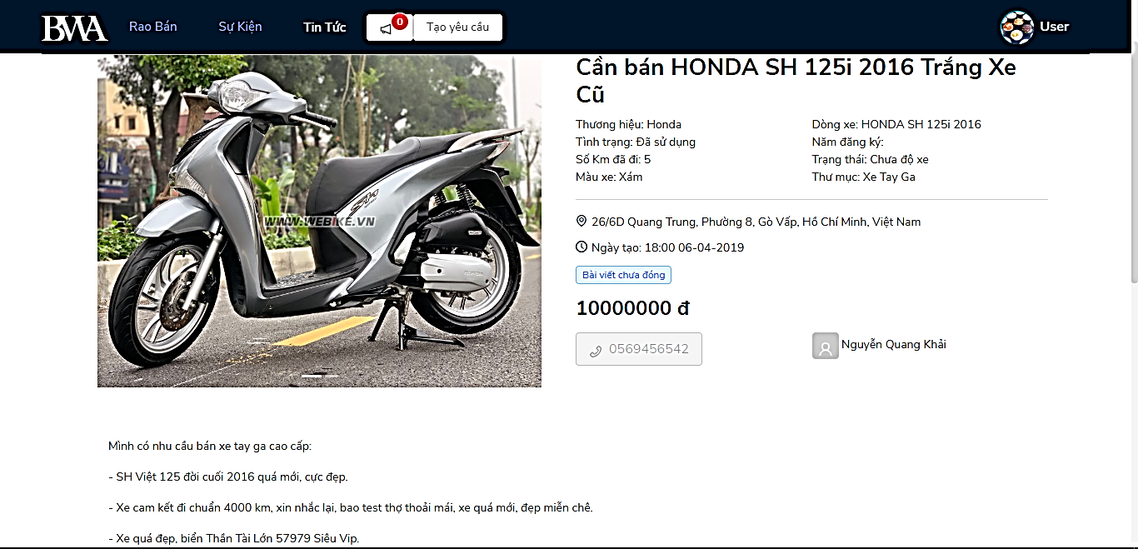

Figure 106 - <Member> View supply products details interface

#### User menu

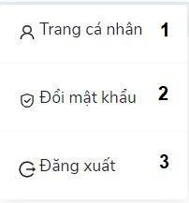

Figure 107 - <Member> User menu interface

Buttons/Hyperlinks

|  |  |  |  |  |
| --- | --- | --- | --- | --- |
| **No** | **Function** | **Description** | **Validation** | **Outcome** |
| 1 | Trang cá nhân | View profile | No | Transfer to view profile |
| 2 | Đổi mật khẩu | Change password | No | Transfer to change password |
| 3 | Đăng xuất | Log out the systems | No | Transfer to home page |

Table 118 - <Buttons/Hyperlinks> User menu

#### View profile

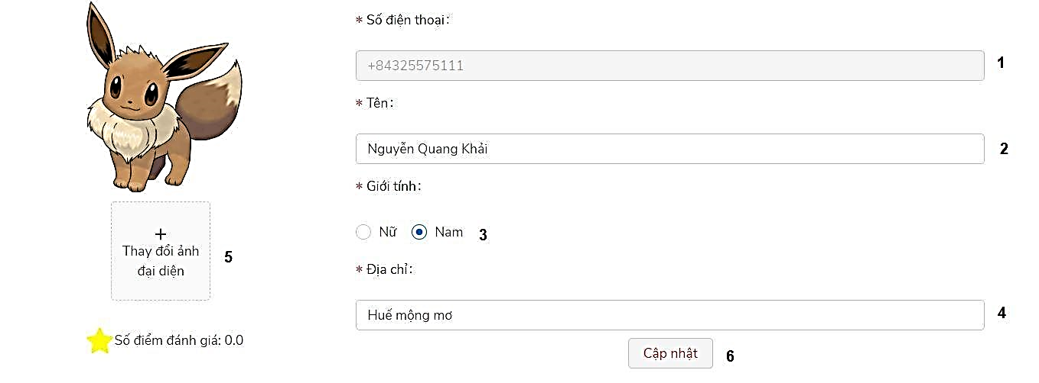

Figure 108 - <Member> View profile interface

Fields

|  |  |  |  |  |  |  |
| --- | --- | --- | --- | --- | --- | --- |
| **No** | **Field Name** | **Description** | **Read only** | **Mandatory** | **Control Type** | **Data Type** |
| 1 | Số điện thoại | Phone number of user | Yes | Yes | TextBox | String |
| 2 | Tên | Name of user | No | Yes | TextBox | String |
| 3 | Giới tính | Gender of user | No | Yes | Radio Button | Boolean |
| 4 | Địa chỉ | Address of user | No | Yes | TextBox | String |

Table 119 - <Fields> View profile

Buttons/Hyperlinks

|  |  |  |  |  |
| --- | --- | --- | --- | --- |
| **No** | **Function** | **Description** | **Validation** | **Outcome** |
| 5 | Thay đổi ảnh đại diện | Upload profile image | No | Upload image |
| 6 | Cập nhật | Update profile | Required | Update profile |

Table 120 - <Buttons/Hyperlinks> View profile

#### Change password

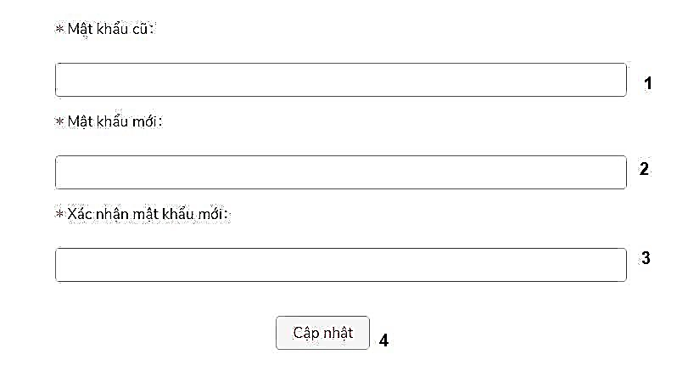

Figure 109 - <Member> Change password interface

Fields

|  |  |  |  |  |  |  |
| --- | --- | --- | --- | --- | --- | --- |
| **No** | **Field Name** | **Description** | **Read only** | **Mandatory** | **Control Type** | **Data Type** |
| 1 | Mật khẩu cũ | Old password | No | Yes | TextBox | String |
| 2 | Mật khẩu mới | New password | No | Yes | TextBox | String |
| 3 | Xác nhận mật khẩu mới | Confirm new password | No | Yes | TextBox | String |

Table 121 - <Fields> Change password

Buttons/Hyperlinks

|  |  |  |  |  |
| --- | --- | --- | --- | --- |
| **No** | **Function** | **Description** | **Validation** | **Outcome** |
| 4 | Cập nhật | Change password | Required | Change password |

Table 122 - <Buttons/Hyperlinks> View profile

#### User navigation

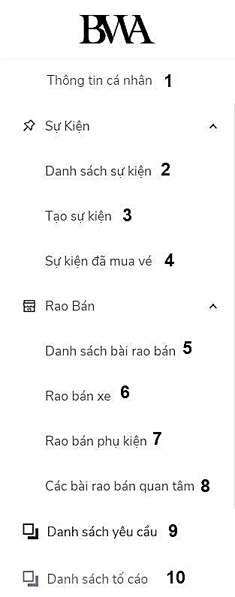

Figure 110 - <Member> User navigation interface

Buttons/Hyperlinks

|  |  |  |  |  |
| --- | --- | --- | --- | --- |
| **No** | **Function** | **Description** | **Validation** | **Outcome** |
| 1 | Thông tin cá nhân | View profile | N/A | Transfer to view profile page |
| 2 | Danh sách sự kiện | List of events | N/A | Tranfer to view list of events page |
| 3 | Tạo sự kiện | Create events | N/A | Transfer to create events page |
| 4 | Sự kiện đã mua vé | Events that have bought ticket | N/A | Transfer to view list event that have bought ticket page |
| 5 | Danh sách bài rao bán | List of supply posts | N/A | Transfer to view list of supply posts page |
| 6 | Rao bán xe | Create bike supply post | N/A | Transfer to create bike supply post page |
| 7 | Rao bán phụ kiện | Create accessory supply post | N/A | Transfer to create accessory supply post page |
| 8 | Các bài rao bán quan tâm | View list supply posts that have followed | N/A | Transfer to view list supply posts that have followed page |
| 9 | Danh sách yêu cầu | View list request | N/A | Transfer to view list request page |
| 10 | Danh sách tố cáo | View list report | N/A | Transfer to view list report page |

Table 123 - <Buttons/Hyperlinks> User navigator

#### View list events

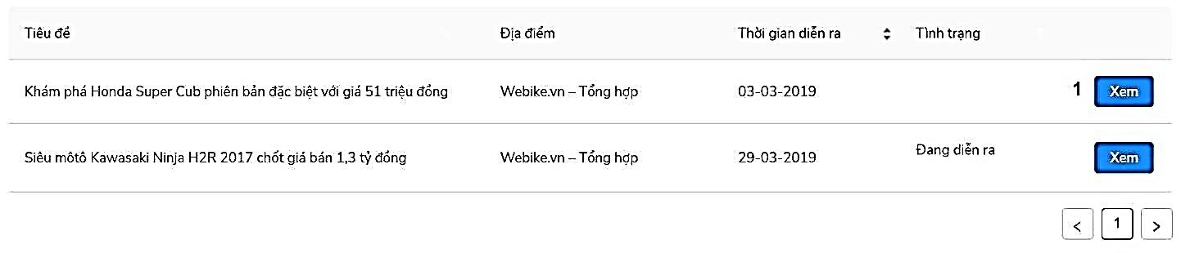

Figure 111 - <Member> View list events interface

Buttons/Hyperlinks

|  |  |  |  |  |
| --- | --- | --- | --- | --- |
| **No** | **Function** | **Description** | **Validation** | **Outcome** |
| 1 | Xem | View event detail | N/A | Transfer to view event detail |

Table 124 - <Buttons/Hyperlinks> View list events

#### Create event

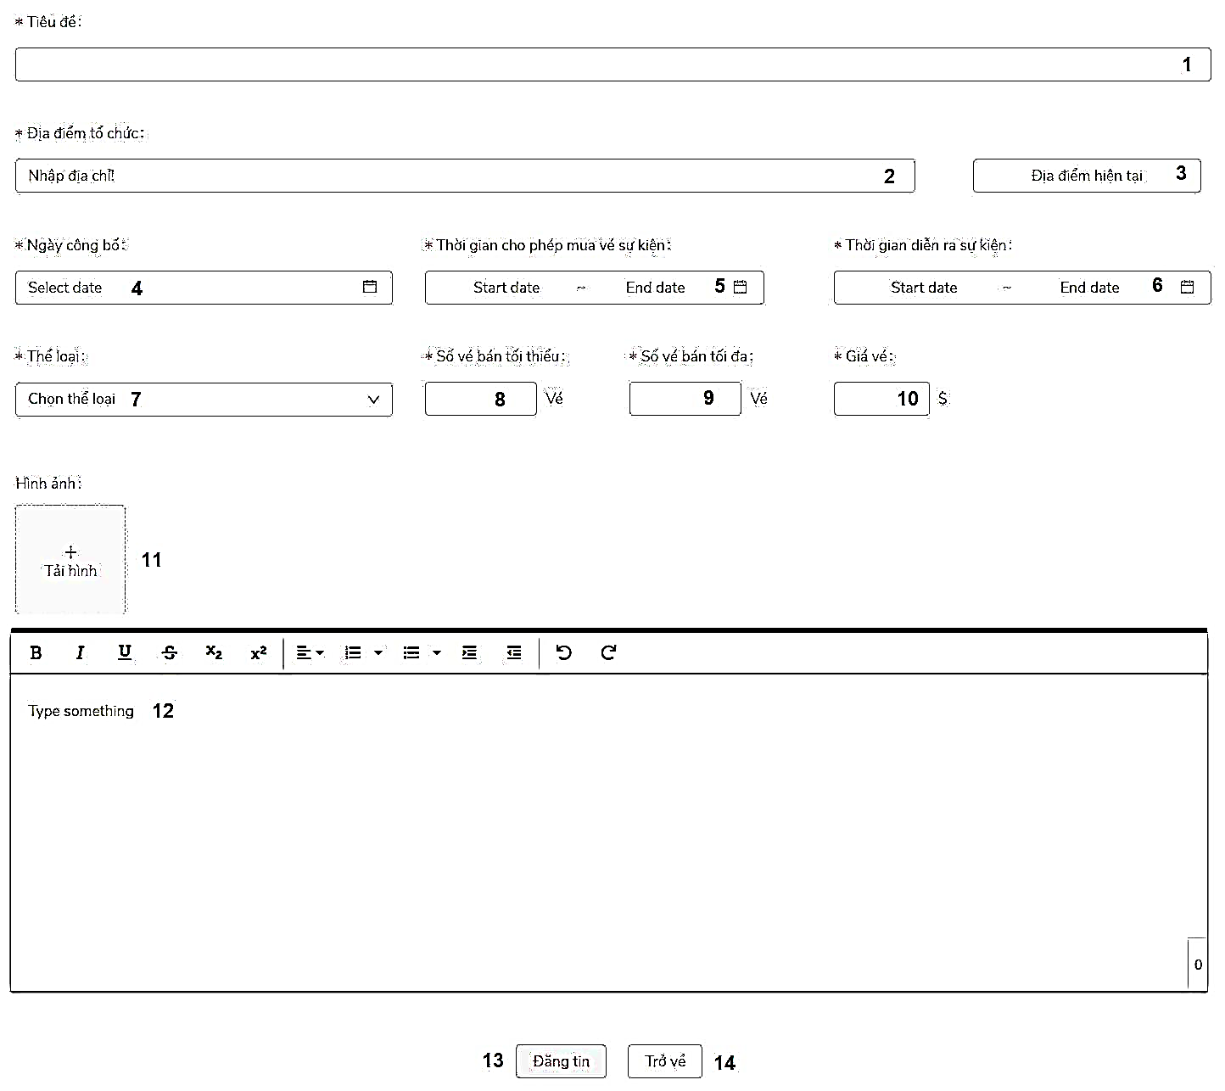

Figure 112 - <Member> Create events interface

Fields

|  |  |  |  |  |  |  |
| --- | --- | --- | --- | --- | --- | --- |
| **No** | **Field Name** | **Description** | **Read only** | **Mandatory** | **Control Type** | **Data Type** |
| 1 | Tiêu đề | Title of event | No | Yes | TextBox | String |
| 2 | Địa điểm tổ chức | Location of event | No | Yes | TextBox | String |
| 4 | Ngày công bố | Public date of event | No | Yes | Datepicker | String |
| 5 | Thời gian cho phép mua vé sự kiện | Sold ticket date of event | No | Yes | Datepicker | String |
| 6 | Thời gian diễn ra sự kiện | Occure date of event | No | Yes | Datepicker | String |
| 7 | Thể loại | Category of event | No | Yes | ComboBox | String |
| 8 | Số vé bán tối thiểu | Minimum number of sold ticket | No | No | TextBox | Number |
| 9 | Số vé bán tối đa | Maximum number of sold ticket | No | No | TextBox | Number |
| 10 | Giá vé | Ticket price | No | Yes | TextBox | Number |
| 11 | Hình ảnh | Upload image of event | No | Yes | FileUpload | File |
| 12 | Text area | Description of event | No | Yes | TextArea | String |

Table 125 - <Fields> Create event

Buttons/Hyperlinks

|  |  |  |  |  |
| --- | --- | --- | --- | --- |
| **No** | **Function** | **Description** | **Validation** | **Outcome** |
| 3 | Địa điểm hiện tại | Get current location | No | N/A. |
| 13 | Đăng tin | Create event | Yes | Submit event for admin to confirm |
| 14 | Trở về | Back to previous page | No | Back to previous page |

Table 126 - <Buttons/Hyperlinks> Create event

#### Create accessory post

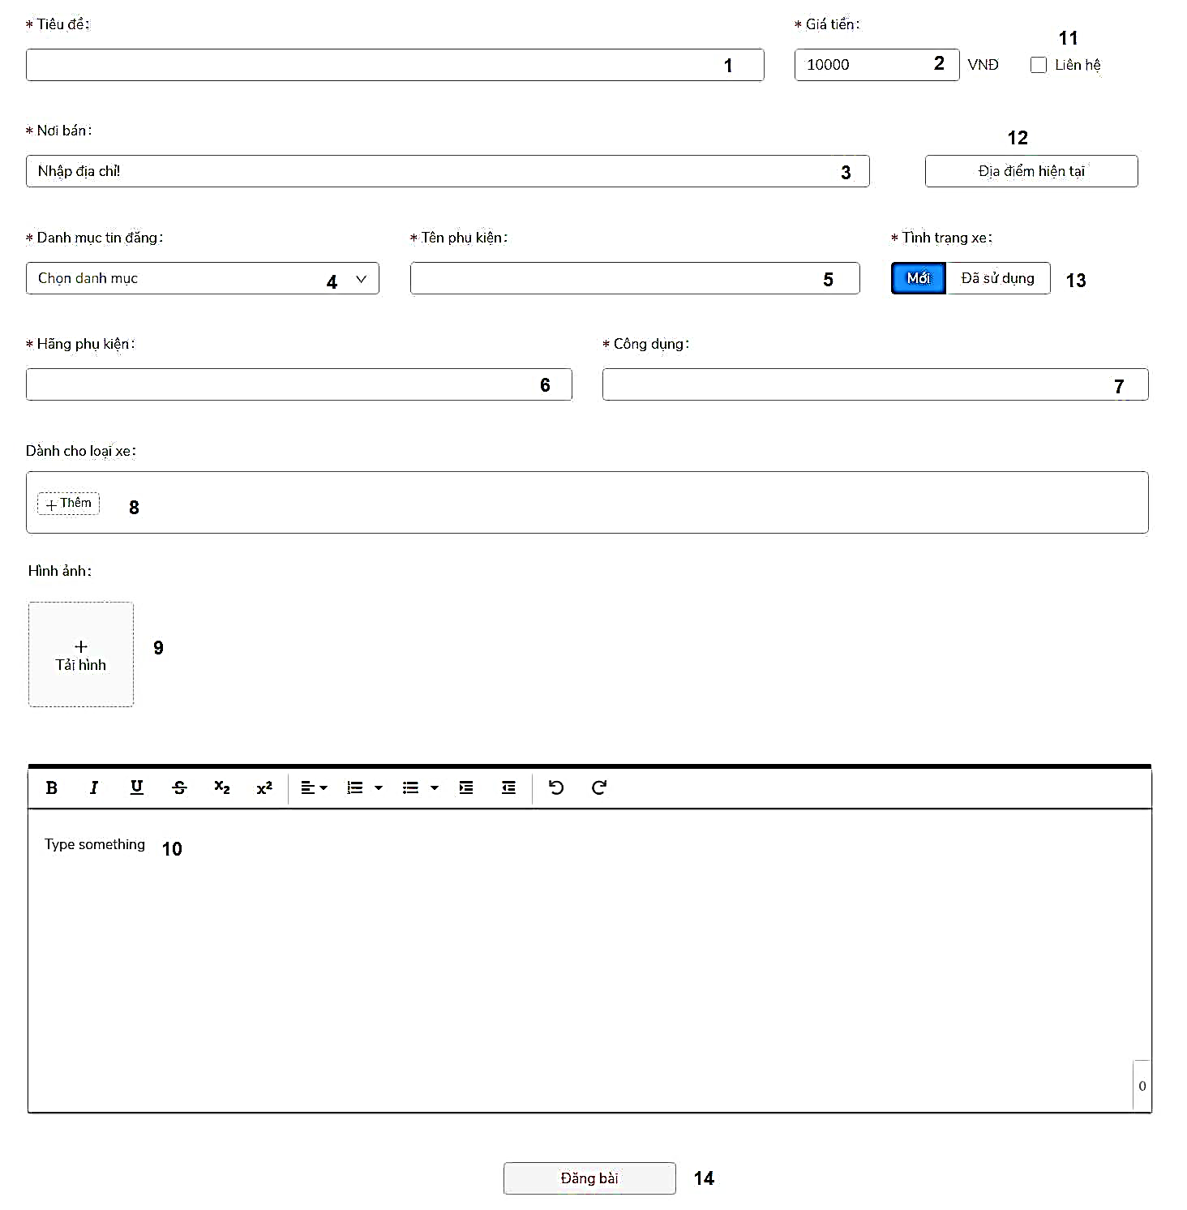

Figure 113 - <Member> Create accessory post interface

Fields

|  |  |  |  |  |  |  |
| --- | --- | --- | --- | --- | --- | --- |
| **No** | **Field Name** | **Description** | **Read only** | **Mandatory** | **Control Type** | **Data Type** |
| 1 | Tiêu đề | Title of accessory post | No | Yes | TextBox | String |
| 2 | Giá tiền | Price | No | Yes | TextBox | Number |
| 3 | Nơi bán | Location | No | Yes | TextBox | String |
| 4 | Danh mục | Category of supply post | No | Yes | ComboBox | String |
| 5 | Tên phụ kiện | Name of accessory | No | Yes | TextBox | String |
| 6 | Hãng phụ kiện | Brand | No | Yes | ComboBox | String |
| 7 | Công dụng | Use of accessory | No | Yes | TextBox | String |
| 8 | Dành cho loại xe | Bike that compatible | No | No | TextBox | String |
| 9 | Hình ảnh | Upload image of accessory | No | Yes | FileUpload | File |
| 10 | Text area | Description of supply post | No | Yes | TextArea | String |

Table 127 - <Fields> Create accessory post

Buttons/Hyperlinks

|  |  |  |  |  |
| --- | --- | --- | --- | --- |
| **No** | **Function** | **Description** | **Validation** | **Outcome** |
| 11 | Liên hệ | Contact for price | N/A |  |
| 12 | Địa điểm hiện tại | Get current location | N/A |  |
| 13 | Tình trạng xe | Choose status of accessory | N/A |  |
| 14 | Đăng tin | Create supply post | Required | Submit for admin to confirm |

Table 128 - <Buttons/Hyperlinks> Create accessory post

#### View list events had bought ticket

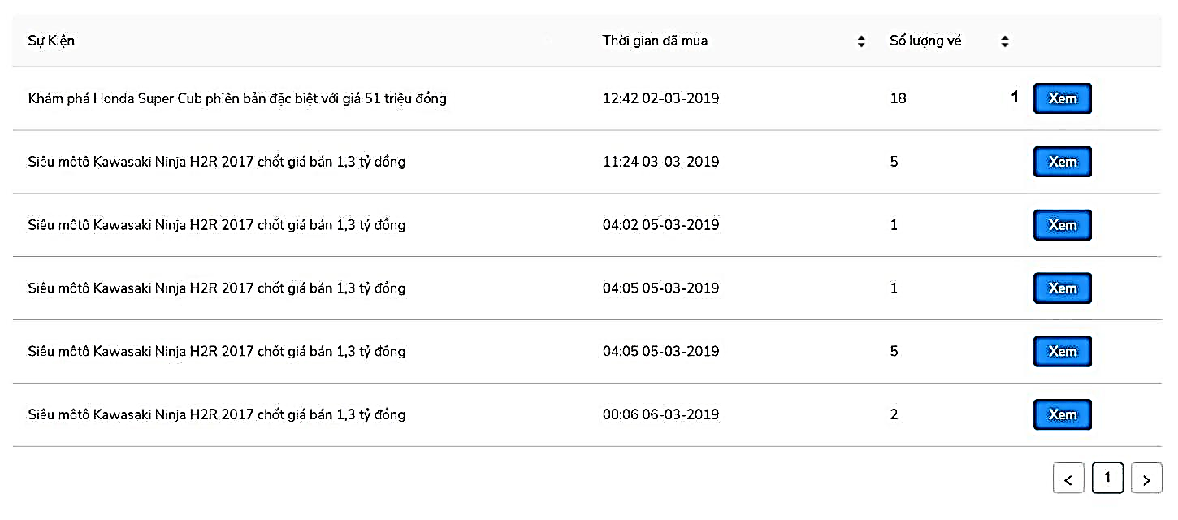

Figure 114 - <Member> View list events had bought ticket

Buttons/Hyperlinks

|  |  |  |  |  |
| --- | --- | --- | --- | --- |
| **No** | **Function** | **Description** | **Validation** | **Outcome** |
| 1 | Xem | View event detail that have bought ticket | No | Transfer to view event detail |

Table 129 - <Buttons/Hyperlinks> View list events had bought ticket

#### View list supply products

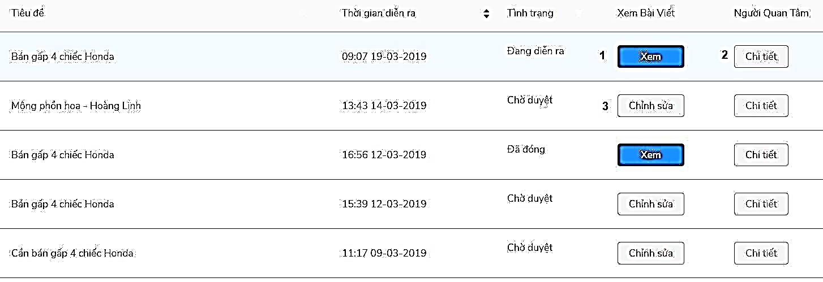

Figure 115 - <Member> View list supply products interface

Buttons/Hyperlinks

|  |  |  |  |  |
| --- | --- | --- | --- | --- |
| **No** | **Function** | **Description** | **Validation** | **Outcome** |
| 1 | Xem | View supply product detail | No | Transfer to view supply post detail |
| 2 | Chi tiết | View user that follow the post | No |  |
| 3 | Chỉnh sửa | Edit supply post | No | Transfer to edit supply post |

Table 130 - <Buttons/Hyperlinks> View list supply products

#### Create bike post

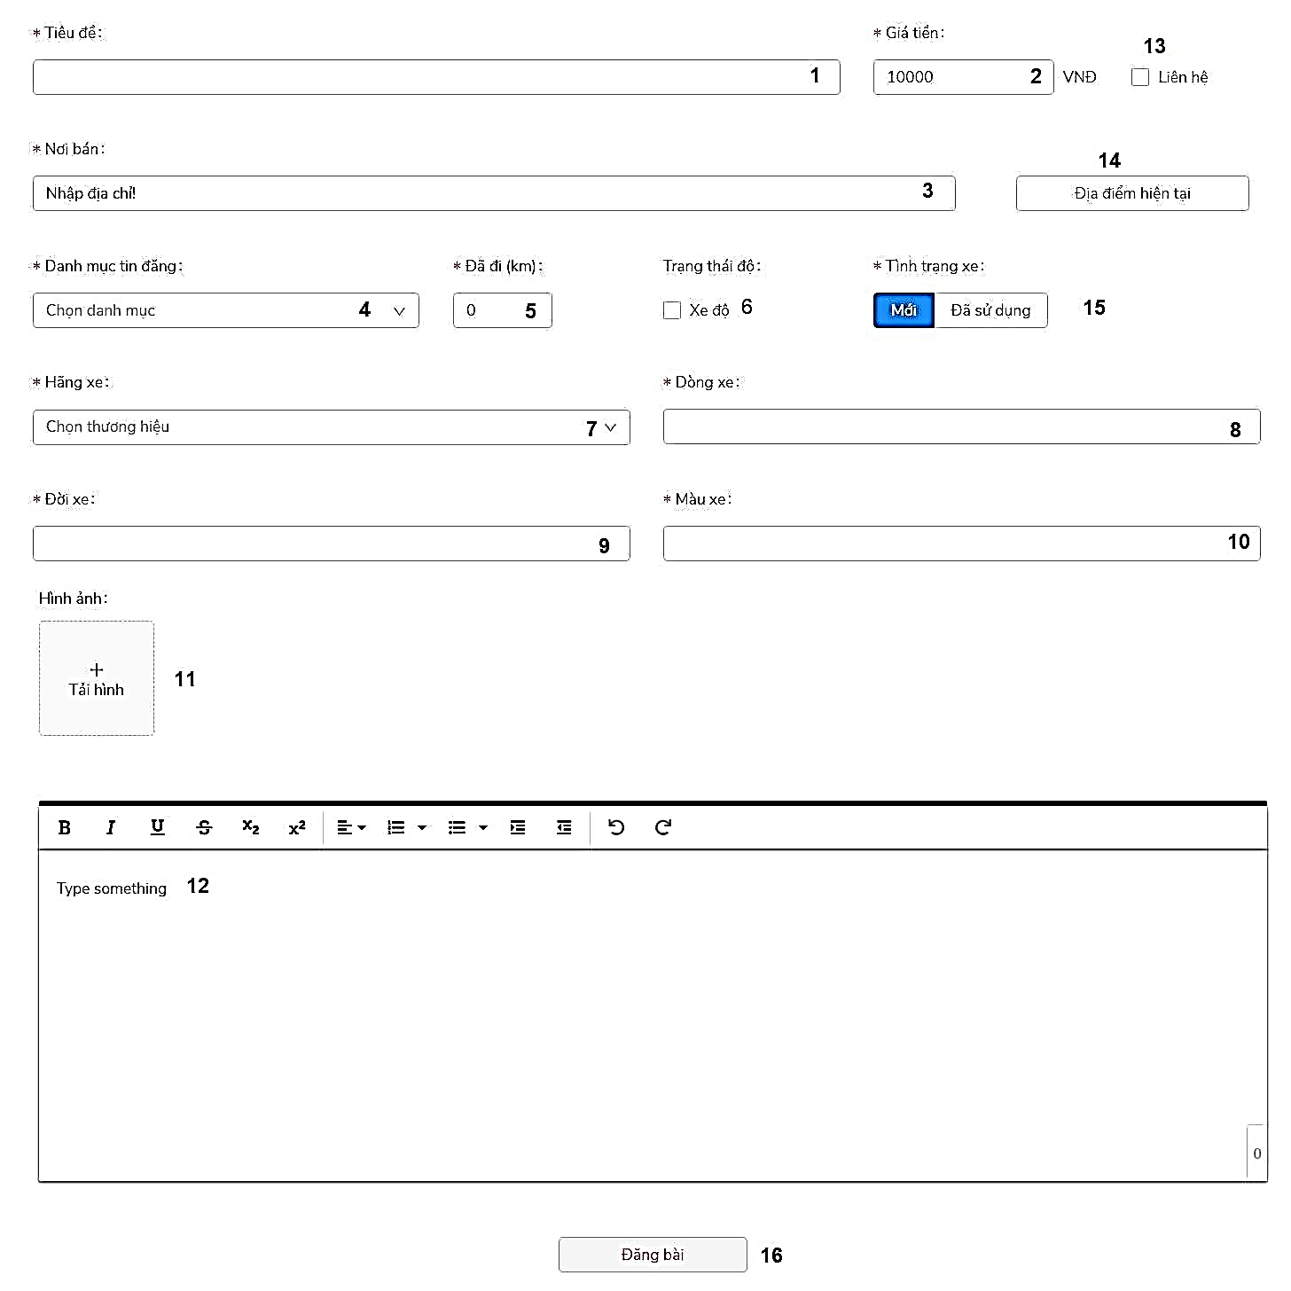

Figure 116 - <Member> Create bike post interface

Fields

|  |  |  |  |  |  |  |
| --- | --- | --- | --- | --- | --- | --- |
| **No** | **Field Name** | **Description** | **Read only** | **Mandatory** | **Control Type** | **Data Type** |
| 1 | Tiêu đề | Title of supply product | No | Yes | TextBox | String |
| 2 | Giá tiền | Price | No | Yes | TextBox | Number |
| 3 | Nơi bán | Location | No | Yes | TextBox | String |
| 4 | Danh mục tin đăng | Category of bike | No | Yes | ComboBox | String |
| 5 | Đã đi | Number of km has taken | No | Yes | TextBox | Number |
| 6 | Trạng thái độ |  | No | No | CheckBox | Boolean |
| 7 | Hãng xe | Brand of bike | No | Yes | ComboBox | String |
| 8 | Dòng xe | Model of bike | No | Yes | TextBox | String |
| 9 | Đời xe | Number of bike | No | Yes | TextBox | String |
| 10 | Màu xe | Color of bike | No | Yes | TextBox | String |
| 11 | Hình ảnh | Upload image of bike | No | Yes | FileUpload | File |
| 12 | Text area | Description of bike | No | Yes | TextArea | String |

Table 131 - <Fields> Create bike post

Buttons/Hyperlinks

|  |  |  |  |  |
| --- | --- | --- | --- | --- |
| **No** | **Function** | **Description** | **Validation** | **Outcome** |
| 13 | Liên hệ | Contact for price | N/A |  |
| 14 | Địa điểm hiện tại | Get current location | N/A |  |
| 15 | Tình trạng xe | Status of bike | N/A |  |
| 16 | Đăng tin | Create supply post | Required | Submit post for admin to confirm |

Table 132 - <Buttons/Hyperlinks> Create bike post

#### View list supply products had added to wishlist

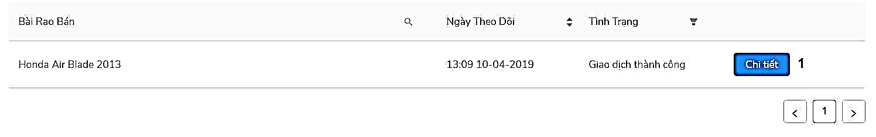

Figure 117 - <Member> View list supply products had added to wishlist

Buttons/Hyperlinks

|  |  |  |  |  |
| --- | --- | --- | --- | --- |
| **No** | **Function** | **Description** | **Validation** | **Outcome** |
| 1 | Chi tiết | View timeline of the exchange | N/A | Transfer to view timeline of the exchange |

Table 133 - <Buttons/Hyperlinks> View list supply products had added to wishlist

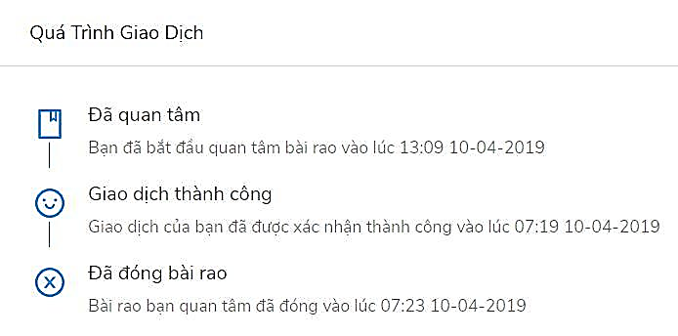

Figure 118 - <Member> View timeline of the exchange interface

#### View list request

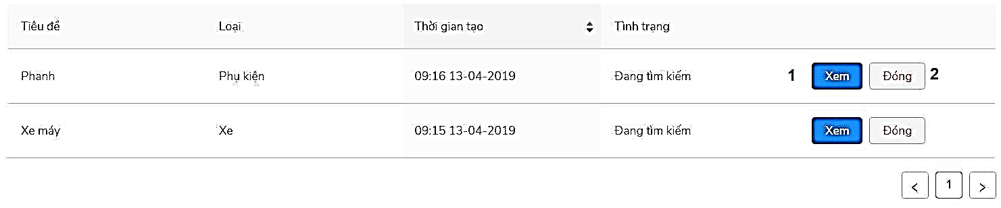

Figure 119 - <Member> View list request timeline interface

Buttons/Hyperlinks

|  |  |  |  |  |
| --- | --- | --- | --- | --- |
| **No** | **Function** | **Description** | **Validation** | **Outcome** |
| 1 | Xem | View request detail | N/A | Transfer to view request detail |
| 2 | Đóng | Close request | N/A |  |

Table 134 - <Buttons/Hyperlinks> View list request

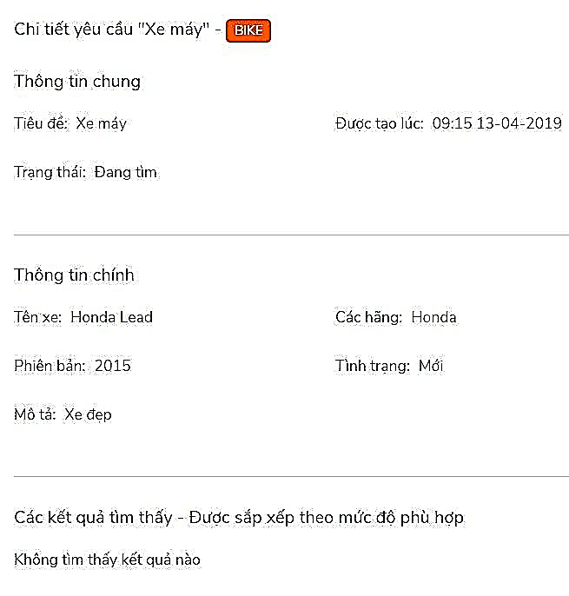

Figure 120 - <Member> View request detail interface

#### Create request

Bike request

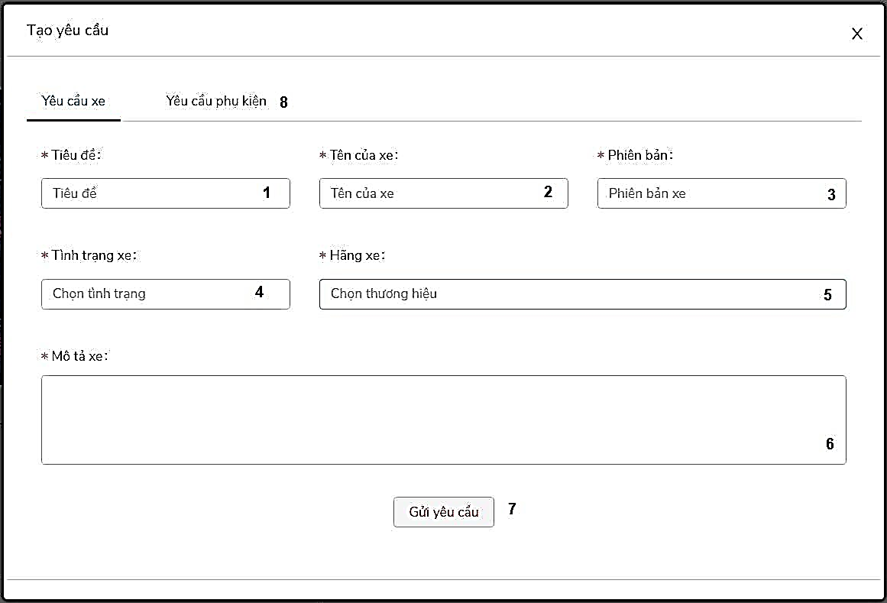

Figure 121 - <Member> Create bike request interface

Fields

|  |  |  |  |  |  |  |
| --- | --- | --- | --- | --- | --- | --- |
| **No** | **Field Name** | **Description** | **Read only** | **Mandatory** | **Control Type** | **Data Type** |
| 1 | Tiêu đề | Title of request | No | Yes | TextBox | String |
| 2 | Tên của xe | Name of bike | No | Yes | TextBox | String |
| 3 | Phiên bản | Version of bike | No | Yes | TextBox | String |
| 4 | Tình trạng xe | Status of bike | No | Yes | TextBox | String |
| 5 | Hãng xe | Brand of bike | No | Yes | TextBox | String |
| 6 | Mô tả xe | Description of bike | No | Yes | TextBox | String |

Table 135 - <Fields> Create bike request

Buttons/Hyperlinks

|  |  |  |  |  |
| --- | --- | --- | --- | --- |
| **No** | **Function** | **Description** | **Validation** | **Outcome** |
| 7 | Gửi yêu cầu | Send request | Required | Submit request for admin to confirm |
| 8 | Yêu cầu phụ kiện | Switch to request accessory | N/A |  |

Table 136 - <Buttons/Hyperlinks> Create bike request

Accessory request

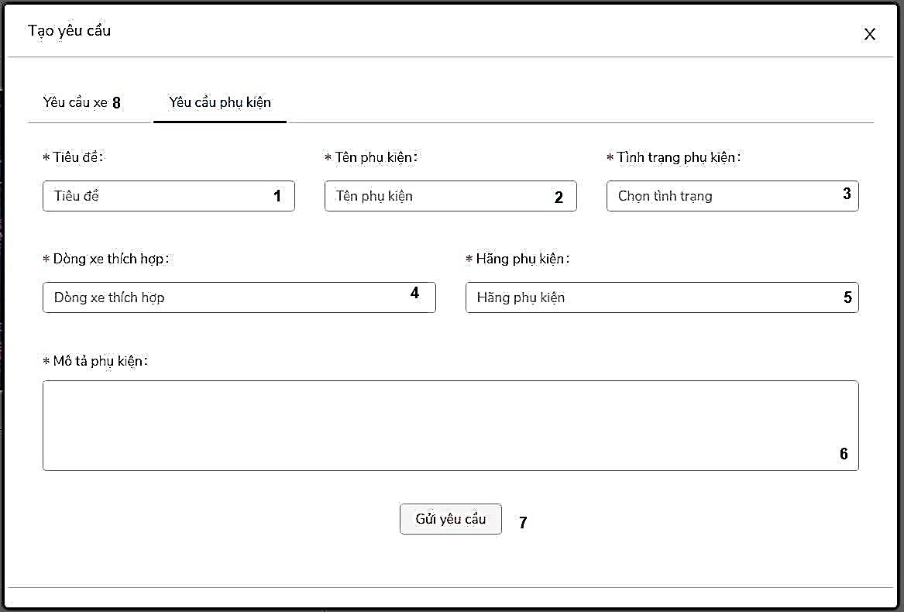

Figure 122 - <Member> Create accessory request interface

Fields

|  |  |  |  |  |  |  |
| --- | --- | --- | --- | --- | --- | --- |
| **No** | **Field Name** | **Description** | **Read only** | **Mandatory** | **Control Type** | **Data Type** |
| 1 | Tiêu đề | Title of request | No | Yes | TextBox | String |
| 2 | Tên của phụ kiện | Name of accessory | No | Yes | TextBox | String |
| 3 | Tình trạng phụ kiện | Status of accessory | No | Yes | TextBox | String |
| 4 | Dòng xe thích hợp | Bike compatible with accessory | No | Yes | TextBox | String |
| 5 | Hãng phụ kiện | Brand of accessory | No | Yes | TextBox | String |
| 6 | Mô tả phụ kiện | Description of accessory | No | Yes | TextBox | String |

Table 137 - <Fields> Create accessory request

Buttons/Hyperlinks

|  |  |  |  |  |
| --- | --- | --- | --- | --- |
| **No** | **Function** | **Description** | **Validation** | **Outcome** |
| 7 | Gửi yêu cầu | Send request | Required | Submit request for admin to confirm |
| 8 | Yêu cầu xe | Switch to request bike | N/A |  |

Table 138 - <Buttons/Hyperlinks> Create accessory request

#### View notification

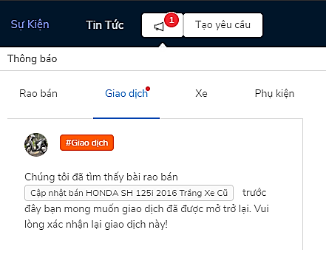

Figure 123 - <Member> View notification interface

#### View transaction of supply post

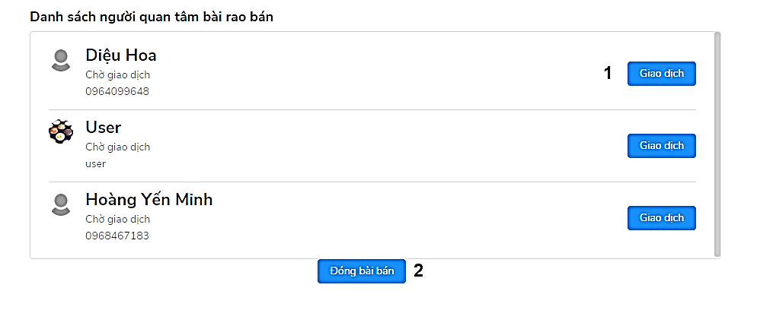

Figure 124 - <Member> View transaction of supply post interface

Buttons/Hyperlinks

|  |  |  |  |  |
| --- | --- | --- | --- | --- |
| **No** | **Function** | **Description** | **Validation** | **Outcome** |
| 1 | Giao dịch | Exchange with the user | N/A | Push a notification to the user |
| 2 | Đóng bài bán | Close supply post | N/A |  |

Table 139 - <Buttons/Hyperlinks> Create accessory request

### 5.3. Admin

#### Admin navigation

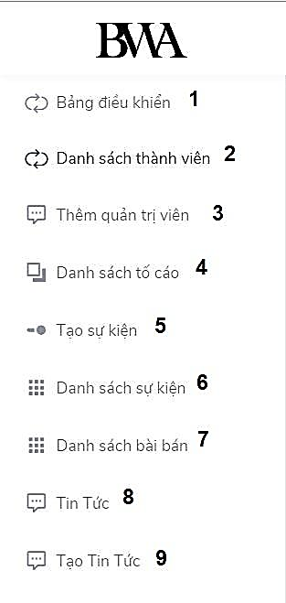

Figure 125 - <Admin> Admin navigation interface

Buttons/Hyperlinks

|  |  |  |  |  |
| --- | --- | --- | --- | --- |
| **No** | **Function** | **Description** | **Validation** | **Outcome** |
| 1 | Bảng điều khiển | Dashboard | N/A | Transfer to dashboard page |
| 2 | Danh sách thành viên | View list of members | N/A | Transfer to view list members page |
| 3 | Thêm quản trị viên | Add admin | N/A | Transfer to add admin page |
| 4 | Danh sách tố cáo | View list reports | N/A | Transfer to view list reports page |
| 5 | Tạo sự kiện | Create events | N/A | Transfer to create events page |
| 6 | Danh sách sự kiện | View list events | N/A | Transfer to view list events page |
| 7 | Danh sách bài bán | View list supply products | N/A | Transfer to view list supply products page |
| 8 | Tin tức | View list news | N/A | Transfer to view list news page |
| 9 | Tạo tin tức | Create news | N/A | Transfer to create news page |

Table 140 - <Buttons/Hyperlinks> Admin navigation

#### View list members

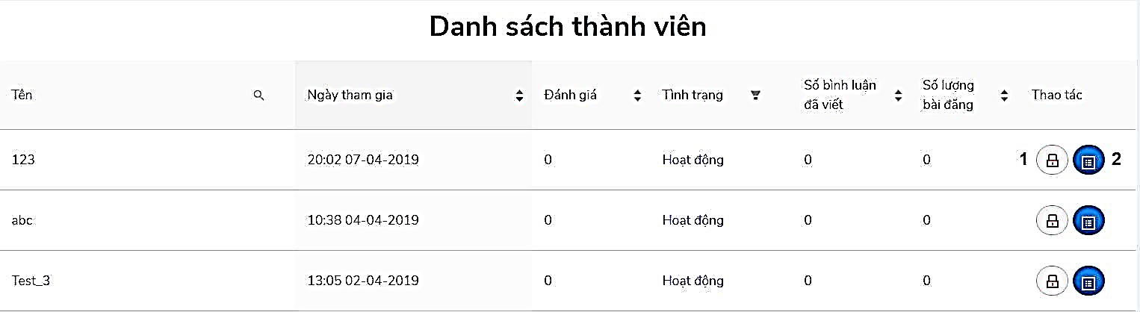

Figure 126 - <Admin> View list members interface

Buttons/Hyperlinks

|  |  |  |  |  |
| --- | --- | --- | --- | --- |
| **No** | **Function** | **Description** | **Validation** | **Outcome** |
| 1 | Lock button | Block/Unblock member | N/A |  |
| 2 | Detail button | View member’s profile | N/A | Transfer to view member profile |

Table 141 - <Buttons/Hyperlinks> View list members

#### Add admin

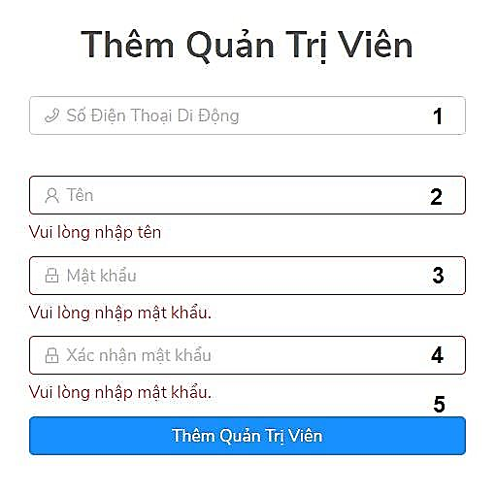

Figure 127 - <Admin> Add admin interface

Fields

|  |  |  |  |  |  |  |
| --- | --- | --- | --- | --- | --- | --- |
| **No** | **Field Name** | **Description** | **Read only** | **Mandatory** | **Control Type** | **Data Type** |
| 1 | Số điện thoại di động | Phone number | No | Yes | TextBox | String |
| 2 | Tên | Name | No | Yes | TextBox | String |
| 3 | Mật khẩu | Password | No | Yes | TextBox | String |
| 4 | Xác nhận mật khẩu | Confirm password | No | Yes | TextBox | String |

Table 142 - <Fields> Add admin

Buttons/Hyperlinks

|  |  |  |  |  |
| --- | --- | --- | --- | --- |
| **No** | **Function** | **Description** | **Validation** | **Outcome** |
| 5 | Thêm quản trị viên | Add admin | Required |  |

Table 143 - <Buttons/Hyperlinks> Add admin

#### View list report

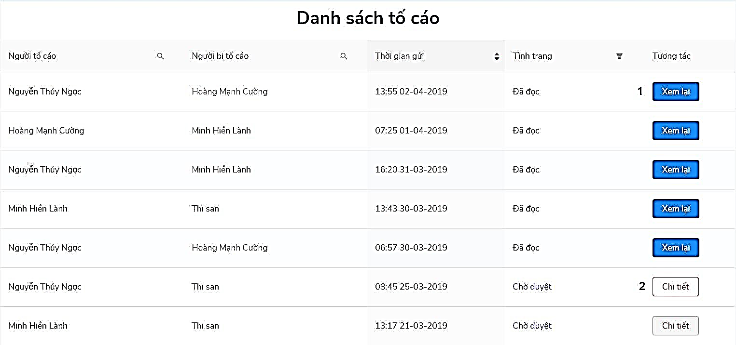

Figure 128 - <Admin> View list report interface

Buttons/Hyperlinks

|  |  |  |  |  |
| --- | --- | --- | --- | --- |
| **No** | **Function** | **Description** | **Validation** | **Outcome** |
| 1 | Xem lại | View report detail | N/A | Transfer to view report detail |
| 2 | Chi tiết | Confirm report | N/A | Transfer to view report to confirm |

Table 144 - <Buttons/Hyperlinks> View list report

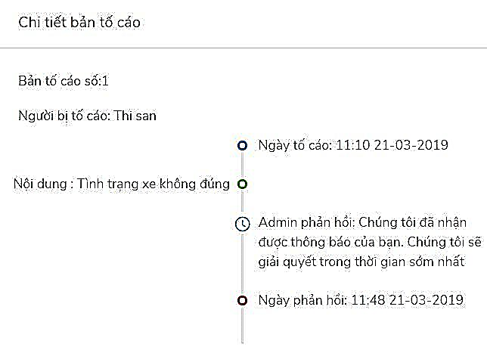

Figure 129 - <Admin> View report detail interface

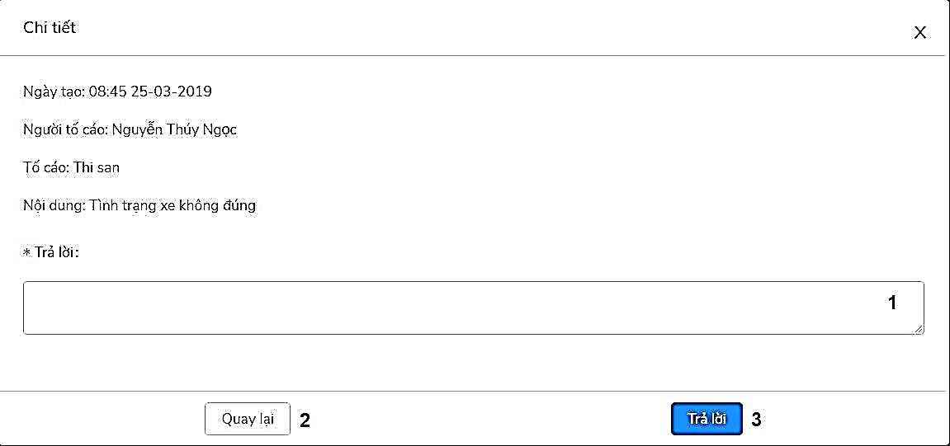

Figure 130 - <Admin> View report detail to confirm interface

Fields

|  |  |  |  |  |  |  |
| --- | --- | --- | --- | --- | --- | --- |
| **No** | **Field Name** | **Description** | **Read only** | **Mandatory** | **Control Type** | **Data Type** |
| 1 | Trả lời | Reply to report | No | Yes | TextBox | String |

Table 145 - <Fields> View list report

Buttons/Hyperlinks

|  |  |  |  |  |
| --- | --- | --- | --- | --- |
| **No** | **Function** | **Description** | **Validation** | **Outcome** |
| 2 | Quay lại | Back | N/A | Transfer view list report page |
| 4 | Trả lời | Reply report | Required | Transfer view list report page |

Table 146 - <Buttons/Hyperlinks> View list report

#### View list events

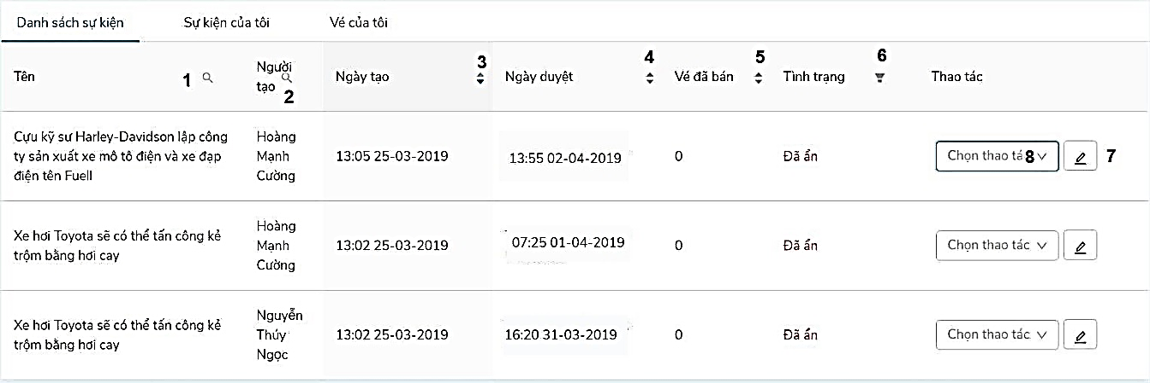

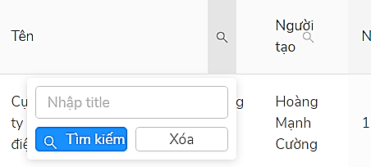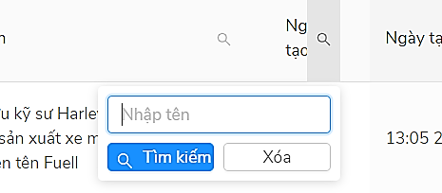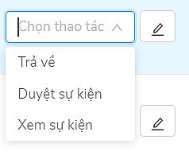

Figure 131 - <Admin> View list events interface

Buttons/Hyperlinks

|  |  |  |  |  |
| --- | --- | --- | --- | --- |
| **No** | **Function** | **Description** | **Validation** | **Outcome** |
| 1 | Search button | Search by name of event | N/A | Show result after search |
| 2 | Search button | Search by name of creator | N/A | Show result after search |
| 3 | Up/Down button | Sort event by create day | N/A | Show result after sort |
| 4 | Up/Down button | Sort event by confirm day | N/A | Show result after sort |
| 5 | Up/Down button | Sort number of sold ticket | N/A | Show result after sort |
| 6 | Up/Down button | Sort by status of event | N/A | Show result after sort |
| 7 | Confirm button | Confirm event | Required | Transfer view list event page |

Table 147 - <Buttons/Hyperlinks> View list events

Fields

|  |  |  |  |  |  |  |
| --- | --- | --- | --- | --- | --- | --- |
| **No** | **Field Name** | **Description** | **Read only** | **Mandatory** | **Control Type** | **Data Type** |
| 8 | Chọn thao tác | Choose action to confirm event | No | Yes | TextBox | String |

Table 148 - <Fields> View list events

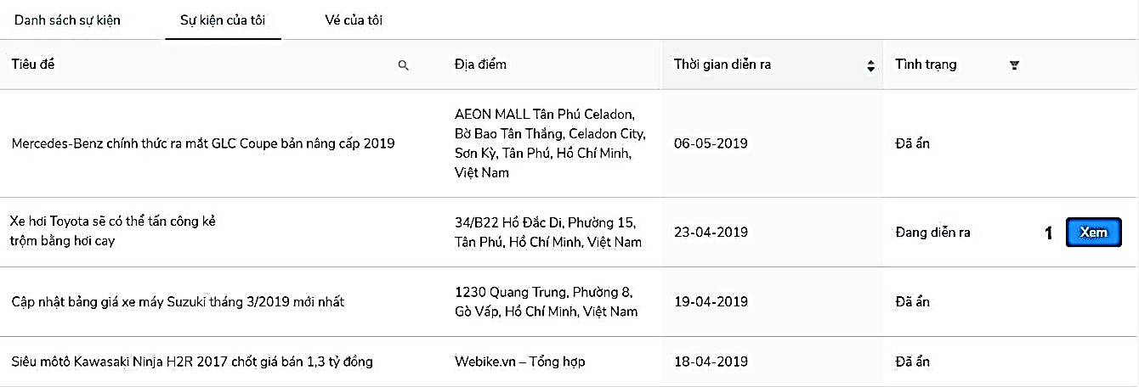

Figure 132 - <Admin> View list of events that had created interface

Buttons/Hyperlinks

|  |  |  |  |  |
| --- | --- | --- | --- | --- |
| **No** | **Function** | **Description** | **Validation** | **Outcome** |
| 1 | Xem | View event detail | N/A | Transfer to view event detail page |

Table 149 - <Buttons/Hyperlinks> View list events that had created interface 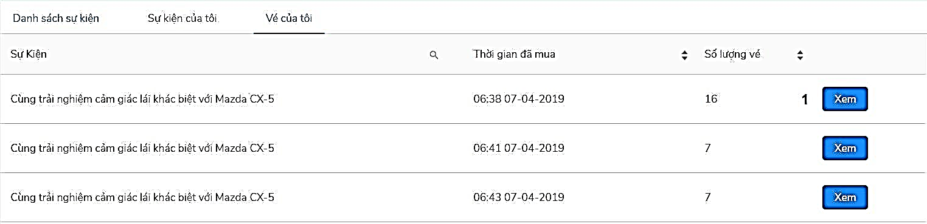

Figure 133 - <Admin> View list tickets that had bought interface

Buttons/Hyperlinks

|  |  |  |  |  |
| --- | --- | --- | --- | --- |
| **No** | **Function** | **Description** | **Validation** | **Outcome** |
| 1 | Xem | View event detail | N/A | Transfer to view event detail page |

Table 150 - <Buttons/Hyperlinks> View list tickets that had bought interface

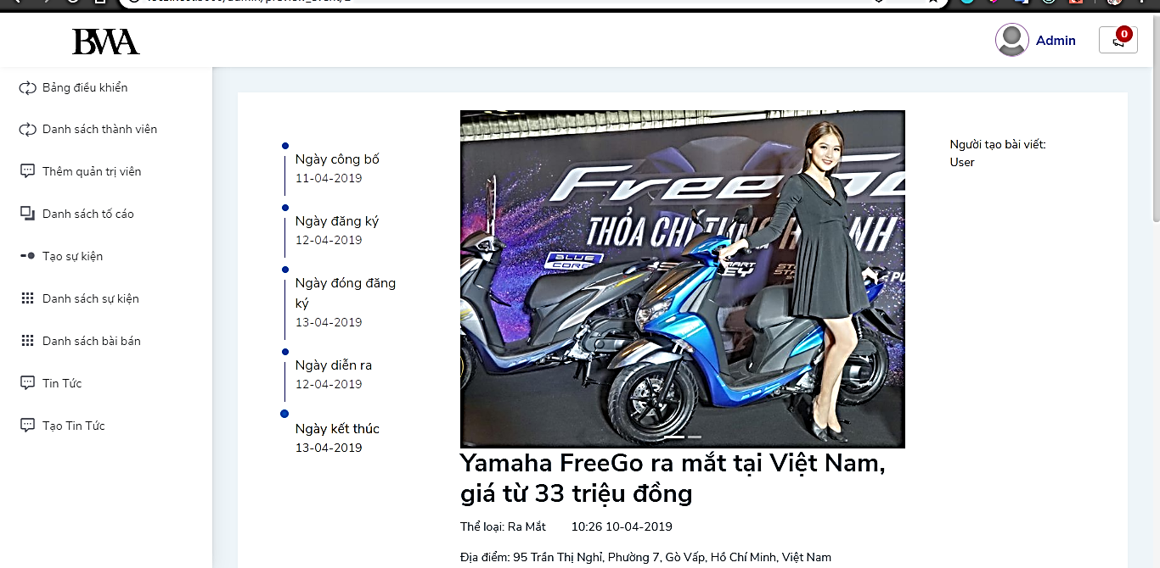

Figure 134 - <Admin> Preview event detail interface

#### View list supply products

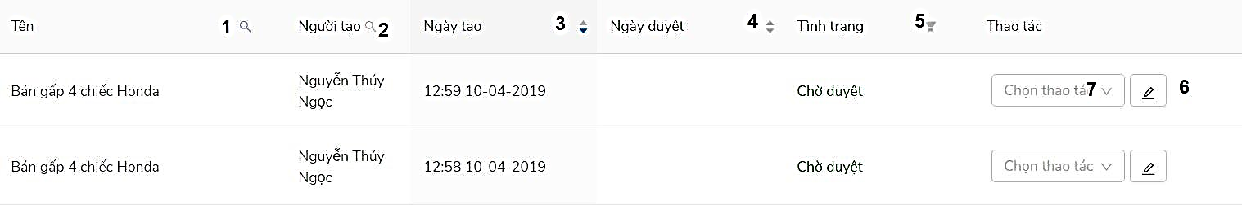

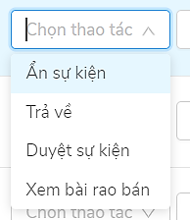

Figure 135 - <Admin> View list supply products interface

Buttons/Hyperlinks

|  |  |  |  |  |
| --- | --- | --- | --- | --- |
| **No** | **Function** | **Description** | **Validation** | **Outcome** |
| 1 | Search button | Search by name of supply product | N/A | Show result after search |
| 2 | Search button | Search by name of creator | N/A | Show result after search |
| 3 | Up/Down button | Sort event by create day | N/A | Show result after sort |
| 4 | Up/Down button | Sort event by confirm day | N/A | Show result after sort |
| 5 | Up/Down button | Sort by status of event | N/A | Show result after sort |
| 6 | Confirm button | Confirm event | Required | Transfer view list event page |

Table 151 - <Buttons/Hyperlinks> View list supply products

Fields

|  |  |  |  |  |  |  |
| --- | --- | --- | --- | --- | --- | --- |
| **No** | **Field Name** | **Description** | **Read only** | **Mandatory** | **Control Type** | **Data Type** |
| 7 | Chọn thao tác | Choose action to confirm supply product | No | Yes | TextBox | String |

Table 152 - <Fields> View list supply products

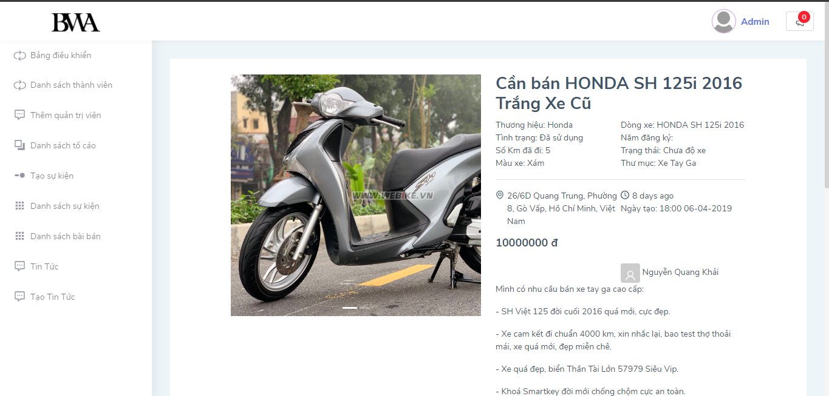

Figure 136 - <Admin> Preview supply products post

#### View list news

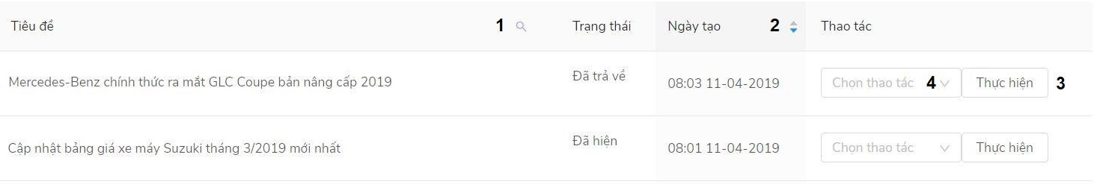

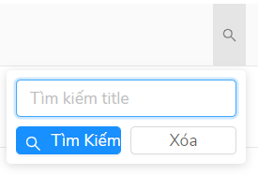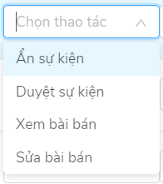

Figure 137 - <Admin> View list news interface

Buttons/Hyperlinks

|  |  |  |  |  |
| --- | --- | --- | --- | --- |
| **No** | **Function** | **Description** | **Validation** | **Outcome** |
| 1 | Search button | Search by name of news | N/A | Show result after search |
| 2 | Up/Down button | Sort event by create day | N/A | Show result after sort |
| 3 | Thực hiện | Confirm event | Required | Transfer view list event page |

Table 153 - <Buttons/Hyperlinks> View list news

Fields

|  |  |  |  |  |  |  |
| --- | --- | --- | --- | --- | --- | --- |
| **No** | **Field Name** | **Description** | **Read only** | **Mandatory** | **Control Type** | **Data Type** |
| 7 | Chọn thao tác | Choose action to confirm news | No | Yes | TextBox | String |

Table 154 - <Fields> View list news

#### Create news

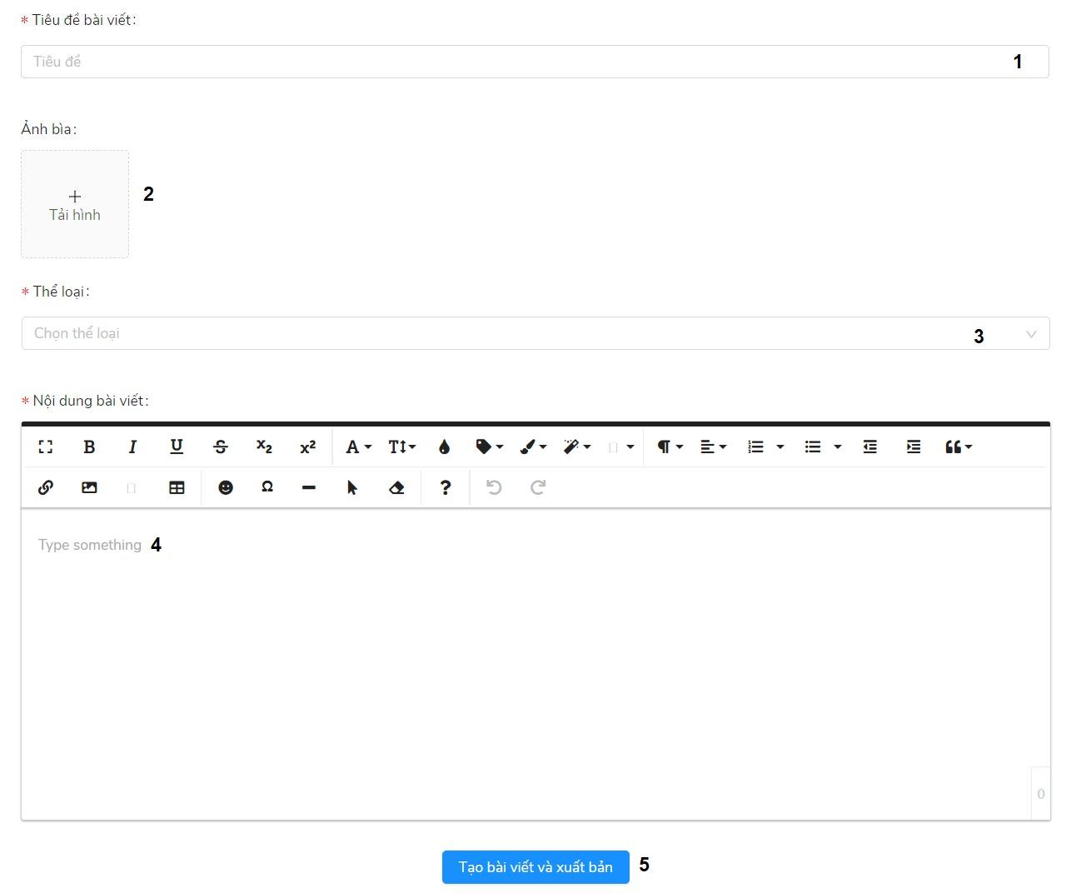

Figure 138 - <Admin> Create news interface

Fields

|  |  |  |  |  |  |  |
| --- | --- | --- | --- | --- | --- | --- |
| **No** | **Field Name** | **Description** | **Read only** | **Mandatory** | **Control Type** | **Data Type** |
| 1 | Tiêu đề bài viết | Title of news | No | Yes | TextBox | String |
| 2 | Ảnh bìa | Image of news | No | Yes | FileUpload | File |
| 3 | Thể loại | Category of news | No | Yes | ComboBox | String |
| 4 | Nội dung bài viết | Content of news | No | Yes | TextArea | String |

Table 155 - <Fields> View list news

Buttons/Hyperlinks

|  |  |  |  |  |
| --- | --- | --- | --- | --- |
| No | Function | Description | Validation | Outcome |
| 5 | Tạo bài viết và xuất bản | Create news | Required | Create news |

Table 156 - <Buttons/Hyperlinks> View list news

## 6. Database Design

### 6.1. Entity Relationship Diagram

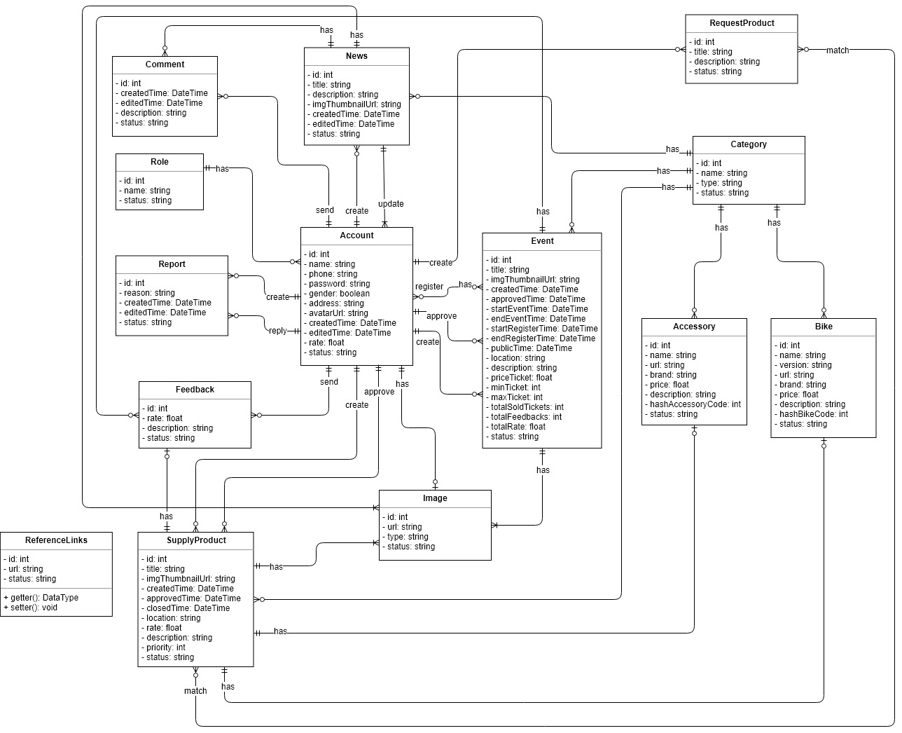

Figure 139 - Entity Relationship Diagram

### 6.2. Data Dictionary

|  |  |  |
| --- | --- | --- |
| **Entity dictionary** | | |
| **Enitity Name** | **Mapping column with Conceptual diagram** | **Description** |
| **Comment** | Comment | Contain the comment information. |
| **News** | News | Contain the news information. |
| **RequestProduct** | RequestProduct | Contain the request product post information |
| **Role** | Role | Contain the role information. |
| **Event** | Event | Contain the event information. |
| **Report** | Report | Contain the report information. |
| **Account** | Account | Contain the account information. |
| **Feedback** | Feedback | Contain the feedback information. |
| **Category** | Category | Contain the category information. |
| **Bike** | Bike | Contain the bike information. |
| **Image** | Image | Contain the image information. |
| **Accessory** | Accessory | Contain the accessory information |
| **ReferenceLinks** | ReferenceLinks | Contain the reference links crawl information |
| **SupplyProduct** | SupplyProduct | Contain the supply product information |

Table 157 - Entity Relationship Diagram Dictionary

### 7. Algorithms

#### 7.1. Searching Distance Place

##### 7.1.1. Definition

Search list events and supply products with nearest current place distance by kilometers.

##### 7.1.2. Define Problem

Find events and supply products within a specific distance, because the radius between the current location to the trading place may be different from the real distance, it leads to low accuracy. For instance, we want to find the location around 5 km on the map but it must be over 8 km in reality.

##### 7.1.3. Solution

To decrease the time to call Google Map API for finding the distance between A and B. We need to take 2 steps: filter the events, supply products with expected radius and continue filtering the remains to get the final result.

Firstly, we filter the events, supply products with expected radius by calculating the distance based on the latitude and longitude.

Assume we have 2 points A (x1, y1), B (x2, y2) with A is the current location and B is the place. Computing the AB:

With Pythagoras’s theorem, we have: AC = $\sqrt{{(x_{a}-x_{c})}^{2}+{(y_{a}-y_{c})}^{2}}$

=> distance = $\sqrt{{(x_{1}-x_{2})}^{2}+{(y_{1}-y_{2})}^{2}}$

After calculating AB, we filter the events and trading place within n km.

The result is still being filtered based on the distance from A to B.

We use Distance Matrix Service provided by Google Map API to find out the distance of route from user’s location to trading place and compare to find the final results which is less than n km.

Finally, we find the results that meet the user’s requirement.

##### 7.1.4. Complexity

The complexity of this algorithm is: O(n)

##### 7.1.5. Flowchart

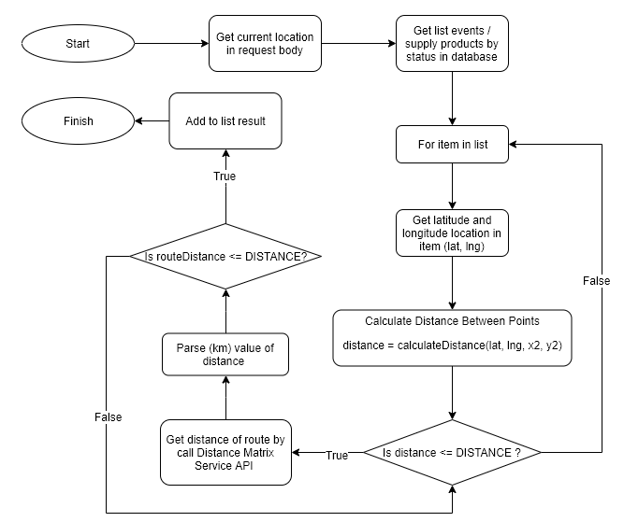

Figure 140 - Flowchart of Searching Distance Place

#### 7.2. Mapping wishlist products of user and list supply products

##### 7.2.1. Definition

Finding the products that meet users’ request.

##### 7.1.2. Define Problem

The system allows the users to send requests to find out products which suit their requirements, this leads to the questions how to find products best suit with the users’ requirement?

##### 7.1.3. Solution

To solve this issue, we build a form for users to fulfil, describe in detail to improve the correctness of finding products.

Based on the information in the form, we start the evaluation phase by applying string comparison method using Levenshtein Distance Computing Algorithm.

Levenshtein distance algorithm is used to identify the differences between the ranges of 2 sequences. The range between these sequences is the minimum steps to make one sequence become the other one. This algorithm includes 3 changing functions:

- Remove a character

- Add a new character

- Replace with another character

Mathematically, the Levenshtein distance between two strings a, b (of length |a| and |b| respectively) is given by leva,b(|a|,|b|) where:

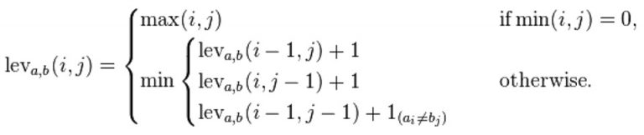

where:

1(ai≠bi) is the indicator function equal to 0 when ai≠bi and equal to 1 otherwise

leva,b(i,j) is the distance between the first i characters of a and the first j characters of b

Note that the first element in the minimum corresponds to deletion (from a to b), the second to insertion and the third to match or mismatch, depending on whether the respective symbols are the same.

*Levenshtein distance between "HONDA" and "HYUNDAI" is 3.*

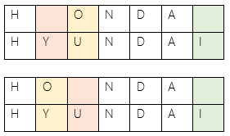

An example that features the comparison of "HONDA" and "HYUNDAI":

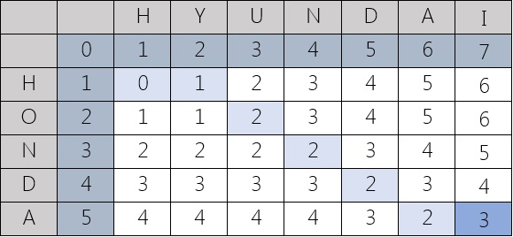

This is a straightforward pseudocode implementation for a function **LevenshteinDistance** that takes two strings:

- *s* of length *m*

- *t* of length *n*

And returns the Levenshtein distance between them:

function LevenshteinDistance(char s[1..m], char t[1..n]):

// for all i and j, d[i,j] will hold the Levenshtein distance between

// the first i characters of s and the first j characters of t

// note that d has (m+1)*(n+1) values

declare int d[0..m, 0..n]

set each element in d to zero

// source prefixes can be transformed into empty string by

// dropping all characters

for i from 1 to m:

d[i, 0] := i

// target prefixes can be reached from empty source prefix

// by inserting every character

for j from 1 to n:

d[0, j] := j

for j from 1 to n:

for i from 1 to m:

if s[i] = t[j]:

substitutionCost := 0

else:

substitutionCost := 1

d[i, j] := minimum(d[i-1, j] + 1, // deletion

d[i, j-1] + 1, // insertion

d[i-1, j-1] + substitutionCost) // substitution

return d[m, n]

##### 7.1.4. Complexity

The complexity of this algorithm is: O (n*m)

*This page is intentionally left blank*

# E. System Implementation & Test

## 1. Introduction

### 1.1. Overview

This section describes approach and methodologies used by our team to plan, organize and manage testing process of BWA.

It provides all necessary information about implementation and testing procedure of the system including test plans, test cases, test results and pass/fail criteria as well as testing flow to cover all possible cases.

### 1.2. Test Approach

* Goal: Test main features in the whole BWA based on core flow.
* Method: Black-box testing.
* Size: System Component.
* Technique: Check list.

## 2. Data Relationship Diagram

### 2.1. Physical Diagram

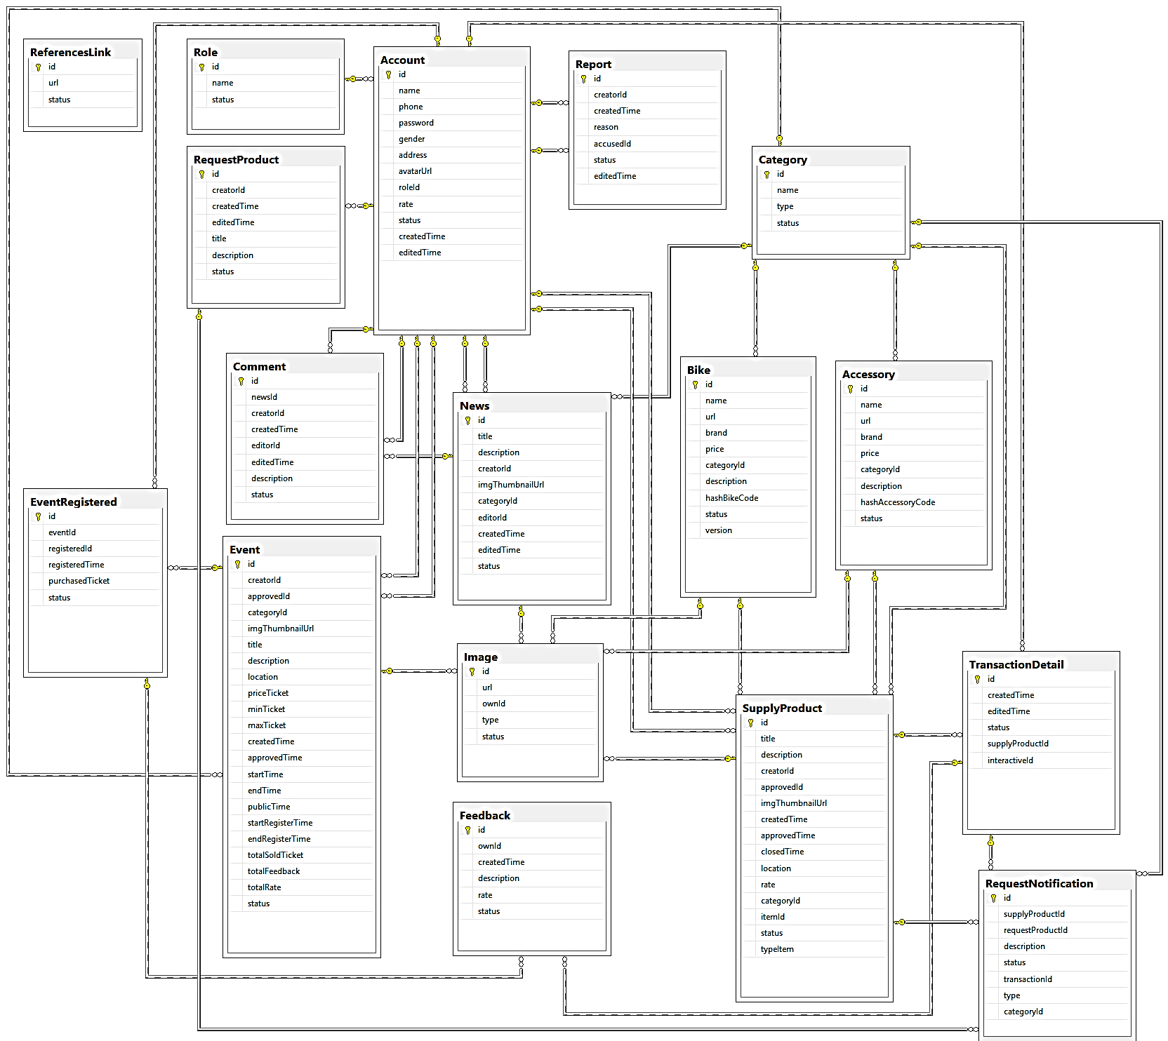

Figure 141- Physical Diagram

|  |  |  |
| --- | --- | --- |
| **Data Dictionary: Describe content of all table** | | |
| **No** | **Table Name** | **Description** |
| 1 | Account | Contain account information |
| 2 | Role | Contain role information |
| 3 | RequestProduct | Contain request product information |
| 4 | Report | Contain report information |
| 5 | Category | Contain category information |
| 6 | Event | Contain event information |
| 7 | News | Contain news information |
| 8 | Bike | Contain bike information |
| 9 | Accessory | Contain accessory information |
| 10 | Comment | Contain comment information |
| 11 | EventRegistered | Contain event registered information |
| 12 | Image | Contain image information |
| 13 | Feedback | Contain feedback information |
| 14 | SupplyProduct | Contain supply product information |
| 15 | TransactionDetail | Contain transaction detail information |
| 16 | RequestNotification | Contain request notification information |
| 17 | ReferencesLink | Contain references link notification |

Table 172 - Physical Diagram Dictionary

**2.2. Database Diagram Explanation**

* + 1. **Comment**

|  |  |  |
| --- | --- | --- |
| **Attribute** | **Type** | **Description** |
| id | int | Unique identifier of a comment |
| createdTime | datetime | The time comment was created |
| editedTime | datetime | The time comment was edited |
| description | nvarchar(max) | The description of comment |
| status | nvarchar(50) | The status of comment |

Table 158 - Comment Attribute

* + 1. **Role**

|  |  |  |
| --- | --- | --- |
| **Attribute** | **Type** | **Description** |
| id | int | Unique identifier of a role |
| name | nvarchar(50) | The name of the role |
| status | nvarchar(50) | The status of the role |

Table 159 - Role Attribute

* + 1. **Report**

|  |  |  |
| --- | --- | --- |
| **Attribute** | **Type** | **Description** |
| id | int | Unique identifier of a report |
| reason | nvarchar(max) | The reason of the report |
| createdTime | datetime | The time when the report was created |
| editedTime | datetime | The time when the report was edited |
| status | nvarchar(50) | The status of the report |

Table 160 - Report Attribute

* + 1. **Feedback**

|  |  |  |
| --- | --- | --- |
| **Attribute** | **Type** | **Description** |
| id | int | Unique identifier of a feedback |
| rate | nvarchar(10) | The rate of the feedback |
| description | nvarchar(max) | The description of the feedback |
| status | nvarchar(50) | The status of the feedback |

Table 161 - Feedback Attribute

* + 1. **SupplyProduct**

|  |  |  |
| --- | --- | --- |
| **Attribute** | **Type** | **Description** |
| id | Int | Unique identifier of a supply product |
| title | nvarchar(500) | The title of the supply product |
| imgThumbnailUrl | nvarchar(250) | The image thumbnail url of the supply product |
| createdTime | datetime | The time when the supply product was created |
| approvedTime | datetime | The time when the supply product was approved |
| closedTime | datetime | The time when the supply product was closed |
| location | nvarchar(200) | The location of the supply product |
| rate | nvarchar(10) | The rate of the supply product |
| description | nvarchar(max) | The description of the supply product |
| priority | nvarchar(50) | The priority of the supply product |
| status | nvarchar(50) | The status of the supply product |

Table 162 - SupplyProduct Attribute

* + 1. **News**

|  |  |  |
| --- | --- | --- |
| **Attribute** | **Type** | **Description** |
| id | int | Unique identifier of a news |
| title | nvarchar(500) | The title of the news |
| description | nvarchar(max) | The description of the news |
| imgThumbnailUrl | nvarchar(250) | The image thumbnail url of the news |
| createdTime | datetime | The time when the news was created |
| editedTime | datetime | The time when the news was edited |
| status | nvarchar(50) | The status of the news |

Table 163 - News Attribute

* + 1. **Account**

|  |  |  |
| --- | --- | --- |
| **Attribute** | **Type** | **Description** |
| id | int | Unique identifier of an account |
| name | nvarchar(50) | The name of the account |
| phone | nvarchar(20) | The phone of the account |
| password | nvarchar(100) | The password of the account |
| gender | nvarchar(50) | The gender of the account |
| address | nvarchar(500) | The address of the account |
| avatarUrl | nvarchar(250) | The avatar url of the account |
| createdTime | datetime | The time when the account was created |
| editedTime | datetime | The time when the account was edited |
| rate | nvarchar(10) | The rate of the account |
| status | nvarchar(50) | the status of the account |

Table 164 - Account Attribute

* + 1. **Image**

|  |  |  |
| --- | --- | --- |
| **Attribute** | **Type** | **Description** |
| id | int | Unique identifier of an image |
| url | nvarchar(max) | The url of the raw data |
| type | nvarchar(100) | The type of the own entity relation |
| status | nvarchar(50) | The status of the image |

Table 165 - Image Attribute

* + 1. **Event**

|  |  |  |
| --- | --- | --- |
| **Attribute** | **Type** | **Description** |
| id | int | Unique identifier of an event |
| title | nvarchar(100) | The title of the event |
| imgThumbnailUrl | nvarchar(250) | The image thumbnail url of the event |
| createdTime | datetime | The time when the event was created |
| approvedTime | datetime | The time when the event was approved by admin |
| startEventTime | datetime | The time when the event was started |
| endEventTime | datetime | The time when the event was ended |
| startRegisterTime | datetime | The time start to register of the event |
| endRegisterTime | datetime | The time stop to register of the event |
| publicTime | datetime | The time when the event was public event in system |
| location | nvarchar(200) | The location of the event |
| description | nvarchar(max) | The description of the event |
| priceTicket | float | The ticket price of the event |
| minTicket | int | The minimum amount of tickets of the event |
| maxTicket | int | The maximum amount of the tickets of the event |
| totalSoldTickets | int | The total of tickets was sold of the event |
| totalFeedbacks | int | The total of feedbacks was received of the event |
| totalRate | float | The total rates of the event |
| status | nvarchar(50) | The status of the event |

Table 166 - Event Attribute

* + 1. **Bike**

|  |  |  |
| --- | --- | --- |
| **Attribute** | **Type** | **Description** |
| id | int | Unique identifier of a bike |
| name | nvarchar(100) | The name of the bike |
| version | nvarchar(500) | The version of the bike |
| url | nvarchar(500) | The url of the raw bike data |
| brand | nvarchar(100) | The brand of the bike |
| price | float | The price of the bike |
| description | nvarchar(max) | The description of the bike |
| hashBikeCode | int | The hash bike code of the bike |
| status | nvarchar(50) | The status of the bike |

Table 167 - Bike Attribute

* + 1. **Accessory**

|  |  |  |
| --- | --- | --- |
| **Attribute** | **Type** | **Description** |
| id | int | Unique identifier of a accessory |
| name | nvarchar(100) | The name of the accessory |
| url | nvarchar(500) | The url of the raw accessory data |
| brand | nvarchar(100) | The brand of the accessory |
| price | float | The price of the accessory |
| description | nvarchar(max) | The description of the accessory |
| hashAccessoryCode | int | The hash accessory code of accessory |
| status | nvarchar(50) | The status of the accessory |

Table 168 - Accessory Attribute

* + 1. **RequestProduct**

|  |  |  |
| --- | --- | --- |
| **Attribute** | **Type** | **Description** |
| id | int | Unique identifier of a request product |
| title | nvarchar(100) | The title of the request product |
| description | nvarchar(max) | The description of the request product |
| status | nvarchar(50) | The status of the request product |

Table 169 - RequestProduct Attribute

* + 1. **Category**

|  |  |  |
| --- | --- | --- |
| **Attribute** | **Type** | **Description** |
| id | int | Unique identifier of a category |
| name | nvarchar(200) | The name of the category |
| type | nvarchar(100) | The type of the category |
| status | nvarchar(50) | The status of the category |

Table 170 - Category Attribute

* + 1. **ReferenceLinks**

|  |  |  |
| --- | --- | --- |
| **Attribute** | **Type** | **Description** |
| id | int | Unique identifier of a reference link |
| url | nvarchar(500) | The url of the reference links |
| status | nvarchar(50) | The status of the reference link |

Table 171 - ReferenceLinks Attribute

## 3. Test Plan

The overall purpose of testing is to ensure BWA meets its entire technical, functional and business requirement. The purpose of this document is to describe the test plan and strategy for testing the BWA. The following part will describe which features to be tested and which will not.

### 3.1. Feature to be tested

* Supply Post test
* Event test
* Request product test
* Account test
* Feedback test
* Comment test

### 3.2. Feature not to be tested

* Login
* Log out
* Manage account
* Crawl data
* Manage notification
* Manage news

## 4. System testing test case

### 4.1. <Member> Supply Product test

|  |  |  |  |  |  |  |
| --- | --- | --- | --- | --- | --- | --- |
| **ID** | **Test Case Description** | **Test case procedure** | **Expected output** | **Inter Dependence Test Case** | **Result** | **Test Date** |
|
| SUP1 | Follow supply product success | 1. User clicks on item to view supply product detail  2. User clicks "Liên hệ ngay" button | System shows success message: "Liên hệ thành công" and shows phone number contact | N/A | Pass | 31/03/2019 |
|  | Follow supply product duplicated | 1. User clicks on item to view supply product detail  2. User clicks "Liên hệ ngay" button  3. User clicks "Liên hệ ngay" button again | System was disabled button "Liên hệ ngay" | N/A | Pass | 31/03/2019 |
| SUP2 | Exchange with list followers | 1. User clicks on "Chi tiết" button in "Danh sách rao bài bán" page  2. User clicks "Giao dịch" button | System shows success message: "Giao dịch thành công" and change button to "Hủy giao dịch" | N/A | Pass | 31/03/2019 |
|  | Exchange again with list followers | 1. User clicks on "Chi tiết" button in "Danh sách rao bài bán" page  2. User clicks on "Giao dịch" button  3. User clicks on "Hủy Giao dịch button | System shows success message: "Hủy giao dịch thành công" and change button to "Giao dịch" | N/A | Pass | 31/03/2019 |
| SUP3 | Close supply product | 1. User clicks on "Chi tiết" button in "Danh sách rao bài bán" page  2. User clicks "Đóng bài rao bán" button | System shows success message: "Đóng thành công" and hiddens all buttons | N/A | Pass | 31/03/2019 |
| SUP4 | Create supply product filling invalid information | 1. User clicks "Tạo bài rao bán xe/phụ kiện" on menu  2. User fills invalid information in fields  3. User clicks "Đăng bài" button | System shows error message. | N/A | Pass | 31/03/2019 |
| SUP5 | Update supply product filling invalid information | 1. User clicks "Sửa" button in "Danh sách bài rao bán" in user page  2. User fills invalid information in fields  3. User clicks "Cập nhật" button | System shows error message. | SUP4 | Pass | 31/03/2019 |
| SUP6 | Create supply product feedback | 1. User clicks supply post detail page  2. User fills feedback information  3. User clicks "Bình luận" button | System shows success messages: "Phản hồi thành công" | N/A | Pass | 31/03/2019 |
| SUP7 | Update supply product feedback in 15 mins | 1. User clicks supply post detail page  2. User fills feedback information  3. User clicks "Bình luận" button | System shows success messages: "Phản hồi cập nhật thành công" | SUP6 | Pass | 31/03/2019 |
| SUP8 | Admin change status of an supply product | 1. Admin clicks "Danh sách bài rao bán" on menu  2. Admin chooses select dropdown | System shows success messages. | N/A | Pass | 17/04/2019 |

Table 173 - <Member> Supply post test

### 4.2 <Member> Event test

|  |  |  |  |  |  |  |
| --- | --- | --- | --- | --- | --- | --- |
| **ID** | **Test Case Description** | **Test case procedure** | **Expected output** | **Inter Dependence Test Case** | **Result** | **Test Date** |
|
| EVE1 | User buy tickets of event | 1. User clicks “Mua vé” button  2. User inputs an invalid number in "Số lượng vé" of buying tickets popup | System shows error messages: "Số lượng vé không hợp lệ" | N/A | Pass | 31/03/2019 |
| EVE2 | User inputs number of tickets more than maximum tickets can be bought | 1. User clicks "Mua vé" button  2. User inputs "130" in "Số lượng vé" of buying tickets popup  3. User clicks "PayPal Payer" button | System shows error messages: "Số lượng vé không đủ" | N/A | Pass | 31/03/2019 |
| EVE3 | User buy tickets fail | 1. User inputs "3" in "Giá vé" field, "Số vé tối thiểu", "Số vé tối đa"  2. User clicks "PayPal Payer" button  3. User closes PayPal popup | System comes back to event detail page and shows failed message: "Thanh toán thất bại. Bạn vui lòng thử lại" | N/A | Pass | 31/03/2019 |
| EVE4 | Subscribers events | 1.1. User goes to his/her event detail page  1.2. User goes to user page  1.2. 2. User clicks on "Danh sách sự kiện" to view his/her events  1.2. 2. 3. User clicks on "Xem" button to view his/her event detail page | System shows in event detail page list subscribers of the event | N/A | Pass | 31/03/2019 |
| EVE5 | Create Event filling invalid information | 1. User clicks "Tạo sự kiện" on menu  2. User fills invalid information in fields  3. User clicks "Đăng bài" button | System shows error messages. | N/A | Pass | 17/04/2019 |
| EVE6 | Create event with invalid public date | 1. User clicks "Tạo sự kiện" on menu  2. User chooses "Ngày công bố" (today)  3. User clicks "Đăng bài" button | System shows error messages: "Ngày công bố phải sau ngày hiện tại" | N/A | Pass | 17/04/2019 |
| EVE7 | Create event with invalid register time and event time | 1. User clicks "Tạo sự kiện" on menu  2. User choose "Thời gian cho phép mua vé sự kiện" after "Thời gian diễn ra sự kiện"  3. User clicks "Đăng bài" button | System shows error messages: "Ngày đóng mua vé phải trước ngày diễn ra" | N/A | Pass | 17/04/2019 |
| EVE8 | Update Event filling invalid information | 1. User clicks "Sửa" at an item in list events  2. User fills invalid information in fields  3. User clicks "Cập nhật" button | System shows error messages. | EVE7 | Pass | 17/04/2019 |
| EVE9 | Admin change status of an event | 1. Admin clicks "Danh sách sự kiện" on menu  2. Admin chooses select dropdown | System shows success messages. | N/A | Pass | 17/04/2019 |
| EVE10 | Create event feedback | 1. User clicks event detail page  2. User fills feedback information  3. User clicks "Bình luận" button | System shows success messages: "Phản hồi thành công" | EVE3 | Pass | 17/04/2019 |
| EVE11 | Update event feedback in 15 mins | 1. User clicks event detail page  2. User updates feedback information  3. User clicks "Cập nhật" button | System shows success messages: "Phản hồi cập nhật thành công" | EVE10 | Pass | 17/04/2019 |

Table 174 - <Member> Event test

### 4.3 <Member> News test

|  |  |  |  |  |  |  |
| --- | --- | --- | --- | --- | --- | --- |
| **ID** | **Test Case Description** | **Test case procedure** | **Expected output** | **Inter Dependence Test Case** | **Result** | **Test Date** |
|
| N1 | Create news filling invalid information | 1. Admin clicks "Tạo tin tức" on menu  2. Admin fills invalid information in fields  3. Admin clicks "Đăng bài" button | System shows error messages. | N/A | Pass | 18/04/2019 |
| N2 | Update news filling invalid information | 1. Admin clicks "Sửa" button in "Danh sách tin tức" in user page  2. Admin fills invalid information in fields  3. Admin clicks "Cập nhật" button | System shows error messages. | N/A | Pass | 18/04/2019 |
| N3 | Create comment | 1. Admin clicks news detail page  2. Admin fills invalid comment information  3. Admin clicks "Bình luận" button | System shows error messages. | N/A | Pass | 18/04/2019 |
| N4 | Update comment filling invalid information | 1. Admin clicks supply post detail page  2. Admin fills invalid information  3. Admin clicks "Bình luận" button | System shows error messages. | N/A | Pass | 18/04/2019 |
| N5 | Update comment in 15 mins | 1. User clicks supply post detail page  2. User fills comment content  3. User clicks "Bình luận" button | System shows success message: "Cập nhật thành công" | N/A | Pass | 18/04/2019 |
| N6 | Admin change status of an news | 1. Admin clicks "Danh sách tin tức" on menu  2. Admin chooses select dropdown | System shows success message: "Cập nhật thành công" | N/A | Pass | 18/04/2019 |
| N7 | Admin block comment | 1. Admin clicks on news detail page  2. Admin clicks on "Ẩn" link at a comment | System shows success message: "Ẩn thành công" | N/A | Pass | 18/04/2019 |
| N8 | Admin unblock comment | 1. Admin clicks on news detail page  2. Admin clicks on "Ẩn" link at a comment  3. Admin clicks on "Mở ẩn" link at a comment | System shows success message: "Mở ẩn thành công" | N/A | Pass | 18/04/2019 |

Table 175 - <Member> News test

# F. Software User’s Manual

## 1. Installation Guide

### 1.1. Setting up environment at server side

#### 1.1.1. Hardware requirements

|  |  |  |
| --- | --- | --- |
| **Server** | **Minimum Requirements** | **Recommended** |
| **Internet Connection** | Cable, Wi-Fi (8 Mbps) | Cable, Wi-Fi (50 Mbps or more) |
| **Operating System** | XP, Vista, 7, 10, Window Server 2008 | 10, Window Server 2008 |
| **Computer Processor** | Intel® Xeon ® 1.4GHz | Intel® Xeon ® Quad Core (12M Cache, 2.50 GHz) |
| **Computer Memory** | 4GB RAM | 32GB or more |
| **Storage space** | 1GB | 5GB or more |

Table 176 - Hardware requirement for server

#### 1.1.2. Software requirements

|  |  |  |
| --- | --- | --- |
| **Name** | **Name/Version** | **Description** |
| **Environment** | Java EE 8.0,Node v10.15.0,npm v6.4.1 | Specification for developing web application |
| **Operating System** | Window 10 | Operating system and platform for development |
| **Modeling tool** | StarUML, draw.io | Used to design diagram |
| **IDE** | IntelliJ IDEA 2019.3.3, Visual Studio Code 1.32.3 | Programming tools |
| **DBMS** | SQL Server 2014 | Used to create & manage the database for system |
| **Web server** | Jetty 9.4.14 | Deployment environment |
| **Web browser** | Chrome 69 or above. | Testing browser |

Table 177 - Software requirement for server

### 1.2. Deployment at server side

#### 1.2.1 Prepare development package

**Step 1:** Download and Install Java 8

Link download: <http://www.oracle.com/technetwork/java/javase/downloads/java-archive-javase8-2177648.html>

**Step 2:** Download and setup Jetty 9

Link download: <https://www.eclipse.org/jetty/download.html>

**Step 3:** Download and Install Node v10

Link download: <https://nodejs.org/en/download/>

**Step 4:** Download and Install IntelliJ IDE

Link download: <https://www.jetbrains.com/idea/download/#section=windows>

**Step 5:** Download, Install and configure Microsoft SQL Server 2014 Express

Link download: <https://www.microsoft.com/en-us/download/details.aspx?id=42299>

#### 1.2.2 Configure server before deploy

**Step 1**: Go to file application.properties

**Step 2**: Input datasource information

spring.datasource.url=jdbc:sqlserver://**server_name**;databaseName=**db_name**   
spring.datasource.username=**username**   
spring.datasource.password=**password**

**Step 3**: Save file

#### 1.2.3. Deployment of Web Service / Web Application

##### 1.2.3.1. Deploy SQL Server

Register Azure account in [https://portal.azure.com.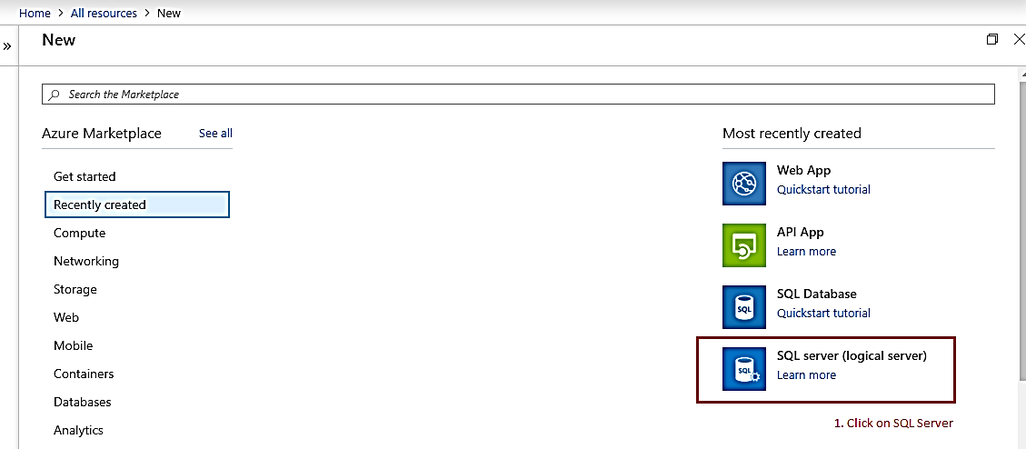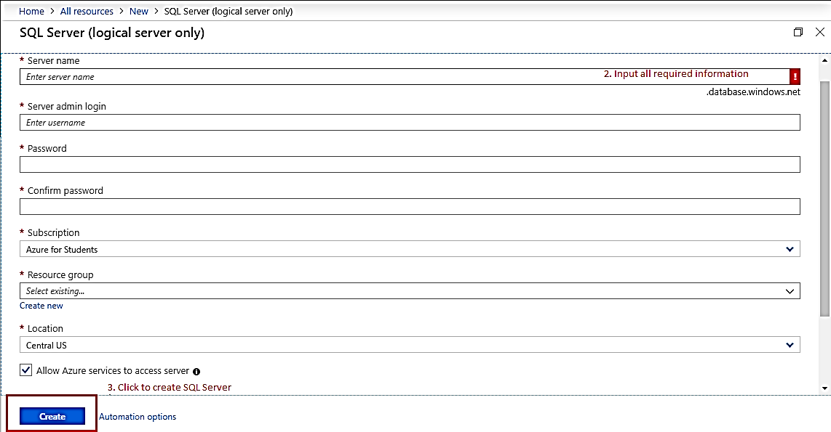](https://portal.azure.com.)

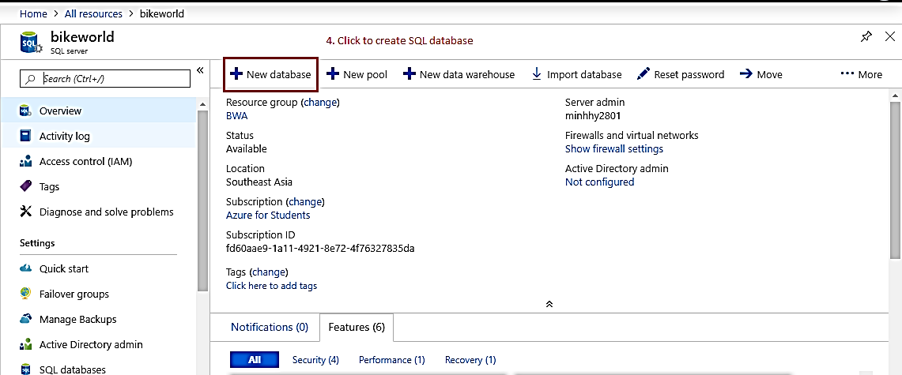

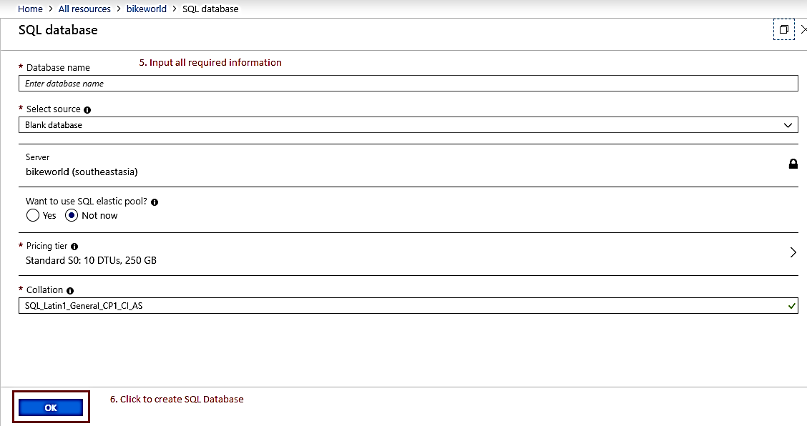

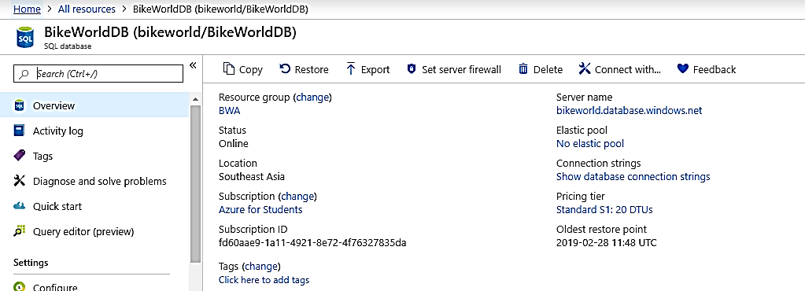

Open Microsoft SQL Server Management Studio 2014. Connect to your SQL Server by entering:

* Server name: Server name of SQL server in azure.
* Authentication: Choose appropriate authentication method that meets your system specification.
* Login: Server admin login.
* Password: password of the above username.

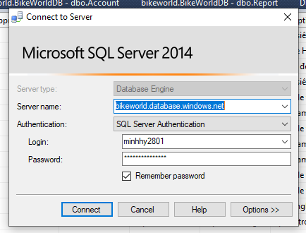

* Click connect and wait for operation to be completed.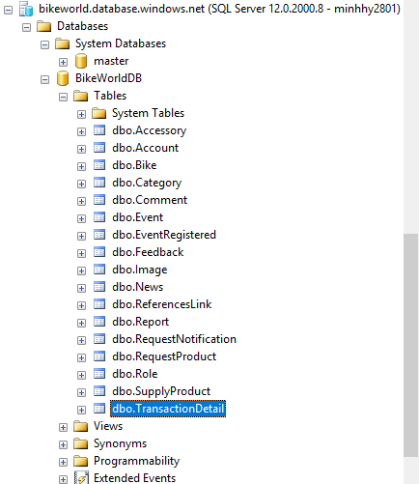

##### 1.2.3.2. Deploy Web Application

* Register Heroku account in [https://heroku.com](https://heroku.com/).

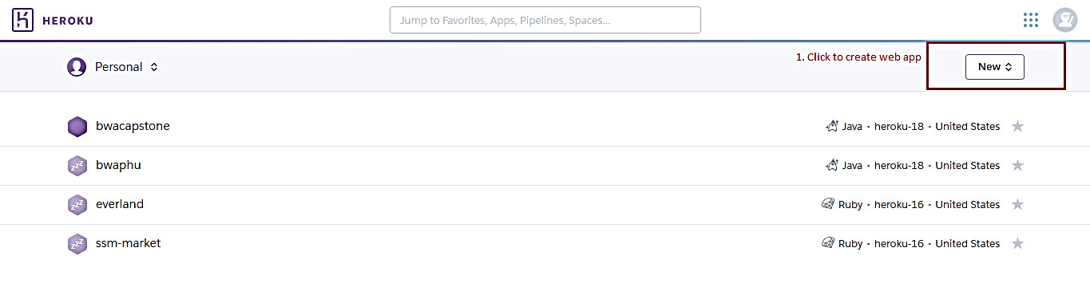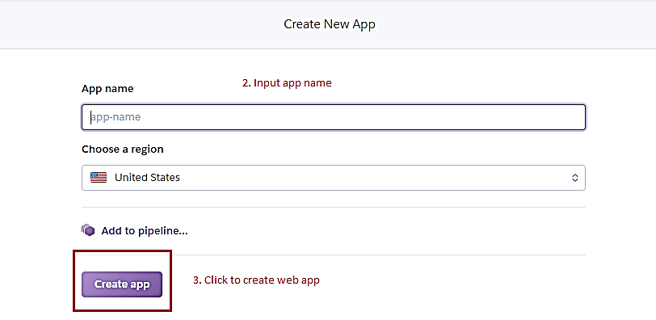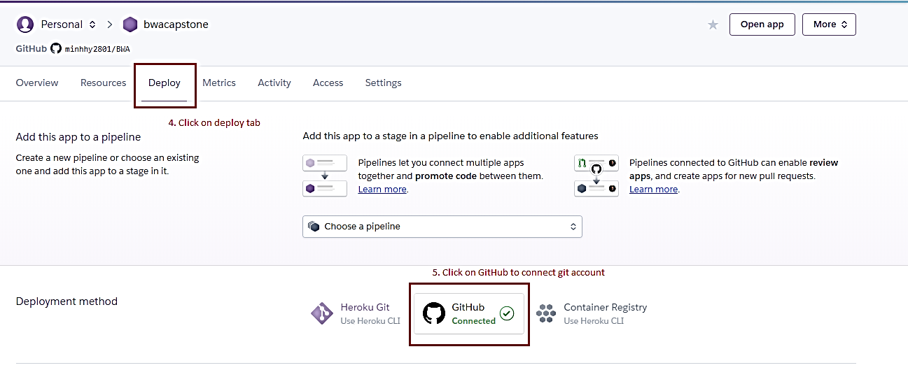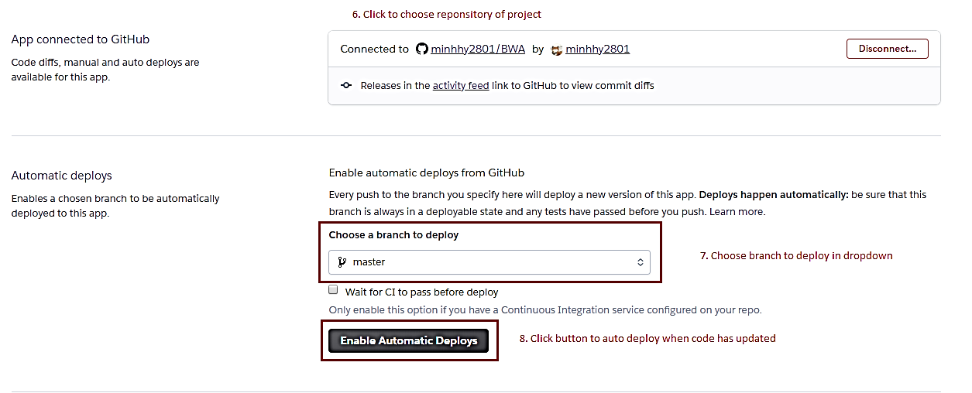

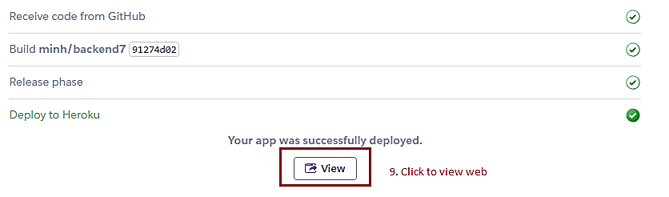

### 1.3. Setting up environment at client side

The client devices should have one of the following browsers to access the website: Google Chrome. Link download: <https://www.google.com/chrome/>

## 2. User Guide

### 2.1 Admin

#### 2.1.1 Block/Unblock member

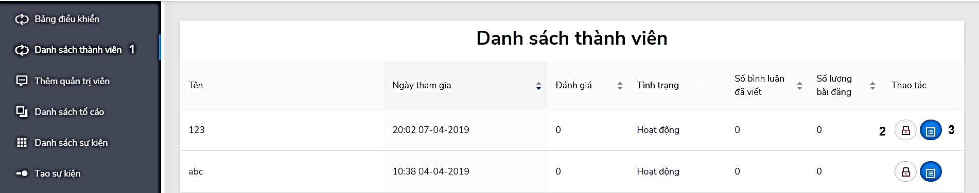

Figure 142 - <Admin> Block/Unblock member guide

|  |  |
| --- | --- |
| **Step** | **Description** |
| Pre-condition | Login as role “Admin” |
| 1 | Click on “Danh sách thành viên” |
| 2 | Click on lock icon to block/unblock member |
| 3 | Click on paper icon to view member profile |

Table 178 - <Admin> Block/Unblock member guide

#### 2.1.2 Add admin

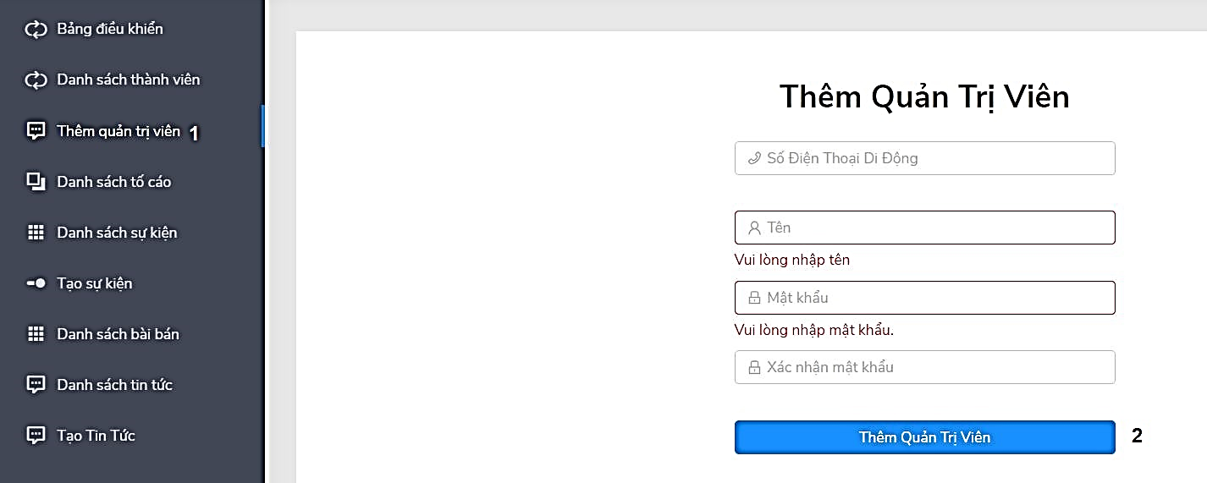

Figure 143 - <Admin> Add admin guide

|  |  |
| --- | --- |
| **Step** | **Description** |
| Pre-condition | Login as role “Admin” |
| 1 | Click on “Thêm quản trị viên” |
| 2 | After fill in all fields, click on “Thêm quản trị viên” button to add admin |

Table 179 - <Admin> Add admin guide

#### 2.2.3 View list report

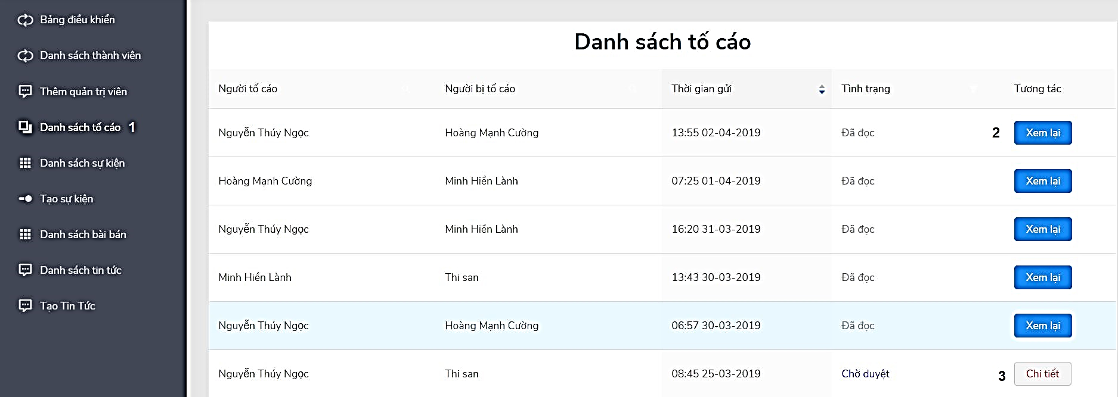

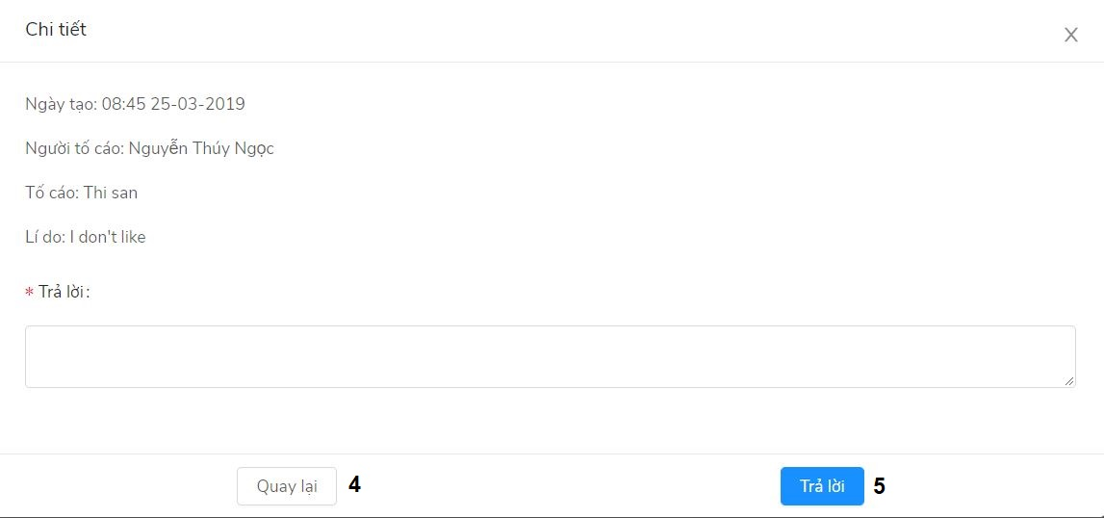

Figure 144 - <Admin> View list report guide

|  |  |
| --- | --- |
| **Step** | **Description** |
| Pre-condition | Login as role “Admin” |
| 1 | Click on “Danh sách tố cáo” |
| 2 | Click on “Xem lại” to view report detail |
| 3 | Click on “Chi tiết” to reply to report |
| 4 | Click on “Quay lại” to back |
| 5 | After type reply, click on “Trả lời” to reply report |

Table 180 - <Admin> View list report guide

#### 2.2.4 Confirm event

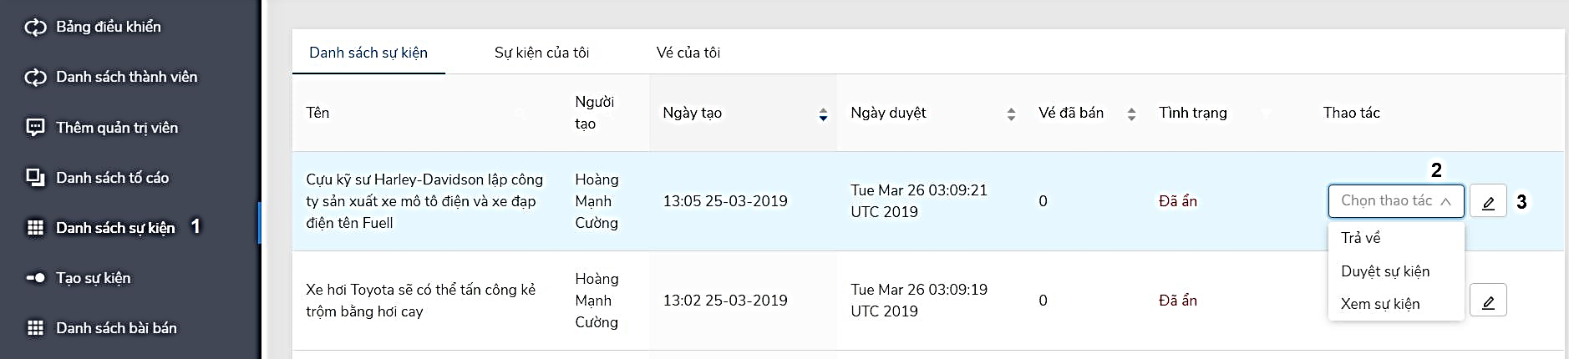

Figure 145 - <Admin> Confirm event guide

|  |  |
| --- | --- |
| **Step** | **Description** |
| Pre-condition | Login as role “Admin” |
| 1 | Click on “Danh sách sự kiện” |
| 2 | Click on “Chọn thao tác” to choose action to confirm |
| 3 | Click on pencil icon to confirm |

Table 181 - <Admin> Confirm event guide

#### 2.2.5 Confirm supply products

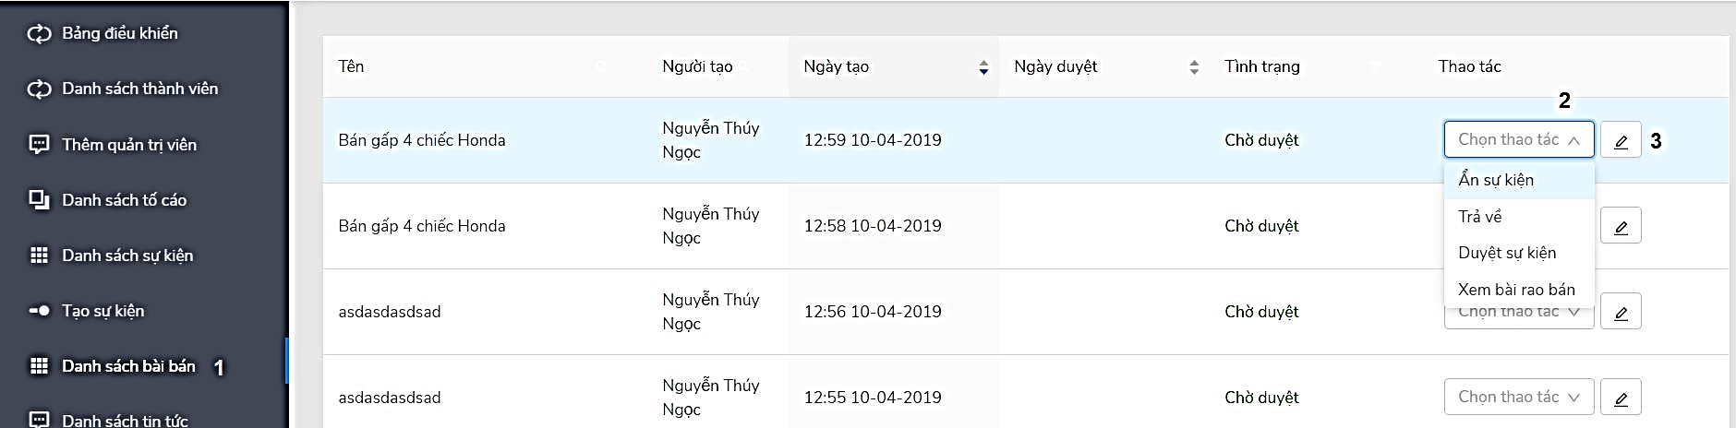

Figure 146 - <Admin> Confirm supply products guide

|  |  |
| --- | --- |
| **Step** | **Description** |
| Pre-condition | Login as role “Admin” |
| 1 | Click on “Danh sách bài rao bán” |
| 2 | Click on “Chọn thao tác” to choose action to confirm |
| 3 | Click on pencil icon to confirm |

Table 182 - <Admin> Confirm supply products guide

#### 2.2.6 Confirm news

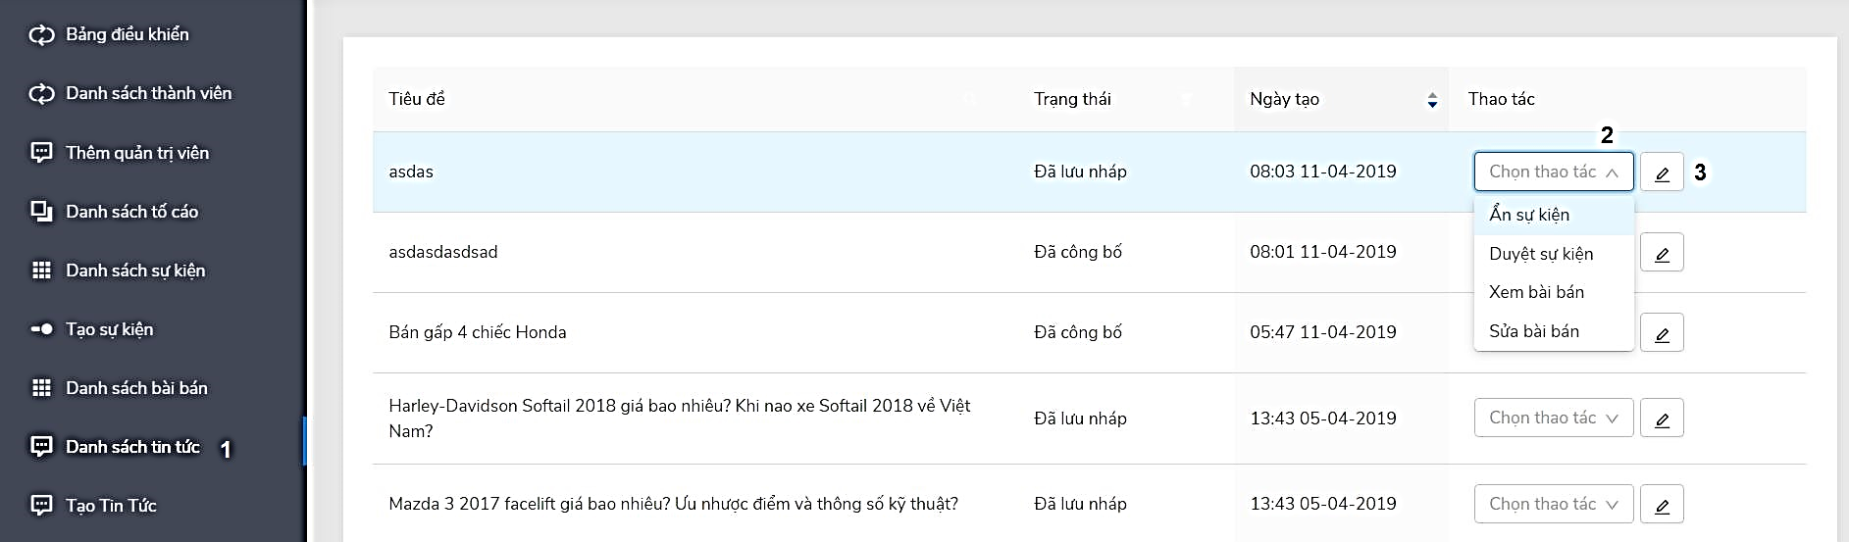

Figure 147 - <Admin> Confirm news guide

|  |  |
| --- | --- |
| **Step** | **Description** |
| Pre-condition | Login as role “Admin” |
| 1 | Click on “Danh sách tin tức” |
| 2 | Click on “Chọn thao tác” to choose action to confirm |
| 3 | Click on pencil icon to confirm |

Table 183 - <Admin> Confirm news guide

#### 2.2.7 Create news

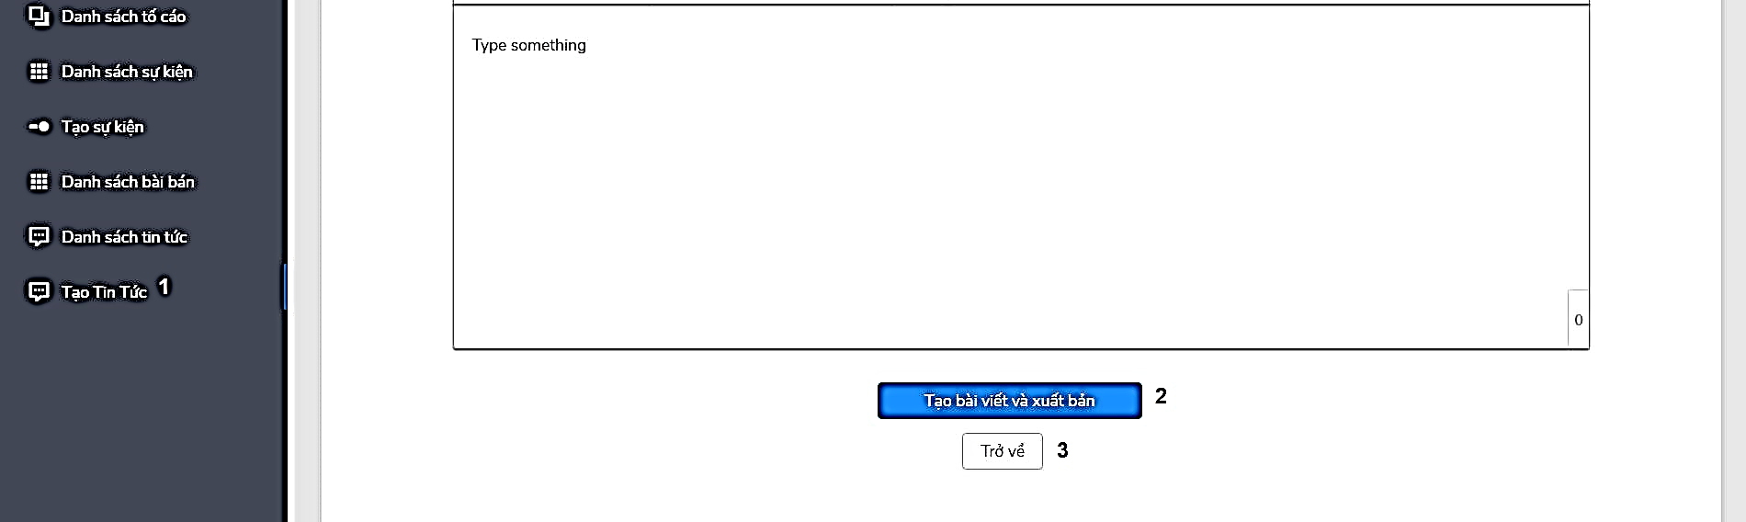

Figure 148 - <Admin> Create news guide

|  |  |
| --- | --- |
| **Step** | **Description** |
| Pre-condition | Login as role “Admin” |
| 1 | Click on “Tạo tin tức” |
| 2 | Click on “Tạo bài viết và xuất bản” button to create news |
| 3 | Click on “Trở về” button to back |

Table 184 - <Admin> Create news guide

### 2.2 Member

#### 2.2.1 View list member buy ticket of event

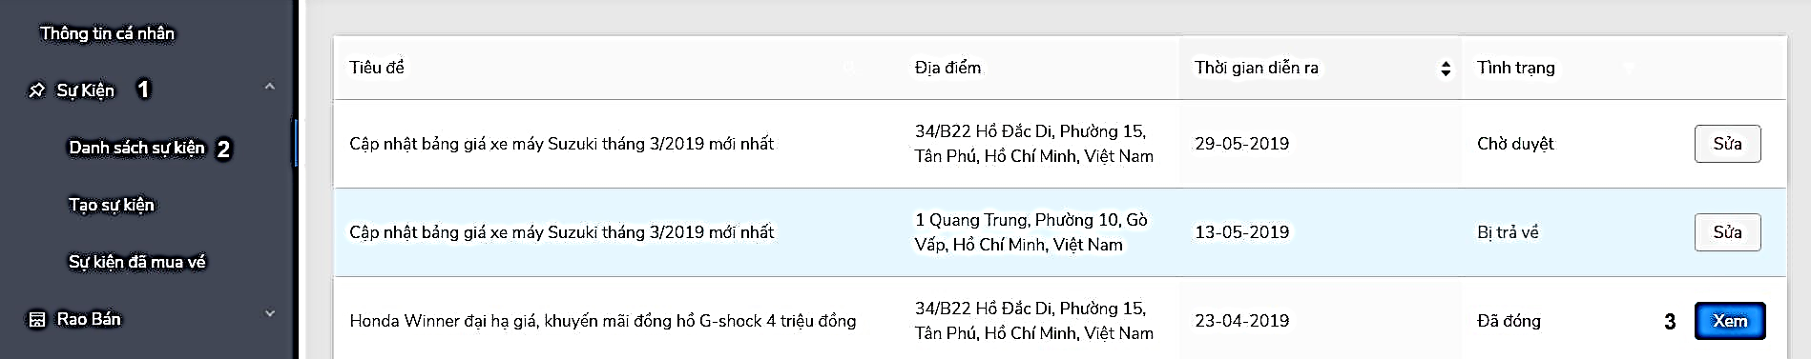

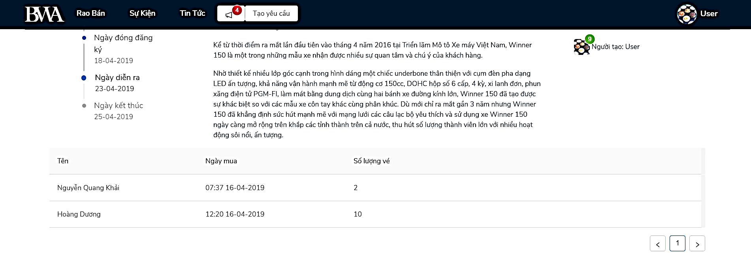

Figure 149 - <Member> View list member buy ticket of event guide

|  |  |
| --- | --- |
| **Step** | **Description** |
| Pre-condition | Login as role “Member” |
| 1 | Click on “Sự kiện” |
| 2 | Click on “Danh sách sự kiện” |
| 3 | Click on “Xem” button to view list member had bought ticket |

Table 185 - <Member> View list member buy ticket of event guide

#### 2.2.2 Update event

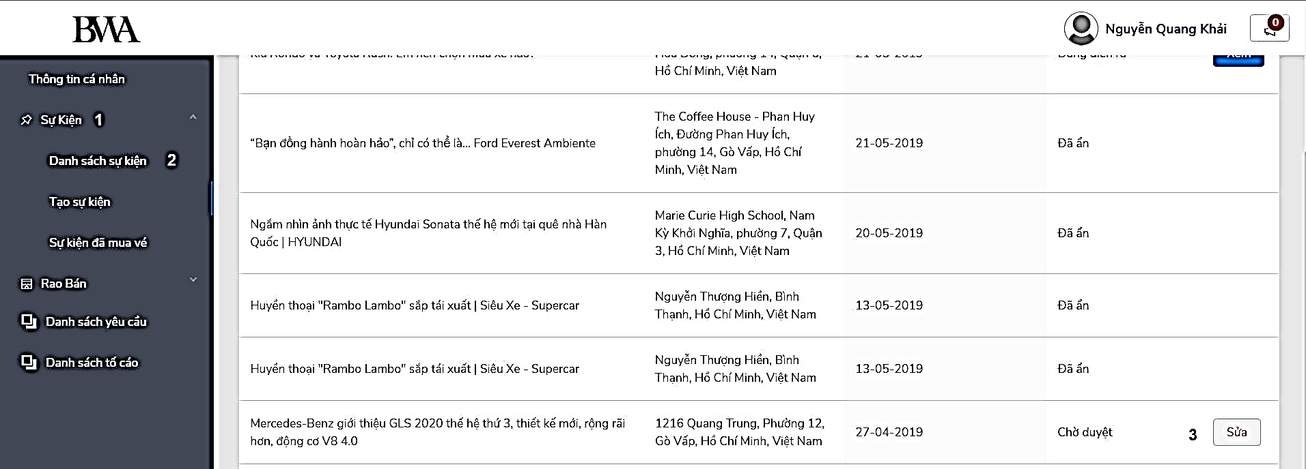

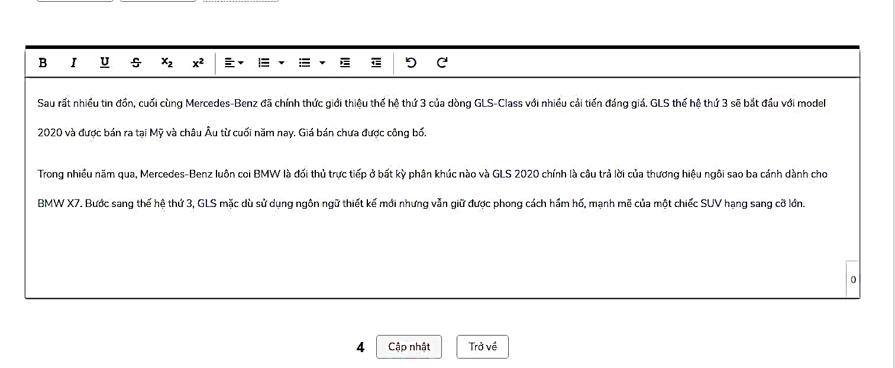

Figure 150 - <Member> Update event guide

|  |  |
| --- | --- |
| **Step** | **Description** |
| Pre-condition | Login as role “Member” |
| 1 | Click on “Sự Kiện” |
| 2 | Click on “Danh sách sự kiện” |
| 3 | Click on “Sửa” button to edit event |
| 4 | After fill in the fields, click “Cập nhật” to update event, “Trở về” to back. |

Table 186 - <Member> Update event guide

#### 2.2.3 Create event

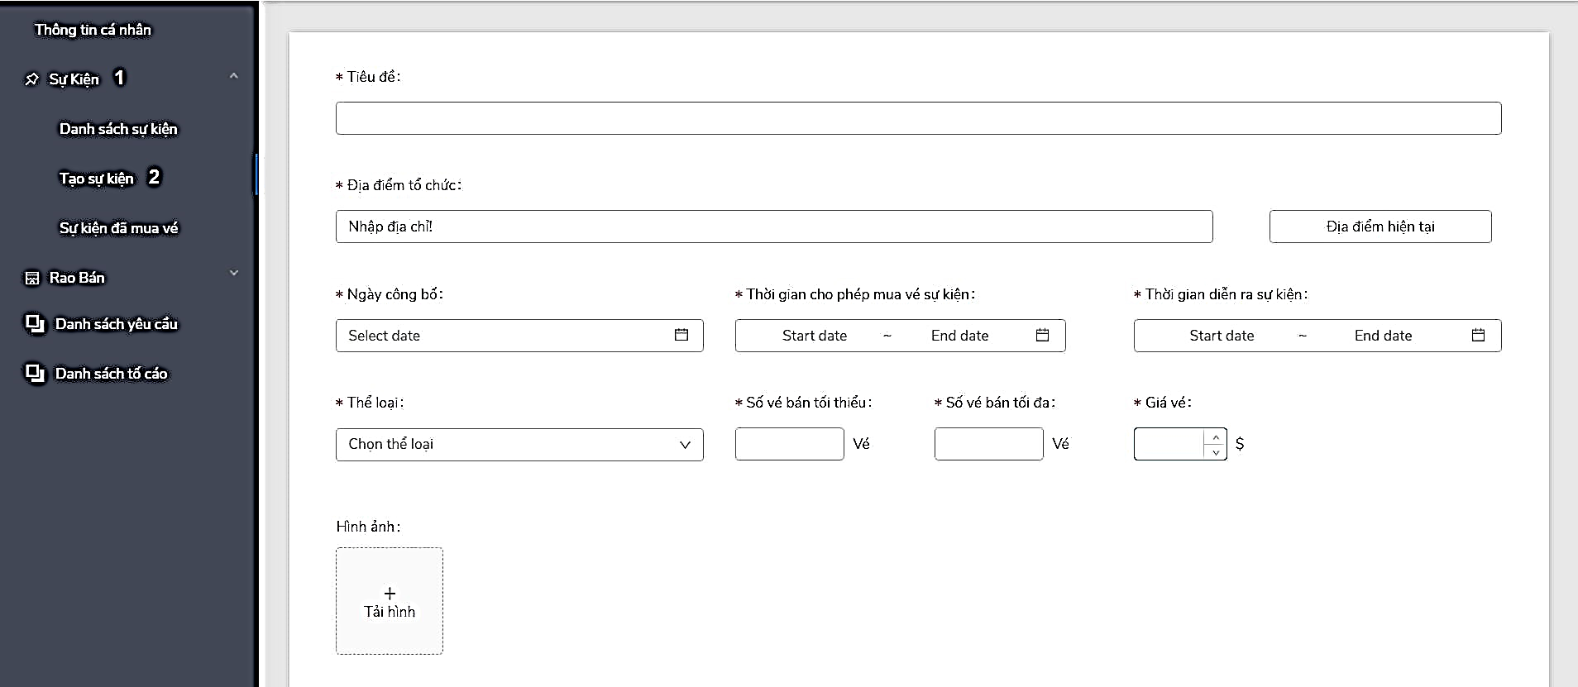

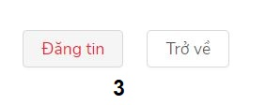

Figure 151 - <Member> Create event guide

|  |  |
| --- | --- |
| **Step** | **Description** |
| Pre-condition | Login as “Member” |
| 1 | Click on “Sự Kiện” |
| 2 | Click on “Danh sách sự kiện” |
| 3 | After fill in the fields, click “Đăng tin” to create event, “Trở về” to back. |

Table 187 - <Member> Create event guide

#### 2.2.4 View list event had bought ticket

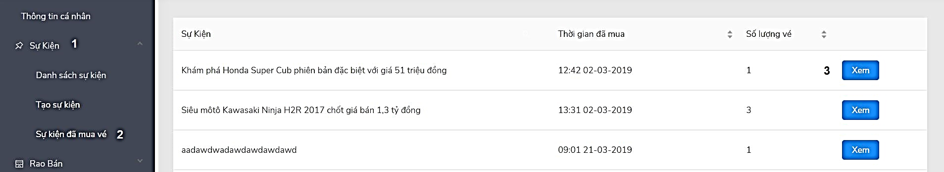

Figure 152 - <Member> View list event had bought ticket guide

|  |  |
| --- | --- |
| **Step** | **Description** |
| Pre-condition | Login as “Member” |
| 1 | Click on “Sự Kiện” |
| 2 | Click on “Sự kiện đã mua vé” |
| 3 | Click on “Xem” button to view event detail |

Table 188 - <Member> View list event had bought ticket guide

#### 2.2.5 Create bike post

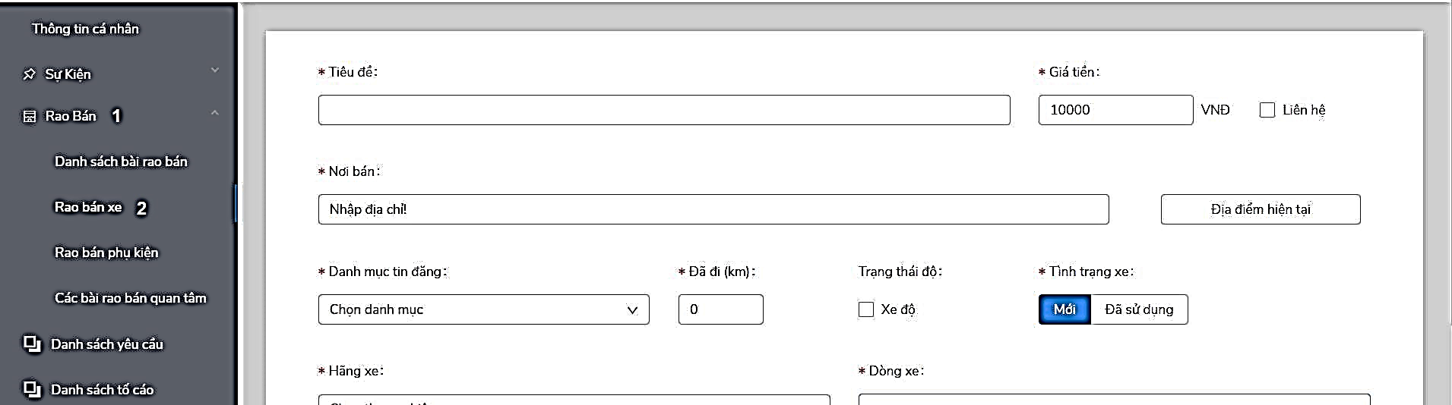

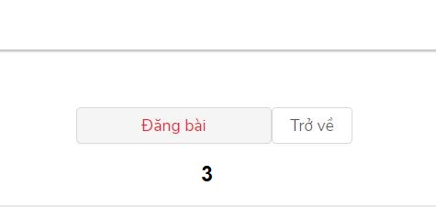

Figure 153 - <Member> Create bike post guide

|  |  |
| --- | --- |
| **Step** | **Description** |
| Pre-condition | Login as “Member” |
| 1 | Click on “Rao Bán” |
| 2 | Click on “Rao bán xe” |
| 3 | After fill in all fields, click on “Đăng bài” to create bike post. |

Table 189 - <Member> Create bike post guide

#### 2.2.6 Create accessory post

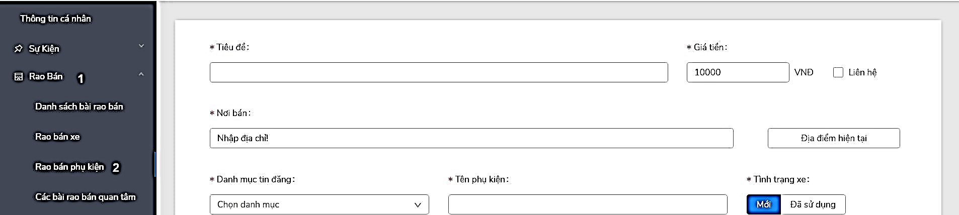



Figure 154 - <Member> Create accessory post guide

|  |  |
| --- | --- |
| **Step** | **Description** |
| Pre-condition | Login as “Member” |
| 1 | Click on “Rao Bán” |
| 2 | Click on “Rao bán phụ kiện” |
| 3 | After fill in all fields, click on “Đăng bài” to create accessory post. |

Table 190 - <Member> Create accessory post guide

#### 2.2.7 View list supply products had added to wishlist

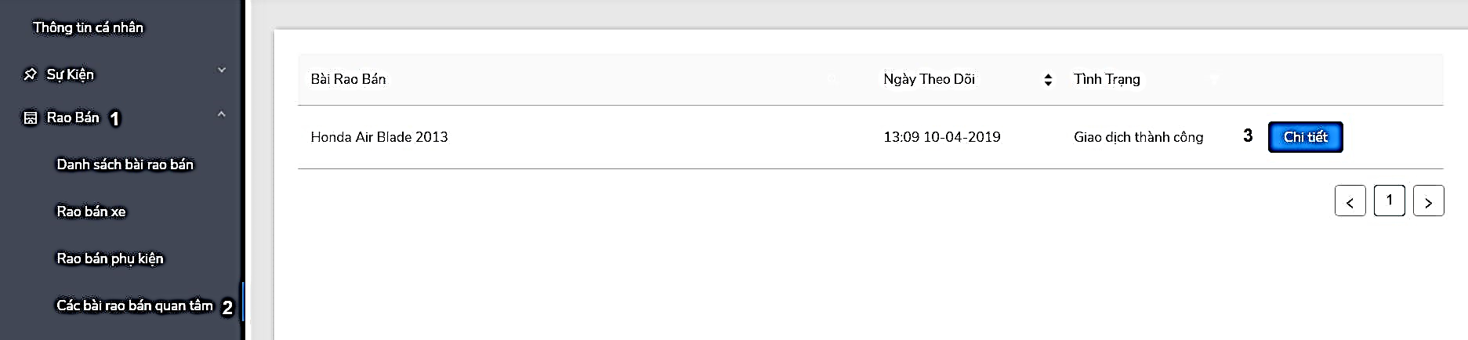

Figure 155 - <Member> View list supply products had added to wishlist guide

|  |  |
| --- | --- |
| **Step** | **Description** |
| Pre-condition | Login as “Member” |
| 1 | Click on “Rao Bán” |
| 2 | Click on “Các bài rao bán quan tâm” |
| 3 | Click on “Chi tiết” to view supply products detail. |

Table 191 - <Member> View list supply products had added to wishlist guide

#### 2.2.8 View request

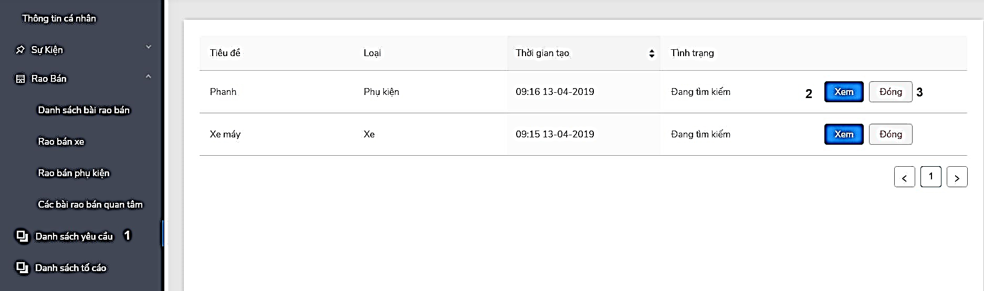

Figure 156 - <Member> View request guide

|  |  |
| --- | --- |
| **Step** | **Description** |
| Pre-condition | Login as “Member” |
| 1 | Click on “Danh sách yêu cầu” |
| 2 | Click on “Xem” button to view request detail |
| 3 | Click on “Đóng” button to close request |

Table 192 - <Member> View request guide

#### 2.2.9 View list report

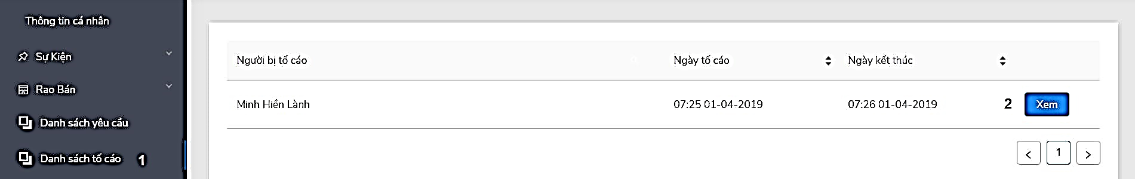

Figure 157 - <Member> View list report guide

|  |  |
| --- | --- |
| **Step** | **Description** |
| Pre-condition | Login as “Member” |
| 1 | Click on “Danh sách tố cáo” |
| 2 | Click on “Xem” button to view report detail |

Table 193 - <Member> View list report guide

### 2.3 Guest

#### 2.3.1 Search title of event, supply product, news

“Địa điểm”: “Tất cả”

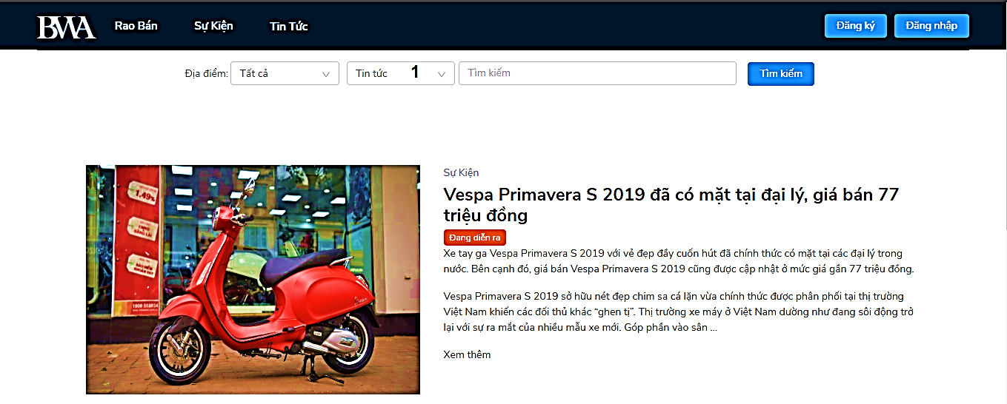

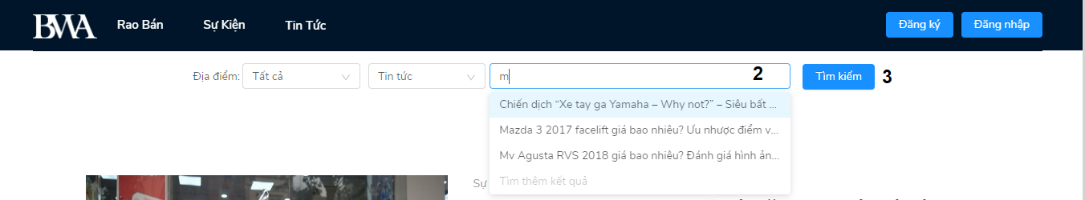

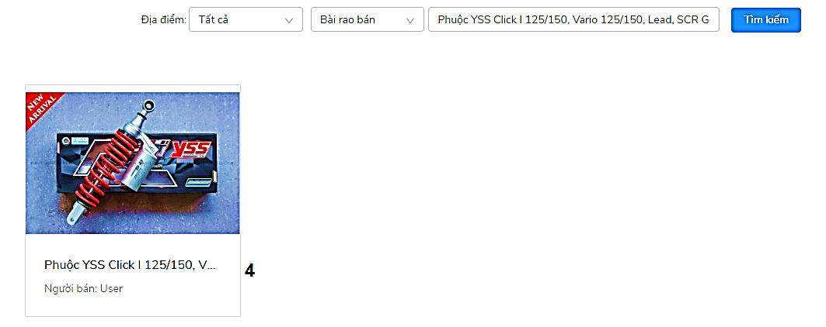

Figure 158 - <Guest> Search title of event, supply products, news guide

|  |  |
| --- | --- |
| **Step** | **Description** |
| Pre-condition | Select “Địa điểm”: “Tất cả” |
| 1 | Select category to search |
| 2 | Type keyword to search |
| 3 | Click “Tìm kiếm” to search |
| 4 | Click on the title of result to view detail |

Table 194 - <Guest> Search title of events, supply products, news guide

“Địa điểm”: “Tất cả”

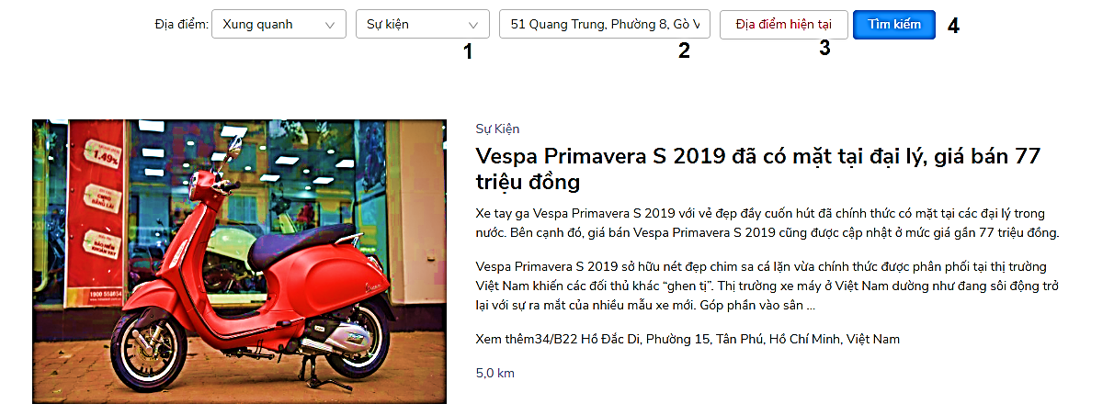

Figure 159 - <Guest> Search location of events, supply products, news guide

|  |  |
| --- | --- |
| **Step** | **Description** |
| Pre-condition | Select “Địa điểm”: “Xung quanh” |
| 1 | Select category to search |
| 2 | Type address to search |
| 3 | Click “Địa điểm hiện tại” button to choose current location to search |
| 4 | Click on “Tìm kiếm” button to search |

Table 195- <Guest> Search location of events, supply products, news guide

# G. Appendix

1. **Spring Framework** *[Online]* Available: [https:/spring.io/docs/reference](https://spring.io/docs/reference).
2. **ReactJS** *[Online]* Available:<https://reactjs.org/docs/getting-started.html>
3. **IntelliJ IDEA** *[Online]* Available: <https://www.jetbrains.com/idea/documentation/>
4. **Visual Studio Code** *[Online]* Available: <https://code.visualstudio.com/docs>
5. **Jsoup** *[Online]* Available: <https://jsoup.org/apidocs/overview-summary.html>
6. **Nodejs** *[Online]* Available: <https://nodejs.org/en/docs/>
7. **Http Code** *[Online]* Available: <https://www.w3.org/Protocols/rfc2616/rfc2616-sec10.html>
8. **PayPal Developer** *[Online]* Available: <https://developer.paypal.com/docs/checkout/>
9. **SpeedSMS** [Online] Available: <https://speedsms.vn/sms-api-service/>
10. **Spring Security JWT** [Online] Available:

<https://jwt.io/introduction/>

<https://auth0.com/blog/implementing-jwt-authentication-on-spring-boot/>

<https://auth0.com/docs/quickstart/backend/java-spring-security>

1. **Google Map Javascript API** *[Online]* Available:

<https://developers.google.com/maps/documentation/javascript/tutorial>

1. **Levenshtein distance** *[Online]* Available: <https://en.wikipedia.org/wiki/Levenshtein_distance>
2. **UML Diagram** *[Online]* Available: <https://www.uml-diagrams.org/>
3. **Ant Design** *[Online]* Available: <https://ant.design/docs/react/introduce>